Analytics: Creating Analytics Objects

1. Analytics: Creating Analytics Objects

1.1 Analytics: Creating Analytics Objects
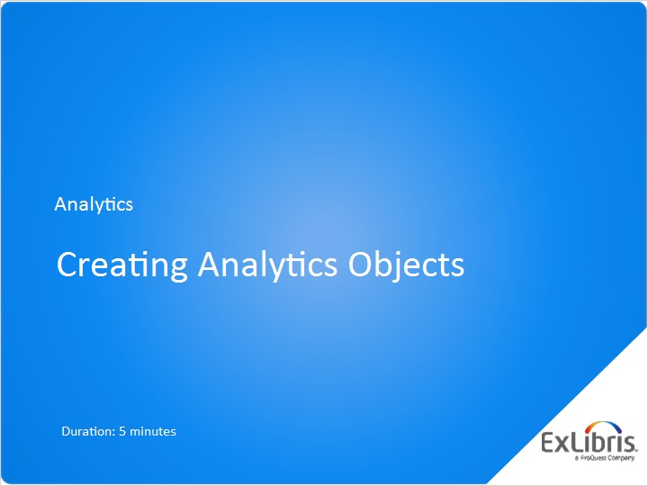
Notes:
Hello, and welcome to this session on Creating Analytics Objects

1.2 Displaying Analytics in Alma
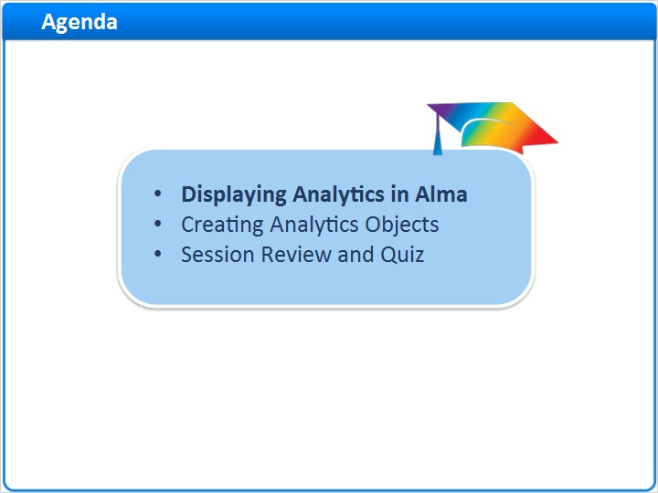
Notes:
In this session, we’ll start by covering how Analytics are displayed in Alma.
Then we’ll see how you as an administrator can create the different Analytics Objects which allow for these displays.

After a session review, there will be a short quiz to test your knowledge.

1.3 Creating vs. Displaying Analytics
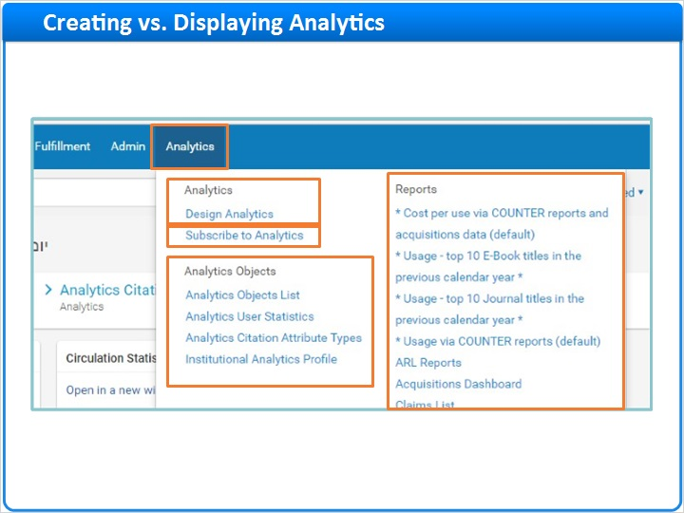
Notes:
Analytics in Alma are created via Design Analytics, which you can learn about in the Introduction to Alma Analytics session under Alma Essentials.

Once Analytics have been created, they are displayed via Analytics Objects, which are the focus of this session.

You as the administrator create the Analytics objects, and define which user-roles can subscribe to them.
The individual users can then view these Analytics, depending on the Object-type, by either subscribing, adding to their homepage, or directly accessing from the Analytics menu.

1.4 Displaying Analytics in Alma
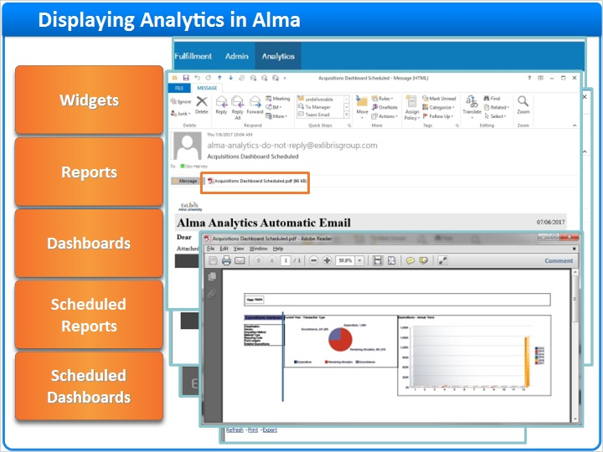
Notes:
There are 5 types of Analytics Objects, used to display Analytics in Alma:

Widgets - which appear on the user’s homepage, enabling users to view Analytics when they log in to Alma
Reports - which can be opened directly from the Analytics Menu by clicking on the name of the report, enabling users to view the latest Analytics on demand
Dashboards - a combination of reports that can be opened directly from the same Analytics Reports menu
Scheduled Reports - An email sent to the user with a report file attached; at a daily, weekly or monthly schedule
Scheduled Dashboards - A scheduled email sent to the user with a Dashboard in PDF format

1.5 Creating Analytics Objects
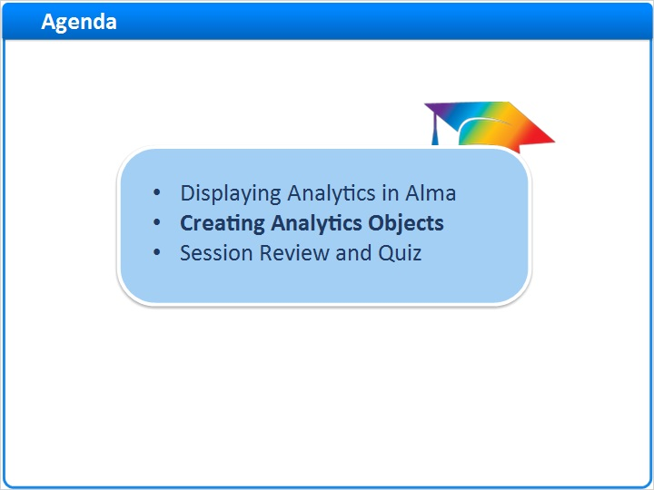
Notes:
Widgets, Reports, Dashboards, and their scheduled counterparts are known as Analytics Objects. Here’s how you create them in Alma.

1.6 Analytics Menu > Analytics Objects List
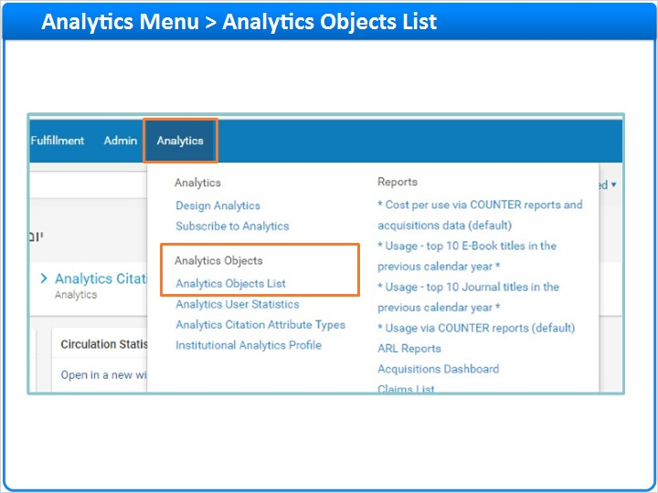
Notes:
Go to Analytics Menu > Analytics Objects List

1.7 Analytics Objects List
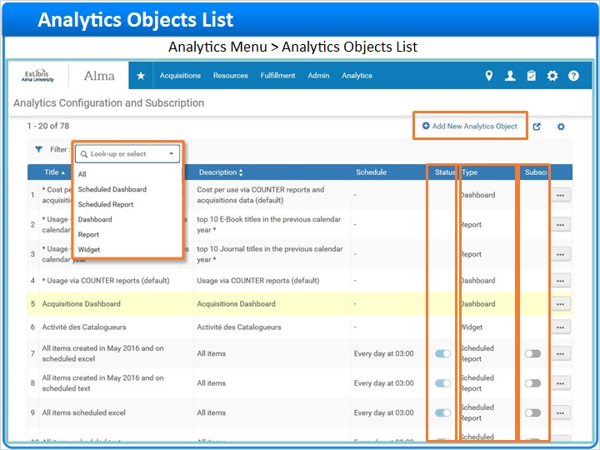
Notes:
Here in the Analytics Objects List you can see all of the existing Analytics Objects.

We can see here the different types of objects, and here we can filter by a specific type.

For scheduled objects, you can see if the status is active, meaning the job will run on schedule, and you can also subscribe to the mailing list from here.

To create a new Object of any type, click Add New Analytics Object

1.8 Creating Widgets, Reports, and Dashboards
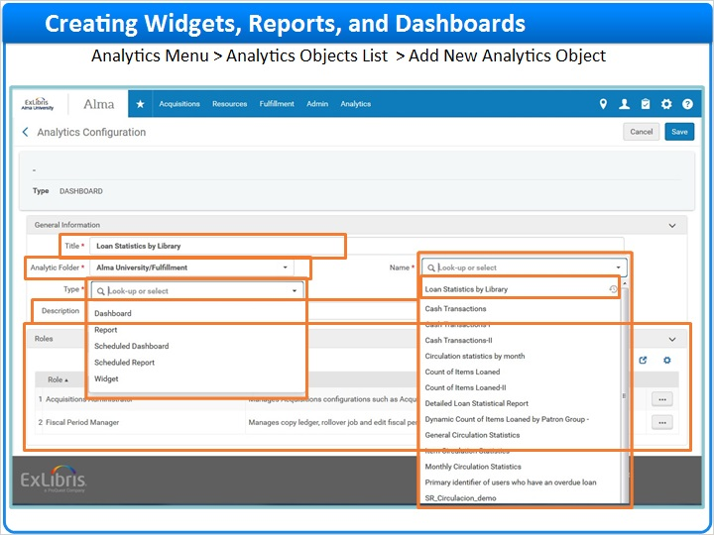
Notes:
Select the Analytics Object Type, let’s first look at Widgets, Reports, and Dashboards which have similar parameters.

- Enter the title for the Analytics object - this should be descriptive enough for the user’s benefit.
- You can also add an optional description.
- Select the Analytic folder. This is the location in Design Analytics where the original Analytics can be found.
- Under Name, select the desired Analytics. The selection here depends on the folder we just now chose. Recently chosen Analytics appear on top, the rest appear in Alphabetical order below, so if you don’t see your analytics in its alphabetical place make sure to look on top as well.
- Under roles, select which user roles can view this Analytics Object if they choose. In our example, the report will be available only to an Acquisitions Administrator or a Fiscal Period Manager.

1.9 Creating Scheduled Reports and Scheduled Dashboards
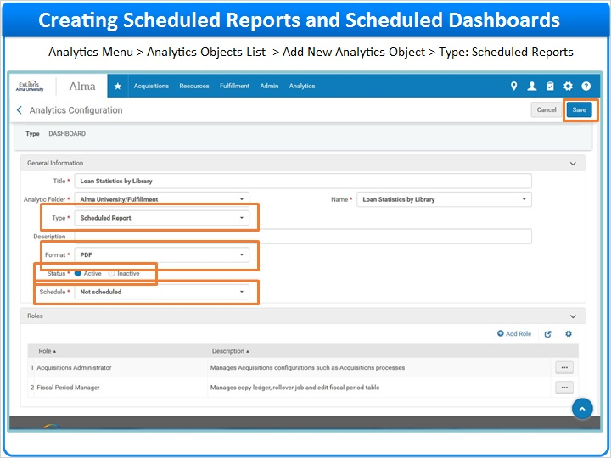
Notes:
If you’re creating a scheduled report or dashboard, which sends the report by email via a job that runs periodically, you need to fill in these additional parameters:

Format: the report file type attached in the email: PDF, Excel, or Text. The format parameter does not apply to Dashboards.
Status: should be active if you want the report to be sent out.
Schedule: allows you to send the report daily, weekly, or monthly

When done click save.

1.10 New Object was Added
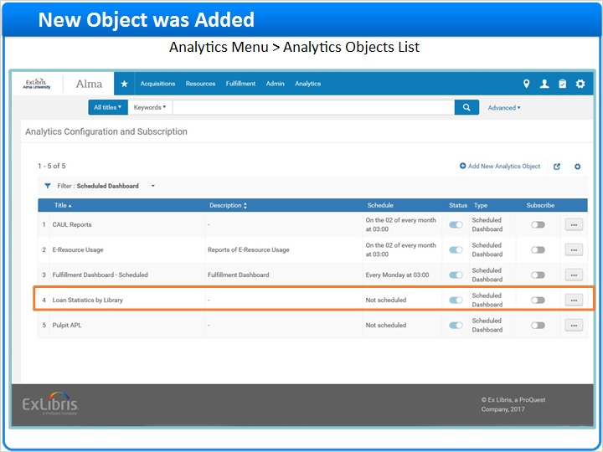
Notes:
The new Object is added to the Analytics Object List, where it is now available for the users with the relevant role to view.

1.11 Viewing and Subscribing to Analytics
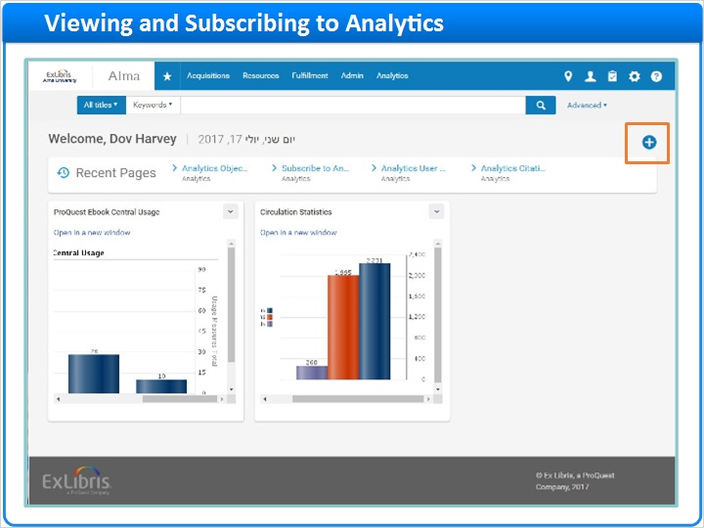
Notes:
As a reminder, if we look at it from the non-administrator user’s perspective, here’s how they can view the analytics objects you’ve just created,
assuming they have the proper role:

1. They can open the Reports and Dashboards under Alma Analytics Menu > Reports
2. They can subscribe to Scheduled Reports and Dashboards under Alma Analytics Menu > Subscribe to Analytics
3. And finally, they can add Widgets via the plus icon on their homepage.

1.12 Session Review and Quiz
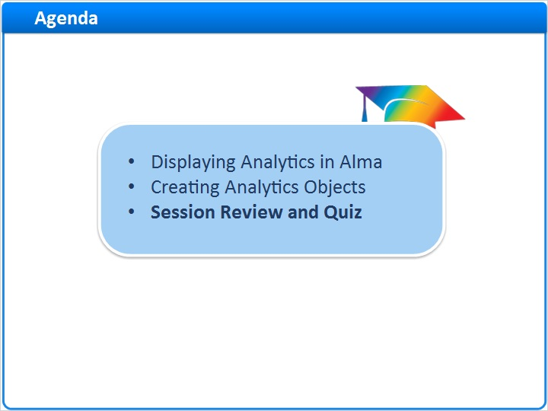
Notes:
That concludes the main portion of this training session. Let’s briefly review what was covered and then proceed to a short quiz.

1.13 Session Review
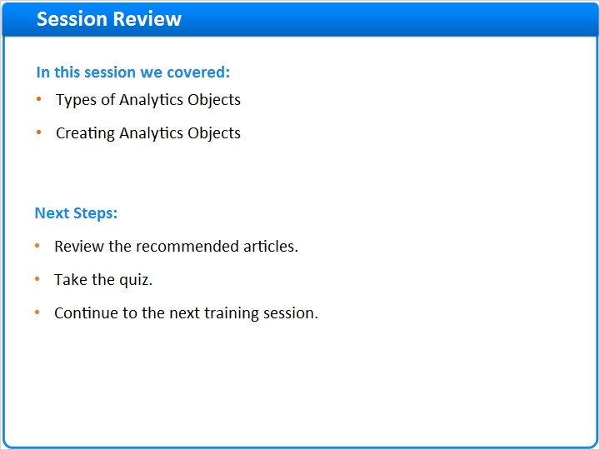
Notes:

In this session we:
- Covered the 5 types of Analytics objects: widgets, reports, dashboards, scheduled reports and Scheduled dashboards
- Then we saw how to create these objects via Analytics Menu > Analytics Objects
- We concluded with how the user can display these objects once they’ve been created.

Please refer to the Recommended Articles section where you launched this training session for additional information.
After the short quiz that begins on the next page, you can continue on to the next training session in this series.

1.14 Quiz: Creating Analytics Objects
(Multiple Choice, 10 points, 1 attempt permitted)
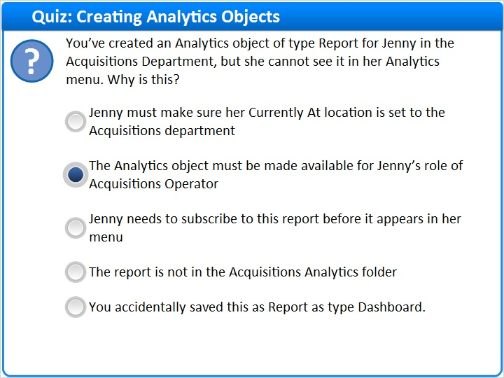
Correct | Choice
 | Jenny must make sure her Currently At location is set to the Acquisitions department
X | The Analytics object must be made available for Jenny’s role of Acquisitions Operator
 | Jenny needs to subscribe to this report before it appears in her menu
 | The report is not in the Acquisitions Analytics folder
 | You accidentally saved this as Report as type Dashboard.
Feedback when correct:
Reports appear in the Reports section of the Alma Analytics menu for users that have the proper role, so you must specify all relevant roles. Unlike a scheduled report, there is no need to subscribe to a regular report. Jenny’s current location, and the location of the report in a specific Analytics folder is irrelevant. And even if you saved it as a dashboard, it should still appear under Reports in the Analytics menu.
Feedback when incorrect:
Reports appear in the Reports section of the Alma Analytics menu for users that have the proper role, so you must specify all relevant roles. Unlike a scheduled report, there is no need to subscribe to a regular report. Jenny’s current location, and the location of the report in a specific Analytics folder is irrelevant. And even if you saved it as a dashboard, it should still appear under Reports in the Analytics menu.

Notes:

Correct (Slide Layer)
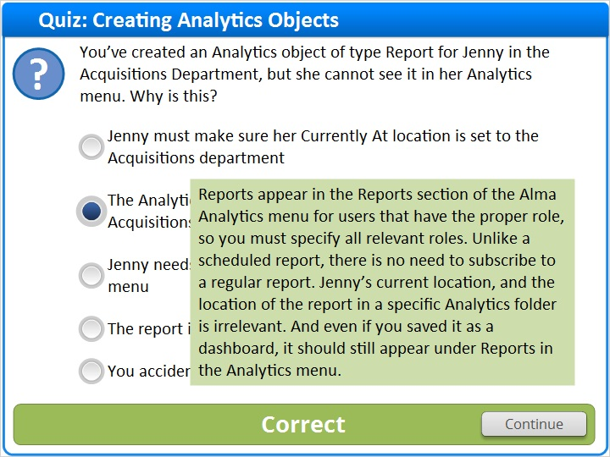

Incorrect (Slide Layer)
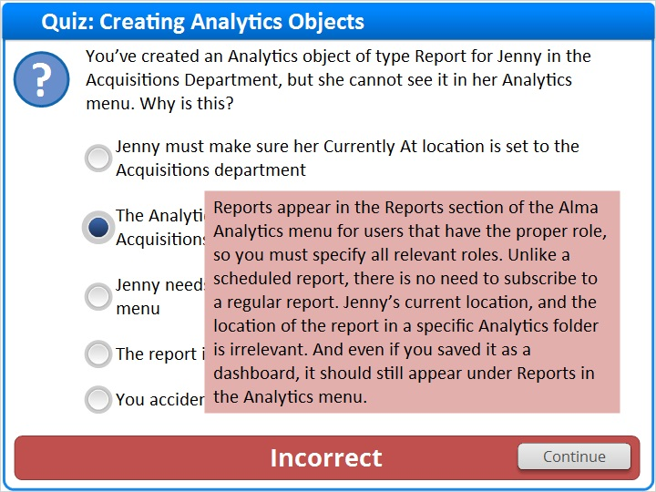

1.15 Quiz: Displaying Analytics in Alma
(Multiple Choice, 10 points, 1 attempt permitted)
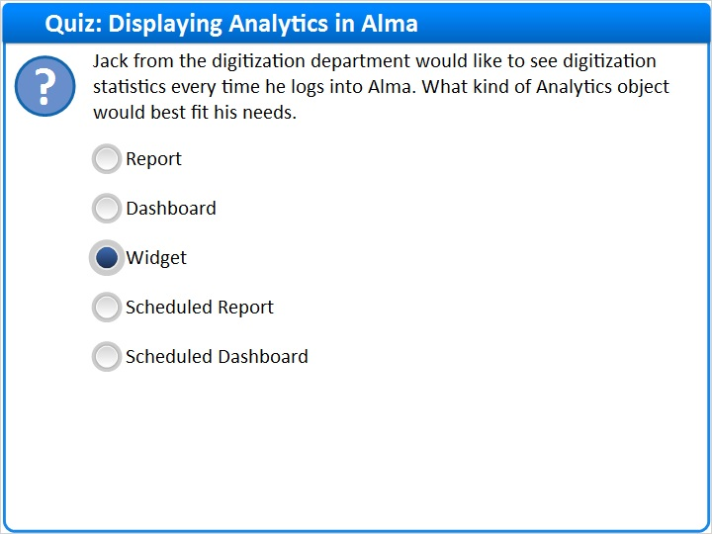
Correct | Choice
 | Report
 | Dashboard
X | Widget
 | Scheduled Report
 | Scheduled Dashboard

Feedback when correct:
Widgets show up in your homepage when you log in, so they best fit Jack’s requirement. Reports and Dashboards are available from the menu, so they would be the second choice. Scheduled reports and dashboards are not available on demand, you need to wait for the next time they’re sent, but a daily scheduled report would be the third choice.
Feedback when incorrect:
Widgets show up in your homepage when you log in, so they best fit Jack’s requirement. Reports and Dashboards are available from the menu, so they would be the second choice. Scheduled reports and dashboards are not available on demand, you need to wait for the next time they’re sent, but a daily scheduled report would be the third choice.

Notes:

Correct (Slide Layer)
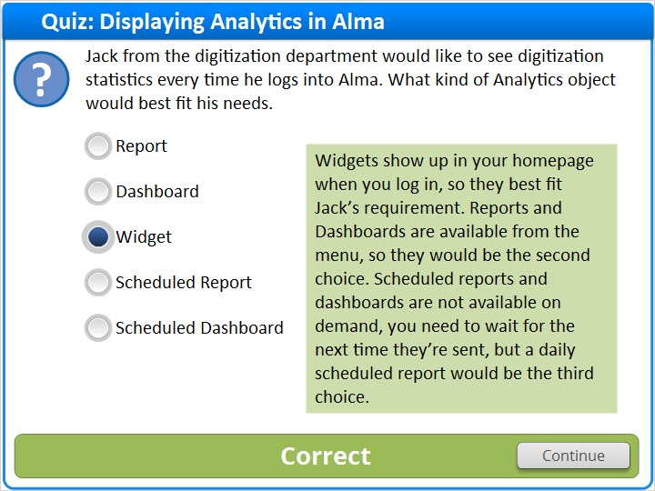

Incorrect (Slide Layer)
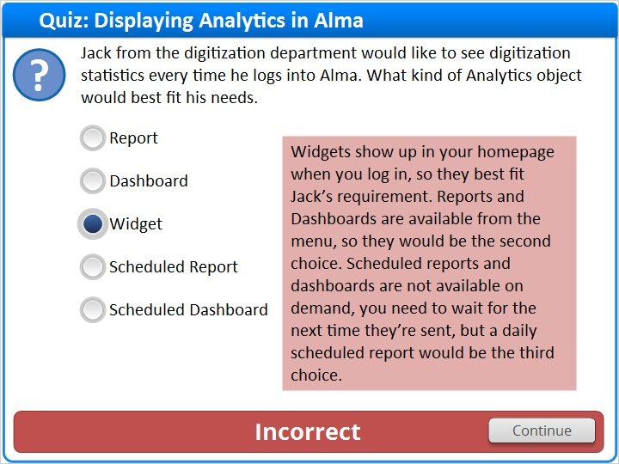

1.16 Thank You!

Notes:
Thanks for joining this session!

1.17 About this Training

Notes:

1 (Slide Layer)
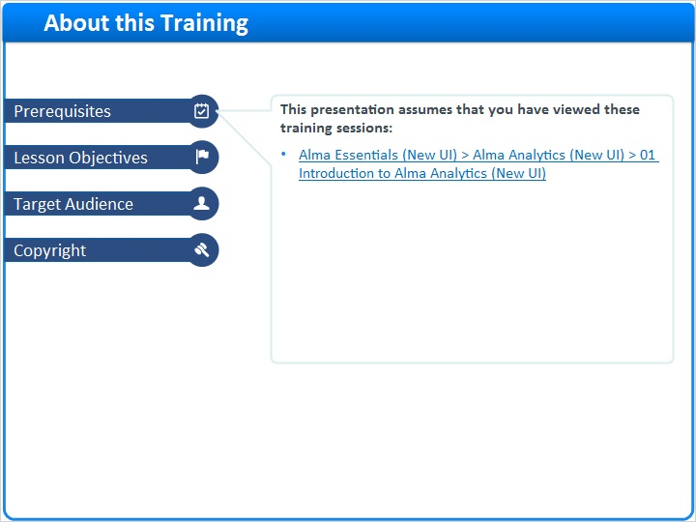

2 (Slide Layer)
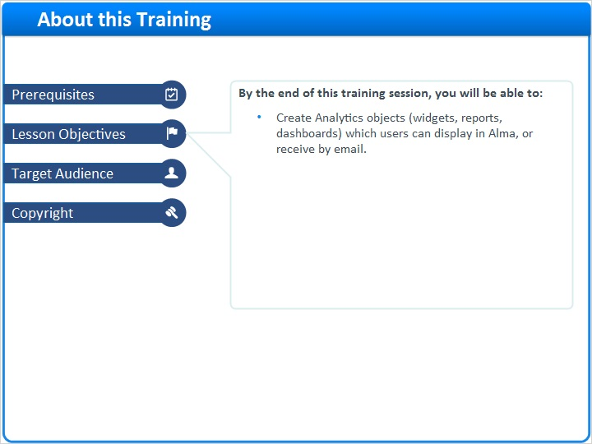

3 (Slide Layer)
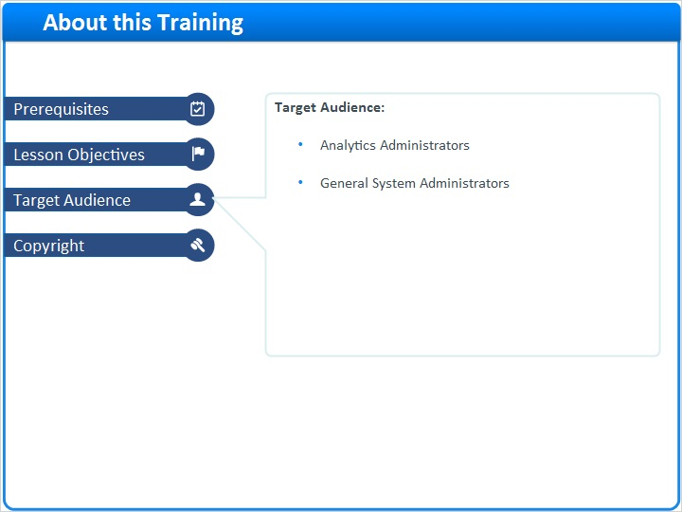

4 (Slide Layer)


