Fulfillment: Discovery - Direct Linking

1. Fulfillment: Discovery - Direct Linking

1.1 Fulfillment: Discovery - Direct Linking
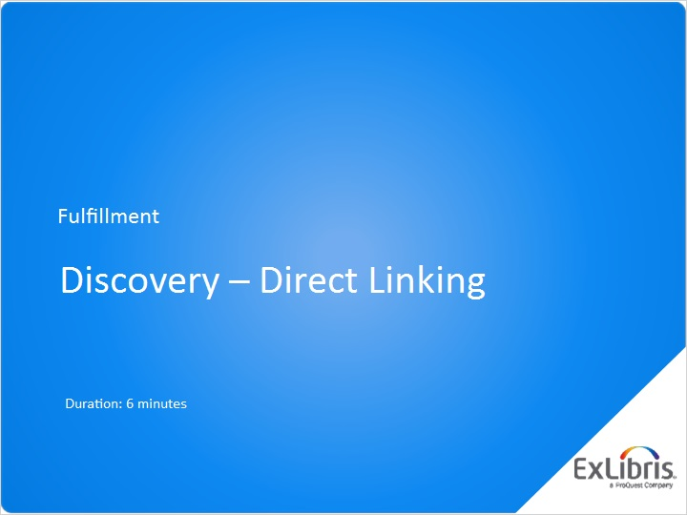
Notes:
Hello, and welcome to this session on Direct Linking.

1.2 What is Direct Linking?
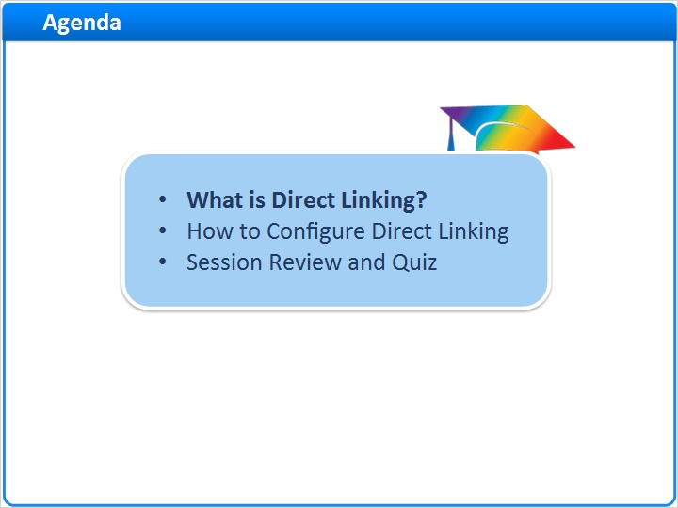
Notes:
In this session, we’ll discuss what Direct Linking is, and how it can improve the user experience in Primo. Then, we’ll learn how to configure Direct Linking. After a brief session review, there will be a short quiz to test your knowledge.

1.3 How Full Text Linking Works
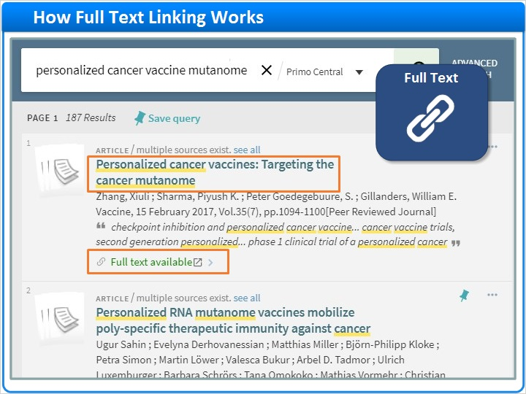
Notes:
But, before we talk about Direct Linking, let’s consider how linking to full text articles works in general.

Here are some search results in Primo. If you click on the title of a search result, you will see the primo Full Record page. To access full text for an electronic resource, navigate to the View It section and click on one of the full text service links provided by the Alma link resolver.

Back on the Primo Brief Results page, we also see a link that says Full text available. If you click this link, your experience could depend on several factors.

Let’s take a closer look. When you click on the Full text available link…

Primo Full Results Page (Slide Layer)
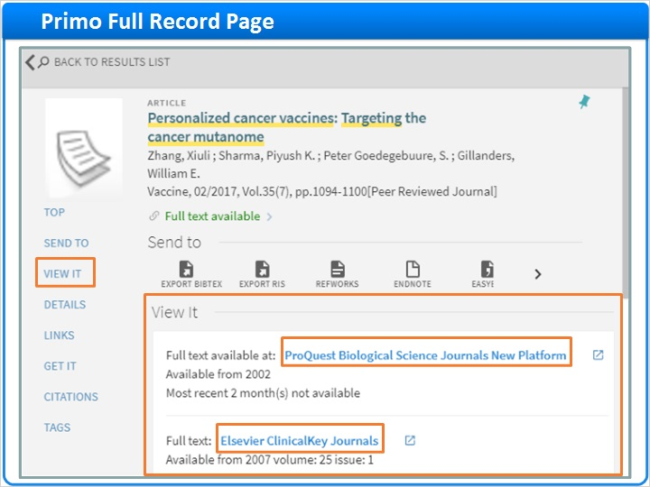

1.4 Linking to Full Text
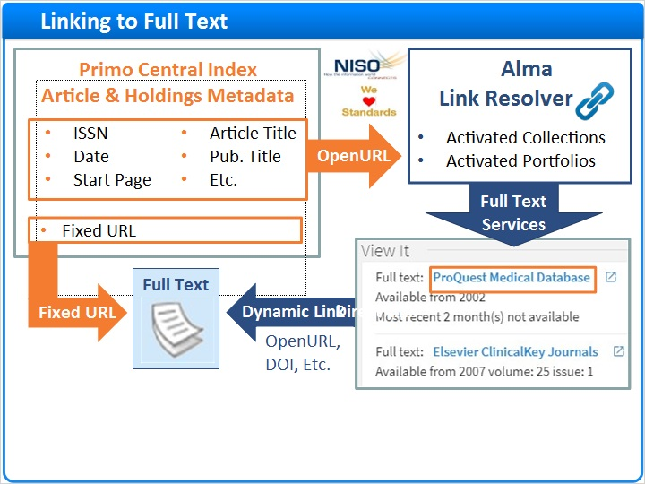
Notes:
…Primo checks for article and holdings metadata in the Primo Central Index. If adequate metadata is available, Primo sends the metadata to Alma using a special URL syntax called OpenURL. OpenURL is the NISO standard for passing metadata such as ISSNs, dates, and start pages along in a URL.

Next, the Alma Link Resolver matches the OpenURL metadata to your activated collections and portfolios. Based on these matches, Alma creates a list of all available full text services for display in the View it section of the Primo Full Record page.

When you click on a full text Service link in the View It section, you are taken to full text via OpenURL, DOI, or other linking syntax.

In some cases, however, there is not adequate metadata or holdings information to request full text services from Alma. In these cases, if a fixed URL is available in the article metadata, the Full text available link will go right to full text without stopping at View It.

So, patrons have two different experiences when they click on Full text available. In one case, they stop off at View It to choose a full text service. And, in the other case, they go right to full text.

But, there is an alternative called Direct Linking. If you activate Direct Linking, Primo can still use OpenURL to request all possible full text services from Alma. But, clicking on Full text available, will take you right to full text instead of stopping off at View It.

Some libraries are concerned that Direct Linking, while convenient, limits the choice of full text services. After all, each of us has our favorites. But, this is not a problem at all. You get the best of two worlds with Direct Linking:

- Use the title link to access the Primo Full Record page including all possible full text services.
- And, use the Full text available link to consistently access full text with a single click.

Primo Search Results Page (Slide Layer)
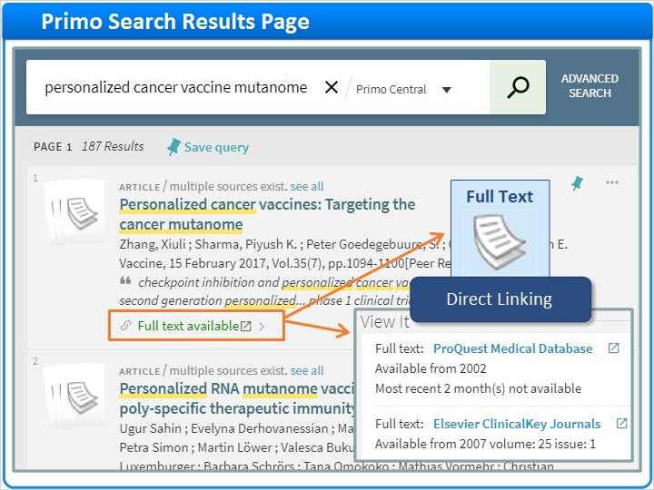

Primo Search Results Page 2 (Slide Layer)
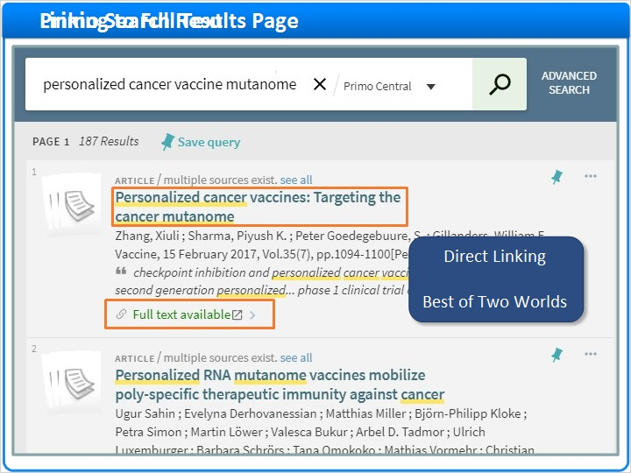

1.5 How to Configure Direct Linking
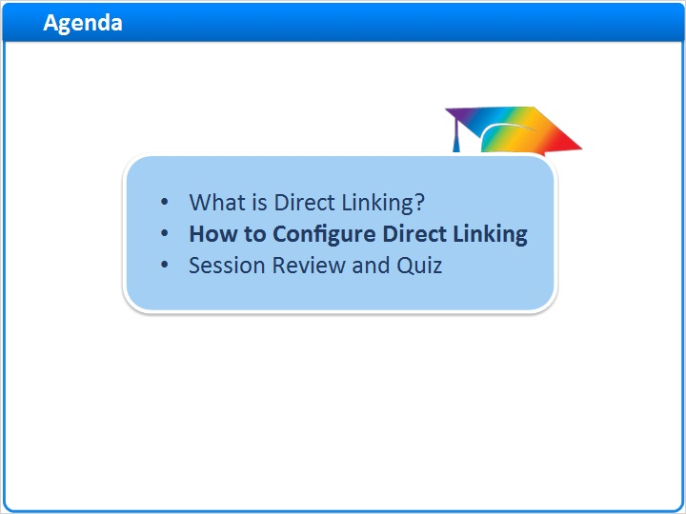
Notes:
Now, let’s learn how to configure Direct Linking.

1.6 Direct Linking: Navigation
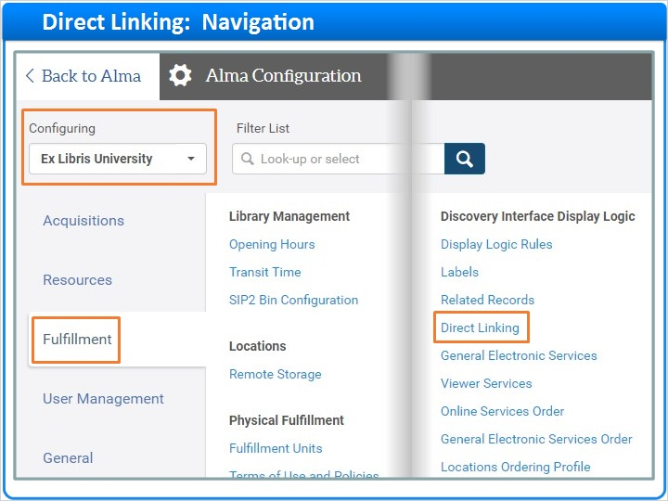
Notes:
Direct Linking is configured at the institution level. To get started, go to the Fulfillment tab on the Alma Configuration page. Then, click on Direct Linking.

1.7 Configure Direct Linking
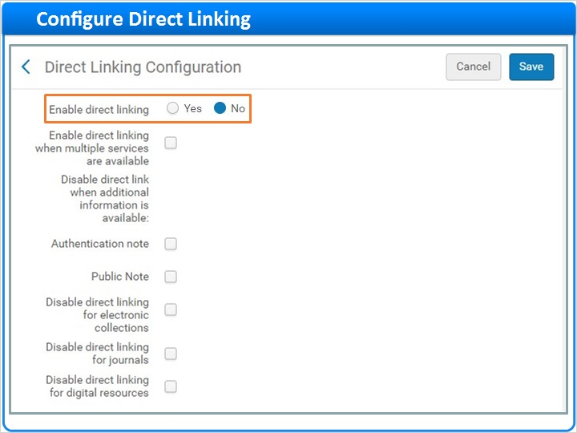
Notes:
The first setting enables Direct Linking. If set to No, Direct Linking is disabled, and Alma will ignore all subsequent settings. If you enable Direct Linking, you have a few choices to make.

First, decide if you want to offer Direct Linking only when a single full text service is available, or also when multiple services are available. If you enable direct linking for multiple services, the Full text available link goes to the first service in the list. For information on how to control the order of full text services, see the Recommended Articles area of the page where you launched this training session.

Next, choose what happens when additional information is available for a service. You can disable Direct Linking when authentication notes or public notes are available.

Finally, consider whether to disable direct linking for electronic collections or for journals. Journal level links go to the journal’s home page, and collection level links go to the database home page.

Imagine you click the Full text available link for this article. Direct Linking will usually take you right to the article as expected. But, occasionally, only journal or collection level links are available. Since this can be confusing for patrons, you can turn off Direct Linking for OpenURL links that go to either journals or collections.

And finally, decide whether or not to offer Direct Linking for your Digital Resources.

Additional Information (Slide Layer)
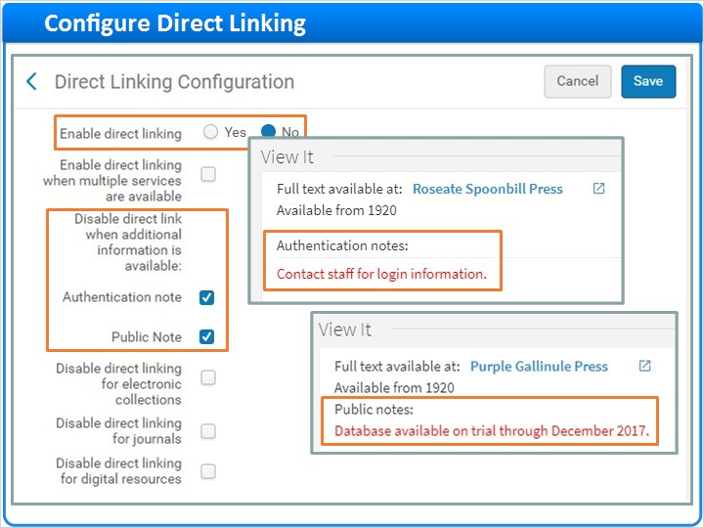

Collections, Journals, Digital (Slide Layer)
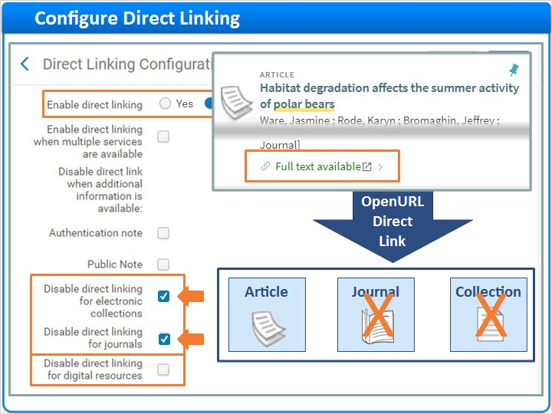

Multiple Services Available (Slide Layer)
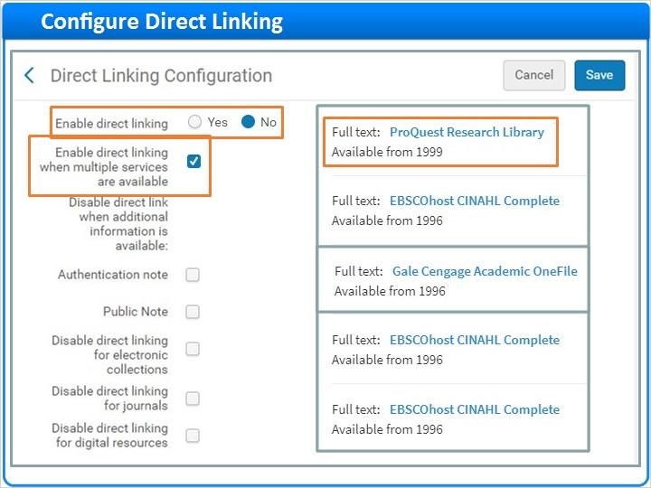

Digital Resources (Slide Layer)
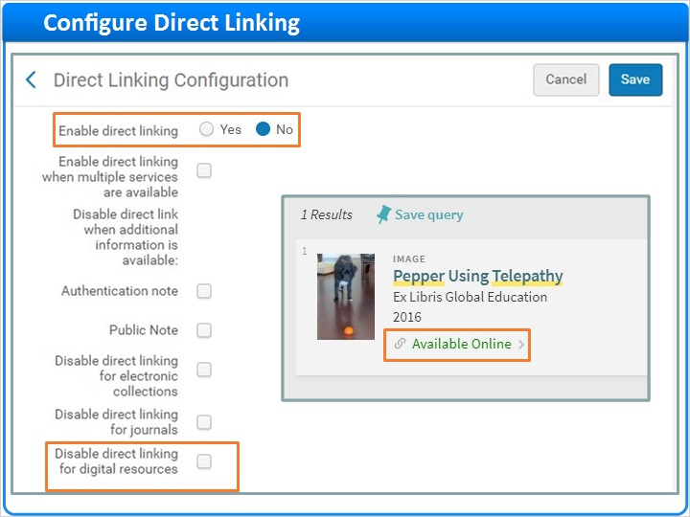

1.8 Session Review and Quiz
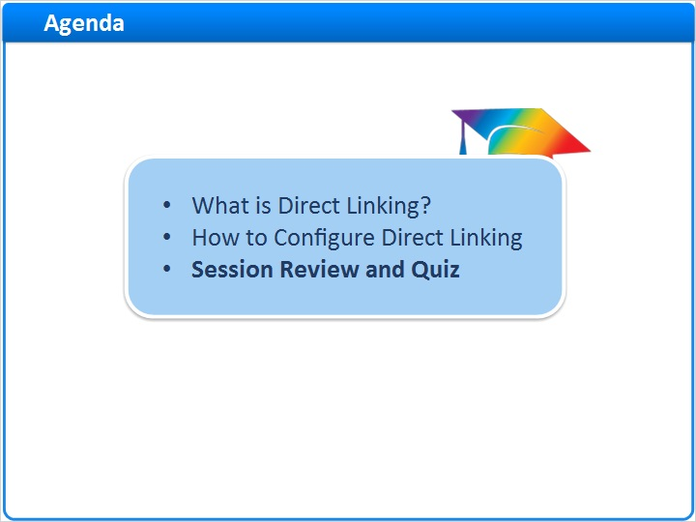
Notes:
That concludes the main portion of this training session. Let’s briefly review what was covered and then proceed to a short quiz.

1.9 Session Review
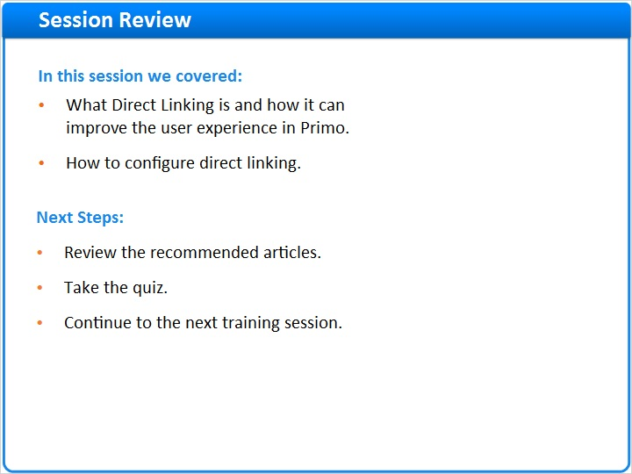
Notes:
In this session, we:
- Covered, what Direct Linking is and how it can improve the user experience in Primo by providing consistent single-click access to full text.
- And, we learned how to configure Direct Linking.

What are your next steps?

Please refer to the Recommended Articles section where you launched this training session for additional information.
After the short quiz that begins on the next page, continue to the next training session in this series.

1.10 Quiz: Inconsistent “Full text available” behavior
(Multiple Choice, 10 points, 1 attempt permitted)
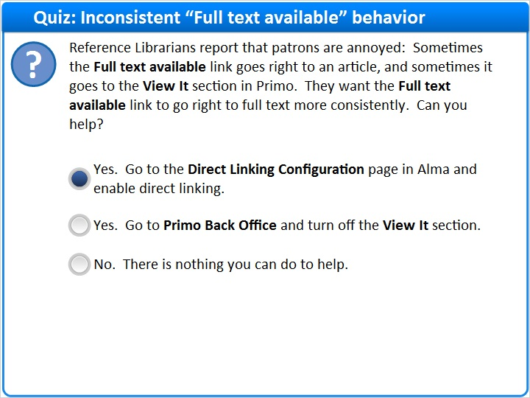
Correct | Choice
X | Yes. Go to the Direct Linking Configuration page in Alma and enable direct linking.
 | Yes. Go to Primo Back Office and turn off the View It section.
 | No. There is nothing you can do to help.
Feedback when correct:
Right! The correct answer is:

Yes. Go to the Direct Linking Configuration page in Alma and enable direct linking.

But, reference librarians may also want to let patrons know that, if they are interested, they can see all their options and great details about the resource by clicking on the title.
Feedback when incorrect:
The correct answer is:

Yes. Go to the Direct Linking Configuration page in Alma and enable direct linking.

But, reference librarians may also want to let patrons know that, if they are interested, they can see all their options and great details about the resource by clicking on the title.

Notes:

Correct (Slide Layer)
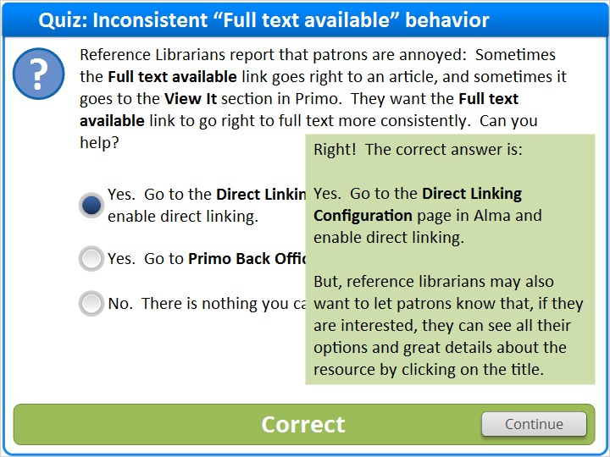

Incorrect (Slide Layer)
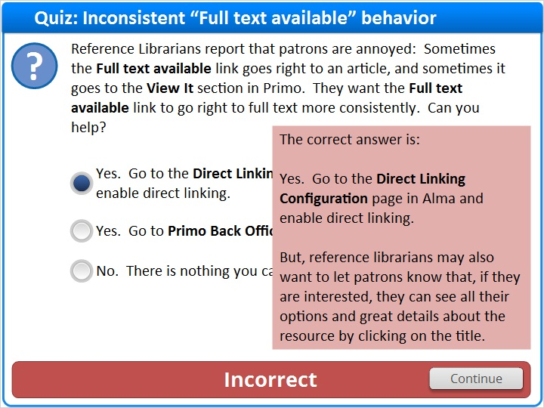

1.11 Quiz: When to Visit “View It”
(Multiple Response, 10 points, 1 attempt permitted)
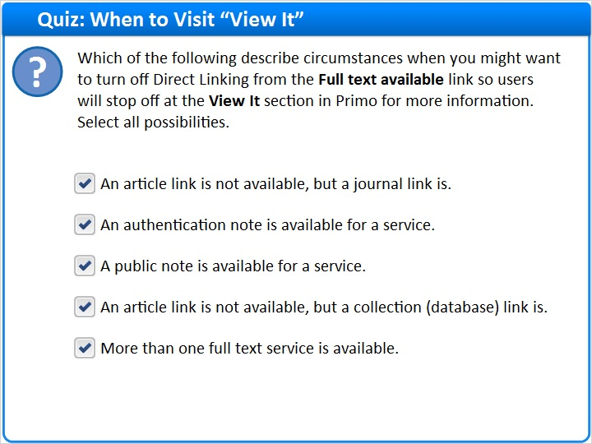
Correct | Choice
X | An article link is not available, but a journal link is.
X | An authentication note is available for a service.
X | A public note is available for a service.
X | An article link is not available, but a collection (database) link is.
X | More than one full text service is available.

Feedback when correct:
Right. The correct answer is:

All these choices describe circumstances when you might want to turn off Direct Linking.
Feedback when incorrect:
The correct answer is:

All these choices describe circumstances when you might want to turn off Direct Linking.

Notes:

Correct (Slide Layer)
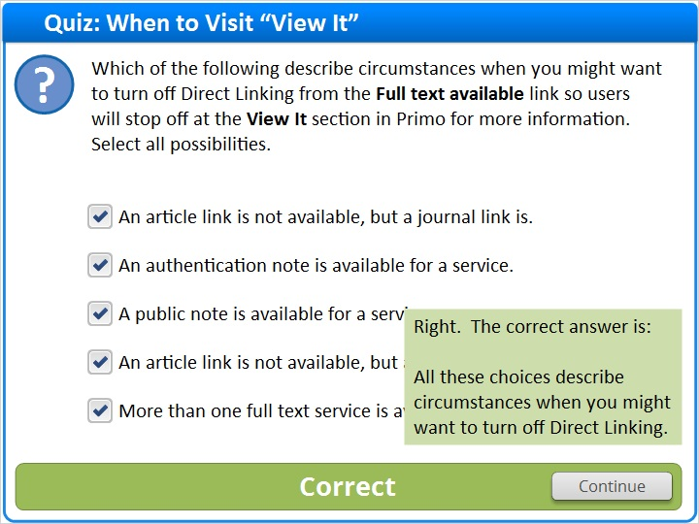

Incorrect (Slide Layer)
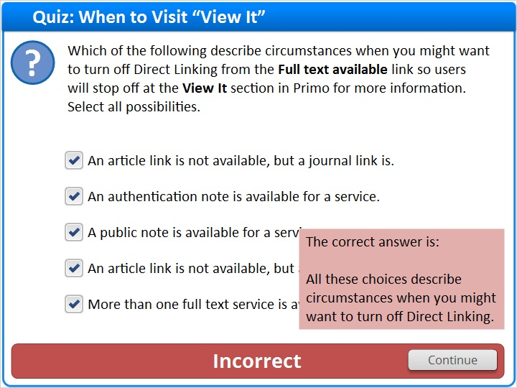

1.12 Thank You!

Notes:
Thanks for joining this session!

1.13 About this Training

Notes:

1 (Slide Layer)
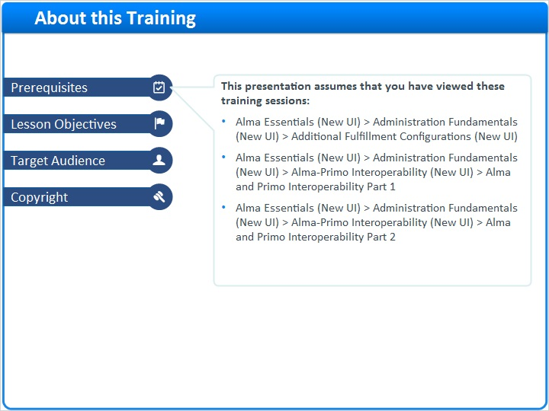

2 (Slide Layer)
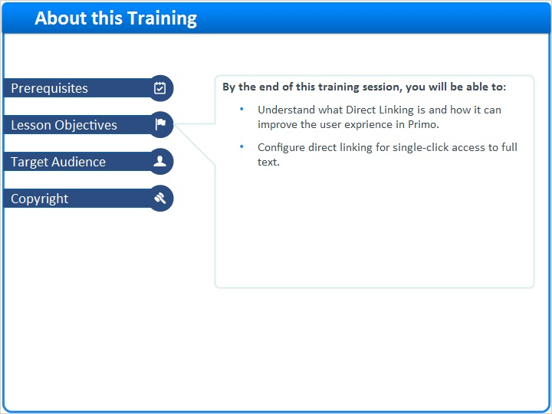

3 (Slide Layer)
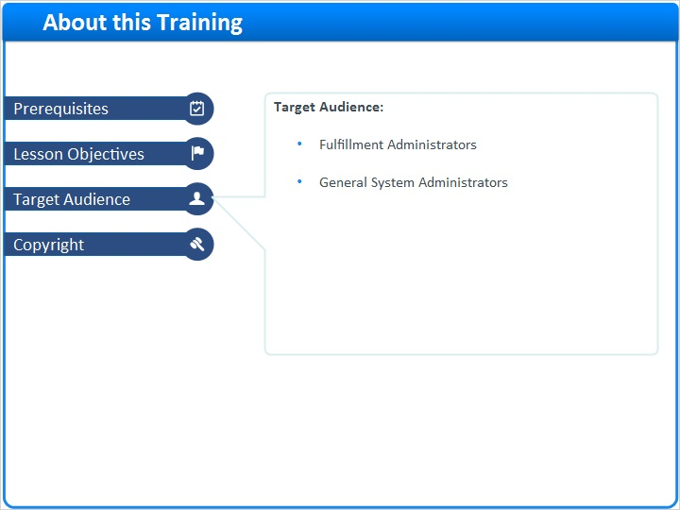

4 (Slide Layer)


