Fulfillment: Physical Locations

1. Physical Locations

1.1 Fulfillment: Physical Locations
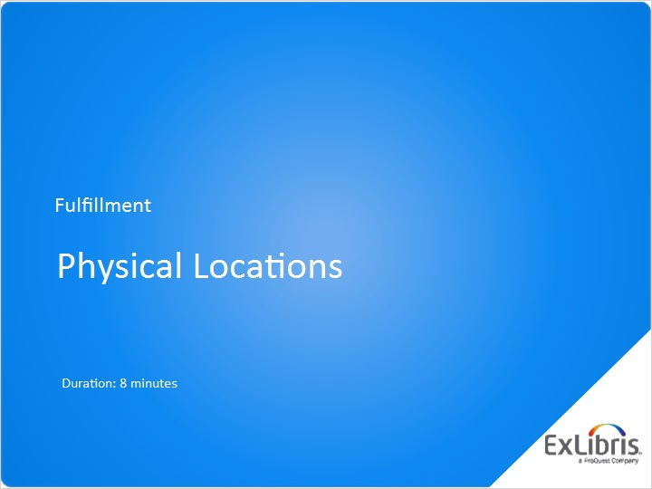
Notes:
Hello, and welcome to this session on configuring physical locations in Alma.

1.2 Locations in Alma
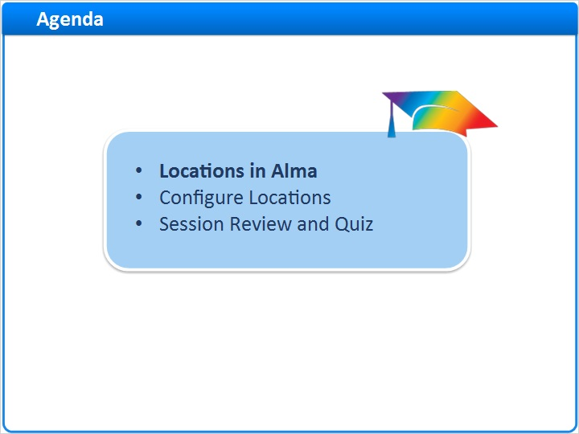
Notes:
In this session, we’ll start by discussing the organizational structure of locations in Alma, and then dig into how to configure locations.

After a session review, there will be a short quiz to test your knowledge.

1.3 Locations in the Alma Hierarchy
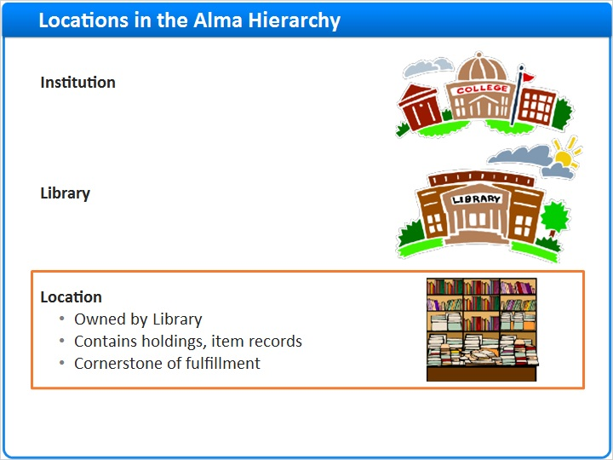
Notes:
As we saw in previous sessions, locations are the third entity in the organizational-structure hierarchy for your institution in Alma.

Locations are owned by libraries; they can’t exist on the institution level nor can they be stand-alone. They each have to be created by, and related to, a particular library.

Generally speaking, locations contain physical inventory. And they are usually defined by the types of physical inventory they contain … that is, the holding records and item records in Alma that belong in that location. Without a location in Alma, a physical item cannot be circulated.

1.4 Configure Locations
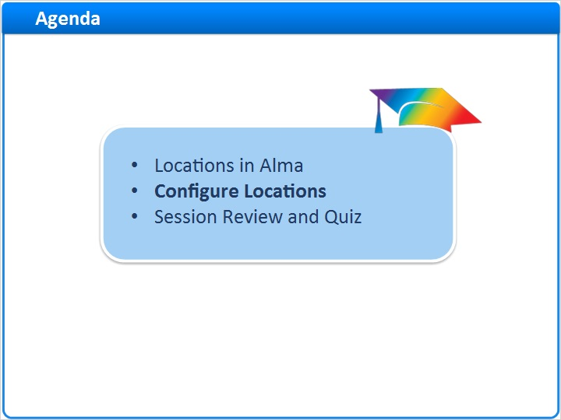
Notes:
Now, let’s look at how to configure Locations.

1.5 Access Location Configuration
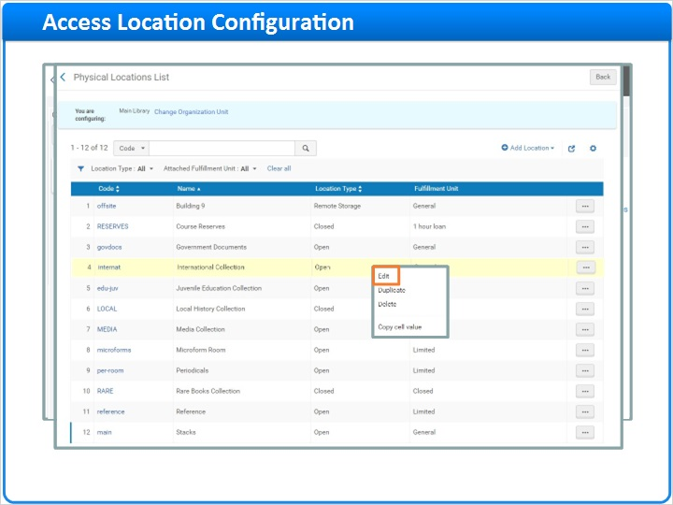
Notes:
Start from the Alma Configuration page on the Fulfillment tab. You need to change the Configuration drop-down menu to the library whose locations you want to configure. Then click the Physical Locations tool.

The list that appears shows the existing physical locations that are already part of this library.

Let’s take a look at one of these locations, to see what configuration options are available.

1.6 Edit Physical Location
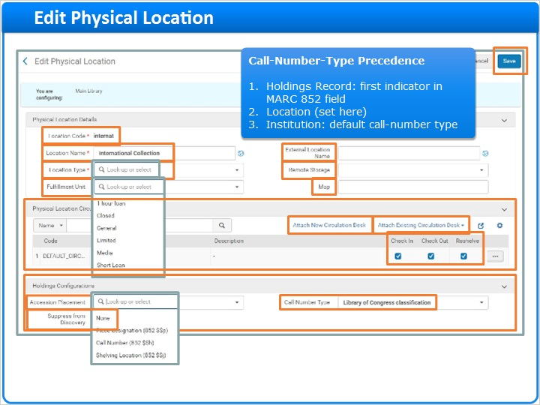
Notes:
On the Edit Physical Location page, you’ll see many configuration options for this location.

The Location Code cannot be edited, but the Location Name can be changed. This name is what Alma users will see when working with materials in this location. This name is also what patrons will see in your discovery service when looking at items found in this location … unless you enter a name in the External Location Name field. In that case, the External Location Name is what patrons will see. External Location Name is optional; and if it is blank, the Location Name will be the one patrons see in your discovery service.

The Location Type can be Open, Closed, Remote Storage, or Unavailable. However, the Location Type here has two very limited effects within Alma: First, it is used for sorting on various lists of locations; and second, items in the Location Type of “Unavailable” are considered unavailable when calculating display logic rules and the display of services in your discovery service. By the way, this setting is different than the Location Type setting you may have worked with on the configuration worksheet during migration from your legacy system, where the Location-Type parameter has significant effects.

You can designate this as a Remote Storage location; details of that designation are discussed in the separate training session on Remote Storage.

You can define a particular Fulfillment Unit for this location. Fulfillment units are discussed in a separate training session; but the key point is that they are a way to group different locations throughout your institution that have similar fulfillment policies. Although this field is optional, any location that has physical inventory that you want to circulate must have a Fulfillment Unit defined here.

Finally, this section has a field where you can enter a URL where patrons could find a Map of this Location, which will then be linkable from within your discovery service.

The next section is the Physical Location Circulation Desk List. You can learn more about Circulation Desks in a separate training session, but the important thing to know here is that this Location must have at least one circulation desk associated with it that has the three circulation services: Check In, Check Out, and Reshelve. You can attach an existing circulation desk to this location, and choose which circulation services apply to this location. By the way, this has the same effect as it does if you’re configuring a Circulation Desk and attach this Location to that Desk.

A location can have more than one circulation desk attached to it, and each could provide one, two, or three of the circulation services. In fact, it is OK to have one circulation desk for Check In, another for Check Out, and so on, as long as all three services for this Location are covered by circulation desks.

You can also Attach a New Circulation Desk, which takes you through the entire five-step wizard for creating a circulation desk; that is discussed in that Circulation Desk training session.

Finally, there is the Holdings Configurations section.

The Accession Placement field is not a mandatory field and should be used only if you’re using accession numbers for all of your holdings records in this location. If you do set an Accession Number here, then that MARC field in your Alma holdings records will become indexed and searchable during a repository search in Alma. Also, that MARC field becomes mandatory when creating a holdings record in Alma; in other words, when working with a holding record in the MD Editor, if that Accession Number field does not have a value, then you won’t be able to save any of your changes to the holding record. So, if you’re not using accession numbers in all holdings records at this location, then we recommend leave the Accession Placement field set to None.

The Call Number Type field is useful only if the default call-number type for this location is different than the default call-number type for your institution. The call-number type is usually defined in the holdings record itself: The first indicator of the MARC 852 field is what determines the call-number type of the particular holdings record. But if the first indicator of the MARC 852 record is empty, then the call-number type will be taken from this field here. If this field is also empty, then the call-number type will be taken from the institutional default call-number type, found in the Resource Configuration settings and discussed in a separate training session. So, if holdings records for items in this location use the default call-number type for your institution, leave the setting here empty.

The last field in the Holdings Configuration section gives you the option to Suppress from Discovery the holding records at this location. If you check this box, then holding records in this Location will not be published in your discovery service, and patrons won’t be able to search for them in that discovery service.

When you’re done editing the location, click Save at the upper right.

Add Existing Circulation Desk (Slide Layer)
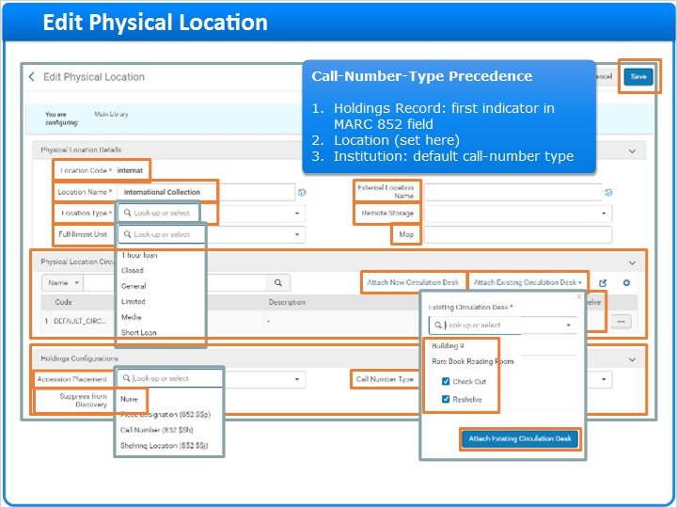

Call Number Type (Slide Layer)
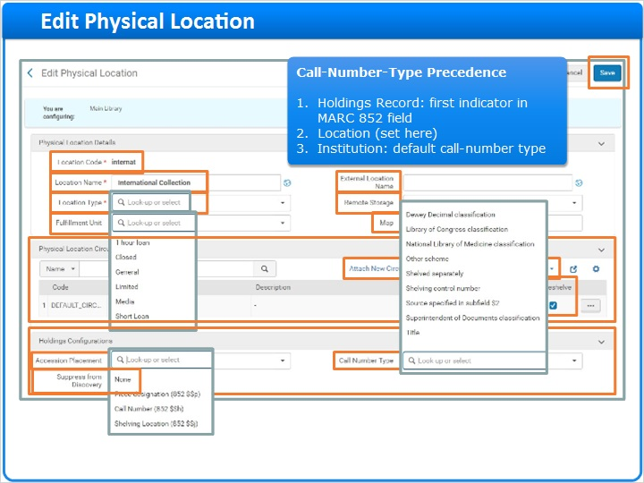

1.7 Add Location
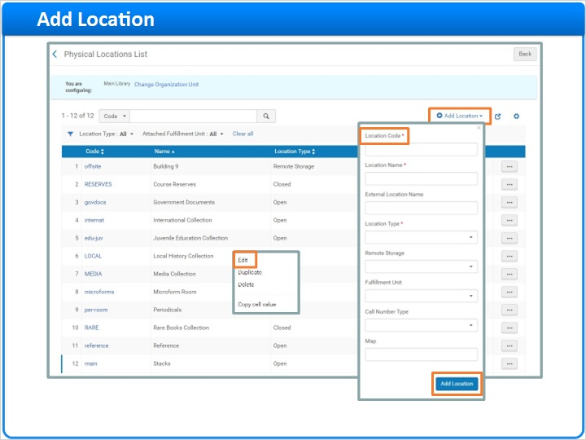
Notes:
Back here on the Physical Locations List, if you need to Add a Location, click the link in the upper-right.

The pop-up that appears begins with the Location Code, which does need to be unique at your institution.

The rest of the fields are the same as we just discussed.

Click Add Location, and then you’ll need Edit this new Location to attach circulation desks and do any holdings configurations, just like we discussed before.

1.8 Session Review and Quiz
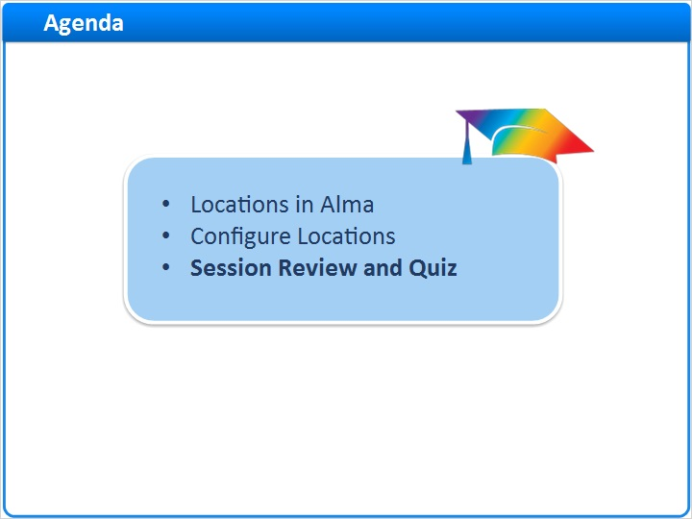
Notes:
That concludes the main portion of this training session. Let’s briefly review what was covered and then proceed to a short quiz.

1.9 Session Review
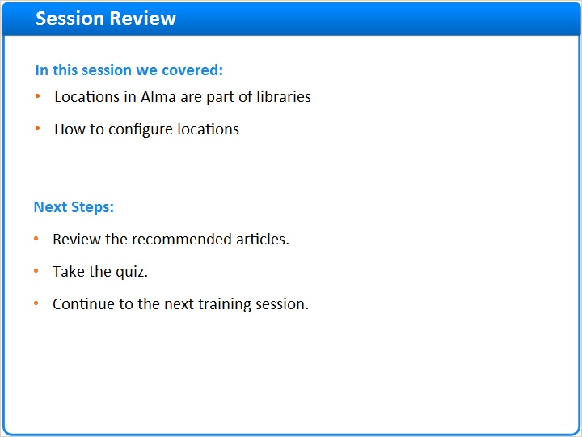
Notes:
In this session we began by discussing how locations fit into the Alma organizational hierarchy, and that they are always part of libraries. Then we went through the steps to configure locations in Alma, both editing existing locations and creating new ones.

Please refer to the Recommended Articles section where you launched this training session for additional information.
After the short quiz that begins on the next page, you can continue on to the next training session in this series.

1.10 Quiz: Locations in the Alma Organization
(Multiple Response, 10 points, 1 attempt permitted)
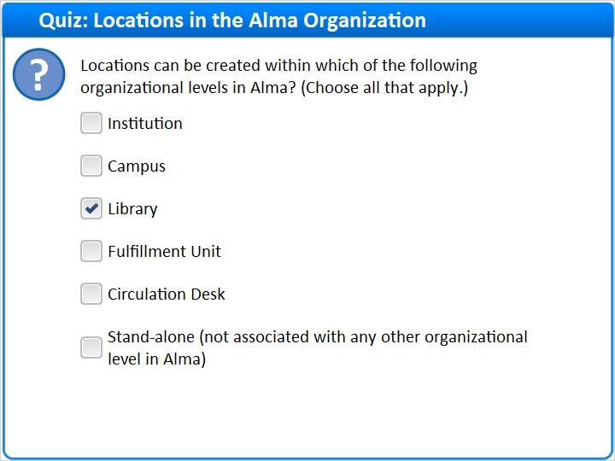
Correct | Choice
 | Institution
 | Campus
X | Library
 | Fulfillment Unit
 | Circulation Desk
 | Stand-alone (not associated with any other organizational level in Alma)
Feedback when correct:
Yes, locations can only be created at the Library level.
Feedback when incorrect:
No, that is incorrect. Locations can only be created at the Library level.

Correct (Slide Layer)
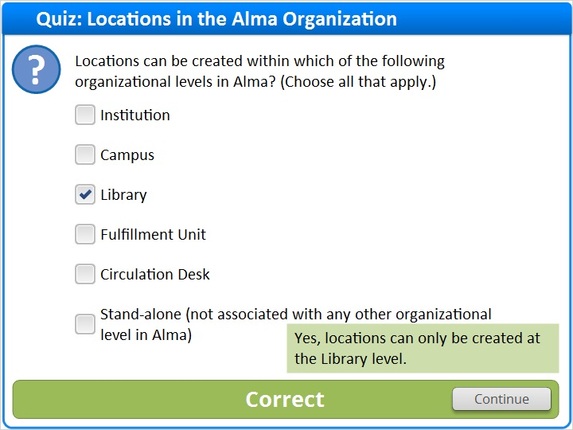

Incorrect (Slide Layer)
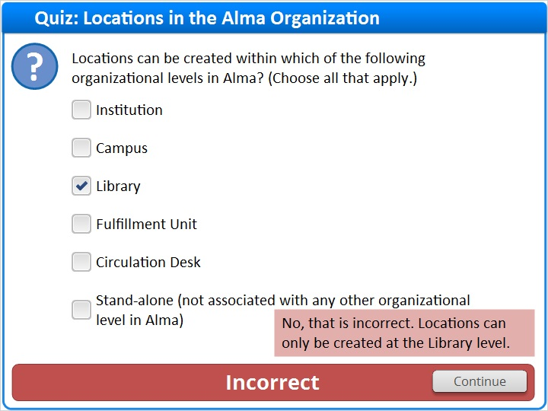

1.11 Quiz: Location-Type Requirement
(True/False, 10 points, 1 attempt permitted)
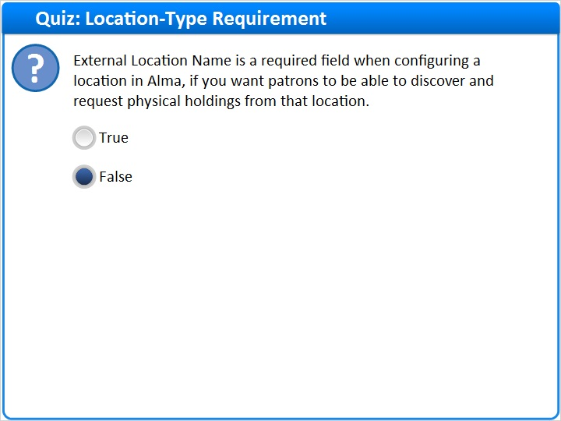
Correct | Choice
 | True
X | False

Feedback when correct:
Yes, this statement is false. If you don’t enter an External Location Name, then Alma (and your discovery service) will show the Location Name to patrons.
Feedback when incorrect:
That is incorrect; this statement is false. If you don’t enter an External Location Name, then Alma (and your discovery service) will show the Location Name to patrons.

Notes:

Correct (Slide Layer)
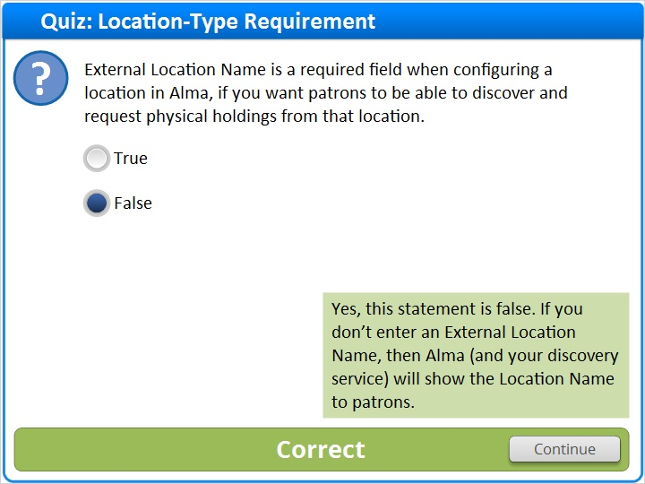

Incorrect (Slide Layer)
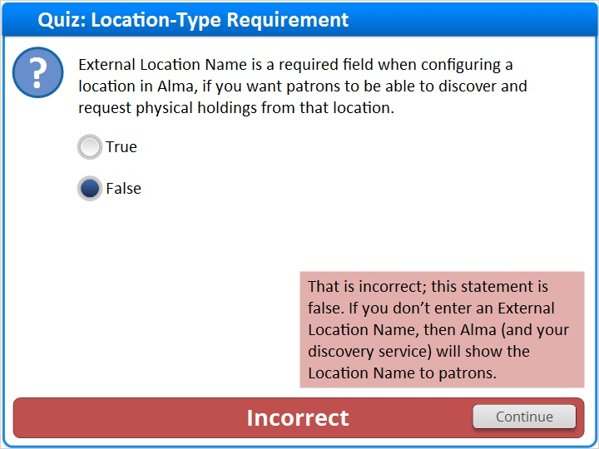

1.12 Quiz: Accession Placement Field
(True/False, 10 points, 1 attempt permitted)
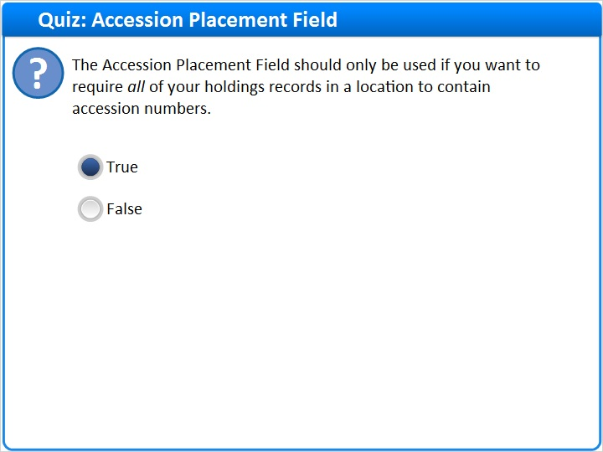
Correct | Choice
X | True
 | False

Feedback when correct:
Yes, this is one major effect of using the Accession Placement field. (The other is the ability to do a repository search on that MARC field in your Alma holdings records.)
Feedback when incorrect:
No, that is incorrect. This requirement is one major effect of using the Accession Placement field. (The other is the ability to do a repository search on that MARC field in your Alma holdings records.)

Notes:

Correct (Slide Layer)
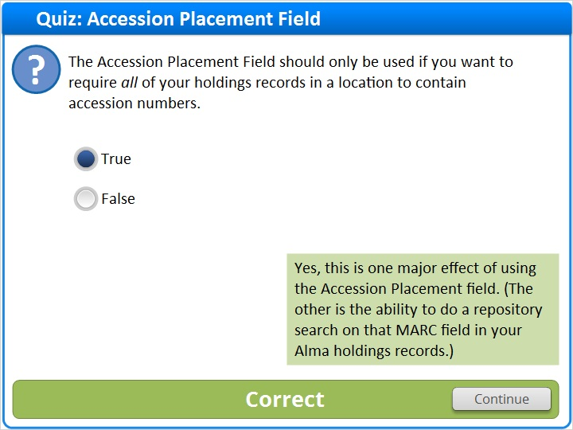

Incorrect (Slide Layer)
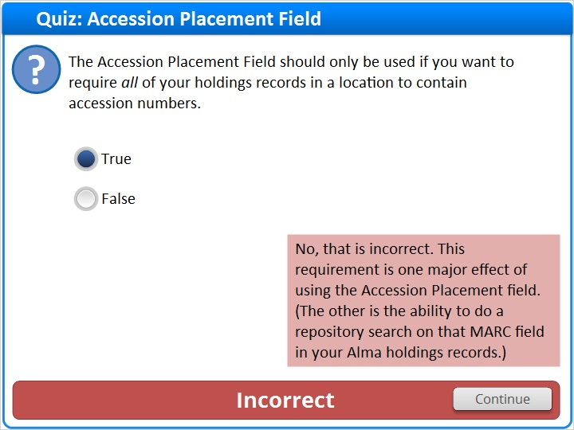

1.13 Thank You!

Notes:
Thank you for joining this session!

1.14 About this Training

Notes:

1 (Slide Layer)
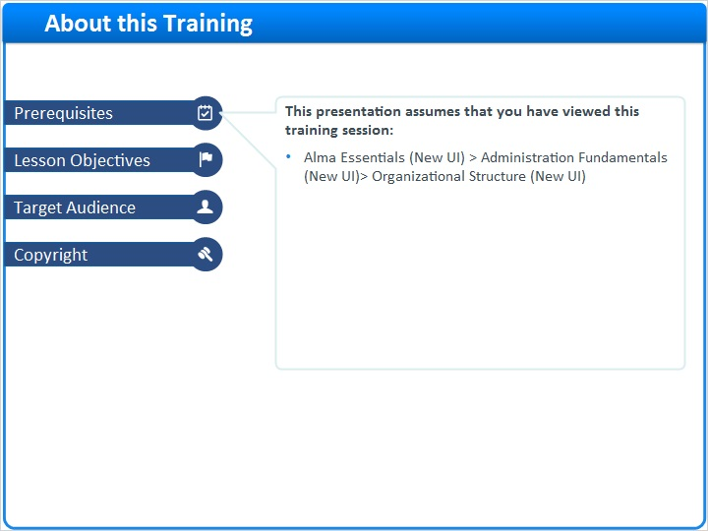

2 (Slide Layer)
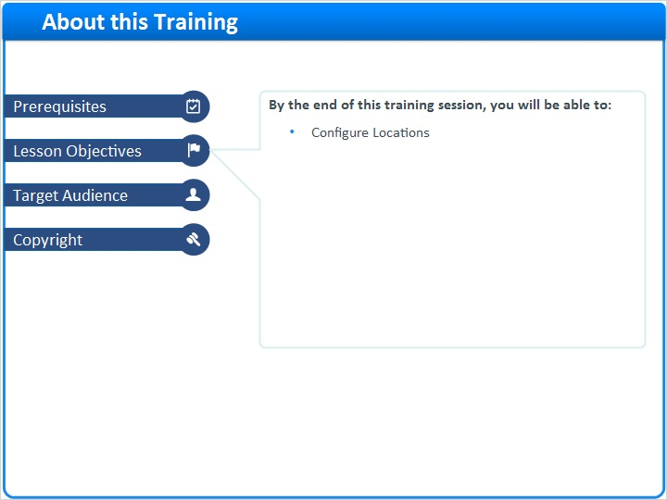

3 (Slide Layer)
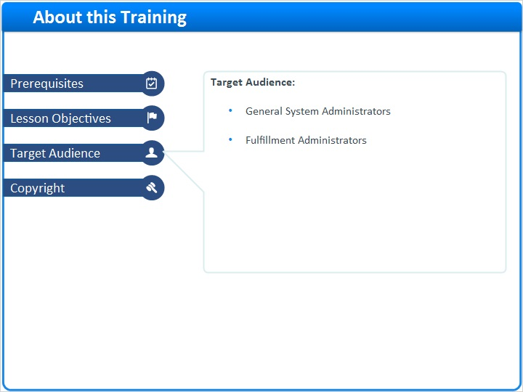

4 (Slide Layer)


