Fulfillment: Terms of Use and Policies

1. Fulfillment: Terms of Use and Policies

1.1 Fulfillment: Terms of Use and Policies
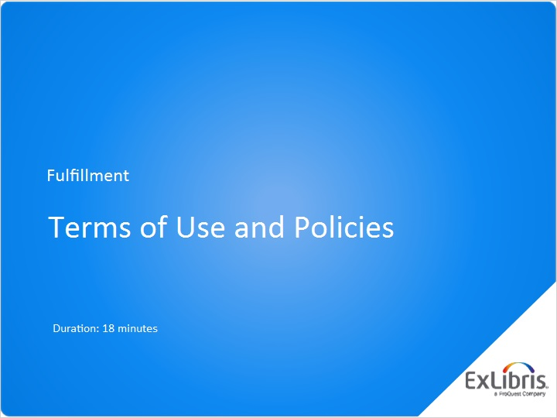
Notes:
Hello, and welcome to this session on configuring terms of use and policies in your institution’s Alma service.

1.2 TOUs, Policies, and Fulfillment
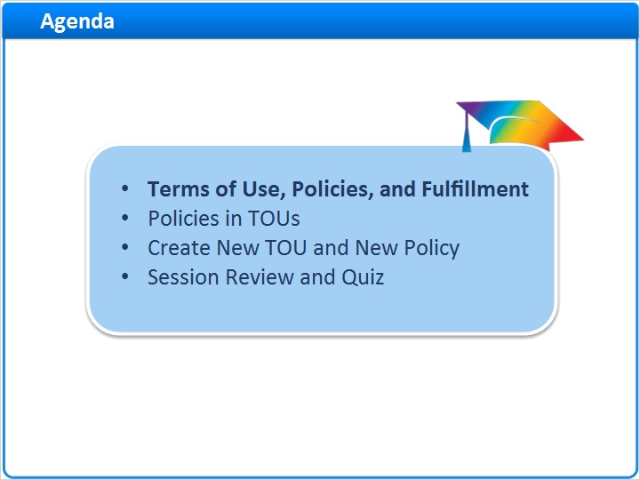
Notes:
In this session, we’ll start by covering how terms of use and policies fit into the whole fulfillment system in your institution, and define the different types of terms of use.

Then we’ll go through the steps of editing policies within TOUs, and explain many of the key policies within the different types of TOUs.

Next, we’ll create a new TOU from scratch, and show how to create a new policy that can be used in any TOU.

After a session review, there will be a short quiz to test your knowledge.

1.3 Terms of Use, Policies, and Fulfillment
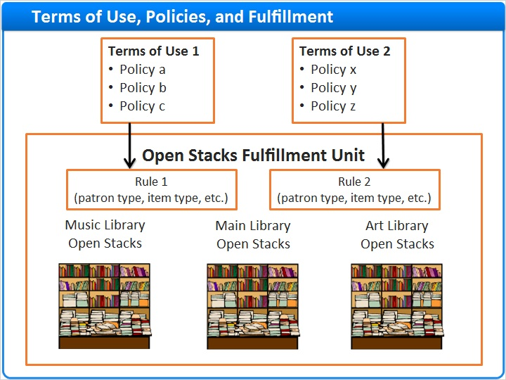
Notes:
You can use fulfillment units in Alma to group together locations with physical items that have more or less the same policies for circulation. You do this by creating all the different kinds of policies you’ll need throughout your institution, grouping the policies into terms of use, and then assigning the terms of use to the rules associated with each fulfillment unit.

Other training sessions address how to configure those fulfillment units and their rules. In this session, we’ll talk about the terms of use, and the policies that go into them.

1.4 Types of Terms of Use
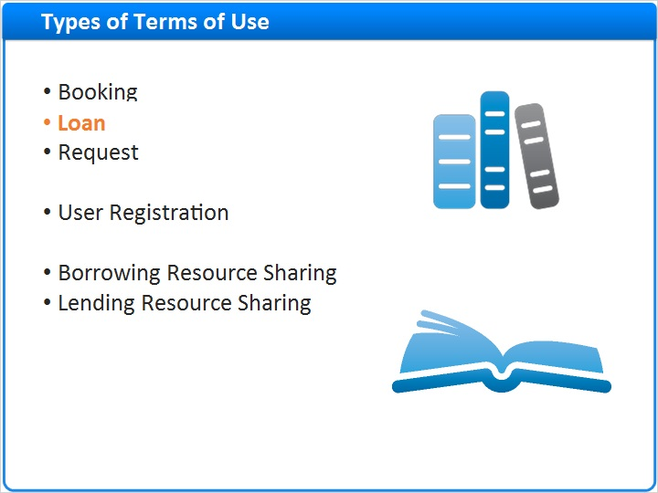
Notes:
There are several types of terms of use:

Booking, Loan, and Request are terms of use for those familiar actions in Alma.

User Registration terms of use involve policies related to creating new users in Alma, such as whether there is a registration fee, the registration renewal period, and so on.

And two types of terms of use are just for resource sharing: Borrowing Resource Sharing, which are policies for how your institution will handle items borrowed from other institutions; and Lending Resource Sharing, which are policies for how items at your institution can be loaned to other institutions.

For this training session, we’ll mostly use examples of terms of use and policies that are the Loan type, because that will probably be the terms of use you spend most of your time configuring. But the process of creating and managing all these types of terms of use is the same, and documentation in the Ex Libris Knowledge Center will explain the details of the different types.

1.5 Policies in TOUs
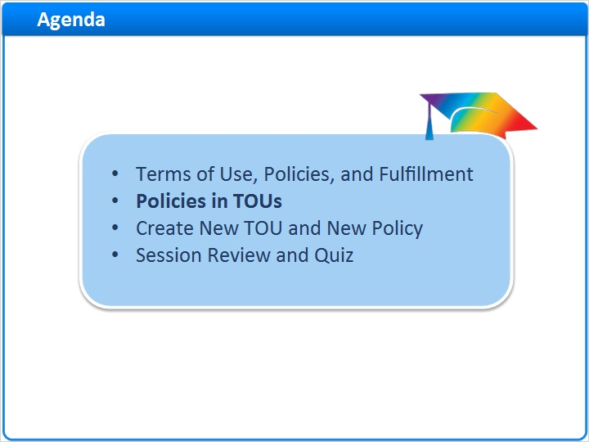
Notes:
So, now we’ll go through the steps of editing policies within TOUs, and explain many of the key policies within the different types of TOUs.

1.6 Edit Policies in a TOU
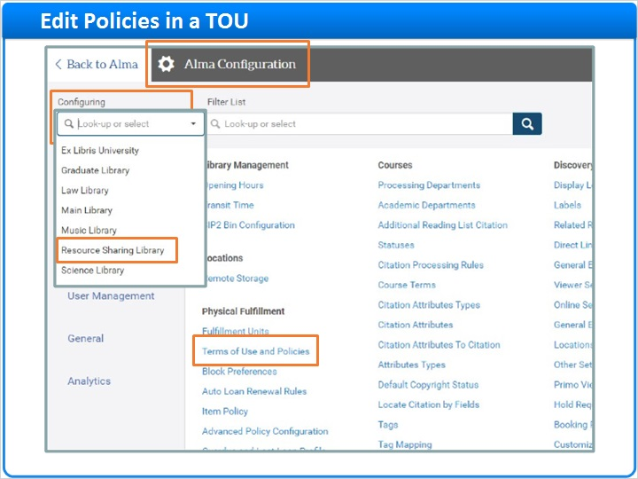
Notes:
Later in this session, we’ll talk about how to create a new terms-of-use. But first, let’s look at the policies themselves, and how you work with them within TOUs.

Start from the Alma Configuration page, on the Fulfillment tab. Make sure you’re Configuring your institution, rather than one of the libraries.

By the way, there is one situation where you will configure TOUs for a library, and that is for the Resource Sharing Library. However, that configuration is not as common, and anyway it is the same process as working on institutional TOUs.

Click Terms of Use and Policies.

On the Terms of Use Management page, you can choose to see all TOU types, or pick just the type you are going to work with right now. We’ll pick Loan. Find the TOU you want to edit, and click the name.

You’re now looking at the policies associated with this loan TOU. This list is part of every loan TOU … sort-of a template for loan TOUs. First is the column with the Policy Type, such as “Is Loanable,” “Is Recallable,” and so on. Then is the column with the Policy Name, which is really the values available for each policy type. For example, the “Is Recallable” policy type has two possible values: Recall Allowed, or No Recall. On the other hand, the Due Date policy type has quite a few choices for value, ranging from a 1-hour loan to a 6-month loan. We’ll talk later in this session about some of these policy types and their typical values. Now, however, let’s look at modifying these policy names, or values.

As an example, imagine that you want this TOU to have a Due Date of 2 days. In the Due Date policy, you’ll see there is no value for a 2-day loan. Right click the row to see the options. You can Add a Policy, which really mean you can add a new policy name, or value, to the Due Date Policy Type. You can Edit, which means editing the policy name, or value, that is currently chosen in the drop-down menu. Or you can Duplicate, which means duplicating the current policy name or value and giving it a new name and value.

Let’s add a new policy name. Right click on the Due Date row and choose Add Policy. On the Policy Details page, confirm the Policy Type is Due Date. The Policy Name, or value, you enter is 2-Day Loan. It is helpful to copy this into the description, even though it isn’t required, because this gets passed along to your discovery service.

Due Date can have a fixed value type, in which case you’ll see the Value drop-down shows any Events that have been added to your institutional calendar, such as End of Term or End of Year, because those occur on fixed days.

Or, you can select a Non Fixed Value Type, which means you’ll choose how long after checkout until the item is due. You select Unit of Measurement - days, in this example - and enter a value: 2.

You have the option to make this Policy Name and Value be the default every time someone makes a new TOU.

Click the Save button in the upper-right corner.

Back on the list of policies in this TOU, our 2-Day Loan value is now available in the Policy Name drop-down.

If you choose to Edit a Policy Name, or value, be aware that you will be changing this policy in every TOU that it appears … not just the TOU you happen to be working on at the time.

At the top-right side of the page, click the Next button. This page is a confirmation of any changes you made on the previous page. You can’t change any policies here; so if you need to do so, click the Back button at the top-right side of the page and make your edits. Or, if you’re done, click the Save button.

Note that, for the most part, changes you make to policies and loan TOUs go into effect for all physical items, even those that are currently on loan. That means that an item that is currently on loan may suddenly have its policies changed, which could surprise patrons! For more details on this issue, please see the Recommended Articles on the page where you launched this session.

Terms of Use Management (Slide Layer)
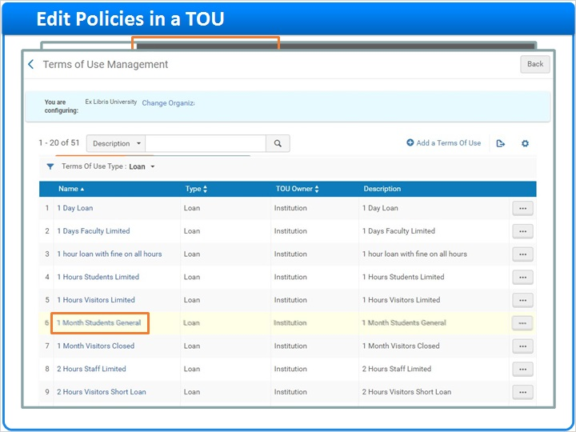

Terms of Use Details (Slide Layer)
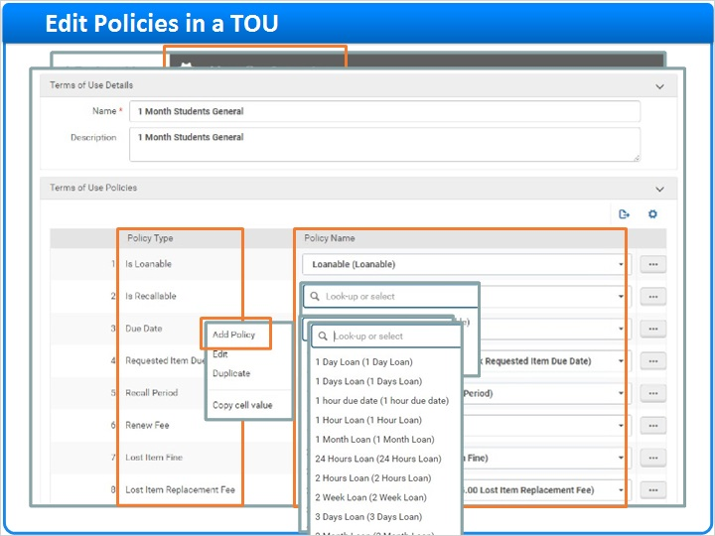

Policy Details (Slide Layer)
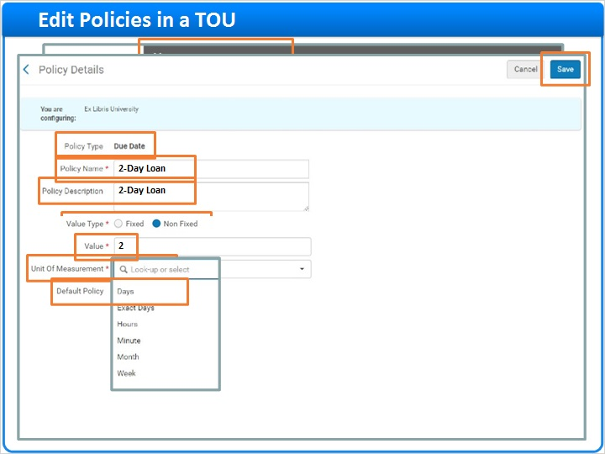

TOU Details after Policy Add (Slide Layer)
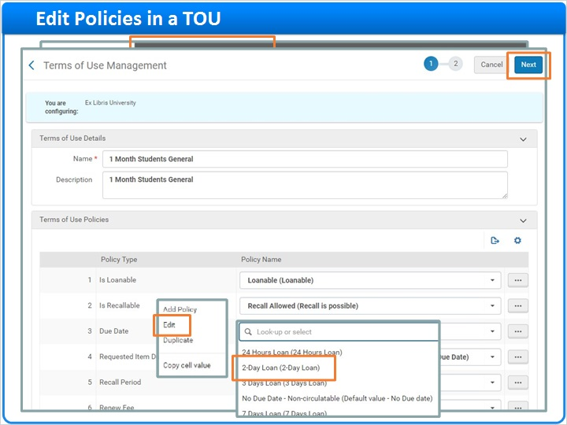

TOU Details Confirmation (Slide Layer)
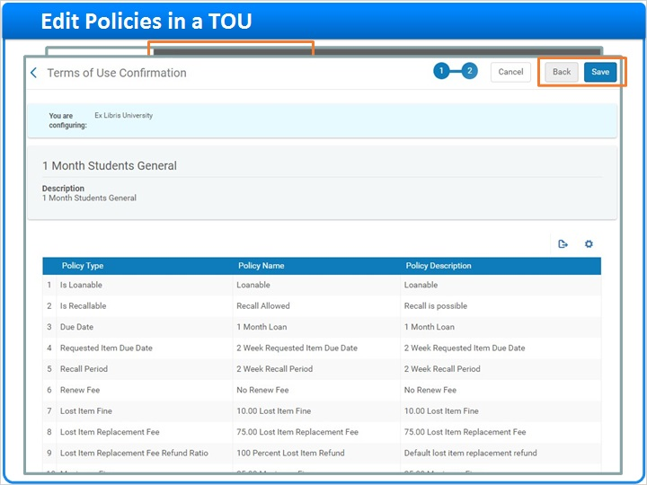

1.7 Policies in Loan TOUs
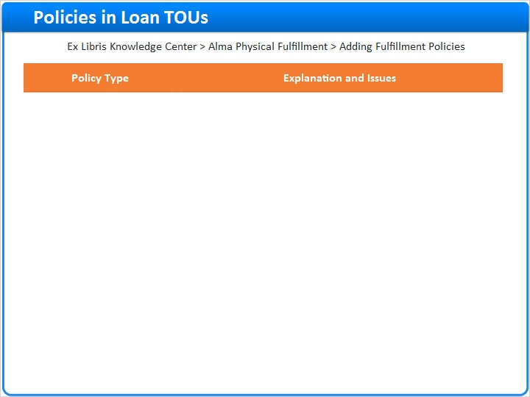
Notes:
Now, let’s look at a few of the policy types in any Loan TOU. We won’t take the time to discuss all of them; instead, you can find an explanation of all policies in the Ex Libris Knowledge Center, under Physical Fulfillment - Adding Fulfillment Policies.

Most of the policy types are intuitive; here are the ones that require a bit of explanation:

- Recalled Overdue Fine is the amount that the patron must pay, per period, if a recalled item was returned late. When placing a hold request, only the item that has been on loan the longest is recalled, while other items are blocked from renewal. If the recalled item is returned late, it is assigned a Recalled Overdue Fine, while other items due are assigned an Overdue Fine.

- Maximum Renewal Period is the maximum amount of time for a loan. This value includes time added to the loan by renewals. If you set this to None, there is no limit to the loan renewal period.

- Grace Period is the length of time that the item may be returned late with no fine being applied. If the grace period passes and the item is not returned, the fine is applied retroactively to the due date. If you define a grace period using the Days unit of measurement (as opposed to Exact Days or other units of measurement), the grace period is calculated from and including the item’s due date. For example, if the item’s due date is March 1 and the grace period is 2 days, the end of the grace period is March 2, after which a fine is applied (so that if you use the Days unit of measurement, a grace period of 1 day is essentially meaningless). If you use the Exact Days unit of measurement, if the item's due date is March 1 and the grace period is 2 days, then the end of the grace period is March 3. The grace period applies to both regularly loaned items and recalled items.

- Closed Library Due Date Management tells Alma how to manage fulfillment activities when the library is closed. The available values are: Keep - Keep the current due date; Move backward - Move to the end of the previous open day; Move forward - Move to the beginning of the next open day; or Move to the end of the next open day.

The various Lost Item policies can be a bit confusing as well, so let’s look at those:
- The Lost Item Fee is the amount the patron will pay if the item is declared Lost. This is on top of any fine accrued to that point.
- The Lost Item Replacement Fee is the amount the patron must pay to replace a lost item. If a specific item has a replacement cost set in Alma, then Alma will use that replacement cost. If not, then Alma will use this Fee here. Note that if you set the value here to 0 (zero), then no fine is added even if the item has a specific replacement cost.
- The Lost Item Replacement Fee Refund Ratio only comes into effect if the patron returns an item that was declared Lost. The percentage here indicates how much of the Lost Item Replacement Fee will be returned to the patron.

Loan Policies 2 (Slide Layer)
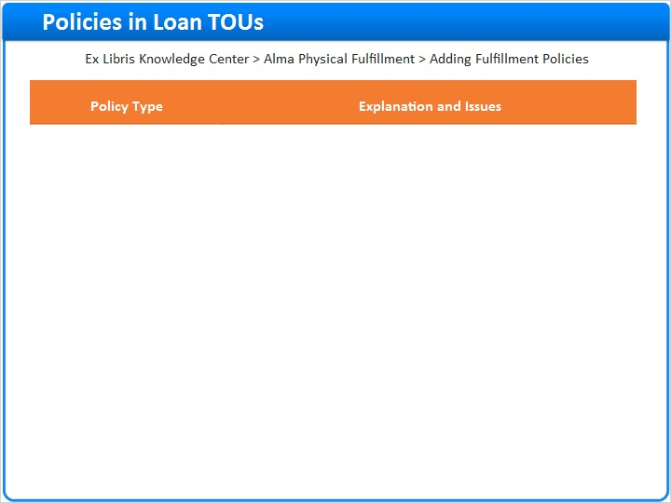

1.8 Policies in Request TOUs
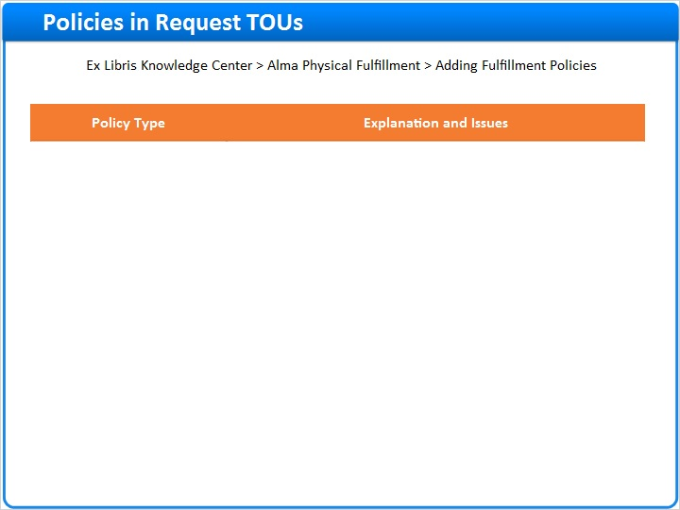
Notes:
Next, we’ll look at a few of the policy types in any Request TOU, ones that may be more difficult to understand.

- On Shelf Request Policy is the policy to use when a patron requests an item that is currently available on the shelf. The options are to allow for pickup anywhere regardless of availability, or to use the fulfillment-unit definition.

- Personal Delivery indicates whether a patron can request personal delivery of the item. The choices here are: All (Deliver items to a home or an office address); Home (Deliver items only to a home address); None (Do not deliver items at all); or Office (Deliver items only to an office address). By the way, a patron can request personal delivery only if there is a home or work address on their User Details page.

- Automatically convert to resource sharing: If this policy is set to True and if the request is going to be canceled due to execution of either the Requests - Handle Expiration Step or Requests - Recalculate After Inventory Update jobs, the unfulfilled request is converted to a resource-sharing request with a status of Created borrowing request. The existing request is automatically cancelled in Alma with the cancellation reason Converted to Resource Sharing Request, and a cancellation letter is sent to the patron with the reason Converted to Resource Sharing Request. The request will not convert to resource sharing if one of the following is true: Pickup location is a circulation desk and not a library; Resource sharing library doesn't have a Deliver To relation with the pickup location; There is no default location for the resource sharing library; or the Date Needed By is in the past.

Request Policies 2 (Slide Layer)
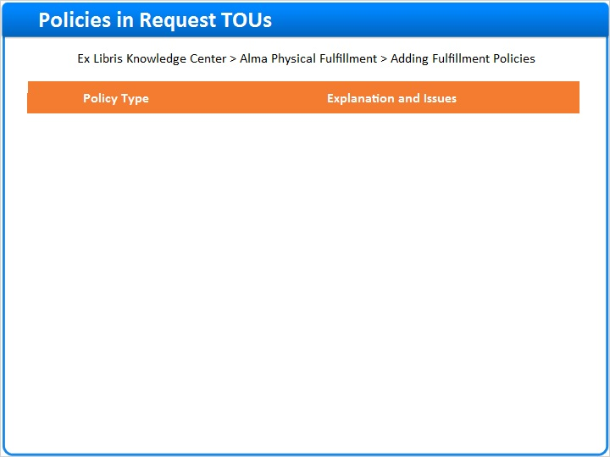

1.9 Policies in Booking TOUs
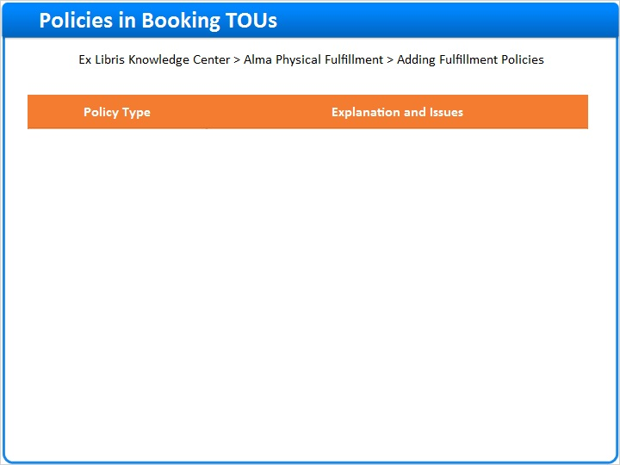
Notes:
Next, we’ll look at a few of the policy types in any Booking TOU; again, those that are less intuitive than others:

- Back to Back Booking is the minimum amount of time required between consecutive booking requests for the same resource by the same patron. If Value type = None for this policy type, there is no minimum: a requester can book immediately after another booking.

- Future Limit is how far in advance an item can be reserved through a booking request.

- Preview Period is the amount of time prior to the booking period that the requester can borrow the item. During this time frame, the resource is blocked from patrons other than the requester.

1.10 Policies in Resource Sharing TOUs
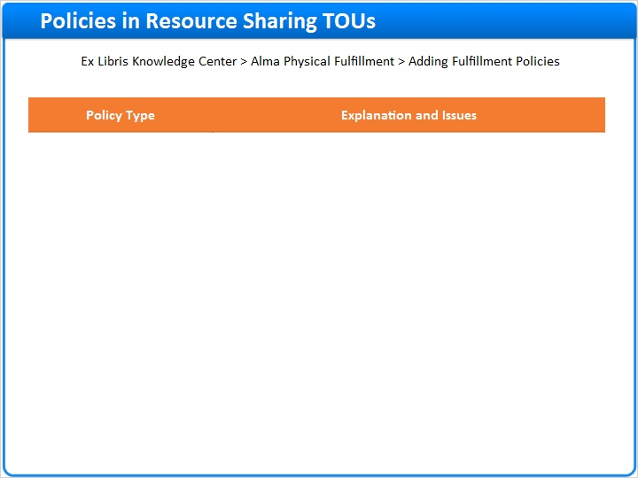
Notes:
Here are a few of the more complicated policy types in Resource Sharing TOUs:

- The Resource Sharing Request Fee is applied at the time that a borrowing request is created. It may be applied on requests coming in from external sources such as Primo requests or NCIP messages. Compare that to ….
- The Resource Sharing Receive Fee, which is applied to resource-sharing requests when the item is received from the lending institution and then scanned in.
- For Active Resource Sharing Requests Limit and Yearly Resource Sharing Requests Limit, be aware that if you select the Value of None, that means patrons can make an unlimited number of requests. If you actually want the patrons to be allowed zero requests for either of these limits, then you need to set Allow Resource Sharing Requesting policy to False.

1.11 Policies in User Registration TOUs
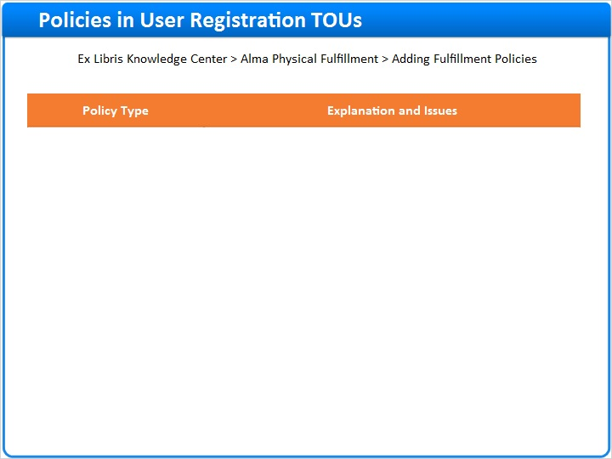
Notes:
Here are a couple of the more complicated policy types in User Registration TOUs:

User Registration Fee is the amount to pay in local currency to register a new user. Although this sounds simple enough, note that this only applies to an internal user. If your user list comes from an external source, such as a student information system, Alma will not assess this fee. Contrast that with …

The Patron Registration Fee, which is the amount to pay in local currency to register a patron. This fee is applied upon creating a Patron role or renewing an existing Patron role. It is applied to both internal and external users.

1.12 Create New TOUs and New Policies
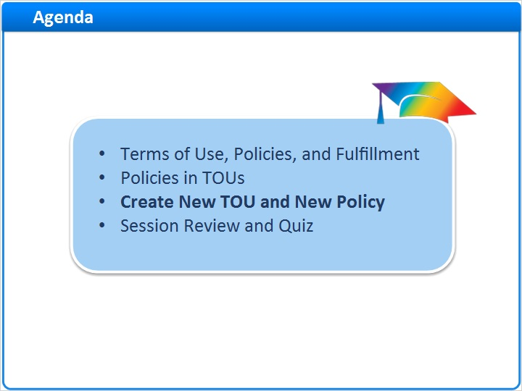
Notes:
Next, we’ll create a new TOU, and show how to create a new policy that can be used in any TOU.

1.13 Create a New TOU
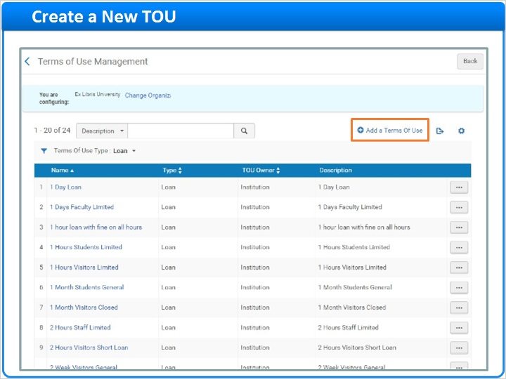
Notes:
Now that you understand the elements of a Terms of Use, it is easy to create a new one.

Starting on the Terms of Use Management page, click the Add a Terms of Use link, which starts a three-step wizard to create a new TOU.

Choose which Type of TOU you want to create, and then click the Next button in the upper-right corner.

Give the TOU a Name. Our best-practice recommendation is to create the name based on three factors: The due-date policy, the user or patron type, and the location type or fulfillment-unit name. This is probably how your library was implemented in Alma, and we recommend you continue this as a best-practice. With a unique and descriptive name for each terms-of-use, you can avoid confusion later when editing and using the terms-of-use.

Although Description is not a required field, it can be useful in certain circumstances. Feel free to just copy the Name into that field.

Now you will choose the policies for this TOU, which we discussed earlier. Note that all policies must have a Policy Name, or Value, set; you cannot leave any policies with a blank in the Policy Name field.

When you’re done, click the Next button in the upper-right corner.

The last page of the wizard is just a summary of the Name, Description, and all the Policy Types, Names, and Descriptions that you chose. Click the Back button if you want to change any of your choices. Or click the Save button to make this TOU available to fulfillment units throughout your institution.

Wizard 1 - TOU Type (Slide Layer)
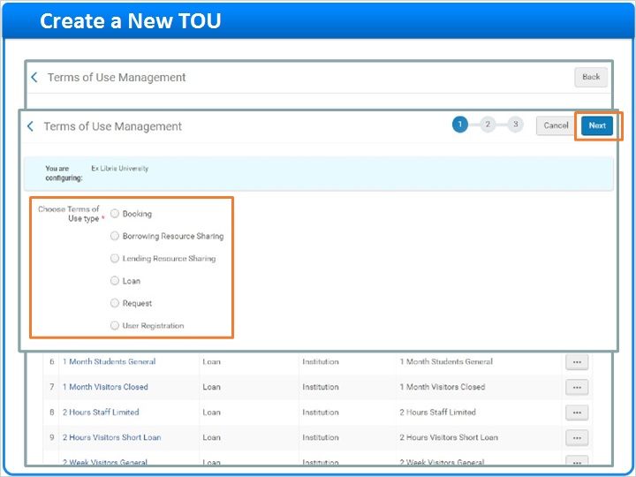

Wizard 2 - Policies (Slide Layer)
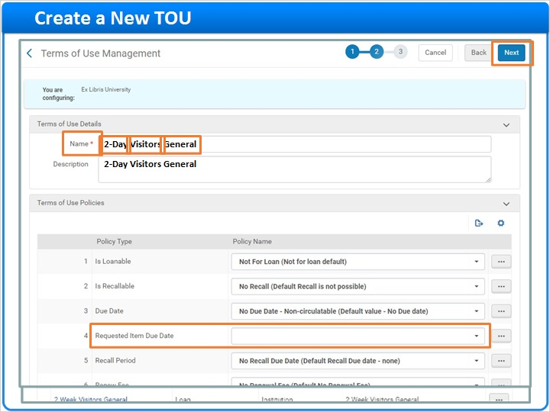

Wizard 3 - Confirm (Slide Layer)
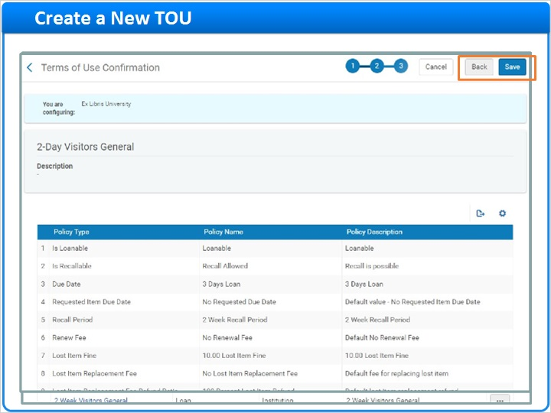

1.14 Create a New Policy
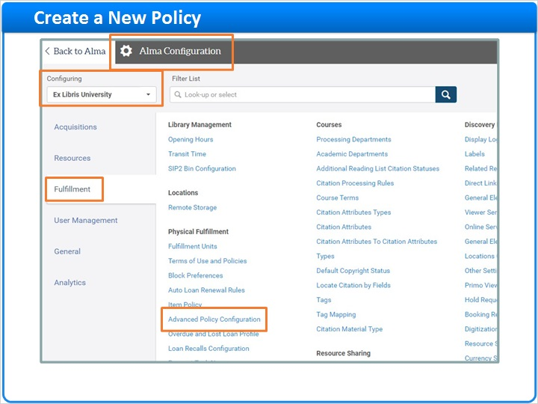
Notes:
Earlier in this session, when you were editing a TOU, we talked about how to add new Policy Names, or Values, to a Policy Type.

You cannot create a new Policy Type in Alma, because that requires development work by Ex Libris. But you can add new Policy Names to a Policy Type even if you’re not working within a particular TOU.

From the Alma Configuration page, on the Fulfillment tab, make sure you are Configuring your institution, and then click the link to Advanced Policy Configuration.

On the Policy Management page, you’ll see the list of all policies in Alma; specifically, each row contains one of the Policy Names and Values that go with the Policy Types.

To see all the Policy Names that go with one Policy Type, use the dropdown menu on the left side.

When you right-click on a row, you have several options: You can Edit that Policy Name and Value; you can Duplicate the Policy Name and Value so as to make a new one associated with that Policy Type; or you can Show related terms of use. This last tool is very useful because you can see which Terms of Use contain that Policy Name and Value. It may be none, or it may be many TOUs.

You may or may not be able to Delete a Policy Name and Value. If the Policy Owner is Generic, that means the Policy Name and Value came from Alma during implementation and cannot be deleted. Only those owned by your institution or a library can be deleted.

By the way, if you choose to Edit a Policy Name and Value, or even delete it, be aware that it changes that policy in every TOU where it occurs. That’s a good reason to Show related terms of use before editing or deleting a policy, so that you know what will be affected.

Policy Management (Slide Layer)
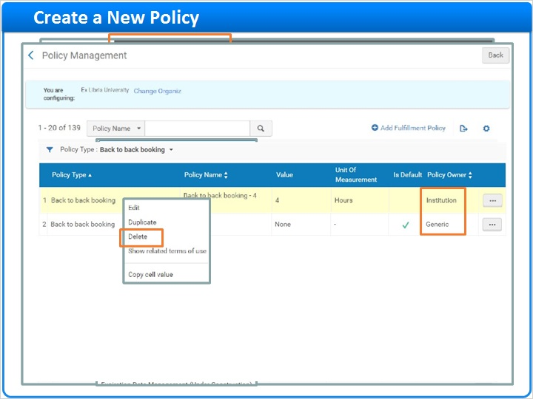

Related TOUs (Slide Layer)
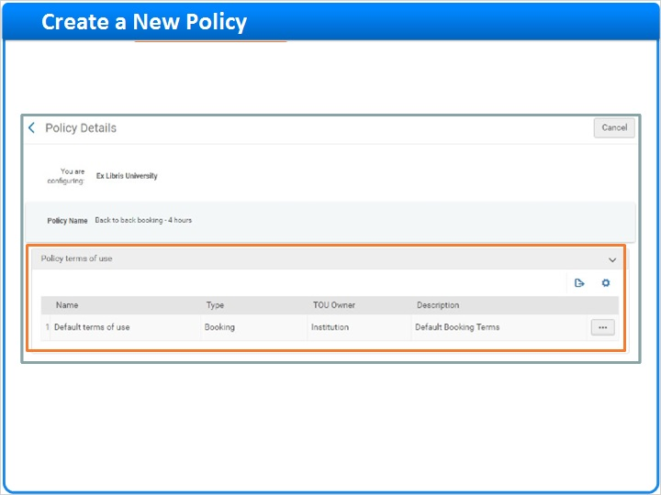

1.15 Session Review and Quiz
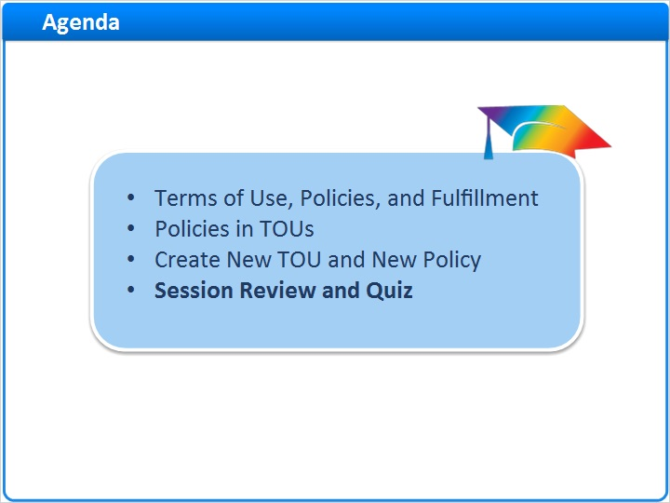
Notes:
That concludes the main portion of this training session. Let’s briefly review what was covered and then proceed to a short quiz.

1.16 Session Review
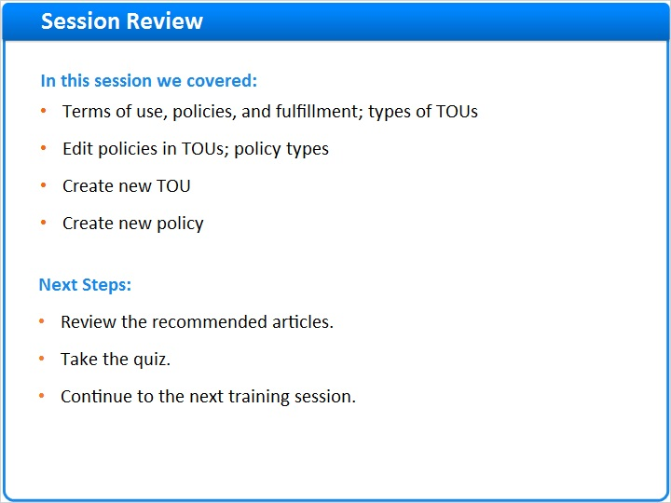
Notes:
In this session we began by covering how terms of use and policies fit into the fulfillment system in your institution, and defined the different types of terms of use. Then we went through the steps of editing policies within TOUs, and explained some of the key policies within the different types of TOUs. Finally, we created a new TOU from scratch, and showed how to create a new policy that can be used in any TOU.

Please refer to the Recommended Articles section where you launched this training session for additional information.
After the short quiz that begins on the next page, you can continue on to the next training session in this series.

1.17 Quiz: TOU Organizational Level
(Multiple Choice, 10 points, 1 attempt permitted)
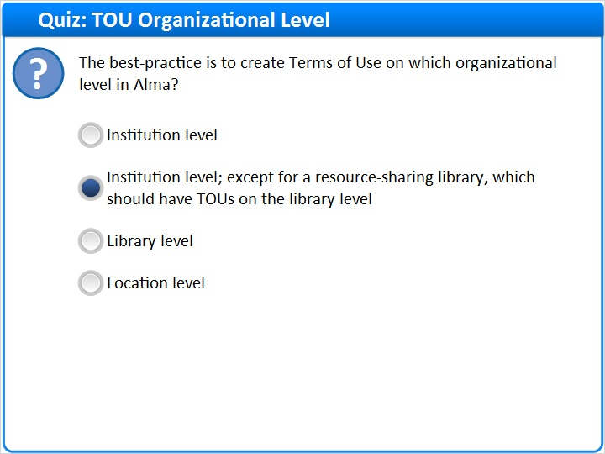
Correct | Choice
 | Institution level
X | Institution level; except for a resource-sharing library, which should have TOUs on the library level
 | Library level
 | Location level
Feedback when correct:
Yes. It is best to create Terms of Use on the institution level, except for those Terms of Use used by the resource-sharing library, which should be created on the library level.
Feedback when incorrect:
No, it is best to create Terms of Use on the institution level, except for those Terms of Use used by the resource-sharing library, which should be created on the library level.

Notes:

Correct (Slide Layer)
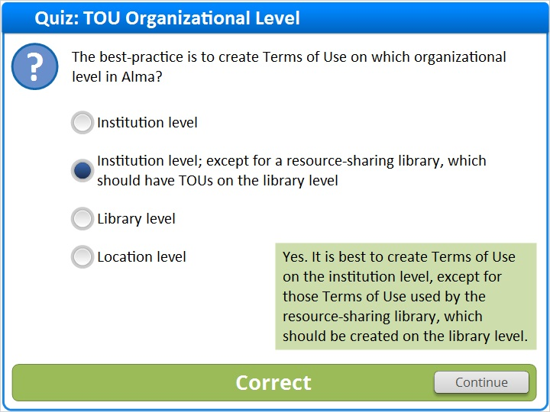

Incorrect (Slide Layer)
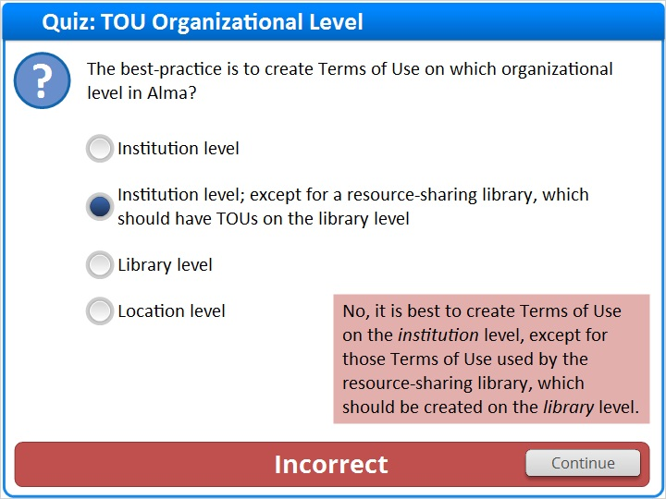

1.18 Quiz: Creating TOUs and Policies
(Multiple Response, 10 points, 1 attempt permitted)
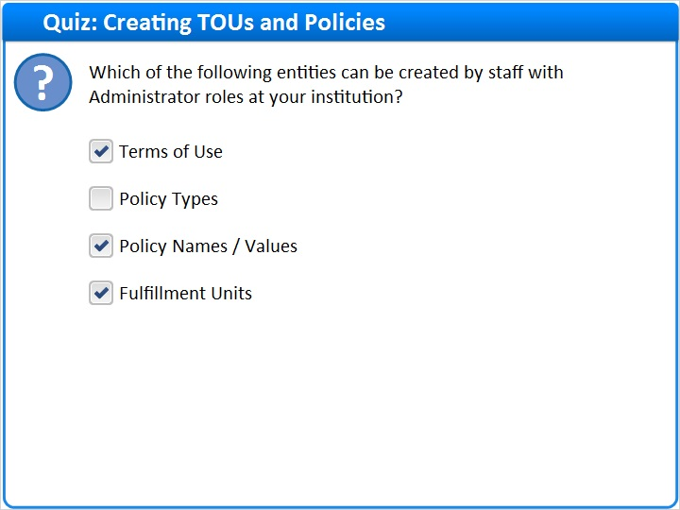
Correct | Choice
X | Terms of Use
 | Policy Types
X | Policy Names / Values
X | Fulfillment Units

Feedback when correct:
Correct. Administrators can create Terms of Use, Policy Names / Values, and Fulfillment Units. They cannot create Policy Types because that requires changes to the Alma software itself.
Feedback when incorrect:
Incorrect. Administrators can create Terms of Use, Policy Names / Values, and Fulfillment Units. They cannot create Policy Types because that requires changes to the Alma software itself.

Correct (Slide Layer)
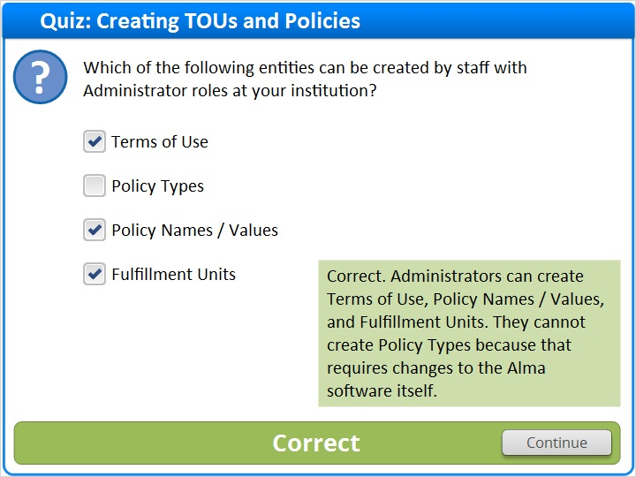

Incorrect (Slide Layer)
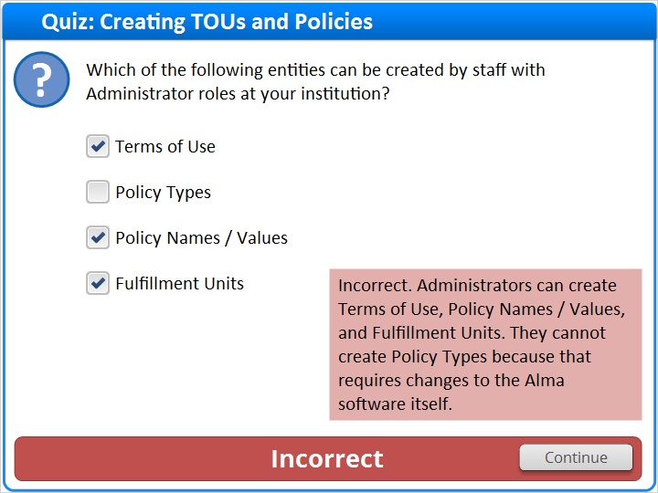

1.19 Quiz: Policies Within TOUs
(True/False, 10 points, 1 attempt permitted)
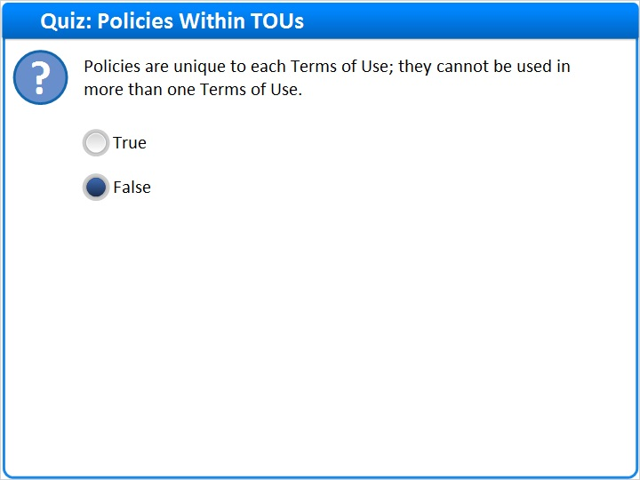
Correct | Choice
 | True
X | False

Feedback when correct:
Correct, this is false. Policies can be used in many different Terms of Use. Therefore, when editing or deleting policies, you can affect many TOUs.
Feedback when incorrect:
Incorrect. Policies can be used in many different Terms of Use. Therefore, when editing or deleting policies, you can affect many TOUs.

Notes:

Correct (Slide Layer)
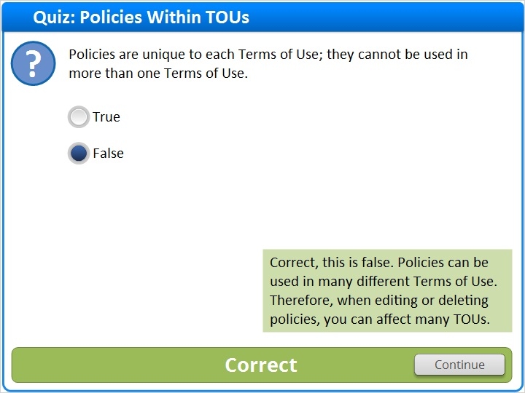

Incorrect (Slide Layer)
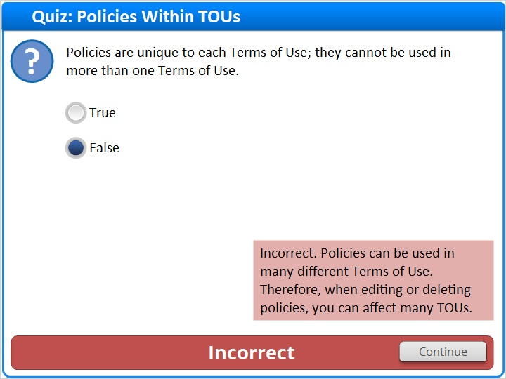

1.20 Thank You!

Notes:
Thank you for joining this session!

1.21 About this Training

Notes:

1 (Slide Layer)
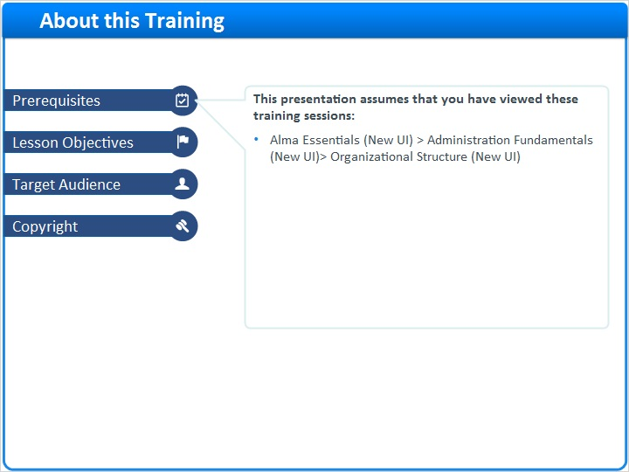

2 (Slide Layer)
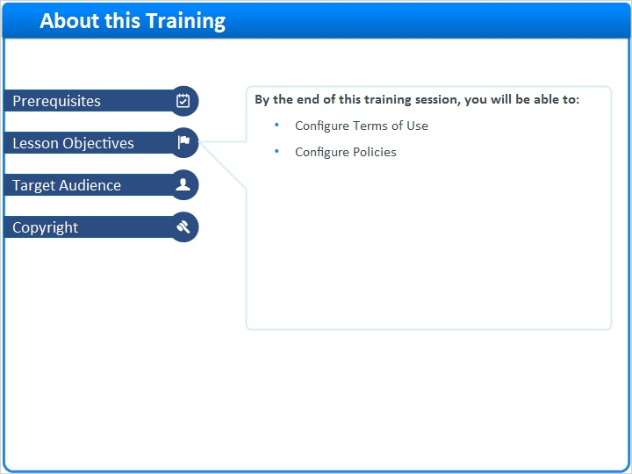

3 (Slide Layer)
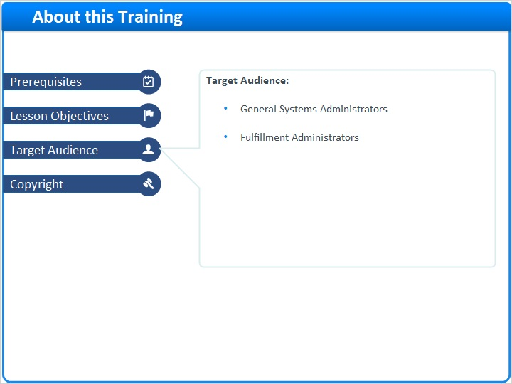

4 (Slide Layer)


