Alma Digital Working with Import Profiles

1. Alma Digital: Working with Import Profiles

1.1 Alma Digital:

Working with Import Profiles
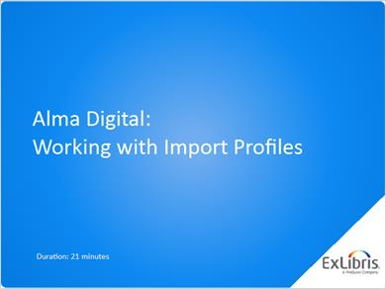
Notes:
Hello, and welcome to this training session about creating import profiles for digital resources. To get the most out of this training, you should have already watched “Alma Digital: Preparing Metadata Files” and completed the recommended activities for that session.

1.2 Agenda: What are Import Profiles?
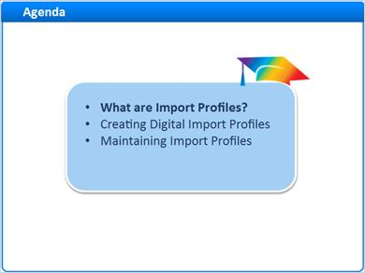
Notes:
We’ll begin this session by discussing what import profiles are. Then, we’ll learn how to create import profiles for loading your digital resources’ metadata and asset files into Alma. And finally, we’ll talk just a little bit about maintaining import profiles.

1.3 User Roles
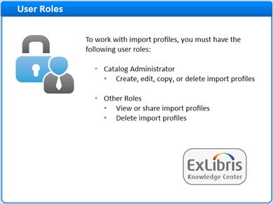
Notes:
Before we get started, let’s talk about the roles required to work with import profiles.

You will need to have the Catalog Administrator role to create, edit, copy or delete import profiles. Additional roles allow more limited interaction with import profiles. For a complete list, see the “Managing Import Profiles” article in the Knowledge Center. You can find a link to this information under the Recommended Articles area of the web page where you launched this training.

1.4 Upload Digital Resource Metadata and Files into Alma
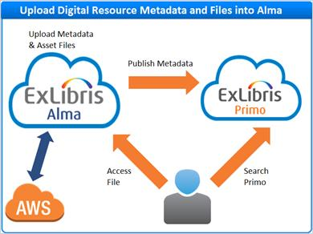
Notes:
This training is the second in a three-part series about using import profiles to load your digital resources’ metadata and asset files into Alma.

You can then publish the metadata to Primo or other services for discovery. Either way, patrons will access the asset files through Alma which in turn communicates with the Amazon cloud where your files are stored.

1.5 Import Profiles for Uploading Files: Three Steps
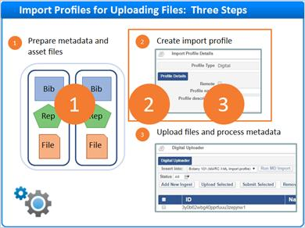
Notes:
The “Import Profiles for Uploading Files” workflow involves three basic steps. By now, you should have already learned about step one, preparing your metadata and asset files for upload.

Now, we’ll look at step two, creating an import profile that tells Alma how to process your uploaded files. You’ll learn about Step 3, sing the Digital Uploader, in the next training session.

1.6 What is a Digital Import Profile?
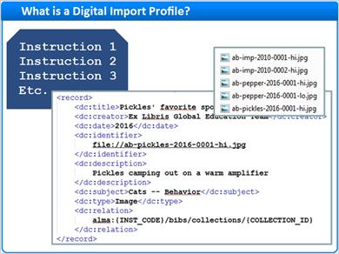
Notes:
A digital import profile is a set of instructions that, when processed, turns provided metadata files and their related assets into bibliographic records and their digital inventory.

Result (Slide Layer)
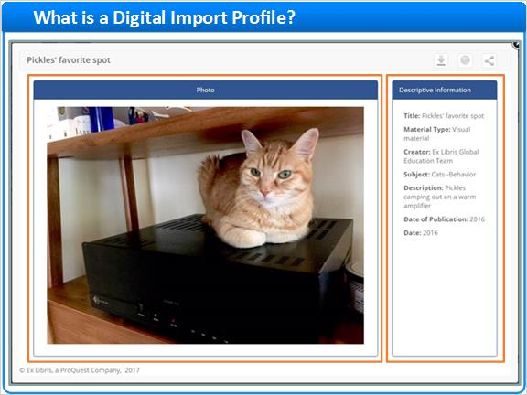

1.7 More about Import Profiles
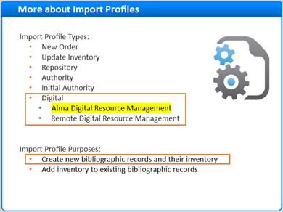
Notes:
As you might have guessed, there is a bit more to import profiles than just that. There are several different types of import profiles based on the type of metadata you are loading. Today, we will learn about digital import profiles for managing both your metadata and asset files in Alma. Import profiles for working with Remote Digital Repositories will be covered in a separate session.

You can design your Digital Import Profile to process metadata that:

- Creates new bibliographic records and their inventory
- Or adds inventory to existing bibliographic records

This session only covers import profiles for creating new records and their inventory.

1.8 The Digital Resource Hierarchy
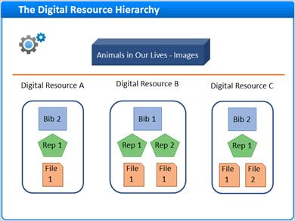
Notes:
Digital import profiles tell Alma how to process imported metadata for all levels of the digital resource hierarchy, the bibliographic record, the representation, and the file. Import profiles can also identify a default collection to hold the imported digital resources.

1.9 Source and Target Formats
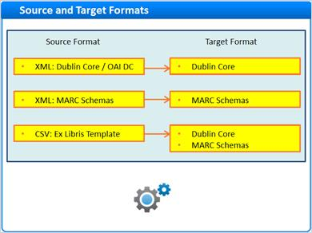
Notes:
As you may recall from the Preparing Metadata Files training session, Alma digital is quite flexible in accommodating a variety of metadata source and target formats.

Fortunately, you don’t need to learn how to create import profiles for every possible combination because many of them are similar. In this session, our examples will focus on:

- Loading Dublin Core metadata into Dublin Core records in Alma
- And also loading MARC21 metadata into MARC21 records in Alma

For the most part, the steps are the same for XML import profiles as they are for CSV import profiles, but a few differences will be noted along the way.

1.10 Agenda: Creating Digital Import Profiles
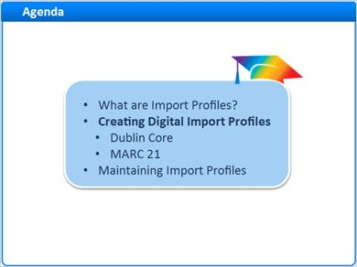
Notes:
Now let’s learn how to build some digital import profiles. We’ll start with some general steps that apply to all digital import profiles. Then we’ll look more closely at information specific to Dublin Core and MARC schemas.

When the steps for Dublin Core and MARC are the same, I’ll note the similarity, but I don’t want to bore you, so I won’t repeat the details.

1.11 Open the Import Profiles Page
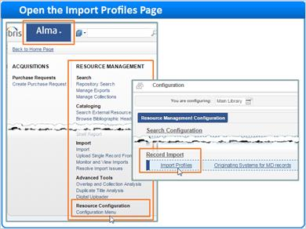
Notes:
To start, go to the main Alma menu and look for the Resource Configuration heading under RESOURCE MANAGMENT. Click on the Configuration Menu link. On the Configuration menu screen, under Record Import, click on Import Profiles to go to the Import Profiles home page.

1.12 Launch Import Profile Wizard
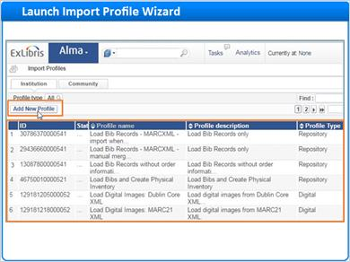
Notes:
The Import Profiles home page lists all of your saved import profiles. To build a new import profile, click the Add New Profile button to launch the Import Profile Wizard.

1.13 Choose Import Profile Type
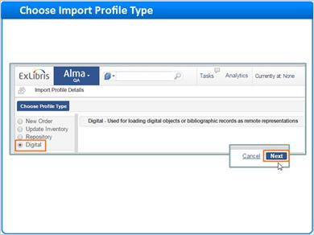
Notes:
Now, select Digital as your profile type, then click Next.

The steps we just followed will apply to any Digital Profile you want to create.

1.14 Agenda: Dublin Core
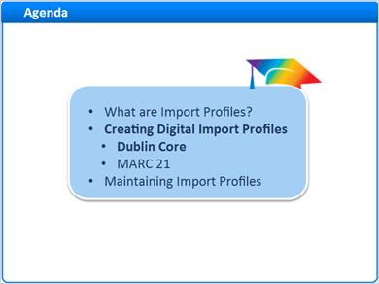
Notes:
Now let’s dig in a bit deeper and learn about import profiles for Dublin Core.

1.15 DC Step 1: Enter Profile Details
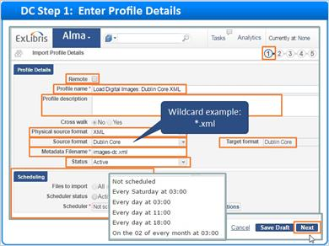
Notes:
The first real step of the Import Profile wizard allows you to set the stage for the import process. First, uncheck the Remote box because you're creating an Import Profile for storing asset files right in Alma, not in a Remote Repository.
Give your profile a meaningful name so that it can be reused in the future. This profile name Load Digital Images: Dublin Core XML offers a good idea of how to use this Import Profile. The Profile description is optional.
The next few settings are the most critical ones. Start by selecting your physical source format, CSV or, in this case XML. Then choose your source file’s metadata schema as the source format. If you choose Dublin Core, Alma will chose the matching target format automatically.
If you want to make sure that only files with a specific name are processed with this profile, you can specify a Metadata Filename. But, this field also supports wildcards. For example, if you want this profile to work with any xml filename, you can enter *.xml.
Next, if you're not ready for this profile to be used when you save it, you can set the profile to inactive instead of active. We’ll keep this one active.
Scheduling is an optional step. If you plan on gradually uploading files over a period of time, and want them to be processed periodically, you can schedule the import profile to run according to one of these schedules. Let’s skip scheduling and click Next.

1.16 DC Step 2: Review Normalization and Validation
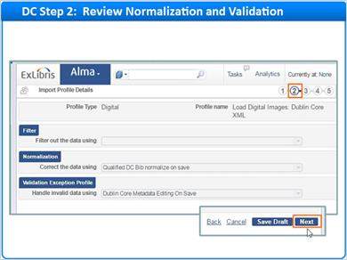
Notes:
When using Dublin Core, Alma pre-selects your normalization and validation settings for you. So there is nothing to do here, but click Next.

1.17 DC Step 3: Review Match Profile
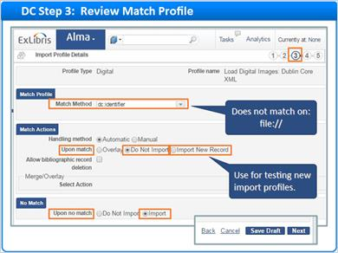
Notes:
The match profile step tells Alma what to do if your uploaded metadata file contains a bibliographic record that matches a record that's already in your catalog. Alma uses dc:identifier values that do not start with the reserved text ‘file://’ to match existing records.
Since this Import Profile is only for uploading brand new digital resources, we don’t want to worry about overlaying or merging records. We can just keep the default settings in place.
The defaults tell Alma that if there is, for some reason, a matching record, do not import that record. And, when there is no match, do import the record. In this way, only new content is loaded. However, when testing new import profiles, you may want to import duplicates as new records so you can easily review the results of your upload tests.
Just remember to save the correct the settings in your production environment.

1.18 DC Step 4: Set Management Tags
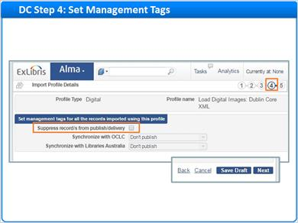
Notes:
For Dublin Core, there is only one choice to be made on this screen. If you want to prevent the imported records from being published for discovery, check the box called Suppress records from publish/delivery.

The other options on this screen are not available for Dublin Core.

1.19 DC Step 5: File Naming Conventions Refresher
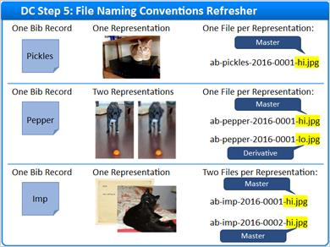
Notes:
Before we dig into Step 5, let’s have a little refresher from the Preparing Metadata Files training. In that session, we learned that file naming conventions help you manage master and derivative representations.
We looked at some examples where the text “-hi.jpg” indicated that the file belonged to a master representation. And, a file name containing -lo.jpg belonged to a derivative representation.
At last, in step 5, you get to tell Alma how to use this information when processing your metadata and asset files.

1.20 DC Step 5: Configure Inventory Information - XML
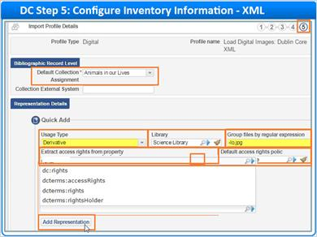
Notes:
In this step, you’ll define the properties of your digital representations. To learn about representation properties and their functions, watch the training session called Managing Digital Resources Manually.
Let’s start at the bibliographic record level of the hierarchy. Select a default collection to which imported records will be assigned when no collection is specified in your metadata.
Now, let’s move onto the representation level and give Alma instructions for processing Master Representations. Select the usage type “Master”. Then, choose a library as the owner of the Master representations processed with this profile.
Next, tell Alma how to identify your Master representations based on file names. In the “Preparing Metadata Files” training session, all of the high resolution, master representations had the text “-hi.jpg” in their file names. So, we’ll enter ”-hi.jpg” in the “Group files by regular expression” text box. This tells Alma that, if a file name contains the text “-hi.jpg”, the file belongs to a Master representation.
If you like, you can define the access rights policy to use for master representations. Access rights policies are configurable rules detailing which types of users have access to your digital resources. A link to information about configuring access rights policies is in the Recommended Articles area for this training.
In the meantime, there are a few things you should know about defining access rights for an import profile:
If different records in your import file need different policies, you should add your policy names to the records in your metadata. Then, you need to tell Alma where to find the data. To select the Dublin Core property from which to extract the access rights policy name, start typing in the field. The Dublin Core property chooser tool will display a list of matching properties from which you can choose. Or, click on the magnifying glass icon to see a full list of properties from which to select.
You can also set a default access rights policy for all records in the import.
It’s a good idea to select a default even if you are extracting rights from the metadata file. That way, if any records are missing data, the default policy will apply.
For convenience, the Dublin Core property chooser tool is also available for telling Alma where to extract representation labels, notes, and public notes from your metadata.
When finished with your selections, click the Add Representation button.
Now, you can repeat the process for your derivative representations. Most likely the key difference will be the "Group by regular expression" value telling Alma that, for example, derivative representations contain the text -lo.jpg in their file names. Remember to click the Add Representation button when done with your selections.
Your saved representation definitions will look like this.
This is the last step in the import profile wizard, so you can click Save. If you are not quite ready for this profile to be used, click “Save Draft” to save your work in an Inactive state. You can always activate the import profile later.

Representations (Slide Layer)
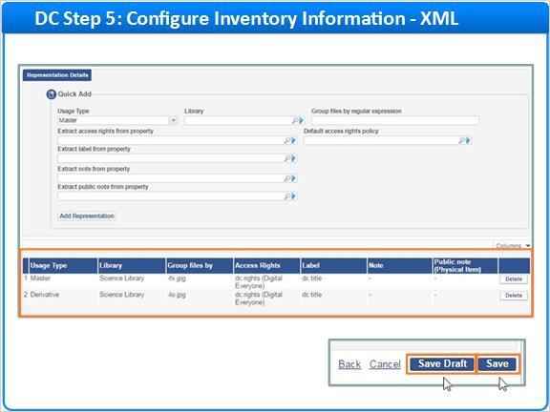

1.21 DC Step 5: Configure Inventory Information - CSV
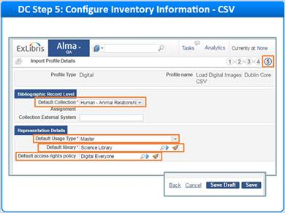
Notes:
Before we leave Step 5 behind, you need to know that this step works differently for CSV imports than for XML.

The Import Profile does not need to tell Alma how to use file names to figure out master versus derivative usage types. Instead, you can include this information in the CSV metadata file. Just fill in the rep_usage_type field for each representation in the file.

Having usage types in your metadata means that this step of the wizard is simplified for CSV files.

Simply select four default property values that Alma can use for records that do not include the relevant metadata. The first three are mandatory:
- Default Collection
- Default Usage Type (of Master or Derivative)
and
Default library
The fourth property, Default Access Rights policy is optional, but a good idea to complete.

CSV File (Slide Layer)
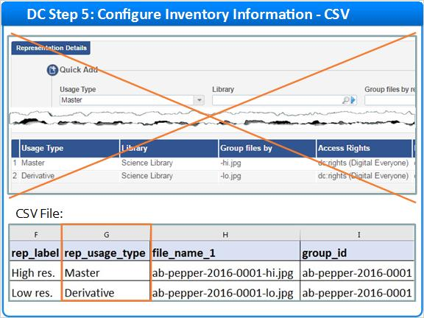

1.22 Agenda: MARC 21
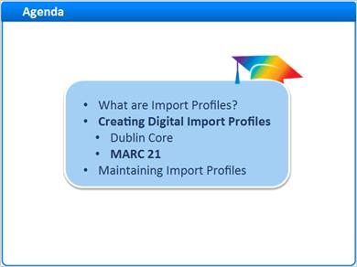
Notes:
Let’s switch to import profiles for MARC 21. These will work in much the same way as for Dublin Core, so most of our work is already done.

1.23 MARC: Choose Import Profile Type
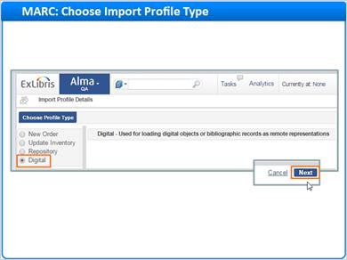
Notes:
Just as with Dublin Core, you need to launch the Import Profile Wizard and select Digital as your profile type. Then click Next.

1.24 MARC Step 1: Enter Profile Details
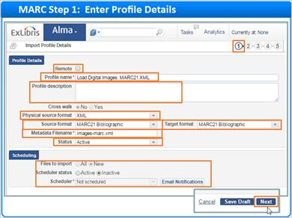
Notes:
Step one of the import profile wizard for MARC 21 is similar to step one for Dublin Core.

Remember to uncheck the Remote box to get started.

Give your profile a meaningful name and description.

Choose either XML or CSV as your physical source format.

Choose your source and target metadata format. Here, we are using MARC21 for both.

Enter a metadata filename for your upload file. Remember that you can use wildcards for more flexibility.

Choose whether to make this import profile active or inactive when done with the wizard.

Consider scheduling, and click Next.

1.25 MARC Step 2: Choose Normalization and Validation
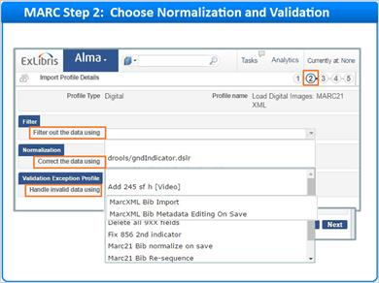
Notes:
With MARC formats, you have some Normalization and Validation choices to make. First, if you need to filter out specific groups of records, you can choose one of your library’s configured drools rule sets.

If you need to apply special normalizations to make your digital resource’s MARC data consistent with your standards, you can select a normalization process to run on import.

And finally, you can choose an exception profile for handling records with invalid data.

It’s beyond the scope of this session to cover these topics in detail, but you can find link to information about Configuring Cataloging in the Recommended Articles area for this training.

1.26 MARC Step 3: Review Match Profile
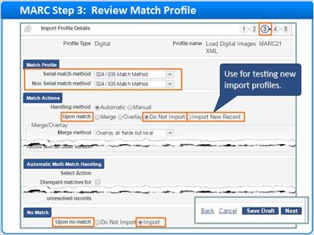
Notes:
For the Match Profile step, we can keep the default settings in place because we are uploading only new records. Just to play it safe, the default settings specify that, if there is a matching record, do not import it. And, if there is no match, do import the record. As with the Dublin Core workflow, you may want to import all records when testing.

One other note, the MARC import profile offers several options for determining a match with existing bibliographic records. For more information, see the “Managing Import Profiles” link in the Recommended Articles area for this training.

1.27 MARC Step 4: Set Management Tags
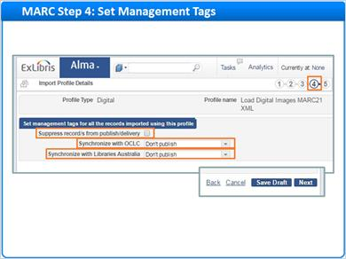
Notes:
On step 4, we have a few more options for MARC than we had for Dublin Core. As before, we can choose to suppress the records from discovery.

But, we can also set options for synchronization with OCLC and Libraries Australia. See the Recommended Articles area of this training for links to more information about synchronization.

1.28 MARC Step 5: Configure Inventory Information - XML
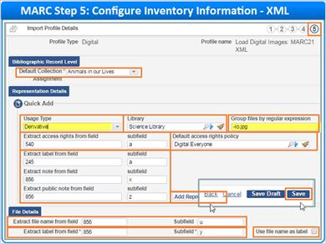
Notes:
Step 5 for MARC is similar to step 5 for Dublin Core.

Begin at the bibliographic record level, and choose a default collection for records without a collection in the metadata.

Next at the representation level, create your Master Representation definition and choose a library as the owner. Using the same example as with the Dublin Core workflow, enter -hi.jpg into the “Group files by regular expression” field. This tells Alma that all master representations have this text in their file names.

Optionally specify, how to extract extra metadata from your file. For example, you might extract your access rights policy name from the “540” subfield “a”. You can also select a default in case rights are missing from the metadata. And, if you like, you can indicate which MARC fields and subfields hold any metadata for representation labels, notes, and public notes.

Remember to click the Add Representation button before moving on. Now, repeat the process for Derivative representations paying special attention to the “Group by regular expression” value. This time, you need to tell Alma how to identify file names for derivative representations. Click on the Add Representation button when done.

With MARC you go a level deeper into the hierarchy than with Dublin Core and work with file level fields. Start by indicating which field holds file names for processing. Typically this will be the “856” subfield “u”.

By default Alma displays the file name as a label that patrons can see, but you can uncheck this box and pick a different field for display, for example the “856” “y”.

This is the last step in the wizard, so click Save when done.

1.29 MARC Step 5: Configure Inventory Information - CSV
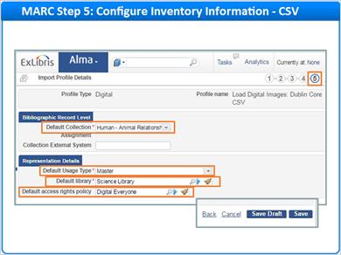
Notes:
As you recall from the Dublin Core workflow, import profile inventory settings are simplified for CSV because you can specify representation usage types right in the CSV metadata file.

Just select these three mandatory property values that Alma can use for records that do not include the relevant metadata:
- Default Collection
- Default Usage Type (of Master or Derivative)
and
Default library
And perhaps select a Default Access Rights policy which is optional, but recommended.

CSV File (Slide Layer)
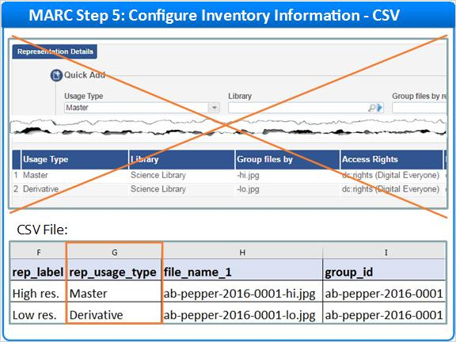

1.30 Agenda: Maintaining Import Profiles
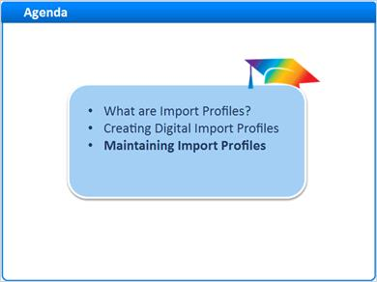
Notes:
Let’s wrap up with a few notes on maintaining import profiles.

1.31 Open the Import Profiles Page
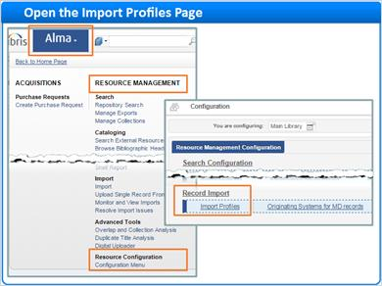
Notes:
To work with existing import profiles, navigate to the Import Profiles home page.

1.32 Import Profile Actions
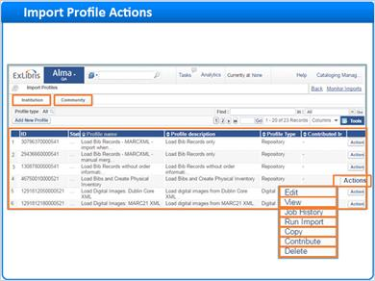
Notes:
The Import Profiles home page lists all of your saved import profiles on the Institution tab. If you need to work with an existing profile, click the Action button to see your choices.
You can edit an existing profile, or just view it. If you find a useful import profile, you can copy it, and edit the copy to suit your needs. And, if you no longer need a profile, you can delete it.
On the other hand, if you have an import profile that could be useful to others, you can contribute that profile Community zone. Likewise, you can browse community zone profiles on the Community tab and copy them to your institution for editing and use.
Finally, you can look at the profile's job history or run an import using the profile. You’ll learn more about these activities in your next session, “Using the Digital Uploader”.

1.33 Session Review
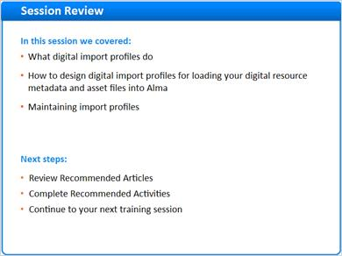
Notes:
This concludes the “Alma Digital: Working with Import Profiles” training session. In this session, we:

- Discussed what import profiles do.
- Looked at how to create digital import profiles for loading your digital resource metadata and asset files into Alma.
- And finally, we learned a bit about maintaining import profiles.

What are your next steps?
- First, read the recommended Articles for this session.
- And, complete the recommended activities for this training.
- Then, continue with your next training session.

1.34 Thank You!

Notes:
Thank you for joining us. Please visit the Ex Libris Knowledge Center for more training materials.

1.35 About this Training
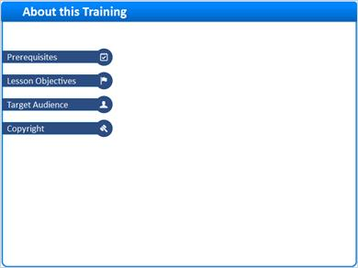
Notes:

1 (Slide Layer)
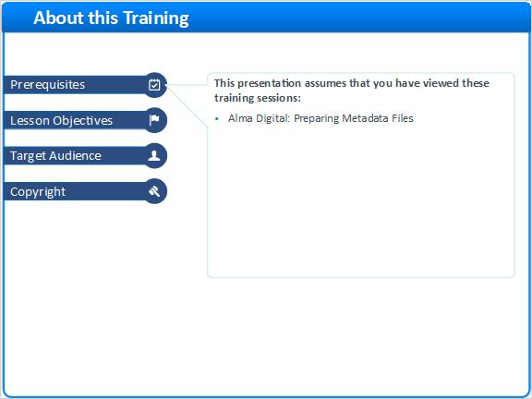

2 (Slide Layer)
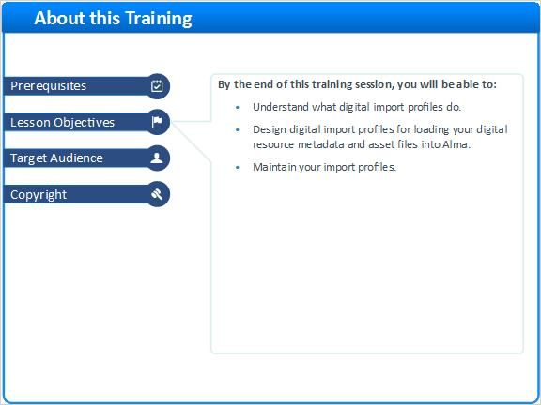

3 (Slide Layer)
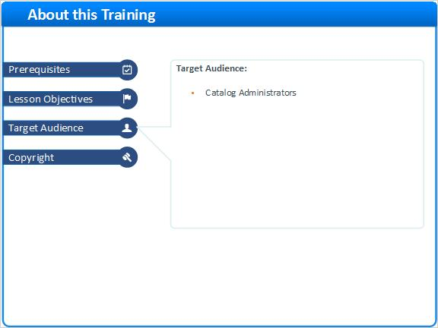

4 (Slide Layer)


