Migrate a Digital Repository to Alma

1.1 Migrate a Digital Repository
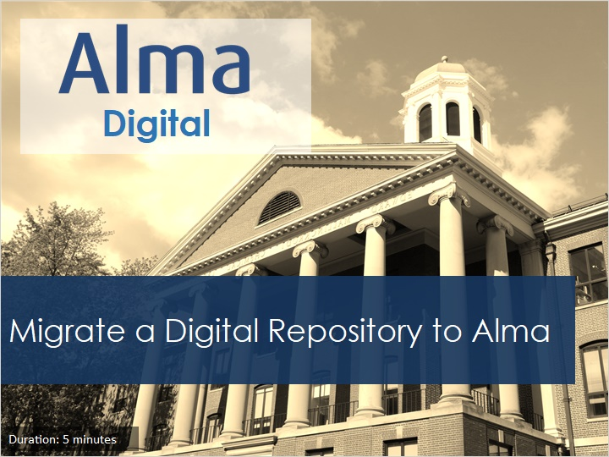
Notes:
Welcome to this session on how to migrate a digital repository to Alma.

1.2 Objectives
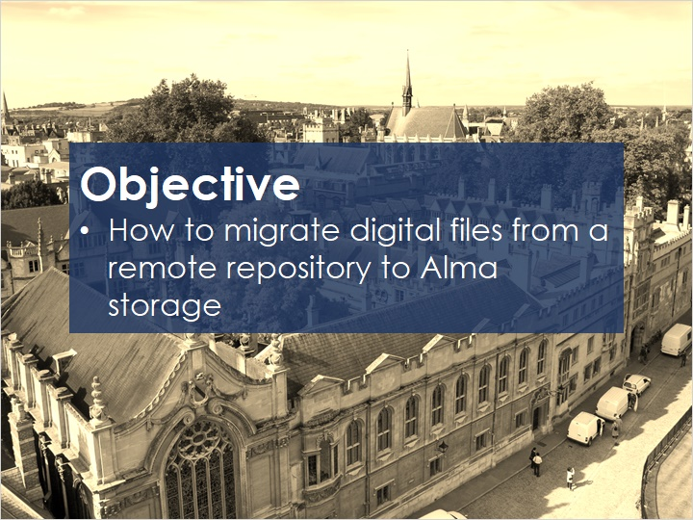
Notes:
In this session, we will demonstrate how to migrate digital files from a remote repository to Alma storage.

1.3 Introduction
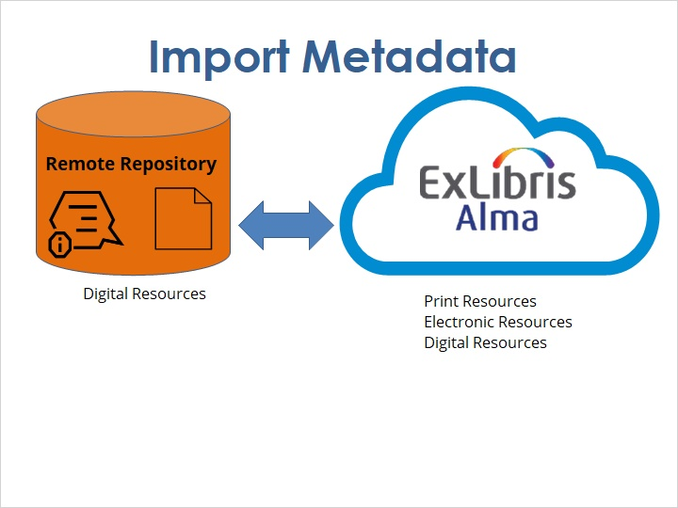
Notes:
As we discussed in the previous session, there are two ways to integrate an existing digital repository into Alma. To import the metadata, follow the instructions in that session.

1.4 Introduction
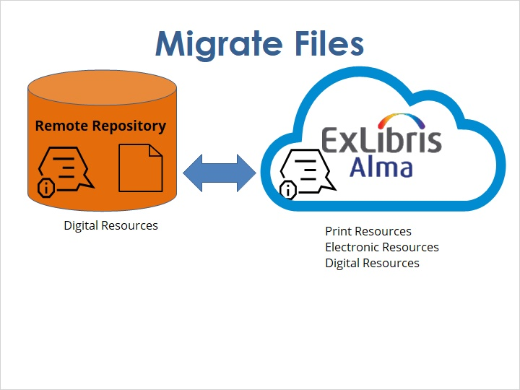
Notes:
To migrate the files, start by following the steps in that session, and then continue with the steps described here.

1.5 How to Migrate Digital Files
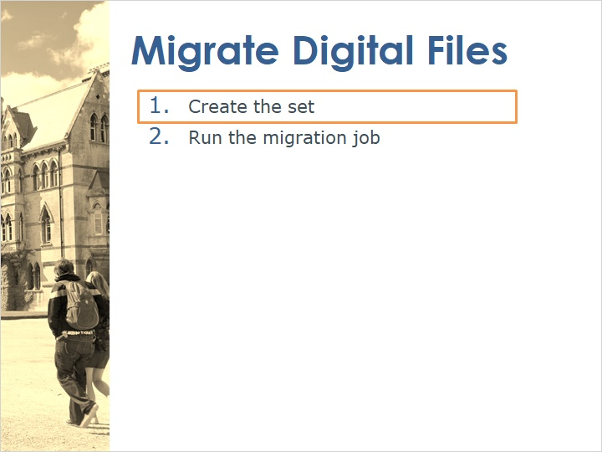
Notes:
The first step is to create the set of records that you want to migrate.

1.6 Create the Set
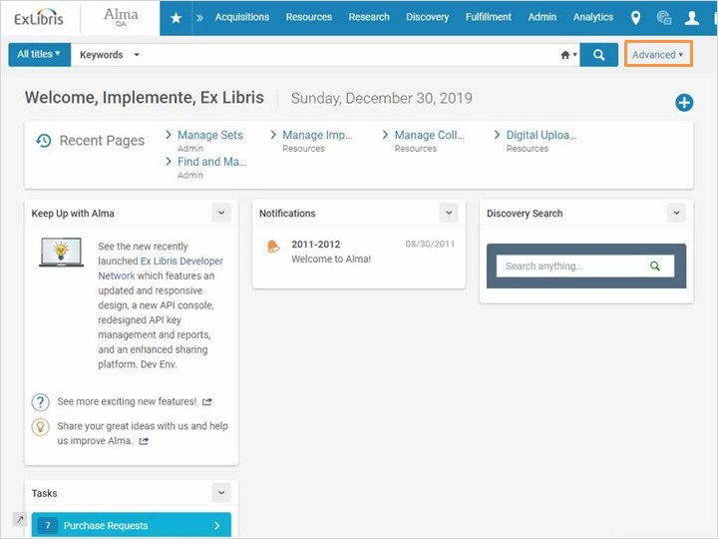
Notes:
There are several ways to create the set of files that you want to migrate.
One way is to use Advanced search.
Choose Digital titles > Representation: Remote repository, Equals, and then the name of your remote repository.
Click Search.
Check that this in fact includes the titles that you want to migrate.
Click Save Query.
Name the set, and save.

1.7 How to Migrate Digital Files
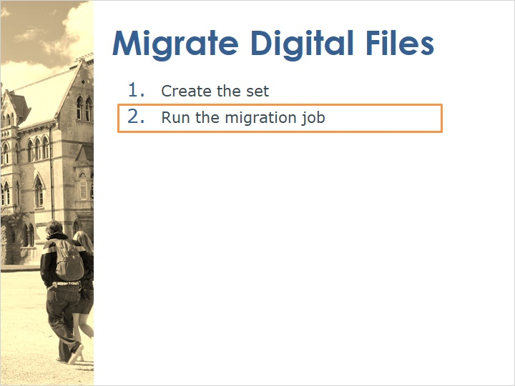
Notes:
The second step is to run the migration job.

1.8 Run the Migration Job
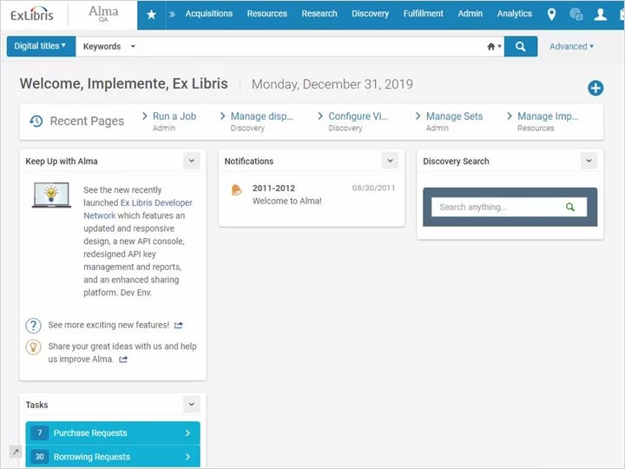
Notes:
Go to Admin > Run a job, and select Remote Representation Migration. We recommend running the job on a small test set first. After confirming that it works the way you want, run the job on the set of files you want to migrate.
If the URL used for delivery does not point directly to the digital file, then you will need to input another URL that does. This way it can be downloaded and migrated.
For the Other URL, you can use linking parameters defined in the transformer rules of the remote repository configuration.
If you are not sure which URL to use, consult with your particular repository.

1.9 Check the Representations
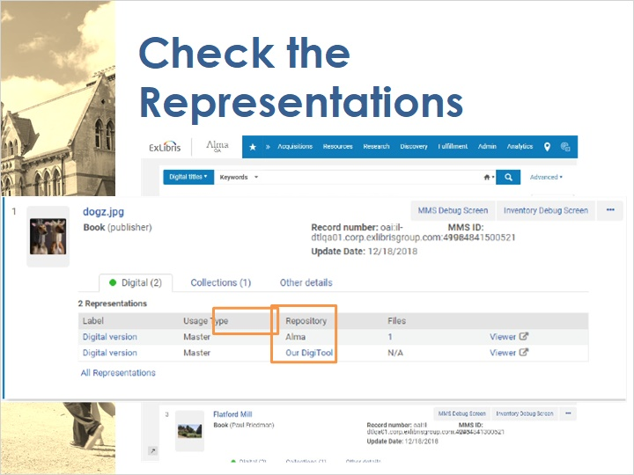
Notes:
You can check that the migration worked correctly. You will see that each title has two representations, a remote one and a local one stored in Alma.

1.10 Withdraw the Remote Representation
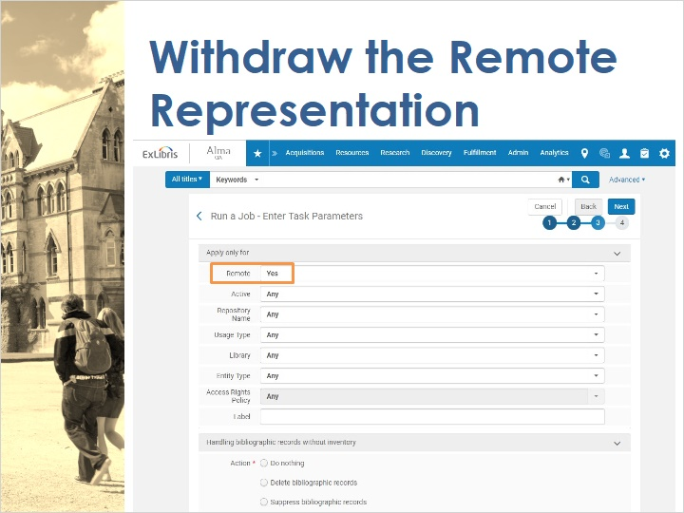
Notes:
When you are ready, you can remove the remote representation by running the job called Withdraw Remote Digital Representations.
In the Remote field, select Yes, so you only withdraw the remote representation and leave the Alma representation intact.

1.11 Review
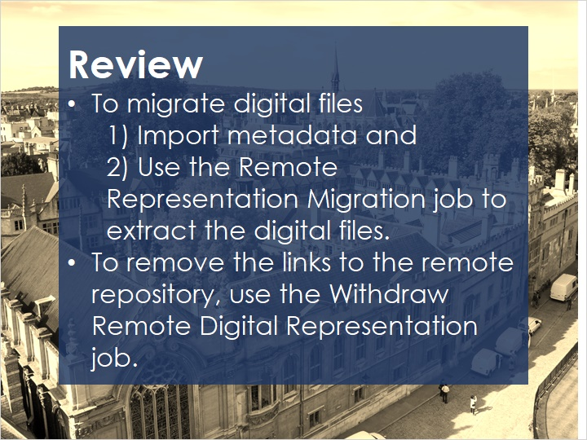
Notes:
To migrate your digital files from a remote repository into Alma's Amazon S3 storage, first follow the instructions in the previous session for importing metadata.
Then use the Remote Representation Migration job to extract the digital files.
Afterward, to remove the representation that links to your remote repository, use the Withdraw Remote Digital Representation job.

1.12 Quiz
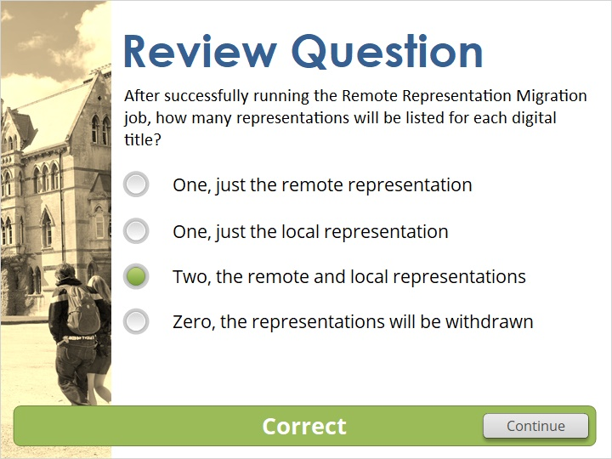 Feedback when incorrect:
Both the remote and local representations will be listed.

1.13 Thank You!

Notes:
Thanks for joining us!

1.14 Copyrights
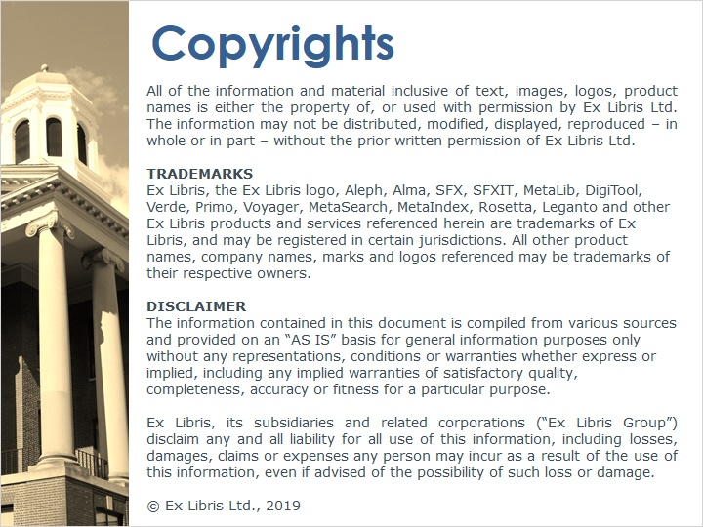
Notes:

