Acquisitions: Activation Workflows (New UI)

1. Aquisitions - Activation Workflows

1.1 Welcome
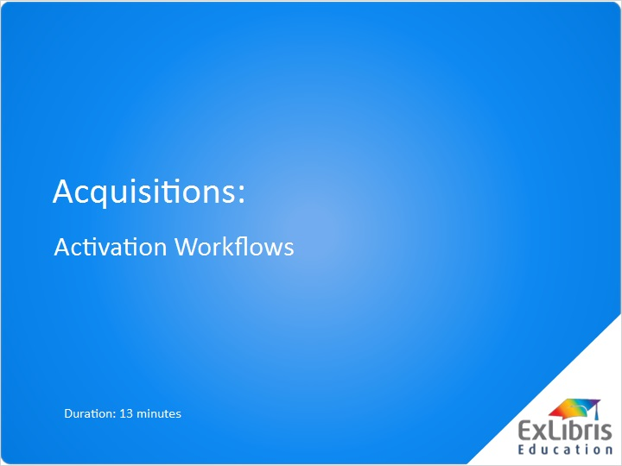
Notes:
Welcome to this session on Acquisitions Activation Workflows.

1.2 Introduction
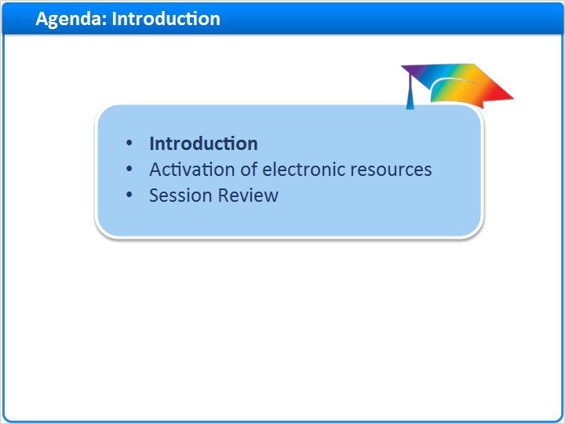
Notes:
In this training session, we will describe the workflow for activating electronic resources in Alma.

1.3 Receiving/Activation Workflow
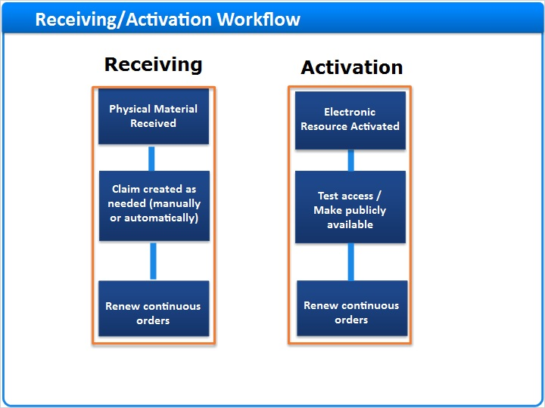
Notes:
In a previous session, we covered the Acquisition processes and workflows for receiving physical items.
In this training session we will review acquisition workflows for Electronic Resources. Electronic Resources are ordered from Vendors similarly to the process used to order Physical Resources. However, Electronic Resources do not follow the standard receiving processes in Alma, but instead follow activation workflows.

1.4 Activation of electronic resources
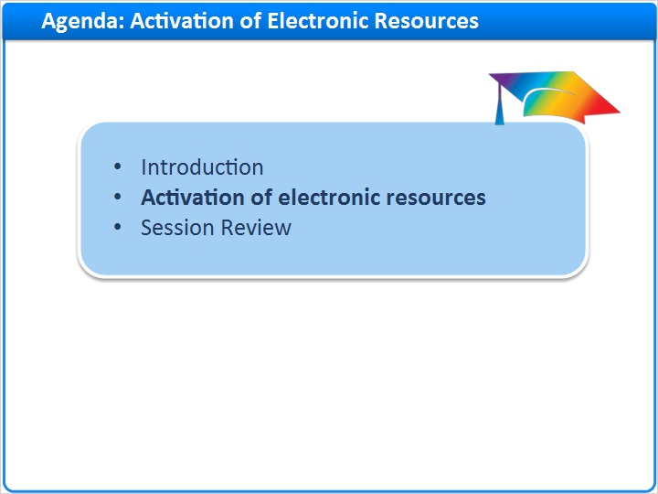
Notes:
Let’s look at the Activation process now.

1.5 Access Activation Task List
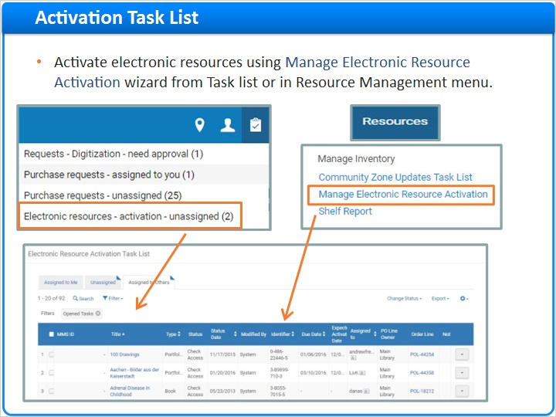
Notes:
After ordering the electronic resource, once it’s available to you from the vendor there are a series of tasks required to activate the electronic resource and make it available to the public. Electronic resources are automatically added to the Electronic Resource Activation Task List if they go through the purchasing process in Alma. The activation task list can be accessed using the Alma task list or under Resource Management > Manage Inventory > Manage Electronic Resource Activation.

1.6 Activation Task List
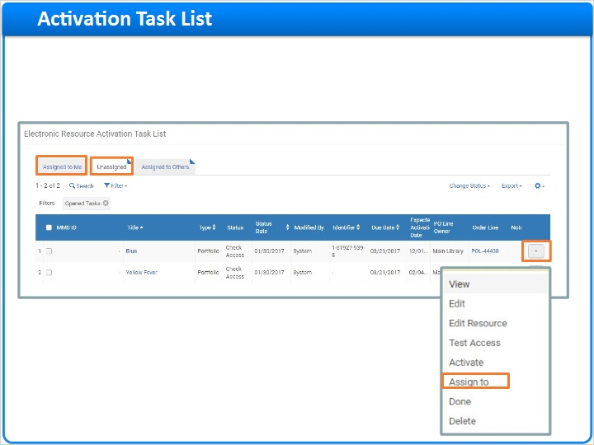
Notes:
By default, the Assigned to Me tab in the Electronic Resource Activation Task List will display. However, when electronic resources first appear in the Activation Task list, they will appear on the Unassigned tab. Once you start working on the activation, it will automatically assign the activation to you. If you have a Manager role, the Assign To option in the row actions list will allow you to assign activations to other staff members. .

1.7 Activation Task List
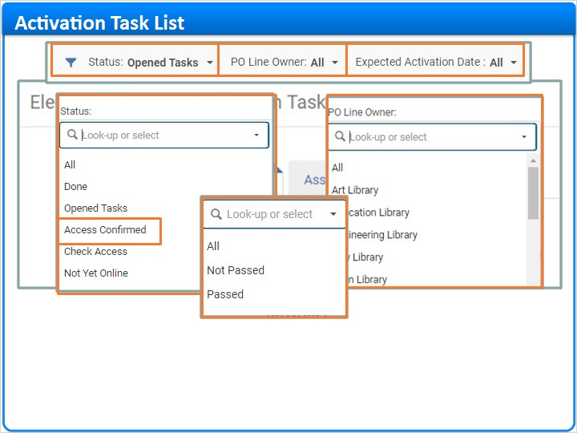
Notes:
Notice the filters to help narrow the task list. Statuses are configurable by your institution and, similar to what we saw in the Receiving Department for physical material, can be assigned to each electronic resource if there are multiple steps or staff members needed during the activation process. For example, after access is tested, you may update the status to “Access Confirmed”
PO Line Owner will filter by library who created the PO line, and Expected Activation Date will filter on whether the expected activation date has passed or not. Each of these fields come from the PO line for the electronic resource.

1.8 Activate Electronic Collections
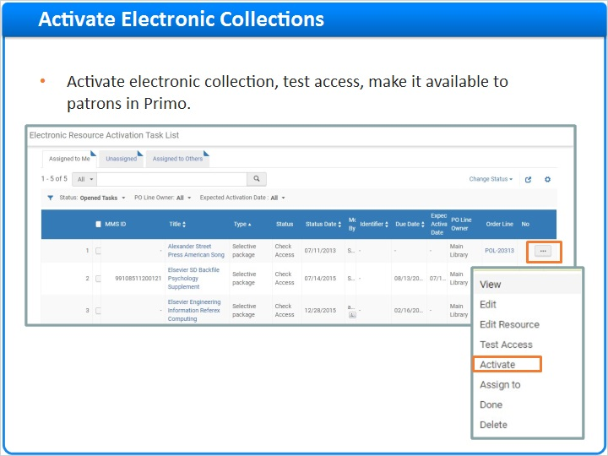
Notes:
There are several types of electronic resources that can be activated. We will first discuss activating electronic collections. Typically electronic resource access is tested before making it available to the public. In order to test access for an electronic collection, click Activate from the row actions list which allows you to activate the resource for testing purposes.

1.9 Activation Wizard
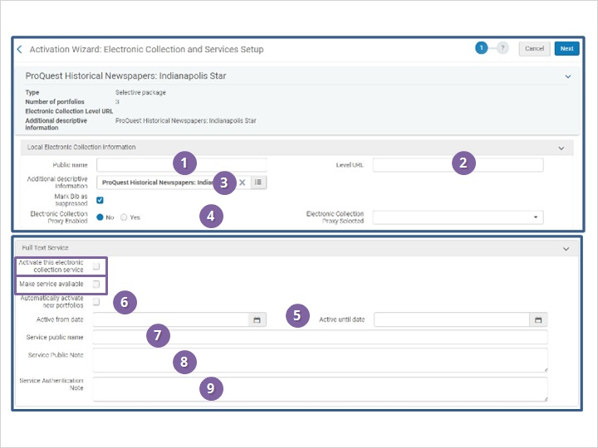
Notes:
The Electronic Collection and Services Setup wizard will display. For activation purposes, the “Activate this electronic collection” check box is important as it needs to be selected in order to test access to the resource. In addition to this check box, select the “Make service available” check box to make the electronic collection available to patrons in Primo. Since we are testing access first, we will leave this check box un-selected.

Click on each of the numbers to see details about the other fields on the screen. When you are finished click the Next button to continue.

1.10 Add Linking Parameters
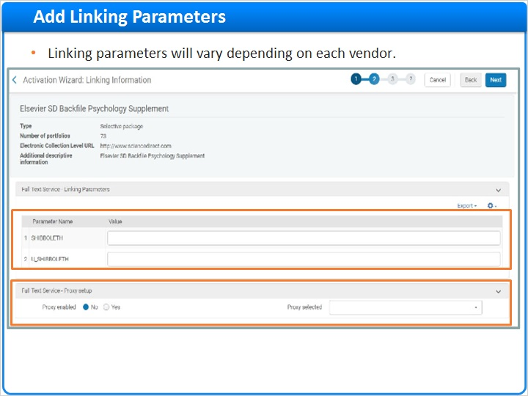
Notes:
The next step in the activation wizard is to add linking parameters, if applicable. Examples of linking parameters are usernames, passwords, or Customer IDs needed to access the electronic collection. Whether linking parameters are needed, or which linking parameters are needed, will vary from vendor to vendor. If linking parameters are not needed, the linking parameters section will not display.
You also can determine if proxy should be enabled at the service level for the electronic collection. Configuring proxy in the service level will apply to everything in the service level, and will be inherited by all portfolios in the electronic collection.

1.11 Select Portfolios
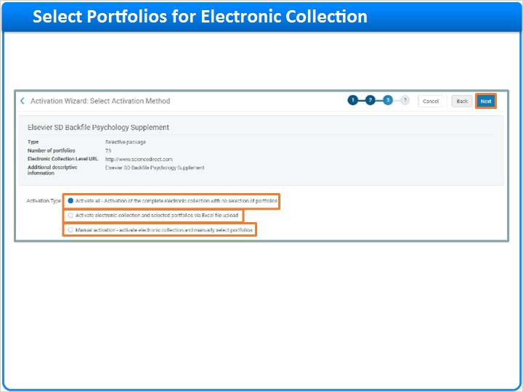
Notes:
The third step in the wizard is to select portfolios to activate within the electronic collection. There are several options when selecting portfolios to activate:
- Activate all portfolios that reside in the collection, which may be useful in the case of aggregator packages where you subscribe to all portfolios in the package
- Upload an Excel file of portfolios to activate using the Portfolio Loader tool, which also might be useful in the case of selective packages. For the upload file, you can use an Excel file template which can be found in the Knowledge Center, or export the entire list of portfolio titles for the package from the Community Zone using Extended Export from the Tools menu and edit the file to include only those titles you subscribe to.
- Manually select the portfolios from a list of portfolio titles that will display later in the activation wizard; this may be useful in the case of selective packages where you just subscribe to select titles within the package.
Click the Next button to go to the next step in the activation wizard.

1.12 Activation Summary Confirmation
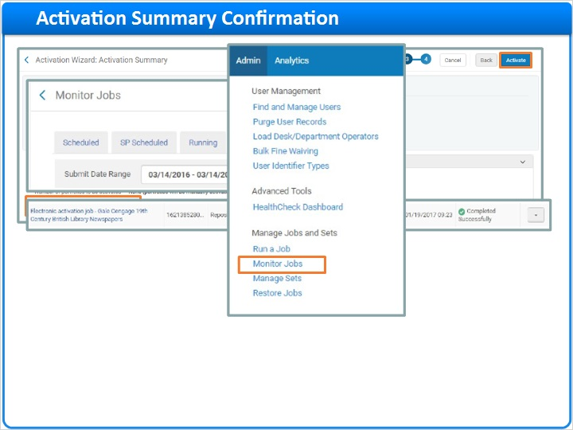
Notes:
A summary screen will display, confirming the number of portfolios to activate, along with the electronic collection level and service level indicated in the Additional Activation count field. If, in the previous step, you choose to manually select the portfolios to activate, it will only activate the electronic collection and service levels at this point. Then click the Activate button.
An activation job will run behind the scenes and an email confirmation will be sent when the job is completed. If desired, the job can be monitored in the Monitor Jobs area of the Alma Administration menu.

1.13 Manually select portfolios
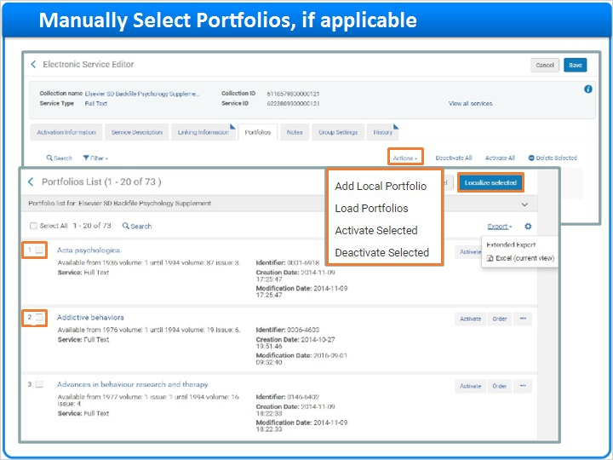
Notes:
If manually selecting the portfolios to activate, you will immediately be presented with options to select portfolios for the electronic collection when the activation job completes.
In this example, we will select portfolios from the Community Zone. A list of portfolios for the electronic collection will display. Click on the checkbox for each portfolio title you wish to activate within the collection and click the “Localize Selected” button.

From the Actions link the following Options will be available
Add Locally created Portfolios
Load portfolios using and Excel file and the portfolio loader tool
Activate Selected Portfolios
Deactivate Selected Portfolios

1.14 Test Access to Electronic Collection
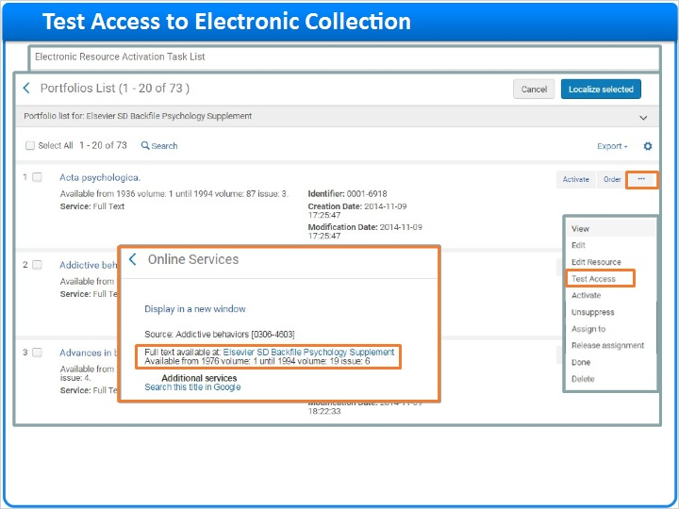
Notes:
Now that the electronic collection is activated, access can be tested before displaying it to the public. From the Activations Task List, notice the electronic collection now appears in the “Assigned to me” tab.
Click Test Access from the row actions list. Note that the “Test Access” option will only display if the activation was successful and if a bibliographic record and URL are present, or if there are services (such as full-text services) associated with the electronic resource.
Access is tested at the portfolio level, as this is what patrons will see in the View It tab in Primo. Click the Test Access link for a portfolio title to view what patrons will see in Primo and click on the electronic collection link to test access.

1.15 Make Electronic Collection Available to Public
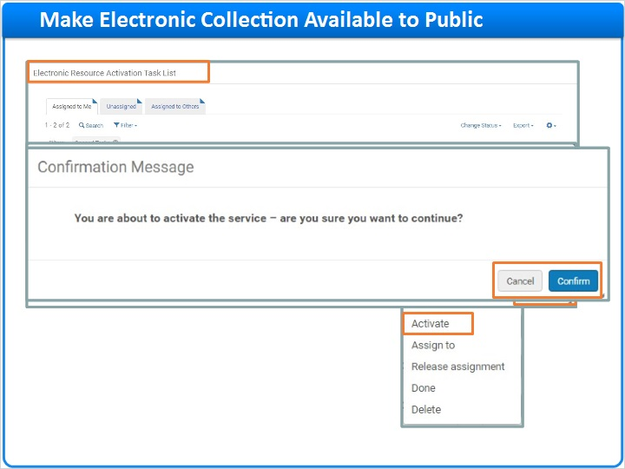
Notes:
After access is tested successfully, the electronic resource may be ready to display to the public. Return to the Activation Task list and update the status for the electronic collection, if applicable.
From the row actions list , select the Activate option once more to make the service available to the public. A confirmation message will display. Click the Confirm button to continue.
Once activated, a second message will display, asking if you want to edit the Electronic Collection record. Select “Confirm” to edit the record, or “Cancel” to not edit the record.
This completes the testing and activation process.

1.16 Complete Activation
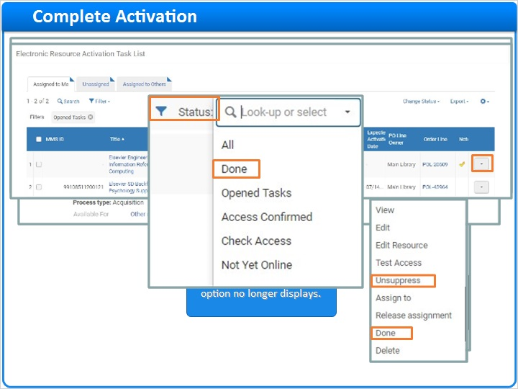
Notes:
Notice that when an electronic resource is fully activated and available to the public, the Activate option is removed from the row actions list. When a Repository search is conducted for the electronic collection, notice that the icons are now in color, meaning it is linked to the Community Zone record and now active and available to patrons.

The next step is to remove the electronic resource from the activation task list. Before removing it, however, you may want to confirm that any bibliographic records associated with the electronic collection are not suppressed. The Suppress/Unsuppress link appears in the row actions list if the electronic collection has an unsuppressed or suppressed bibliographic record linked to it and a URL. Clicking it will change the value to its opposite, suppressing or un-suppressing the bibliographic record from being published to Primo.

To remove the electronic resource from the task list, select Done from the row actions list. To see the history of all activations that have been completed in the past, use the Status filter and select Done.

1.17 Activate Standalone Portfolios
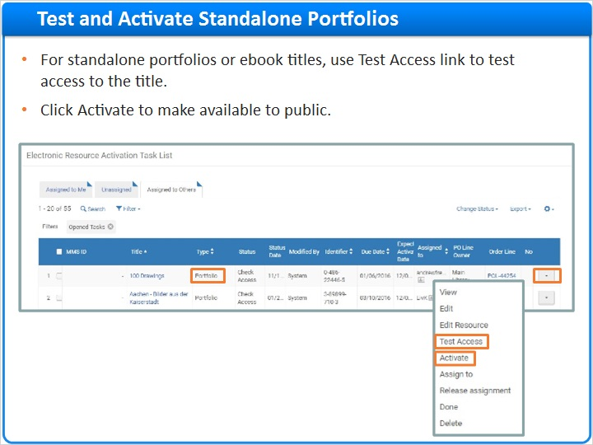
Notes:
For standalone portfolios or ebook titles, the activation process is very similar to the process used to activate electronic collections, but slightly simplified.

The Test Access link will appear immediately in row actions list for items in the Activation Task List. Click Test Access to test access to the individual portfolio. Then click Activated from the row actions list to make it available to the public.

1.18 Activate Local Electronic Collections and Portfolios
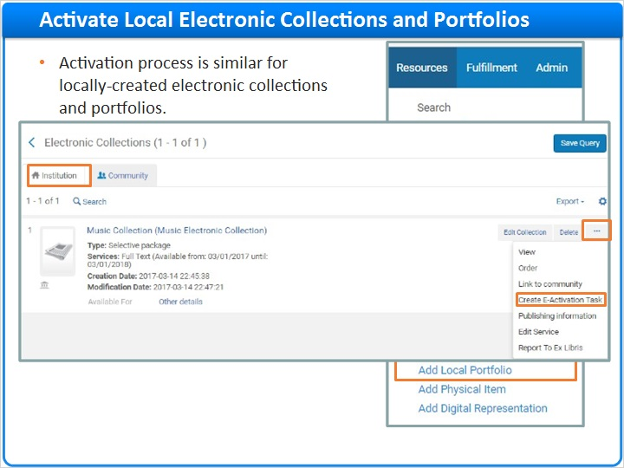
Notes:
Locally-created electronic collections and portfolios can also display in the Activation task list if they are created and go through the ordering process in the Institution Zone.

If an electronic resource does not go through the ordering process, it can still be added to the activation task list by clicking “Create E-Activation Task” in the row actions list.

1.19 Activate Local Electronic Collections and Portfolios
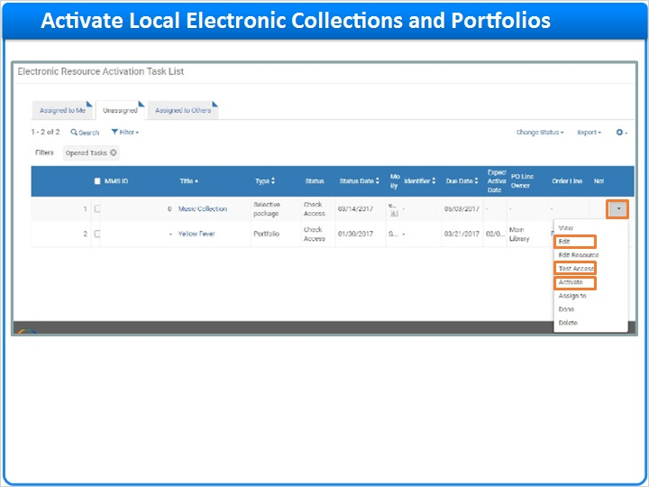
Notes:
To activate locally-created electronic collections or portfolios in the Activation task list, select Test Access from the row actions list to test access to the resource, and then select
activate from the row actions list to make it available to the public. Finally, Click Edit to make any edits to the locally-created electronic collection or portfolio.

1.20 Activate Free Electronic Collections or Portfolios
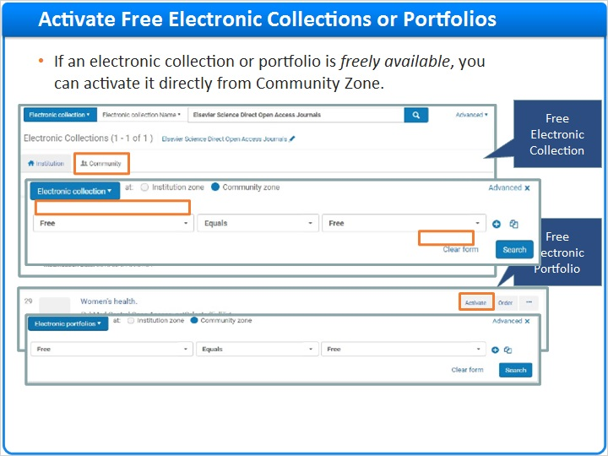
Notes:
If an electronic collection or portfolio is a free resource - where no ordering or other tasks are needed, it can be activated directly from a Repository search in the Community Zone tab. Clicking the Activate link from the row actions list will open the activation wizard and you can activate the free resource, test access, and make it available to users. Note that because you are not ordering it, the free electronic resource will not appear in the Activation Task List automatically.

To find a list of free electronic resources that are available in the Community Zone, conduct an advanced Repository search with Electronic Collection in the Find box and select the condition for “Free”.

1.21 Activate Electronic Portfolios using Import Profile
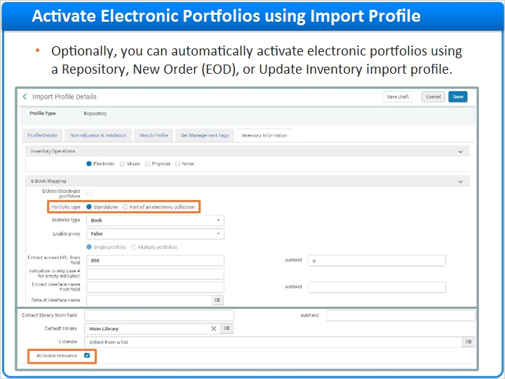
Notes:
One last option to mention is electronic portfolios can be activated automatically during the import process. When configuring the import profile, you have the option to activate portfolios that are being imported. These can be either standalone portfolios, or portfolios that are part of an electronic collection. This is covered in more detail in the Resource Management Batch Imports session.

1.22 Session Review
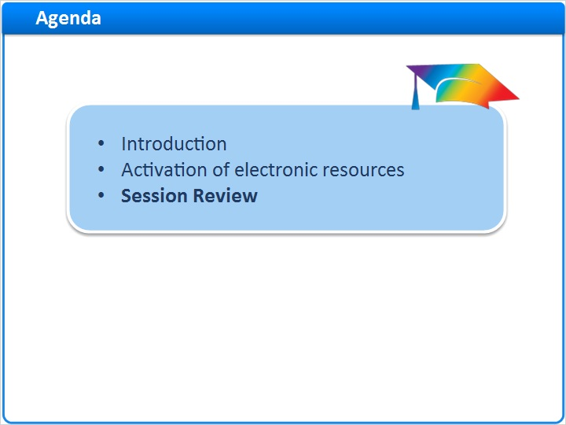
Notes:
This brings us to the end of this session.

1.23 Summary
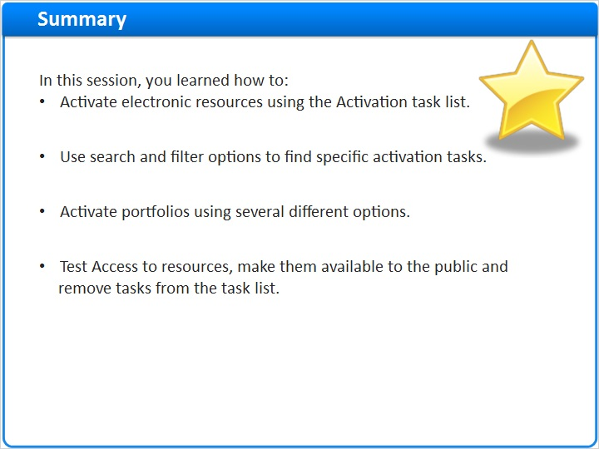
Notes:
In this session we covered how to:
- Activate electronic resources using the Activation task list.
- Use search and filter options to find specific activation tasks.
- Activate portfolios using several different options.
- Test Access to resources, make them available to the public and remove tasks from the task list.

1.24 Thank You!

Notes:
Thanks for joining us. For more information visit the Ex Libris Knowledge Center.

1.25 About this Training
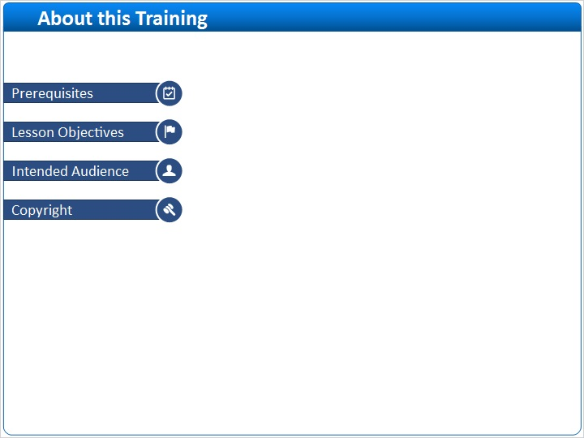
Notes:

1 (Slide Layer)
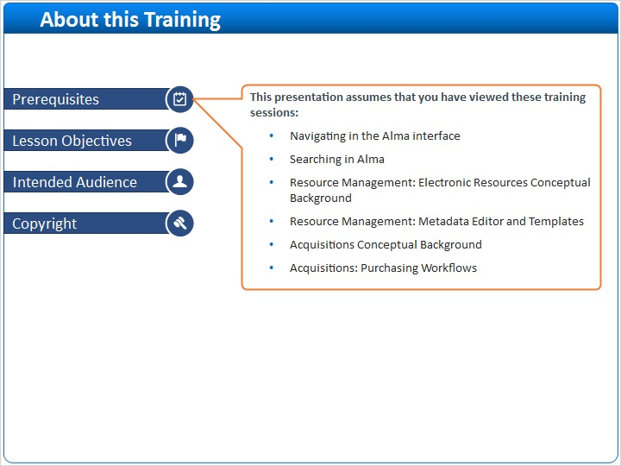

2 (Slide Layer)
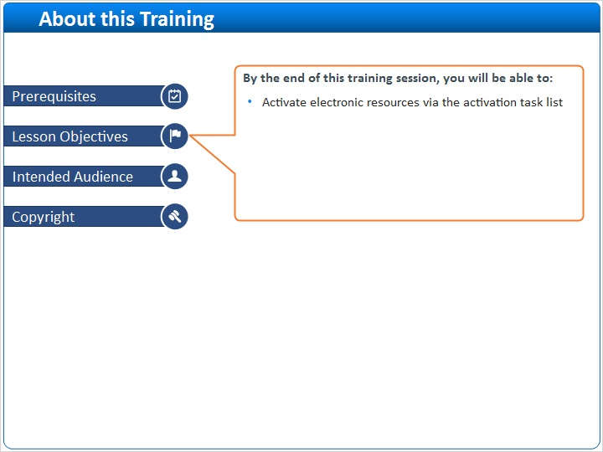

3 (Slide Layer)
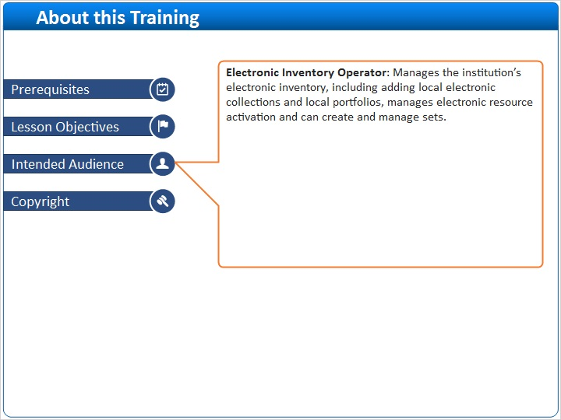

4 (Slide Layer)


