Course Reserves (New UI)

1. Alma

1.1 Welcome
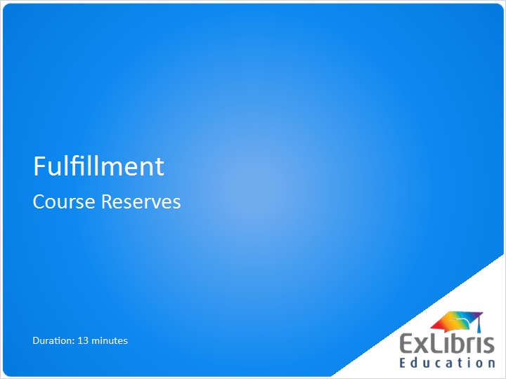
Notes:
Welcome to this presentation on Course Reserves in Alma.

1.2 Introduction
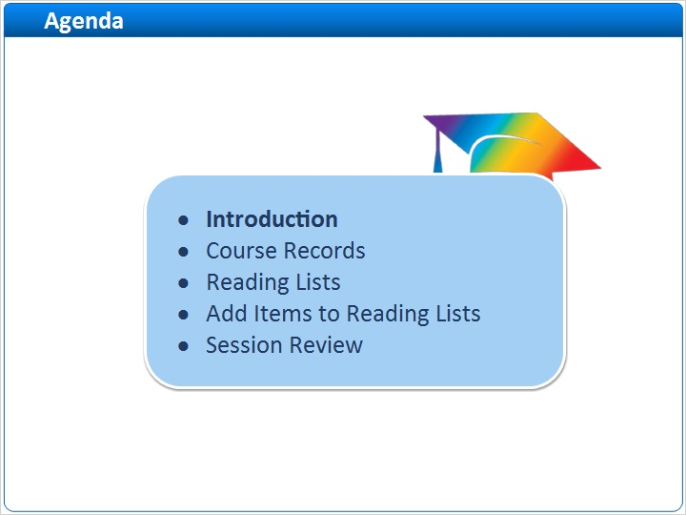
Notes:
In this session we will cover:
- an introduction to the Course Reserves workflow
- how to create Course records
- how to create Reading Lists
- and how to Add Items to Reading Lists

Note, that this session does not cover Ex Libris Leganto. If your institution uses Leganto to manage reading lists, we recommend watching the Leganto for Library staff training sessions.

1.3 Course Reserves Model
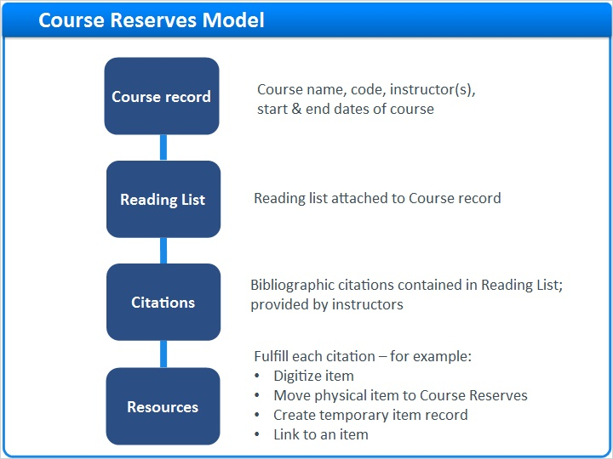
Notes:
We will first look at the structure of course reserves in Alma.
- We start with a course record which has basic details about the course such as the course name, course code, instructors, and start and end dates of the course. The course record is the highest level in the hierarchy and every course is associated with an Academic department as we will see in the course record shortly. Note that you can also update course records and reuse them from term-to-term.
- A reading list is attached to the course record. Note that a course can have more than one reading list.
- A reading list contains bibliographic citations. Citations are provided by, for example, instructors - and are literally just citations. For example, an article or book title, author, publisher, and page numbers.
- Citations become resources when they are fulfilled. For example, should we use a digitized file to fulfill the citation? Or should we move a physical item to course reserves? A digital file is an example of a Resource, and a physical item moved to Course Reserves is also a Resource. Other possibilities include creating a temporary item or having users link to an item in the inventory as in the case of an electronic resource.

1.4 Course Reserves Workflow
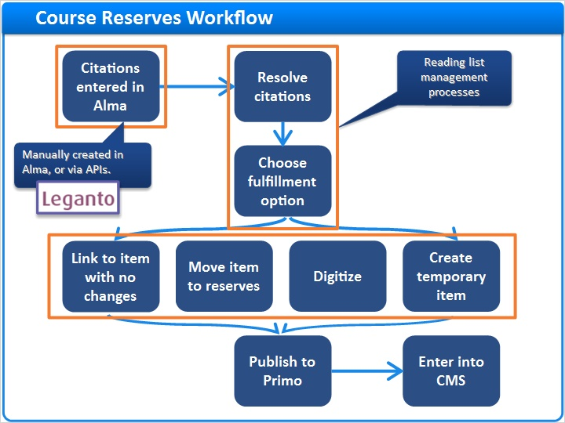
Notes:
Let’s now put this into context with the entire course reserves workflow.
The workflow begins with bibliographic citations being entered into Alma. Citations can be entered manually in Alma via the user interface, or loaded via APIs.
The APIs allow your institution to develop an online request form, where instructors can enter their course reserve citations. The online request form can call the APIs to load the citations directly into Alma.
Citations can also be added via Leganto, if you have it.

The next step is to resolve the citations - that is, to search the Alma inventory for an item that matches the cited resource. If inventory is discovered, staff decide how best to fulfill the citation. Resolving citations and deciding how to fulfill them is at the heart of reading list management.

1.5 Course Reserves Workflow: Fulfillment options
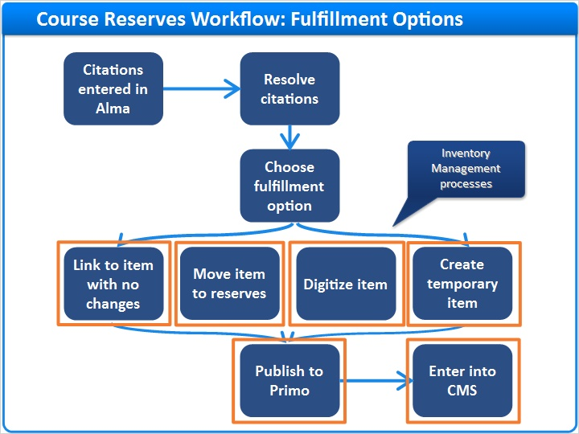
Notes:
Options for how to fulfill citations include:

1. Linking an item to the reading list.
This means students will discover the item when searching for their course in Primo, and then will see that the item is at the permanent shelving location, or perhaps available electronically. No real ‘managing’ of the item is needed because students will only be navigating to it from the reading list.

2. Moving physical items to the Course Reserves location.
This can be handled by any staff member with the Requests operator role.
Moved items will inherit the fulfillment policies assigned to that location.

3. Digitizing an item using the standard digitization workflow, which again can be handled by any staff member with the appropriate role.
The staff member can then decide to post the digitized file for student discovery in Primo, or email the digitized file to the instructor to load into a course management system.

4. Creating a brief item record. Here a brief record might be created for a faculty-copy or for an online item outside the current catalog.
You can create a brief record from within the Reading List.

At the course start date, Alma will publish the reading list information to Primo, so when students search for the course, all items on that course’s reading list will be retrieved.
The staff member may then pass the list back to the instructor to enter into a course management system.

1.6 Course Records
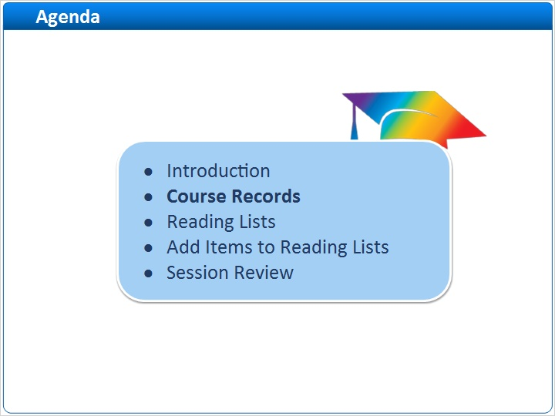
Notes:
Now let’s cover course records and how to create them.

1.7 Course Records Introduction
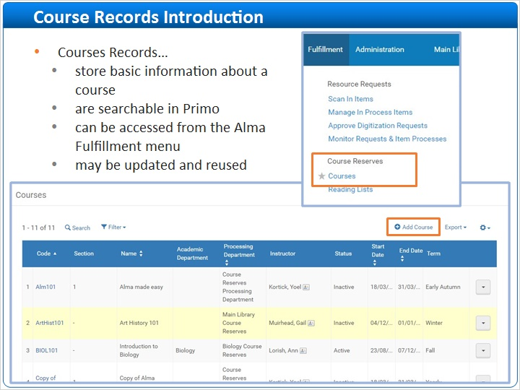
Notes:
Staff users with the Fulfillment Services Manager or Operator role, or a Course Reserves Manager or Operator role, can access course records from the Fulfillment menu, in the Course Reserves area. From there you can view and edit course records that have already been created, or create new ones.

1.8 Create Course Record (Fulfillment > Courses > Add/Edit Course)
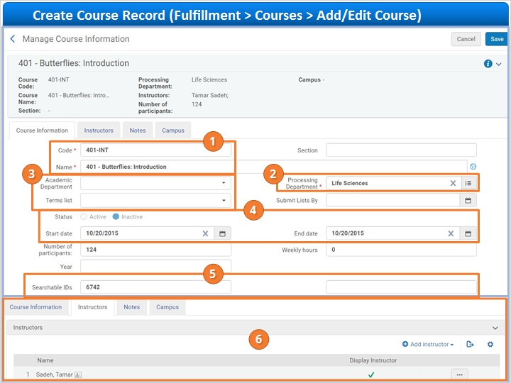
Notes:
This is an example of a course record. Click on each of the numbers for more information about each field. Notice the Course Code, Course Name, and the Processing Department are required fields.

When done, click the Next button to continue.

1.9 Reading Lists
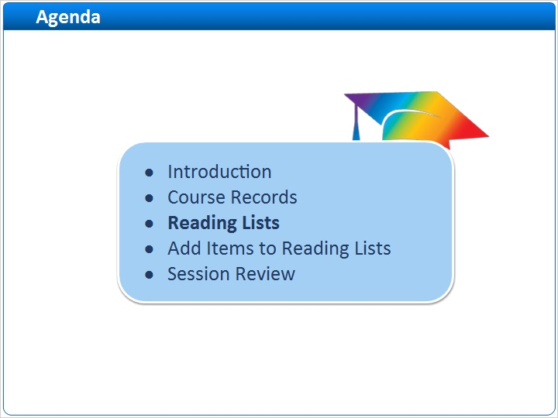
Notes:
Course records are made up of Reading lists, which we’ll talk about next.

1.10 Reading Lists Introduction
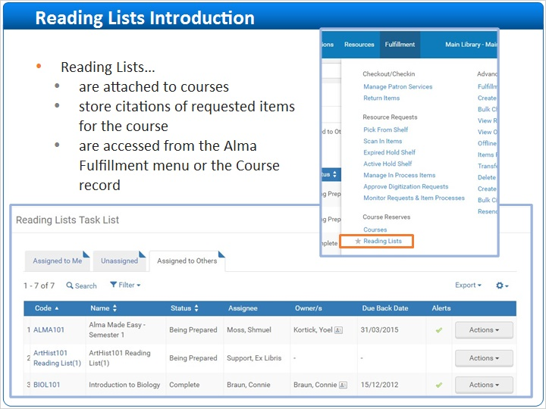
Notes:
All existing Reading lists can be viewed and edited from the Alma Fulfillment menu > Reading Lists.

1.11 Viewing and Adding a Reading List for a Course
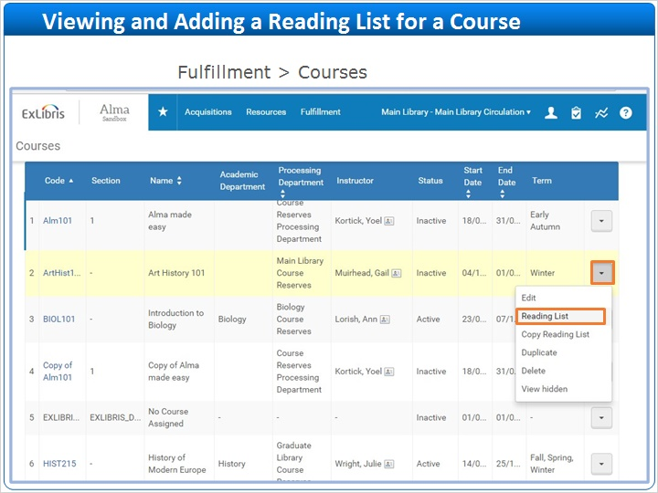
Notes:
You can view the reading lists of a specific course, or create new Reading Lists, from the Courses page.

Click the Row Action List for the desired course > Reading List.

1.12 Create Reading List
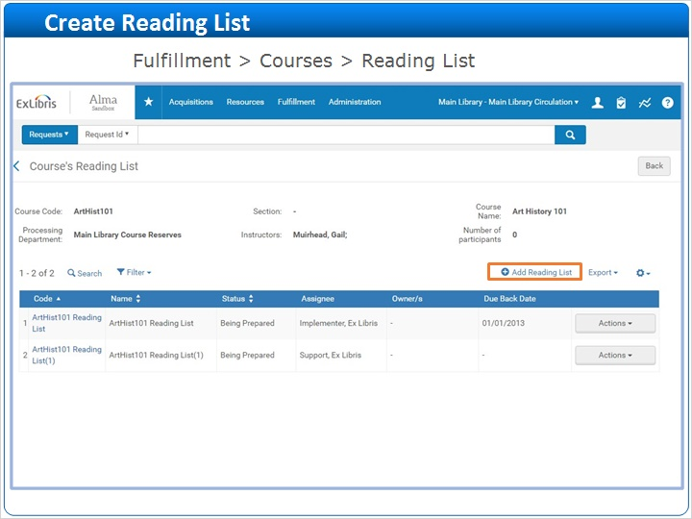
Notes:
Here in this course’s reading list page, you can see existing lists. To create a new list, click Add Reading List.

1.13 Create Reading List
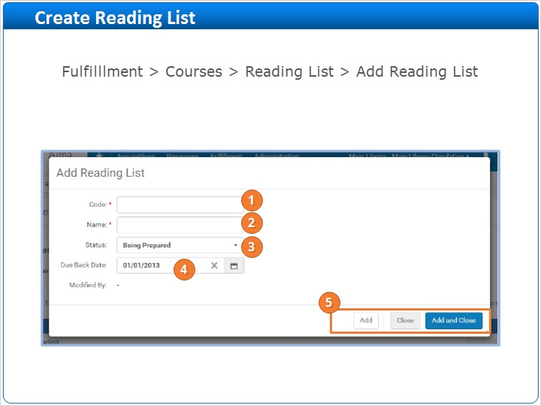
Notes:
This is an example of the pop-up window that displays when initially creating a reading list. For more information about each field you can click on its number. Note that more than one reading list may be created for the course from here. Click Next to continue

1.14 Create Reading List
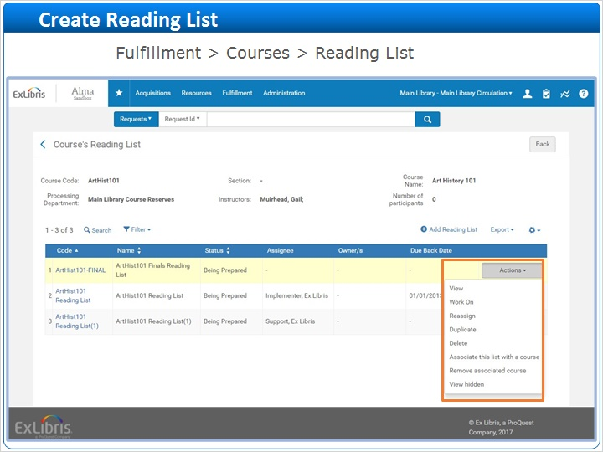
Notes:
Once the reading list is created, click the Row Actions list and select the Work On option to begin adding items to the reading list. Notice that once you start working on the reading list, it will automatically be assigned to you. If you have a Course Reserves Manager or a Fulfillment Services Manager role, you can reassign the reading list to a different staff member.

1.15 Add Items to Reading Lists
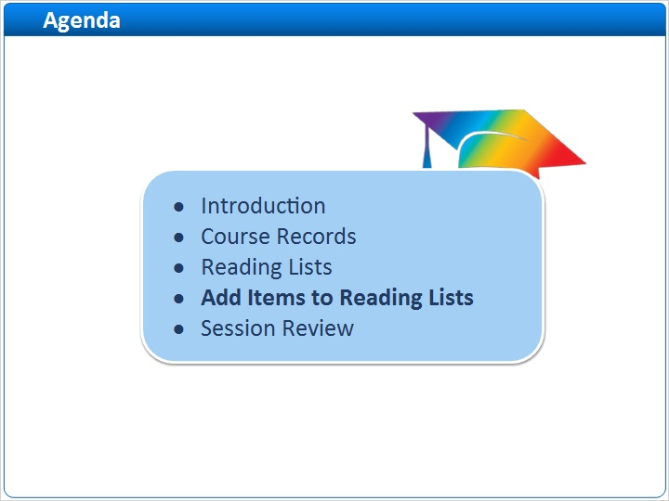
Notes:
Now that we have our Reading list created, let’s talk about how to add citations to it and fulfill those citations. We will discuss 3 ways to add items to a Reading list.

1.16 Add from Repository Search
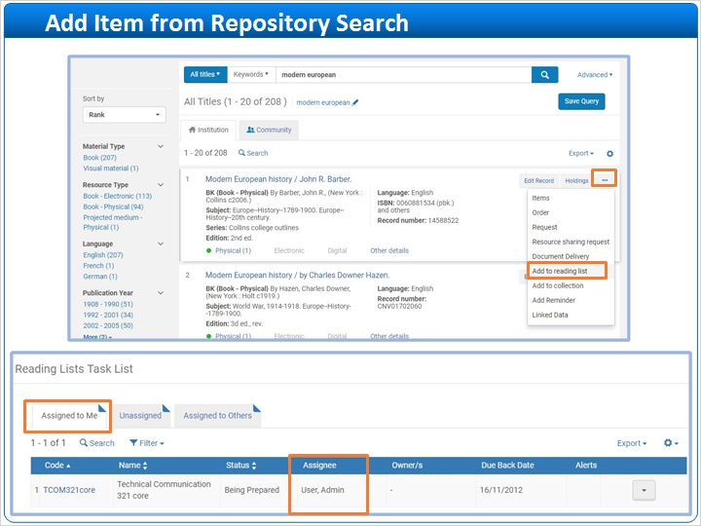
Notes:
The first quick way to add citations to a reading list is to search for a title via Repository Search. Once the title is found, click Options > Add to Reading List. Then select the reading list to which the title should be added.

Note that you must have at least one reading list assigned to you for this option, and you cannot add to lists not assigned to you. Also keep in mind that the item location may need to change and the item moved to the Course Reserves location if applicable.

1.17 Add From Scan In Items
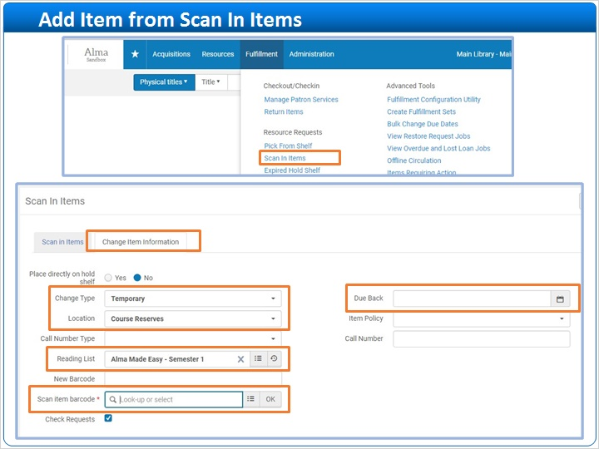
Notes:
A second way to rapidly add items to a reading list, as well as move the items to Course Reserves, is to use the Scan-In Items option in the Fulfillment menu.

In the Scan-In Items interface, click the Change Item Information tab. Here you can indicate that the item is temporarily moved to the Course Reserves location and associated with a particular course reading list. Note that you can also indicate a Due date for when the item is due back in its permanent location - for example, at the end of the semester.

Once this information is set, you can continually scan in items that will be associated with the particular course reading list and temporarily located to Course Reserves.

1.18 Add from Reading List
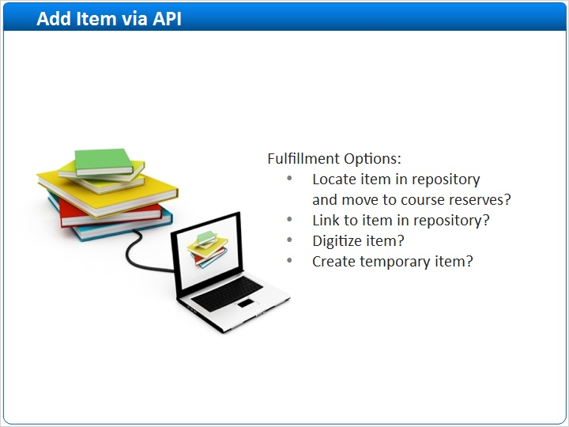
Notes:
The third way to add items to a reading list is by loading citations via a web form and the Alma APIs, this is normally done by the course instructor. With this option, once the citation is added to the Reading List, you then decide how to fulfill the citation.

1.19 Add from Reading List
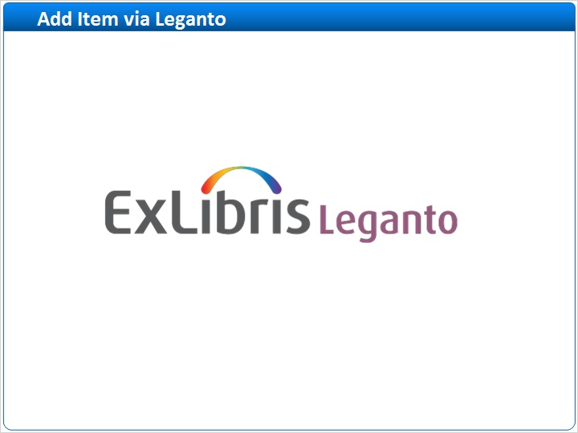
Notes:
If your institution uses Leganto, there are several additional ways to add citations, which you can learn about in the Leganto for Instructors training sessions.

1.20 Add Item From Reading List
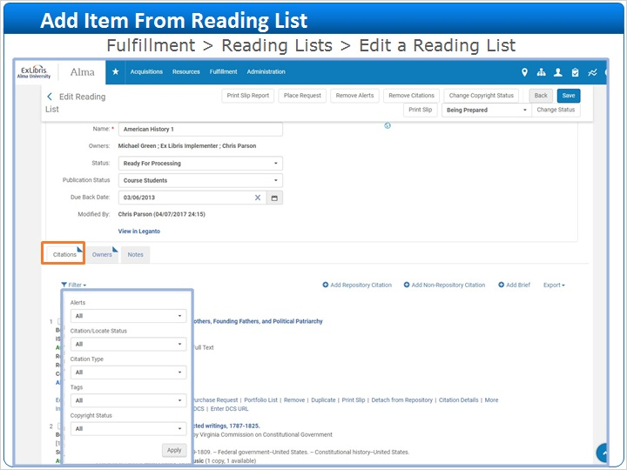
Notes:
Regardless of the method used for adding the citations, once they have been added to the reading list by course instructors or by library staff, they will automatically display in the citations tab of the Reading list.

You can filter the list of citations by different criteria such as Alerts or Citation Type.

1.21 Add Repository Citation
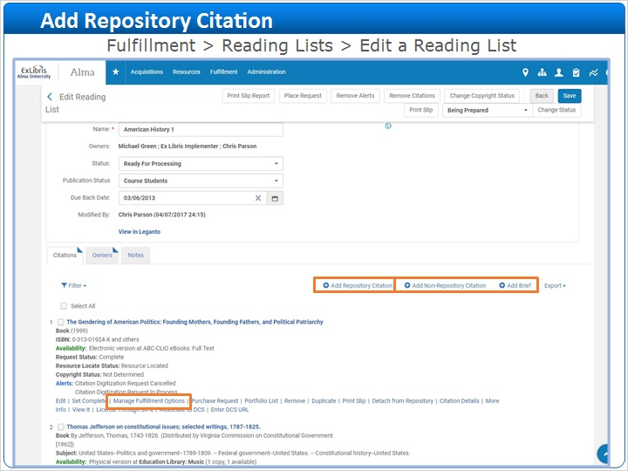
Notes:
There are several ways to manually add items to the reading list.

Clicking on Add Repository Citation means we will conduct a Repository search and select an item from our inventory to add to the reading list. At this point, when the item is added, the title will be linked to the reading list, meaning it will display in the reading list indicating its current location. If it is an electronic resource, it will display a link to the electronic resource in the reading list.

If the item needs to be moved to the Course Reserves location or digitized, click the Manage Fulfillment Options link to create a request.

1.22 Manage Fulfillment Options
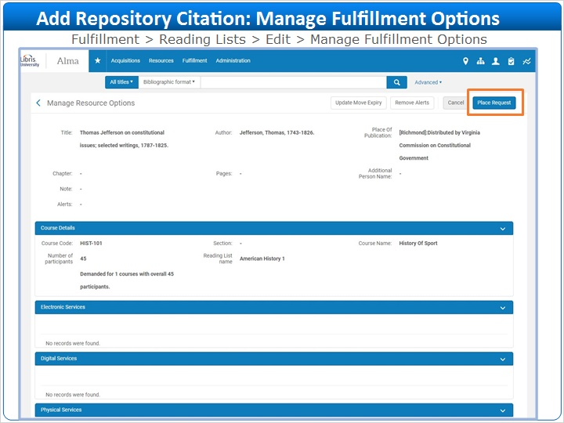
Notes:
In the Manage Resource Options screen, click Place Request.

1.23 Manage Fulfillment Options
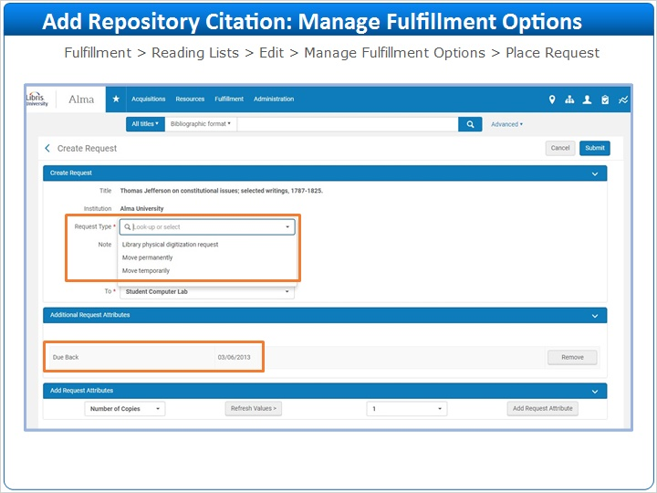
Notes:
This will display a standard request form where you can indicate if the item needs to be temporarily or permanently moved to the Course Reserves location, or if the item should be digitized. Move requests and Digitization requests are covered in separate sessions.

Note that the Due Back date on the request form will default to the course end date. This can be changed or removed from the request as needed.

1.24 Fulfillment Alerts
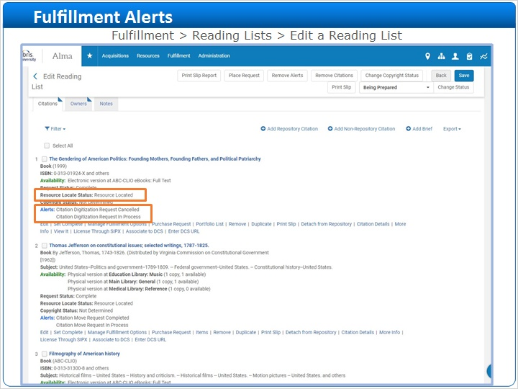
Notes:
On the Reading list, there are Alerts which will be updated as the move request or digitization request is processed for the item. Also notice that the Resource Locate status will state “Resource Located” if the resource has been located in the repository.

1.25 Add Brief Citation
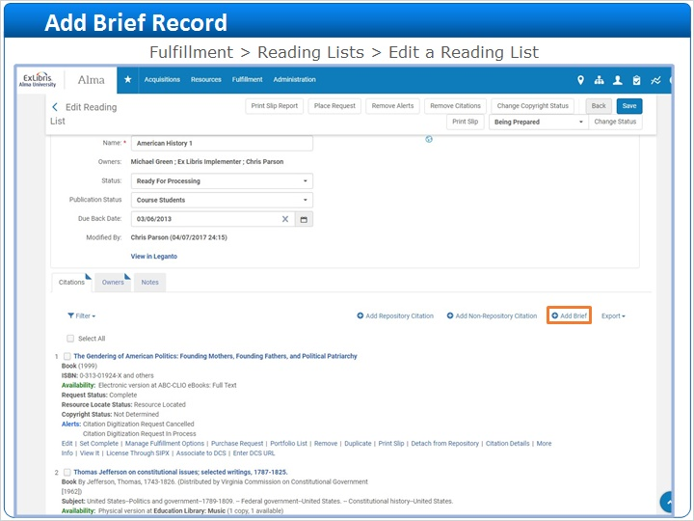
Notes:
The next option is Add Brief. This is where you can create and add a brief record for an Instructor’s personal copy, for example.

1.26 Create Brief record
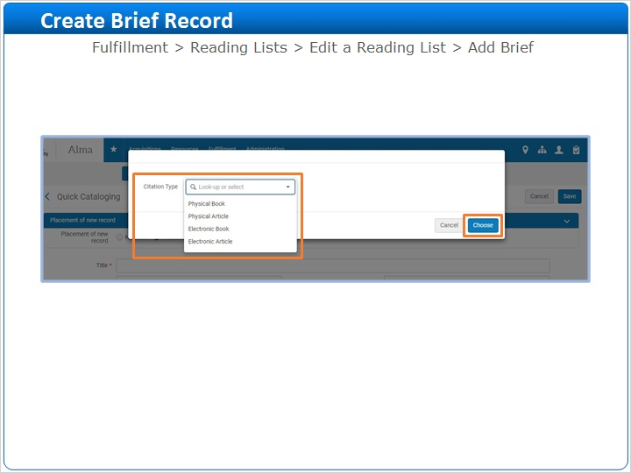
Notes:
Select the type of citation record you wish to add. Note that the citation types can be used for different formats. For example, the physical book citation type might be used for a sound recording. Click Choose.

1.27 Create Brief record
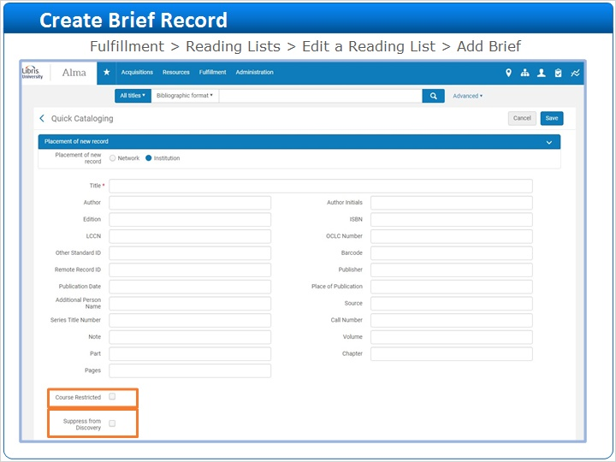
Notes:
In the In the form that displays, enter the information to create the brief record.

Select the Course Restricted checkbox if you want the item to be searchable in Primo only within a Courses search scope. Select the Suppress from Discovery checkbox if you do not want the brief record to appear in Primo. You will also be able to enter the library and location for the item and provide a barcode, if desired.

Save the record and it will then appear on the reading list.

1.28 Add Non-Repository Citation
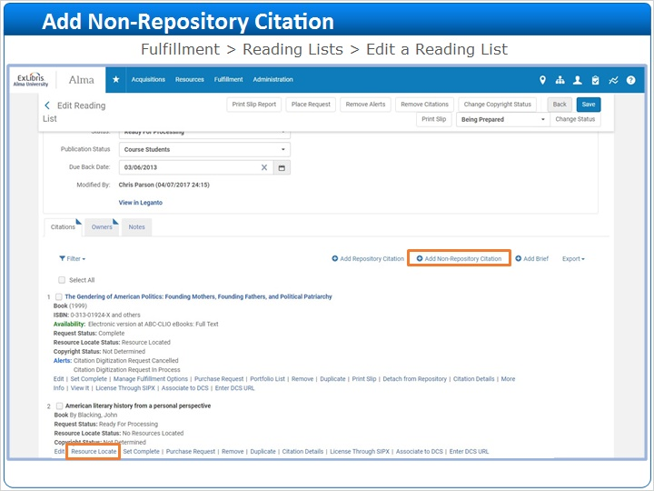
Notes:
Lastly, you can create a Non-Repository citation as a placeholder for an item in the event you are unsure if the title is in your inventory, or if it will need to be ordered or borrowed via Resource Sharing.

Note that Non-Repository Citations are automatically created if instructors enter citations into a Web form and Alma’s APIs automatically load the citations into the Reading List.

When the Add Non-Repository Citation button is clicked, a form similar to the brief record form will display. Enter citation details and save the record. To see if the item exists in the Repository, click the Resource Locate link. It will search the Repository for the item based on the information that was entered for the citation.

1.29 Set Complete
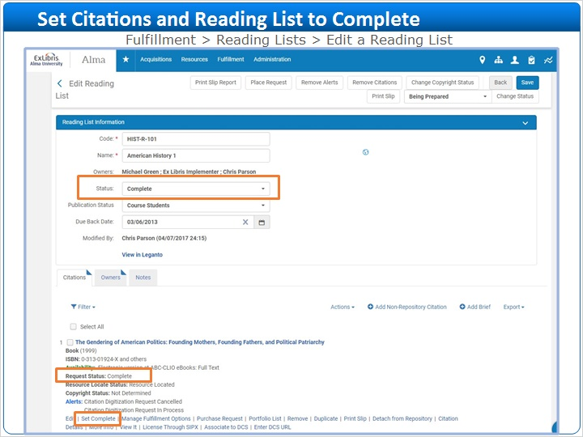
Notes:
When each citation is fulfilled, click the Set Complete link. It will change the Request status to Complete.

When the entire reading list is completed, set the status for the Reading List to complete.

1.30 Reading Lists in Alma
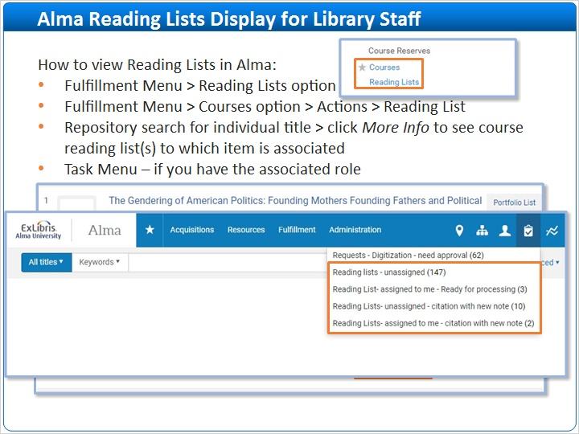
Notes:
Besides viewing courses and reading lists using the Fulfillment menu, another option is to conduct a Repository search for a specific title to see if the title is associated with any course reading lists.

Once the title is displayed, click the Other Details link. Looking at the Courses field, this example title is associated with 1 reading list. Click on the hyperlinked number to see the reading lists associated with the title.

Lastly, if you have the Course Reserves Operator/Manager role attached to a course department, or Fulfillment Services Operator/Manager role attached to a course department , then you will see reading lists that require attention in your task menu / list.

1.31 Reading Lists in Primo
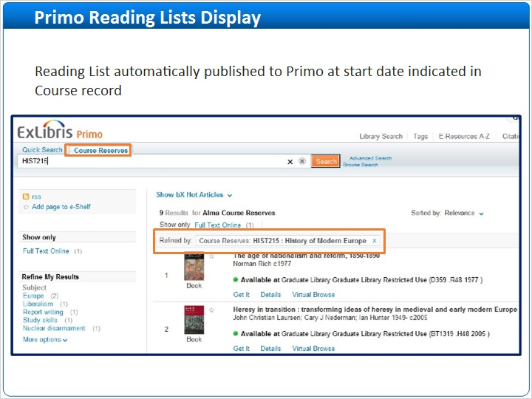
Notes:
End users (or students) will see items in the Reading List published to Primo at the start date indicated in the course record.

1.32 Session Review
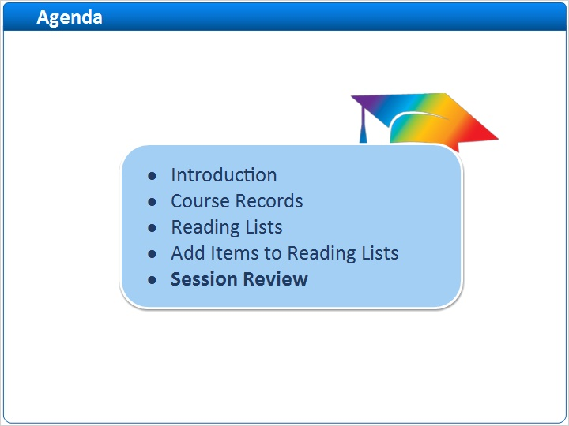
Notes:
Let’s now review the course reserves workflow steps.

1.33 Workflow Review
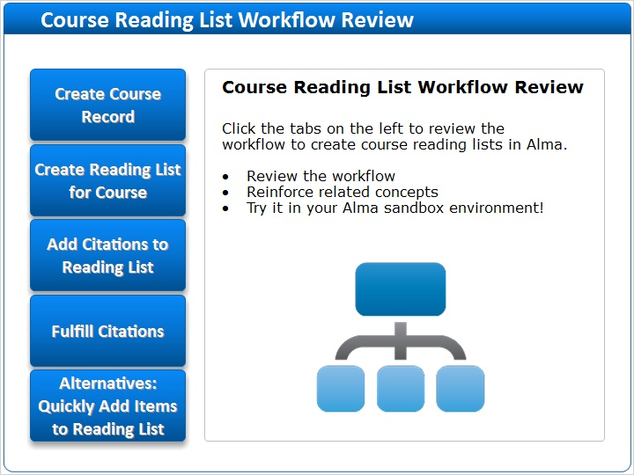
Notes:
Click on each of the tabs on the left to review the workflow to create a course reading list in Alma. The steps can also be practiced in your Alma sandbox environment. Once completed, click the Next button to continue.

Tab1 (Slide Layer)
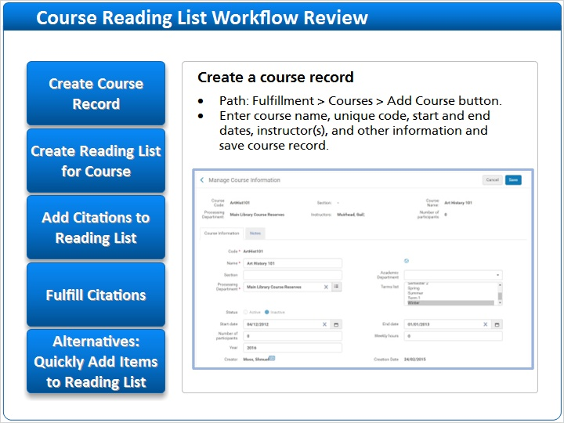

Tab2 (Slide Layer)
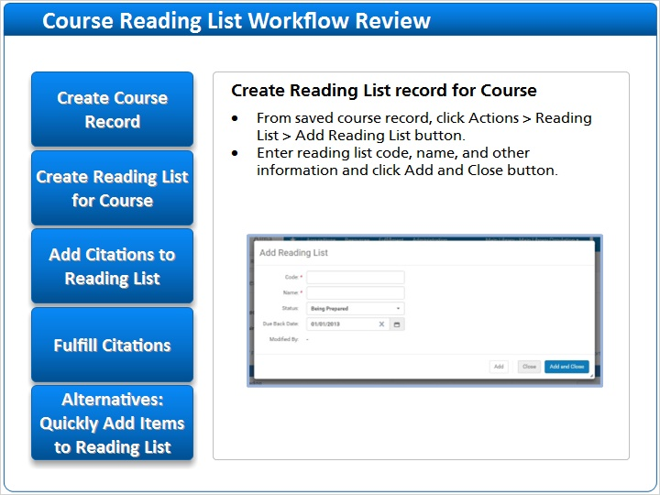

Tab3 (Slide Layer)
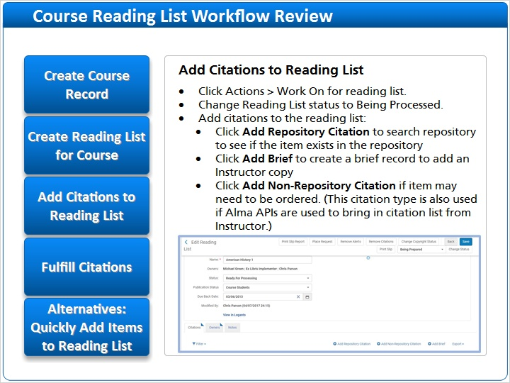

Tab4 (Slide Layer)
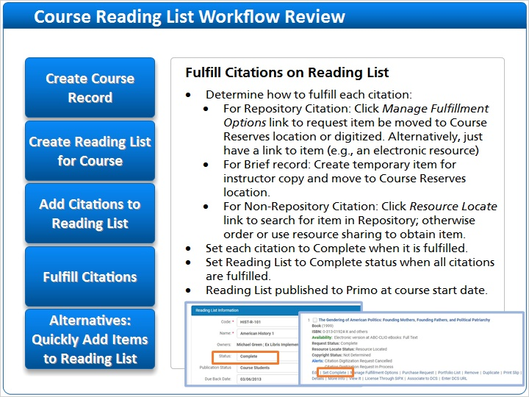

Tab5 (Slide Layer)
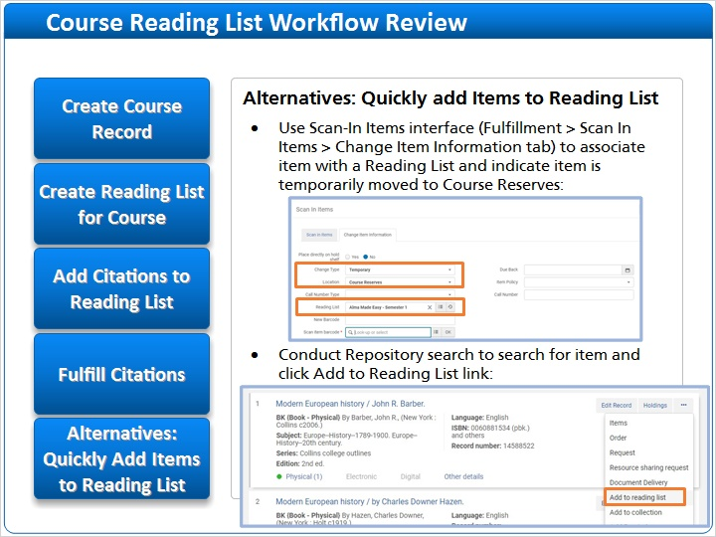

1.34 Thank you!

Notes:
Thank you for taking this lesson. More information about Course Reserves can be found in the Ex Libris Knowledge Center.
If your institution uses Leganto, we recommend viewing Leganto Training, also in the Knowledge Center..

1.35 About this Training
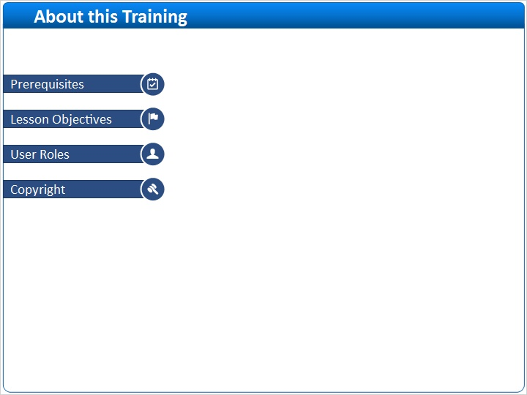
Notes:

1 (Slide Layer)
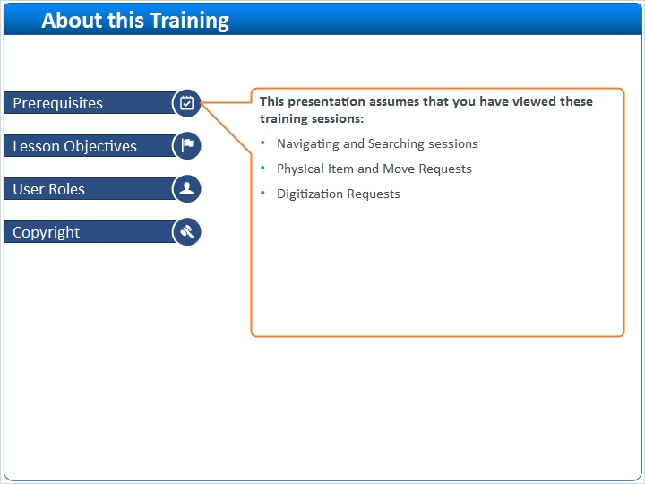

2 (Slide Layer)
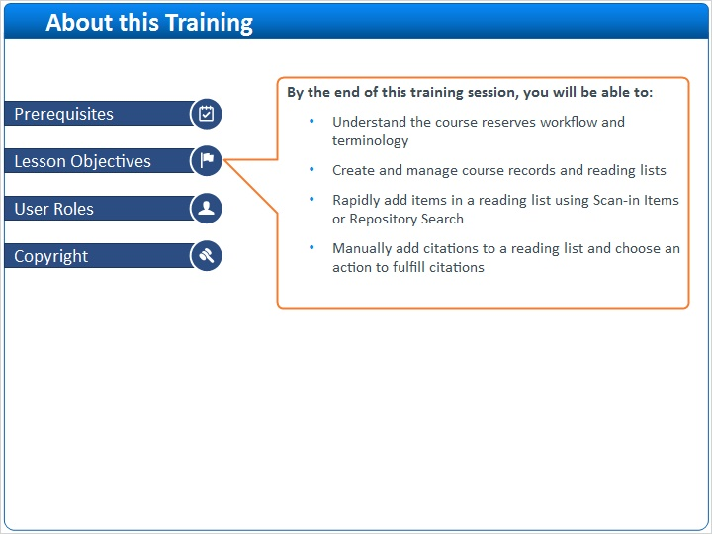

3 (Slide Layer)
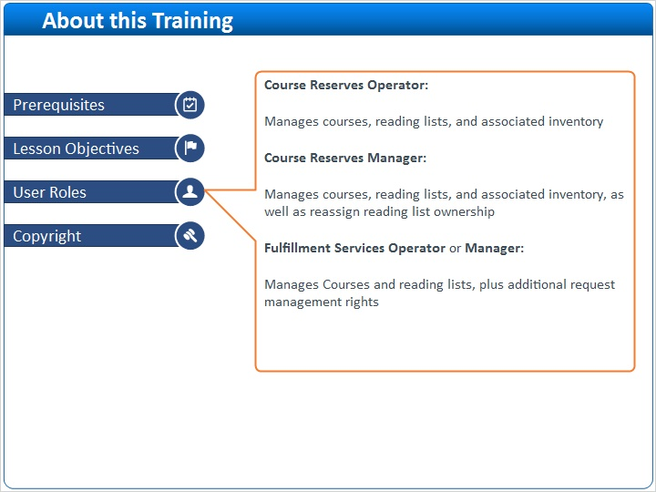

4 (Slide Layer)


