Acquisitions Workflows: Creating a Ledger Handout

1. Creating a Ledger

1.1 Creating a Ledger

Notes:
Welcome to this tutorial, Creating a Ledger.

1.2 Objective

Notes:
In this session, you will learn how to create a ledger.

1.3 Acquisitions Workflows Tutorials
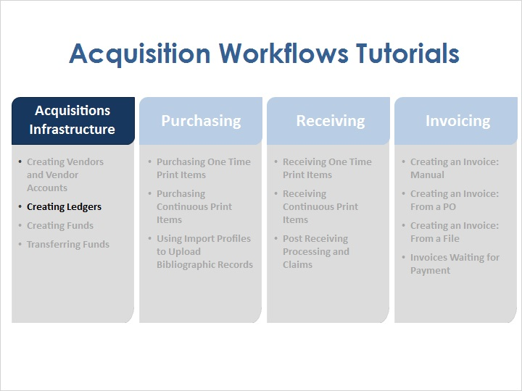
Notes:
Creating ledgers is one of the first steps in the overall acquisitions process. As part of the Acquisitions Infrastructure, at least one ledger will need to be configured before purchasing, receiving, and invoicing can take place.

1.4 Ledgers
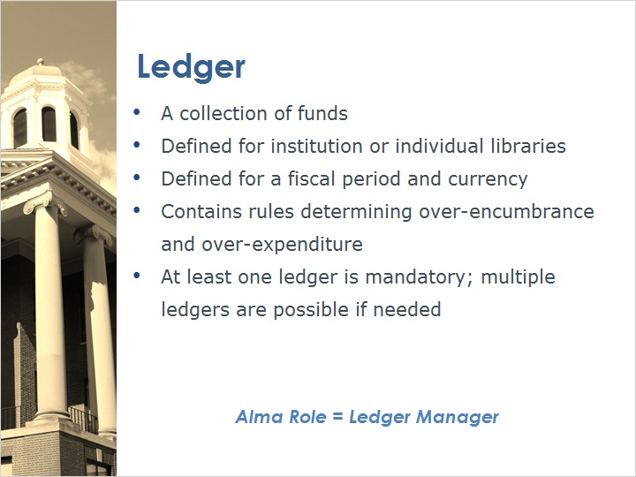
Notes:
A ledger in Alma represents a collection of funds, while funds represent actual money in an account.

A ledger can be available for the entire institution or only for some libraries; and it is defined for a fiscal period and a currency.

The ledger contains rules that define how over-encumbrance and over-expenditures are handled.
Having at least one ledger is mandatory, though you might have more than one ledger in your institution depending on your needs.
To create and configure ledgers, you will need to have an Alma user with the Ledger Manager role.

1.5 Accessing Ledgers
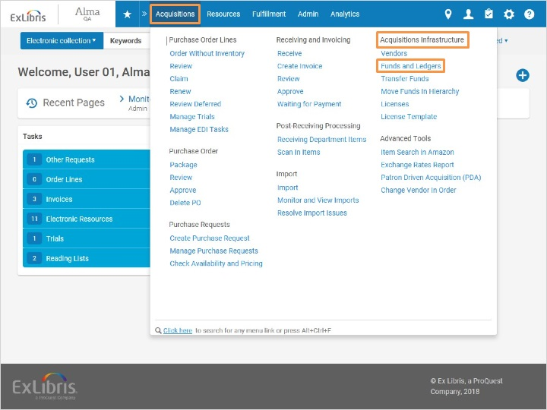
Notes:
To configure a ledger, log into Alma and go to Acquisitions > Acquisitions Infrastructure > Funds and Ledgers.

1.6 Create Ledger
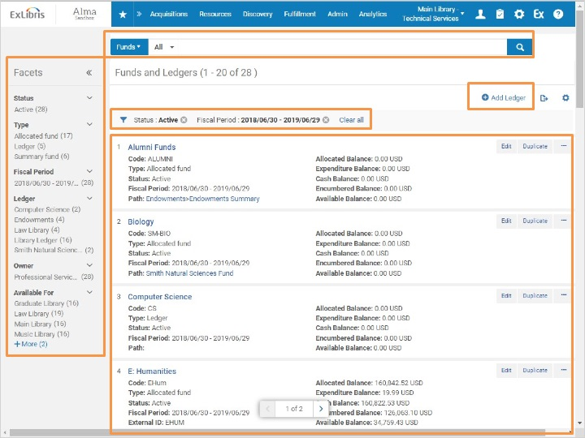
Notes:
This brings us to the Funds and Ledgers screen, with a list of the existing ledgers and funds. Note that you can search the list using the search bar at the top of the page, and filter by status (All, Active, Inactive). Also note that by default, the current fiscal period is selected. The main portion of the screen contains a list of both funds and ledgers that meet the filtered criteria. On the left, the facets allow for additional filtering of the results.
To add a new ledger, click Add Ledger at the top of the screen.

1.7 Ledger Details
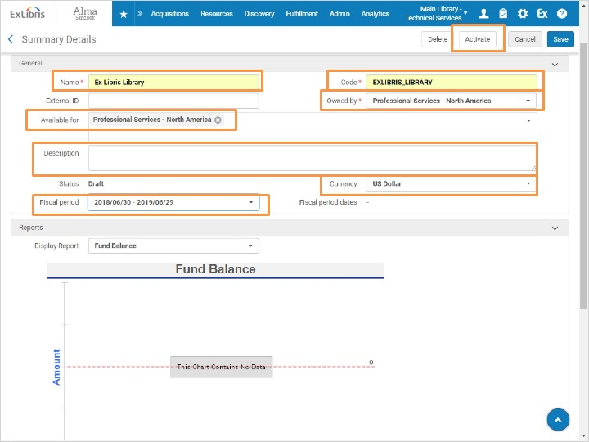
Notes:
This opens the Summary Details for the Ledger. Enter a Name, Code, and Description for the ledger.
In the Owned by dropdown, it is possible to select either the institution itself, or an individual library within the institution. This is the institution or libraries that owns the ledger. Here we’ll keep the default Owned by entry; here on our training server, our institution is called Professional Services - North America.
The Available for box allows us to define who will be using the ledger. We will keep this set to the institution as well, but it is possible to select one or more libraries here as well.
Let’s keep the currency set to US Dollar, and we will want to select the current Fiscal Period. Note that by default, the fiscal period that appears here is the first fiscal period that was created in your Alma environment, so you will want to ensure you have the correct one selected before moving forward. The dates here come from a fiscal year mapping table which you can populate by hand. You can also add to this table by closing out a fiscal period and rolling ledgers and funds forward.
Click Activate. Activating the ledger also saves it, and it will bring us back to the Funds and Ledgers list.

Funds and Ledgers List (Slide Layer)
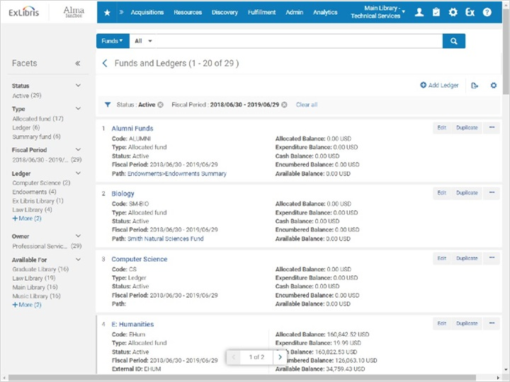

1.8 View Created Ledger
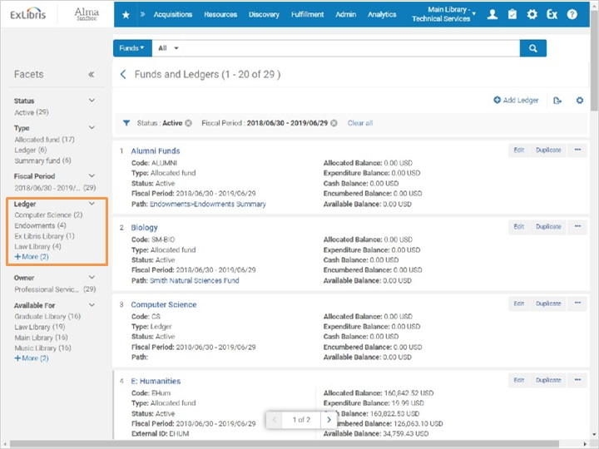
Notes:
To see the ledger we just created, use the ledger facet on the left to select the ledger. Now we can see the ledger with its summary details, and we can edit it further if needed.

Ex Libris Library Ledger (Slide Layer)
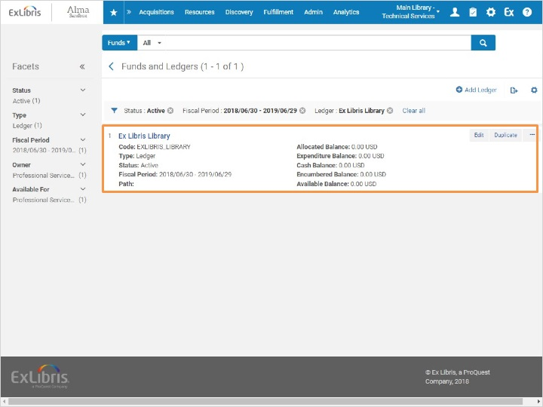

1.9 Review & Quiz

Notes:
Now that you’ve watched this session you should be able to create a ledger.

Please take the short quiz to test your knowledge.

1.10 Quiz: Ledgers
(Multiple Choice, 10 points, 1 attempt permitted)
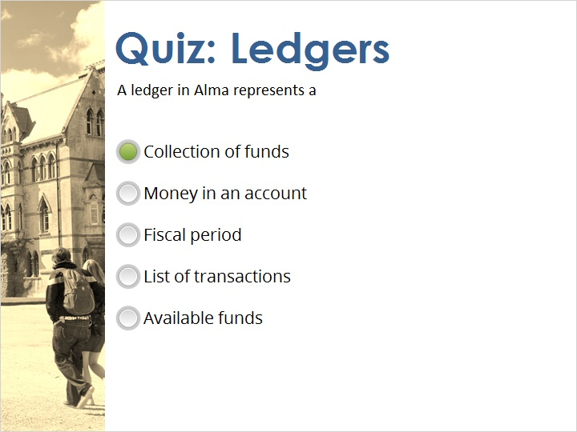
Correct | Choice
X | Collection of funds
 | Money in an account
 | Fiscal period
 | List of transactions
 | Available funds
Feedback when correct:
A ledger in Alma represents a collection of funds.
Feedback when incorrect:
A ledger in Alma represents a collection of funds.

Notes:

Correct (Slide Layer)
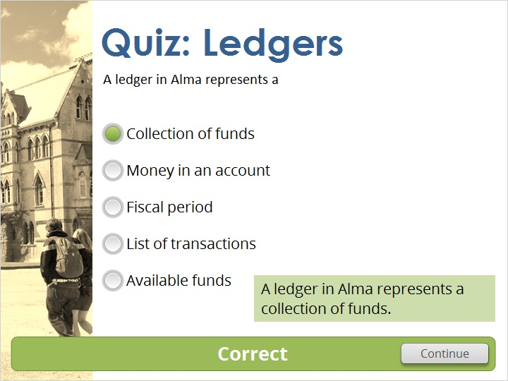

Incorrect (Slide Layer)
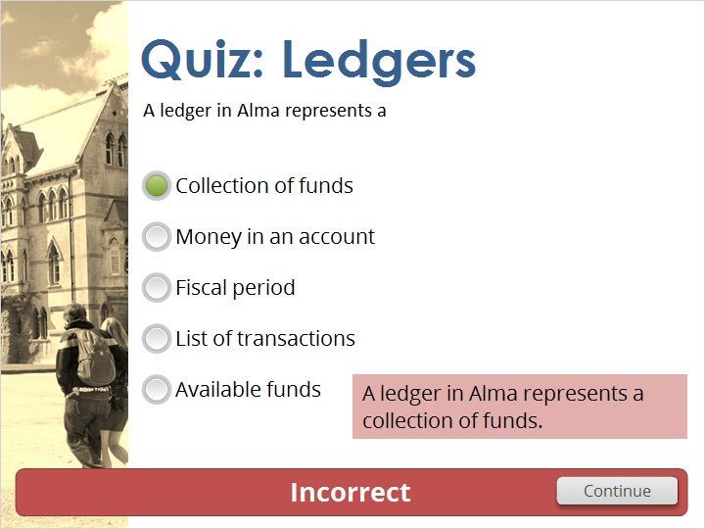

1.11 Thank You!

Notes:
Thank you for joining this session!

1.12 Copyrights

Notes:

2. Quiz Results

2.1 Results Slide
(Results Slide, 0 points, 1 attempt permitted)
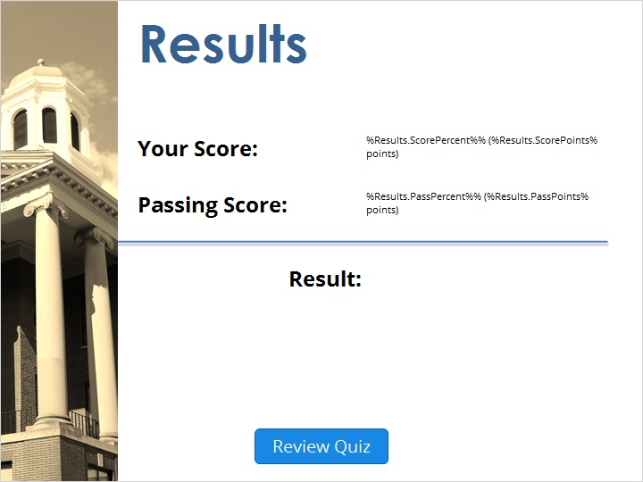

Notes:
fgsfdgsfdgfdg

Success (Slide Layer)
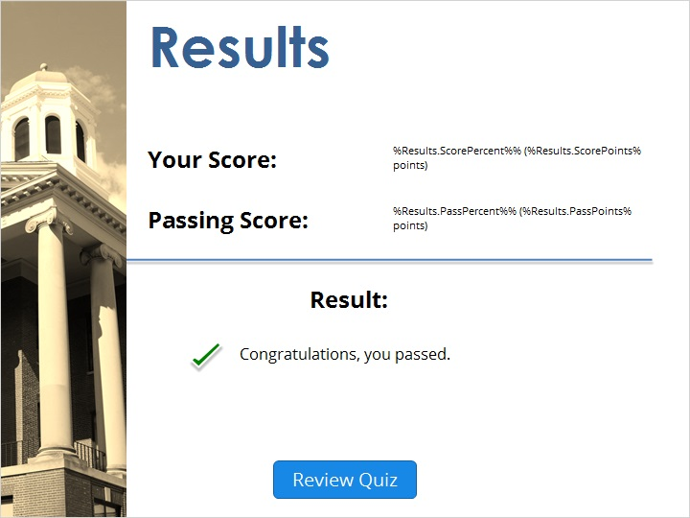

Failure (Slide Layer)


