Acquisitions Workflows: Post Receiving Processing and Claims Handout

1. Post Receiving Processing and Claims

1.1 Post Receiving Processing and Claims

Notes:
Welcome to this tutorial, Post Receiving Processing and Claims.

1.2 Acquisitions Workflows Tutorials
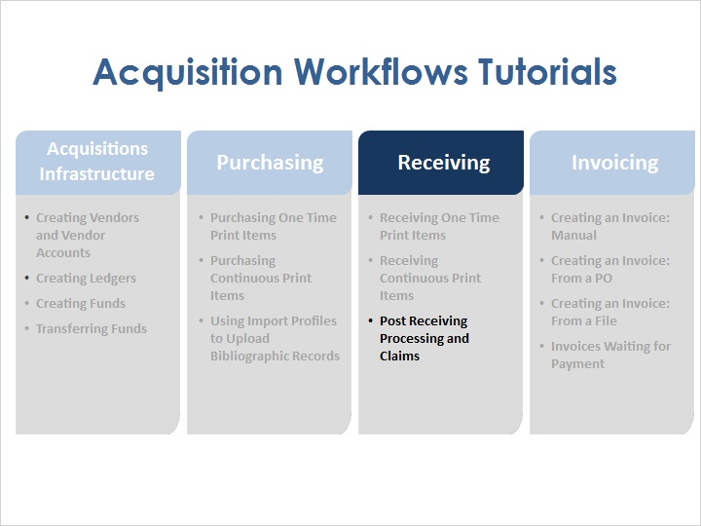
Notes:
If items that have been received need additional processing, the items can be accessed from the Post Receiving Processing area of Alma. And if items have not been received, they enter the Claims process.

1.3 Objectives

Notes:
In this session, you will learn about post receiving processing and claims.

1.4 Post Receiving Processing
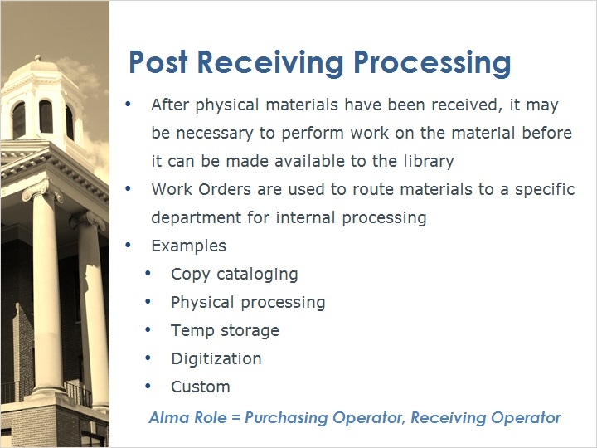
Notes:
After physical materials have been received, it may be necessary to perform work on the material before it can be made available to the library. In Alma, Work Orders are used to route materials to a specific department for internal processing.

These work orders might be requests for:
- Copy cataloging
- Physical processing
- Temp storage
- Digitization

It is also possible to create Custom work orders. For more information, please refer to the Alma documentation in the Knowledge Center.

In order to work with Post Receiving Processing items in Alma, one must have the Purchasing Operator or Receiving Operator role.

1.5 Access Post Receiving Processing
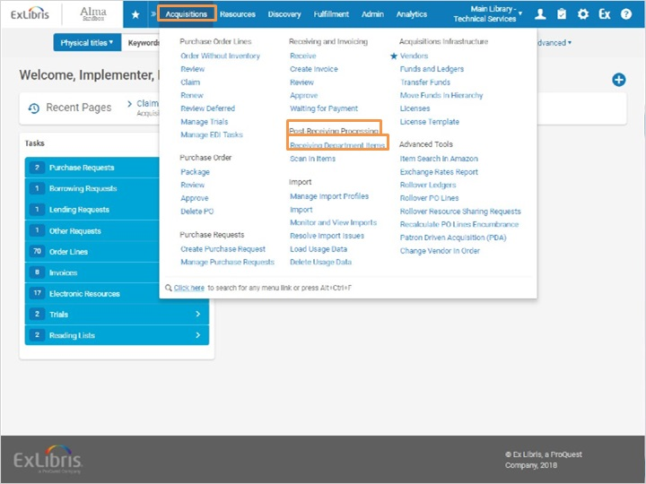
Notes:
To access the receiving area of Alma, go to Acquisitions > Post Receiving Processing > Receiving Department Items.

1.6 In Process Items
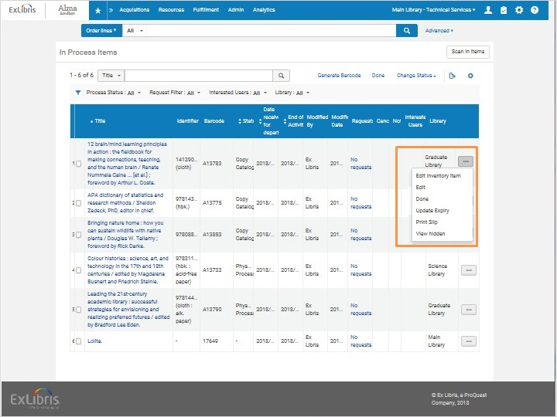
Notes:
This brings us to the In Process Items screen. Here we can see the list of all of the materials that have been received, and were kept in the department. In the status column, we can see the work order type; there are several items that need copy cataloging, and a few others that need physical processing.
If we click on the row actions list, we can edit the work order to change its status and add notes. We can edit the inventory item as needed as well.
Click Done when the work order request has been completed to remove the title from this list.

1.7 Claims
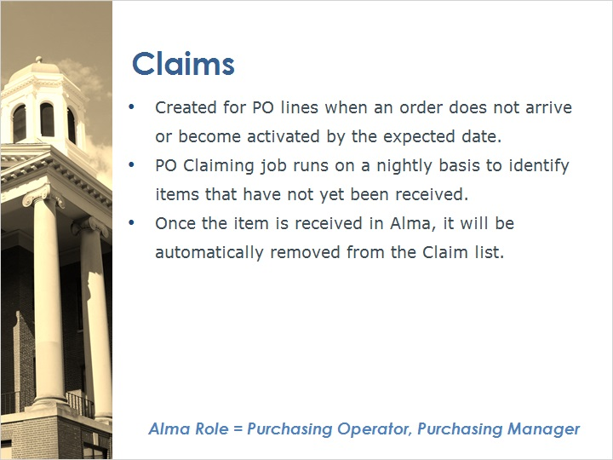
Notes:
Claims are created for PO lines when an order does not arrive or become activated by the expected date.

A PO Claiming job runs on a nightly basis to identify items that have not yet been received. For physical one-time items, claim letters can be sent automatically from Alma to the vendor. For continuous/subscription PO lines, an email notification can be sent manually to the vendor from the Communication tab of the PO line.
Once the item is received in Alma, it will be automatically removed from the Claim list.
In order to process claims on the claims page in Alma, one must have the Purchasing Operator or Purchasing Manager role.

1.8 Access Post Receiving Processing
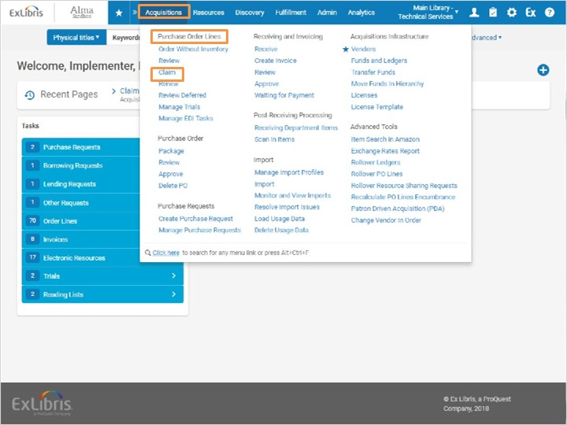
Notes:
To access the receiving area of Alma, go to Acquisitions > Purchase Order Lines > Claim.

1.9 Claims
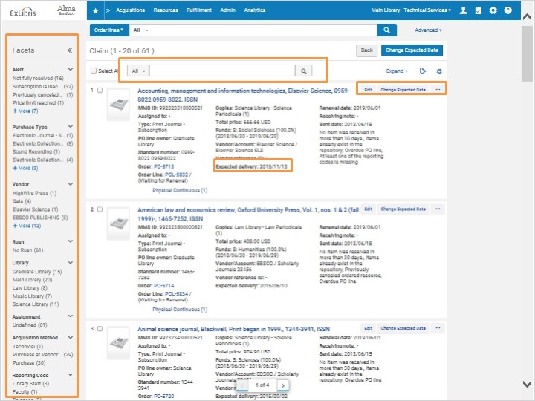
Notes:
This brings us to the claim page. It is possible to search for the claim in the search box at the top, and to use the facets on the left to refine the list.
Each PO line has an expected delivery date. From the claim page, we can edit the PO line, and we can also change the expected due date if needed.

1.10 Review
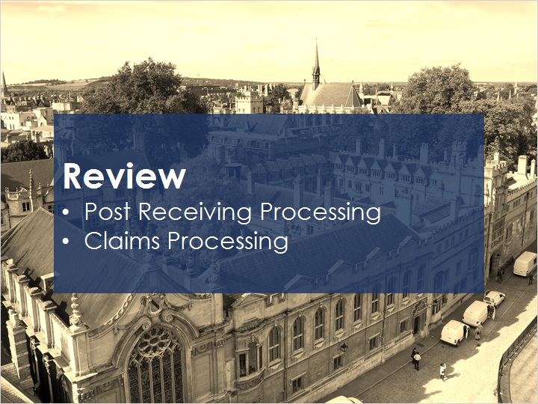
Notes:
Now that you’ve watched this session you should be able to access and have a basic understanding of the post receiving process and the claims process.

Please take the short quiz to test your knowledge.

1.11 Quiz: Post Receiving Processing and Claims
(True/False, 10 points, 1 attempt permitted)
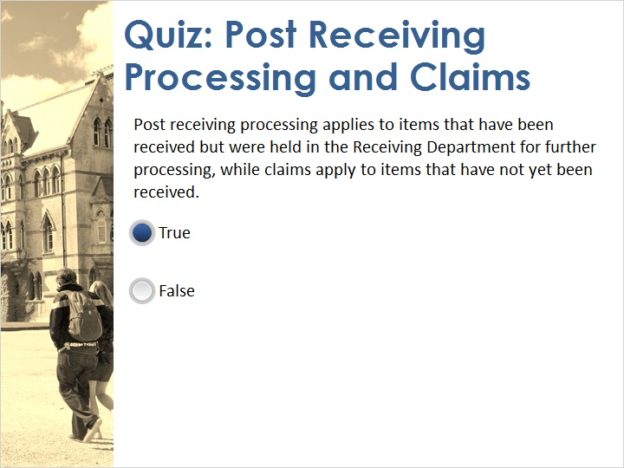
Correct | Choice
X | True
 | False
Feedback when correct:
That's right! Post receiving processing applies to items that have been received but were held in the Receiving Department for further processing, while claims apply to items that have not yet been received.
Feedback when incorrect:
No sorry, that’s not right. Post receiving processing applies to items that have been received but were held in the Receiving Department for further processing, while claims apply to items that have not yet been received.

Notes:

Correct (Slide Layer)
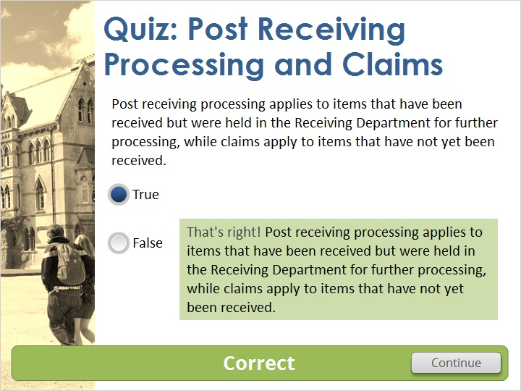

Incorrect (Slide Layer)
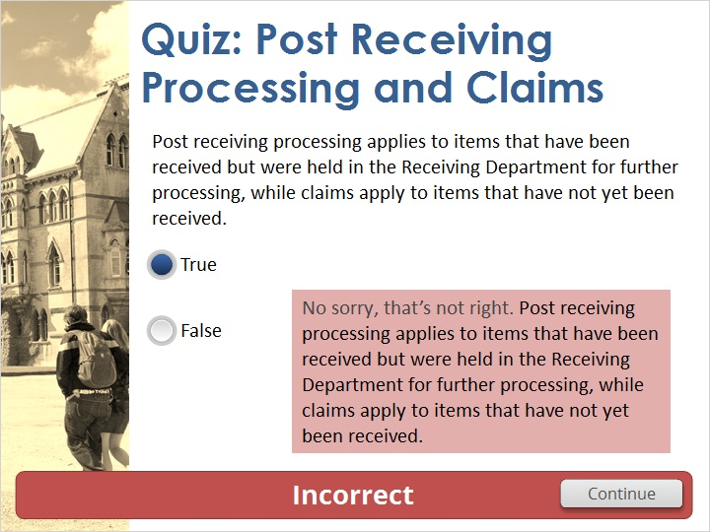

1.12 Thank You!

Notes:
Thank you for joining this session!

1.13 Copyrights

Notes:

2. Quiz Results

2.1 Results Slide
(Results Slide, 0 points, 1 attempt permitted)
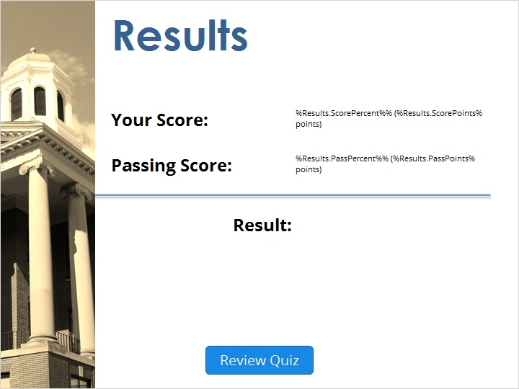

Notes:
fgsfdgsfdgfdg

Success (Slide Layer)
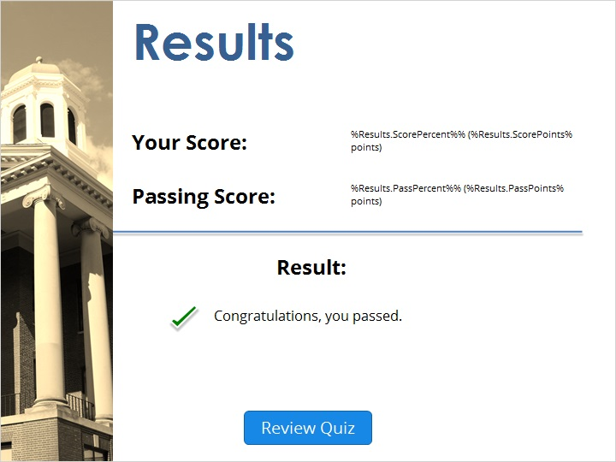

Failure (Slide Layer)


