What is Discovery and Delivery?

1. Getting Started: What is Discovery and Delivery?

1.1 What is Discovery and Delivery?
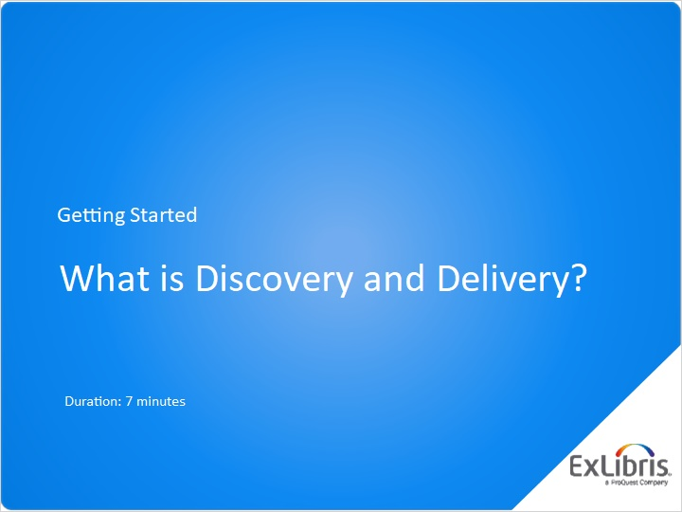
Notes:
Hello, and welcome to this session What is Discovery and Delivery?

1.2 Agenda
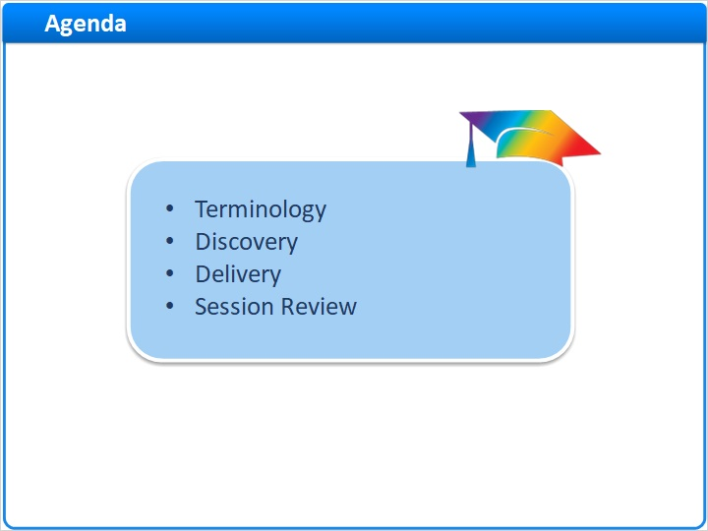
Notes:
In this session, we’ll start by introducing some terminology that is useful in understanding discovery and delivery. Then, we will focus on what discovery is, and how discovery works in Primo. Then we will focus on what delivery is, and how it works in Primo. And then we will wrap up the session with a brief review.

1.3 Terminology
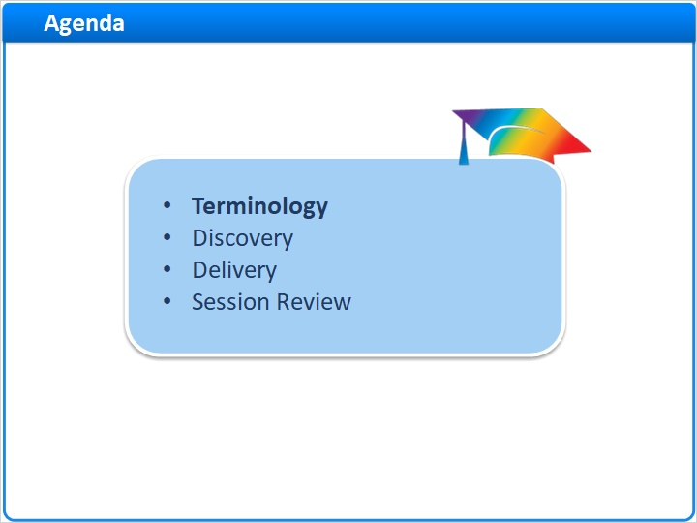
Notes:
Terminology

1.4 Terminology
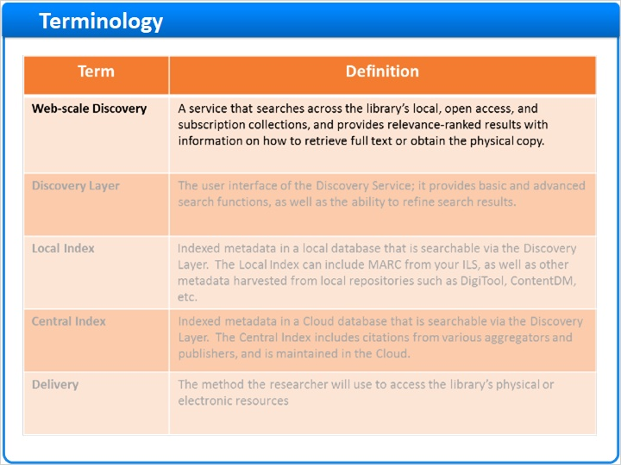
Notes:
Web-scale Discovery services are tools that are used to search across the library’s local, open access and subscription collections. They provide relevancy ranked results, and they also provide information on how to retrieve full text, or obtain the physical copy. Primo provides Web-scale discovery.
The Discovery Layer is really the user interface of this discovery service; it provides basic and advances search functions, as well as the ability to refine search results. Primo includes a customizable Discovery Layer.
The Local Index is indexed metadata within a local database that is searchable using the discovery layer. The Local Index can include MARC from your ILS, as well as other records harvested from local repositories such as DigiTool, ContentDM, or other OAI harvestable databases.
The Central Index is indexed metadata within a Cloud database, which is also searched using the discovery layer. The Central Index includes citations from various aggregators and publishers, and it’s maintained in the Cloud, meaning that it’s accessed remotely.
And for delivery, this is the method researchers will use to access the library’s physical or electronic resources. In Primo, delivery can be an availability statement, showing that the resource is checked in and where it is located, or it can be a way to authenticate and access subscription content online.

Discovery Layer (Slide Layer)
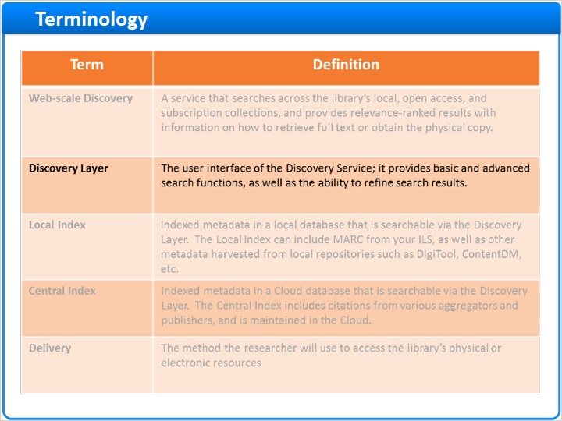

Local Index (Slide Layer)
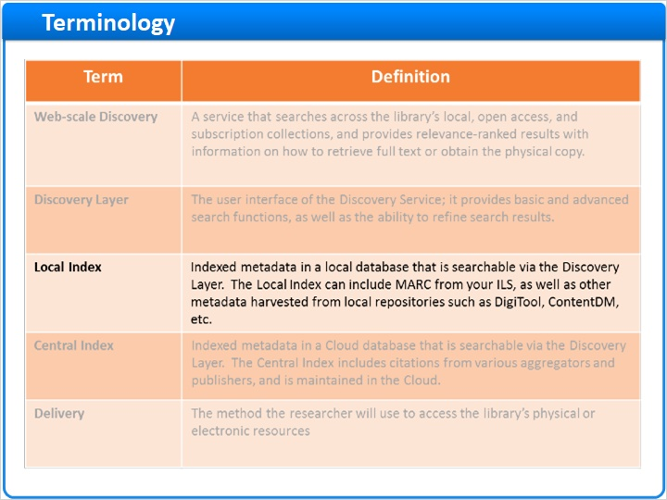

Central Index (Slide Layer)
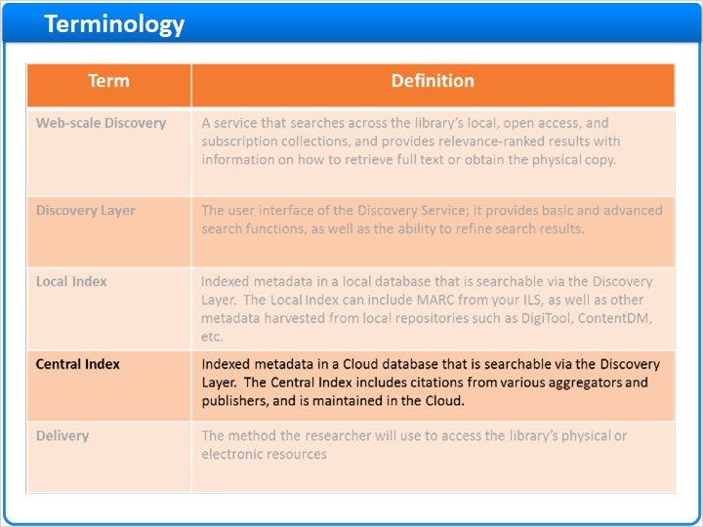

Delivery (Slide Layer)
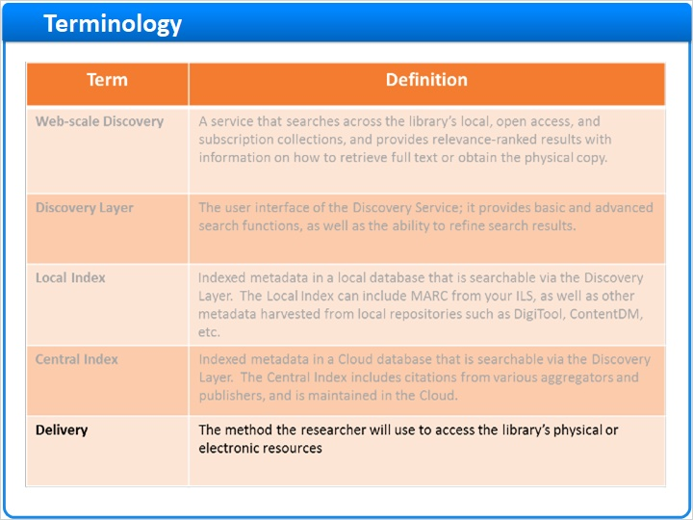

1.5 Discovery
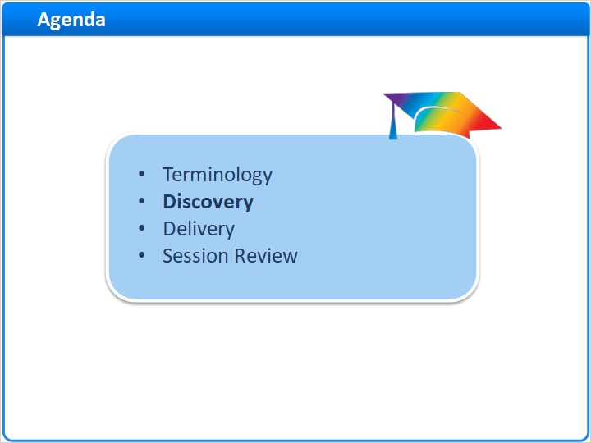
Notes:
Discovery

1.6 Primo as the Discovery Layer
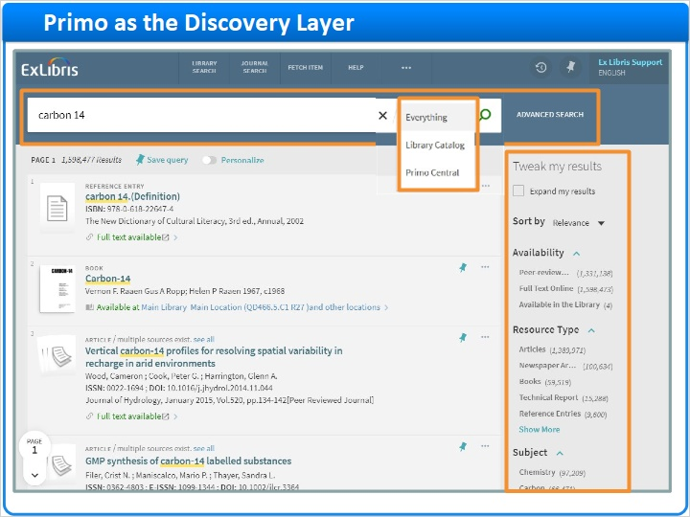
Notes:
Discovery is about finding the resources you are interested in across a broad variety of sources. To do this, we need a way to enter our search and a way retrieve and view relevant results.
Let us look at Primo as the discovery layer.
Here is the user interface after conducting a search for carbon 14. Notice the search bar at the top, as well as the filters on the right that allow the user to refine their results.
The search box searches both the local and central indices, retrieving books, journals, and videos from the library as well as articles and other online materials from subscription resources in the central index.
These results are also ranked by relevancy, which means the user will find the first page of results a great place to start their research.
In Primo, the discovery layer is customizable. Ideally we want all of the data sources possible available to search, but we may also want the flexibility to search specific sources or collections. We call these targeted searches ‘scopes’. Usually scopes are used to provide a targeted search within a specific data source. In this case, we can see that the scopes in the drop down include the library catalog, the Central Discovery Index, and the option to search both at once.

1.7 Primo as the Discovery Layer – Advanced Search
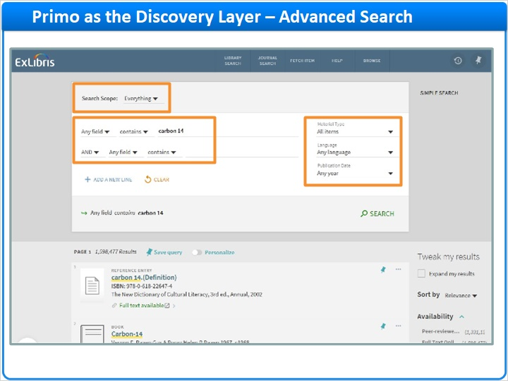
Notes:
There are other ways to discover resources in Primo, including advanced search
In the advanced search, we can select which fields we want to search and where the search term should be in the field. And we can define multiple search terms.
We can also restrict these searches by scope, material type, language, and publication date.

1.8 Summary of Discovery
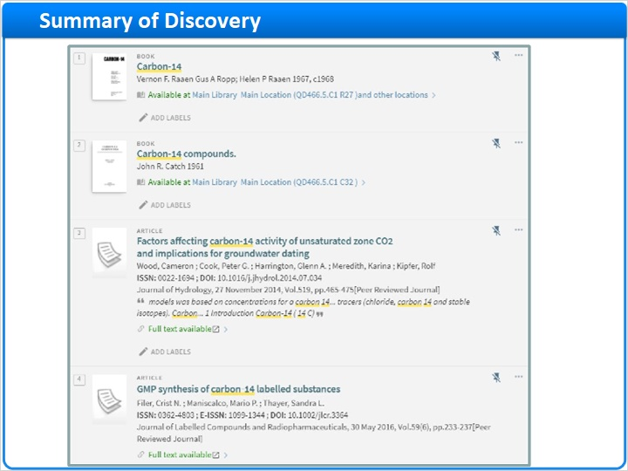
Notes:
Discovery ends when the user finds the citation or record for a material that they are interested in.

Here are our results from our initial search - I’ve selected a few resources that look promising.

1.9 Delivery
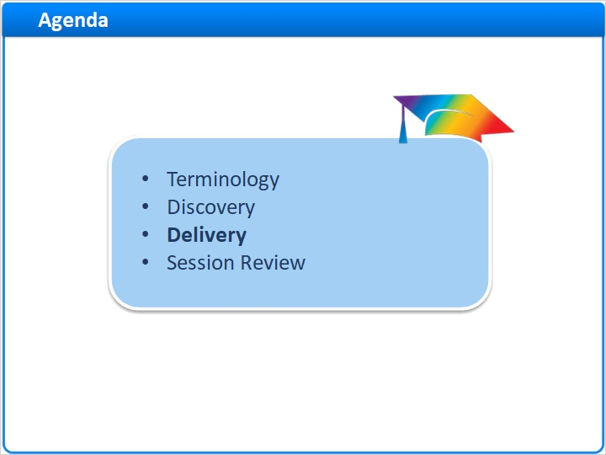
Notes:
Delivery

1.10 Delivery – Physical Resources
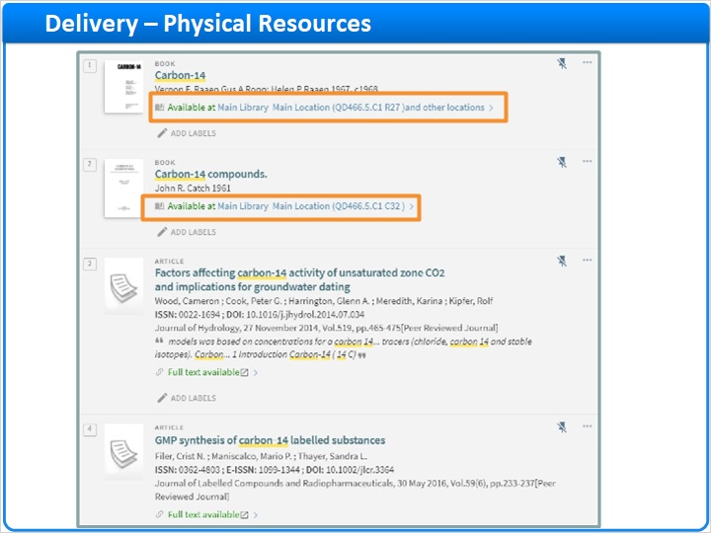
Notes:
Delivery is all about getting access to the resources that have just been discovered.
In Primo, delivery for physical resources consists of an availability statement and the ability to place holds or requests.
Here we can see two library records where both are is checked in, or ‘Available’.
If I click on the title of the record,, we can see that the item is available in multiple locations in the full record.
I can request this title by clicking here - when I do so, I am prompted to fill in a request form.

full record (Slide Layer)
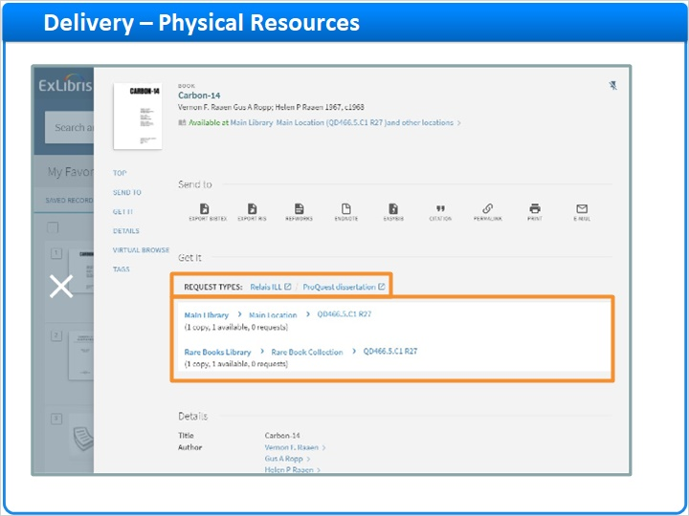

1.11 Delivery – Online Resources
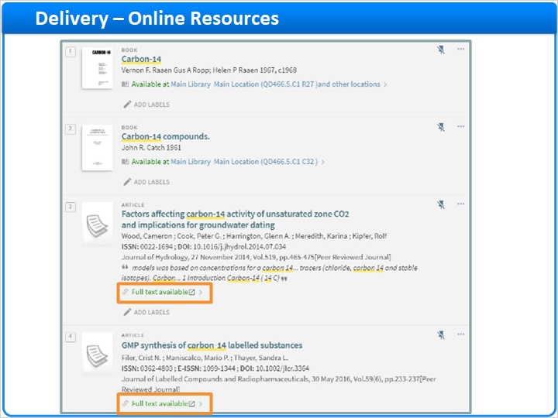
Notes:
Online resources can be from your local index, as well as the Central Discovery Index.
Here we can see several records where full text is available. By clicking on the full text link, I can access the full text of this resource.
Access to online resources involves linking to the full text content online, If it’s subscription content, the user may also be prompted to log into a proxy if the user is not on campus.

1.12 Summary of Delivery
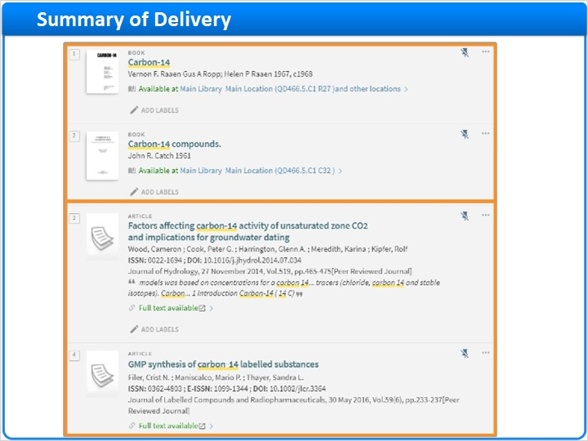
Notes:
Delivery ends when the user has the information they need to access the resource, whether it be a physical book on a shelf or a full text article online.

1.13 Session Review
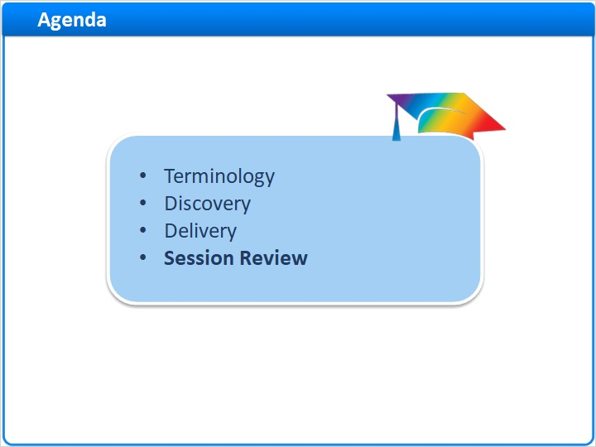
Notes:
Session Review

1.14 Session Review
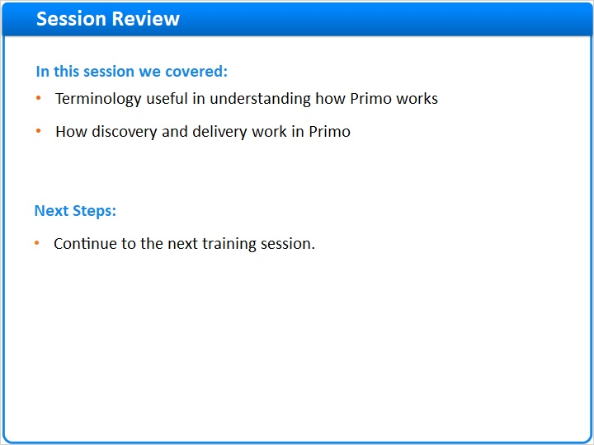
Notes:
In this session we learned terminology that is useful in understanding how Primo works, and how discovery and delivery work in Primo.

Please continue on to the next training session in this series.

1.15 Thank You!

Notes:
Thank you for joining this session!

1.16 About this Training
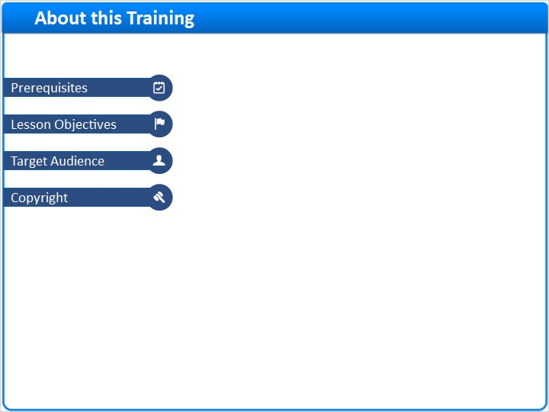
Notes:

1 (Slide Layer)
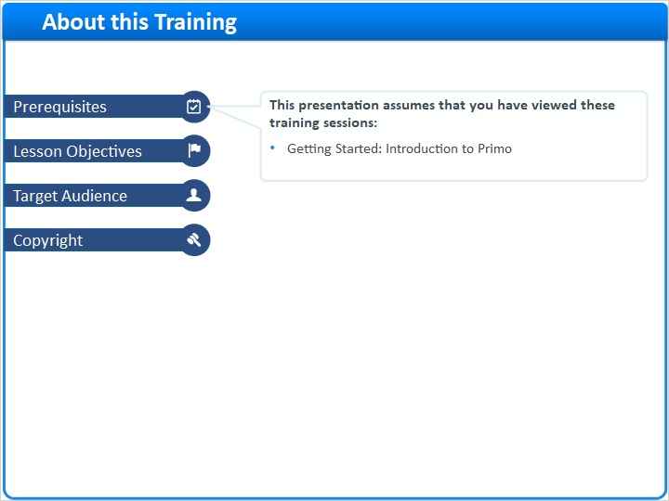

2 (Slide Layer)
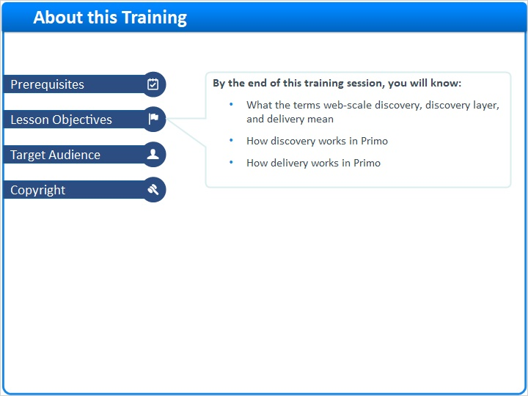

3 (Slide Layer)
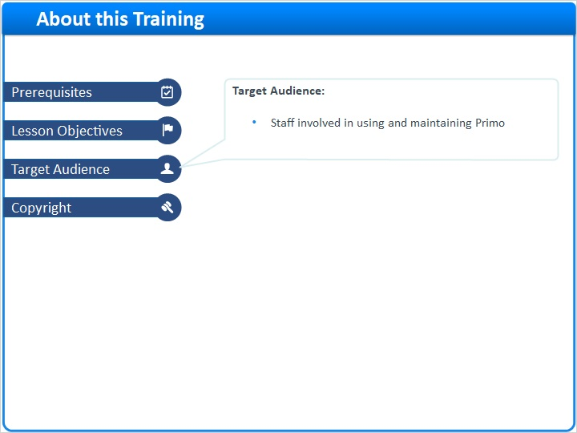

4 (Slide Layer)


