Using Primo

1. 5 - Introduction to Primo PNX and Publishing

1.1 Welcome
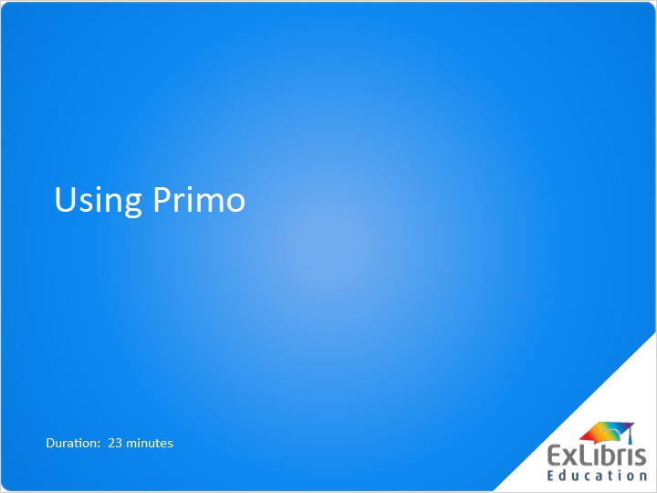
Notes:
Welcome to Primo.

1.2 Objectives
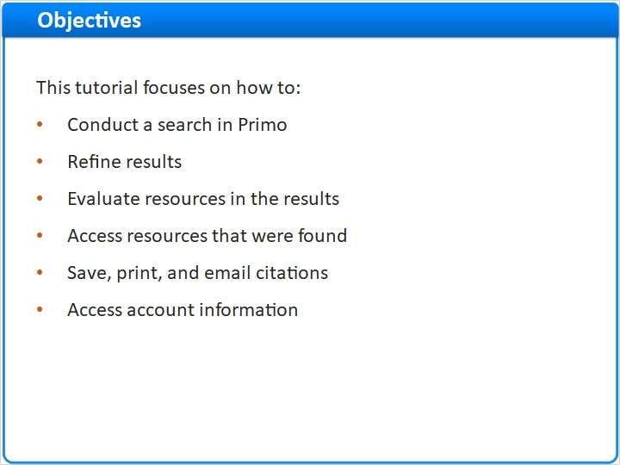
Notes:
This tutorial focuses on how to conduct a search in Primo, how to refine results, how to evaluate the resources in the results, and then how to access the resources that were found. We'll also see how to save, print, and email citations, and access your account information.

1.3 What is Primo?
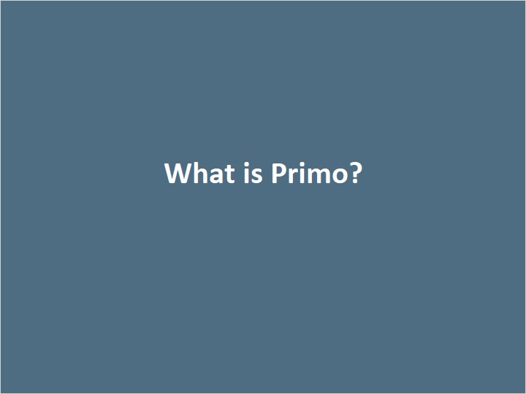
Notes:

1.4 What is Primo?
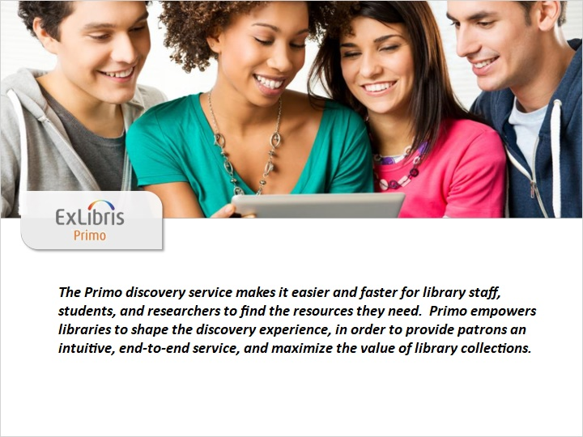
Notes:
The Primo discovery service makes it easier and faster for library staff, students, and researchers to find the resources they need. Primo empowers libraries to shape the discovery experience, in order to provide patrons an intuitive, end-to-end service, and maximize the value of library collections.

This means that Primo can be configured to search your library catalog, your subscription databases, and other digital collections all at once. It will retrieve a list of those results, and allow you to refine your results based on the records that returned. And it will provide information on how to access the materials, whether they’re on a shelf in the library or in a subscription database online.

1.5 Conducting Searches in Primo
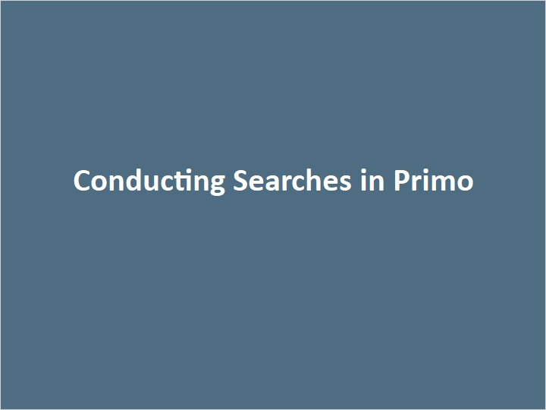
Notes:

1.6 Conducting Searches in Primo
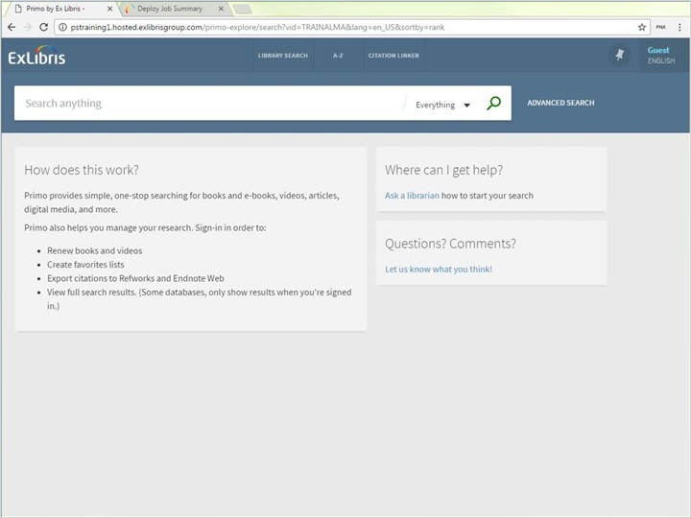
Notes:
This is the Primo homepage of our training environment. The top section of the screen with the dark blue background contains the search box, and below that, there is information about how Primo works, where to get help, and where to go to ask questions or submit comments.

Let's say that we are doing research for several assignments.

The first is on ecotourism in Antarctica.

The first step would be to determine which keywords we should use to search in Primo. I’m going to start with just the term 'ecotourism’.

I can conduct my search in a few different ways. I can search the library catalog, or I can search the Central Discovery Index to get to articles, ebooks, and more in the library’s electronic collections. I want to keep searching both at once, so I’m keeping ‘Everything’ selected.

After clicking on the magnifying glass or hitting enter, Primo quickly retrieves over 16K results. The results returned are records that have the term ‘ecotourism’ anywhere in the record, so it’s considered a keyword search.

Notice that I'm prompted to sign in - if Primo recognizes who I am, I may have more results available to me, and I will be able to see my account and request items. I could have also signed in before conducting a search by hovering over the ‘Guest’ link and selecting ‘Sign In’.

I'm going to sign in now.

OK. Back to our 16K results. Since I’m searching the library catalog AND our index of citations, there's a combination of books, reference entries, book chapters, articles, journals and more in my search results.

Keep in mind that even though there are too many items to examine manually in our initial set of results, Primo does sort the search results based on relevance. Because I entered ecotourism, which is a fairly general topic, the first few results have ecotourism prominently in the title. As I scroll down, I can see where my search term appears in the brief record for each result - it’s underlined in yellow. We can be confident that these first few results will have information that will be useful in our research.

The first result is a book in the library and it's checked in. I'm going to take a closer look by clicking on the title. Now I have access to the full record.

In the send to section, I can send the citation to any number of citation managers, I can generate a permanent link to this record by clicking here, and I can also print or email the citation.

In the get it section, I can see the book is checked in and I can see where it's located in the Graduate Library.

In the details section, I can also see more information about this resource. In Primo the author and subject fields provide links to new searches in Primo. So if I were to click on Jim Butcher 1966 here, I would conduct a new search for that term - and in this case it would not be a keyword search, it would be an author search. Moving down, I can read the description of this book, the publication date, the format, and more.

I can see even more information in the links section by going to the table of contents, the publisher’s description, this item in Amazon, or this item in WorldCat.

For now I’ve decided I want to take a look this book, but I want to keep searching, so I'm going to close out of the Full record and I'm going to keep this item in my favorites by clicking on this pin here. Notice that when I did that, the pin up at the top of the screen flashed orange - when I’m ready to see all of the records I’ve saved, I can access them here.

Let’s keep looking at the search results.

With such a broad search, Primo may return a reference entry within the first few results. This reference entry contains useful introductory information on the topic, and can provide some clues as to how to narrow down the search.

In this example though, I know that there is an additional term that I can add to my query to narrow the results. So I'm going to go back up to the search box and enter Antarctica.

There. Just by adding in keywords to refine my search I've narrowed the field down to 425 results. Even so it will take me more time than I'd like to evaluate all of these results.

At this point I can do several different things. I could rely on Primo’s relevancy ranking, and look through just the first handful of results. Or I could think a little bit more about the results that would be most useful to me and try to refine my results further.

For example, the first article meets all of my criteria so far - it's a specific article on ecotourism in Antarctica, but it was published in 1993. For the purposes of my research paper, I'd like to use something a little more recent. The next result was published 10 years later, in 2003, which looks more promising.

Instead of going through each of the results one by one, I can filter out resources based on the publication date. On the right I could scroll down and adjust the creation date. Let's start by looking at everything published after 2000. I'll click refine, and now I have 334 results.

OK. I can also use the filters on the right to give me some information about my results set. Under the availability filter, I can see that 153 results are from peer review journals, and all of the results are available online. Let’s say that I want to refine the results further. I may want only the resources from peer review journals, so let’s click that. Notice that my active filters now includes that criteria. Ok. Next, the Material Type filter. Before I applied the peer review journals filter, the material type had a few more formats under it. So we can tell that my filters are generated based on the current set of search results. Under the material type, I’m going to hover over ‘reviews’. Notice this red checkmark? I can click on that if I wanted to exclude those items. Ok - so I’m going to exclude reviews, and now I can see Active filters was updated again.

There. I have 146 results now. I could continue to refine my results set using the facets, or even entering in additional search terms. But I could also start looking at the first few results to see if they are going be useful - remember, Primo is still sorting these results by relevance, so the more relevant results are at the top of the list.

These articles are available online and Primo gives us the link to the article. By clicking on full text available I'm leaving Primo and going to the article in one of the libraries subscription databases. Notice that I can go back to Primo in the previous tab.

Back in Primo, I can click on the title to give me more information about this record. The full record for online resources contains information similar to the book we looked at earlier, except here we have the link to the online resource instead of the availability information.

I’m going to close out of the full record, and for now I’m going to add a few more of these articles to my favorites list.

I’m also curious to see the most recent articles that published on this topic, so I’m going to sort my results differently. I’ll select ‘date-newest’ for that. Notice that I’m not seeing ‘ecotourism’ or ‘Antarctica prominently in the titles now, but I can see those terms underlined in yellow in the snippets. While these records may not be as relevant to my topic, I might want to read through the article anyway to see if there’s information I can use in my paper.

I'm going to add this article to my favorites. In fact, I’m going save this search as well by clicking on the ’Save query’ pin at the top of the results. As soon as I click that, I get a message that appears at the top of the screen telling me that it’s saved in my favorites, and I can turn on an alert for it now if I’d like. I’m going to demonstrate how to do that later in the tutorial, so I’m just going to let that message disappear for now.

Let’s move onto our next research assignment, where we’ll see how to search for more specific topics. Though I could conduct a new search by just entering search terms into the search box, I’m going to click ‘Library Search’ at the top of the screen to go back to the Primo homepage.

1.7 General Topic, Specific Collection
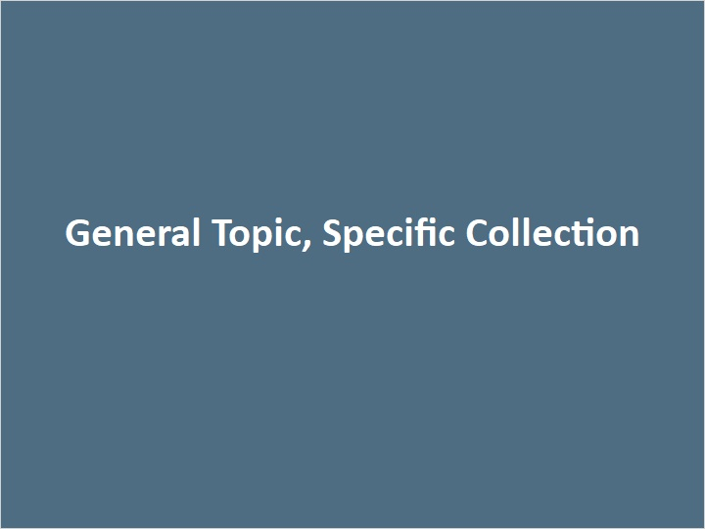
Notes:

1.8 General Topic, Specific Collection
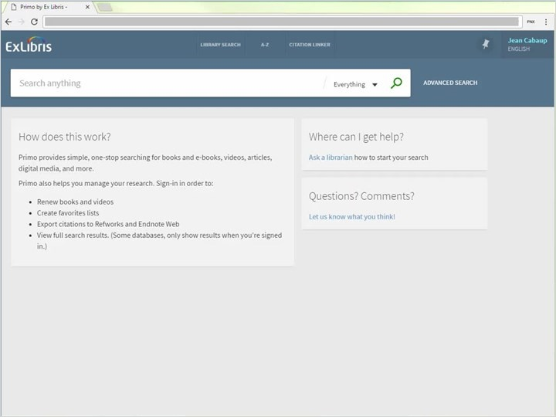
Notes:
Let’s say that I'm sitting in the Main Library and I would like to look over some books on landscaping. I'm going to search for landscaping, then select ‘Library Catalog’ once the option appears. I notice that after I click search, I have a typo. Since the search for my misspelled term did not produce any results, Primo offers up a suggestion and asks did you intend to search for landscaping. I can click on the word landscaping here to conduct search again with the term corrected.

Now I have 208 results, and as I look at the first few I can see that Primo recognizes landscape as the root of the word landscaping. In other words when the results set is small enough, Primo will expand the search to include variants that include ing and ed. Primo will still give priority to the word landscaping over landscape when it ranks the results because that was the term we used to do the search.

As I'm reviewing my results and looking at the filters over on the right, I notice the term landscape architecture. I’m curious to see what these books are, so I'm going to click on the subject. It also occurs to me that I'm still seeing results from both the Main Library and Graduate Library, and right now I just want to see the results from the Main Library. So I'm going to apply another filter and now I can see 17 results. As I look at the results I see one titled Landscape design and cultural and architectural history. This book looks interesting, so I'm going to add it to my favorites, and go find it on the shelves after I’m finished researching the rest of my topics.

1.9 Specific Topic, Multiple Terms
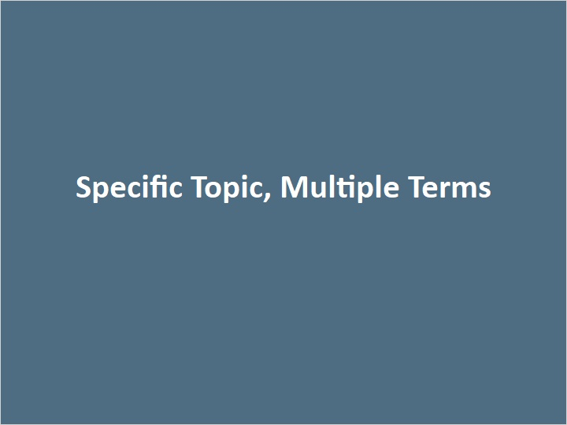
Notes:

1.10 Specific Topic, Multiple Terms
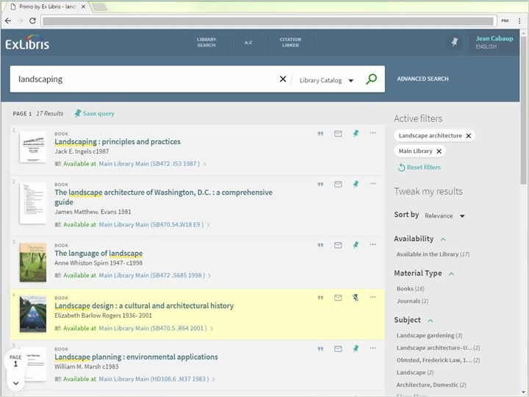
Notes:
For my next search I'm going to do a search for recent articles on how music can lower anxiety in clinical settings. This is a pretty specific search so I'm going to start in the advanced search. I'm going to think about the best terms to use in my search, and then I’m going to select subject contains music therapy, and I'll just do a keyword search for anxiety. Notice that my Boolean operator is AND so it’s combining these terms, but I could select OR or NOT if it applied to this search.

I’m going to select articles in English that were published in the last year. Then I’ll click on search. And I get 88 results. I could use some of the filters on the right to refine my results further if I wanted to, but already I'm seeing some useful articles right here at the top of the results. I'll add a few of these to my favorites.

1.11 Known Item Search
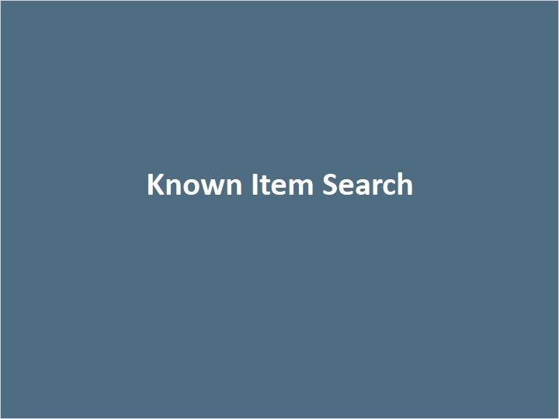
Notes:

1.12 Known Item Search
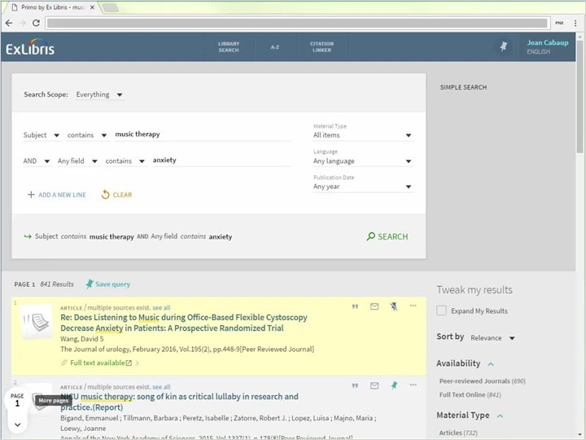
Notes:
Now that I think of it, I remember that my professor recommended a specific article on this topic - Music interventions for dental anxiety. To search for a known item I can clear my search, then select title, type in the title, Music interventions for dental anxiety, and then click search. Here’s the article.

I could have also used a simple search - let’s do that now. I’m going to reset my search by clicking on ‘Library Search’. And I’ll type the title in the search box. Now if I click search, I would be doing a keyword search for all of these terms - not just a search within the title of the records. Because it's a specific title most likely I would find this result at the top of a larger list like this. But notice I still have additional results below that that include those keywords as well.

If I wanted to ensure that my simple search targeted just the article I was looking for, I could put quotes around the title to do a phrase search. Phrase searching is another name for exact matches. So in other words the search will look for all of these terms next to eachother in that order. And here's the article. Let's add that to our favorites as well.

1.13 Wildcard Search

Notes:

1.14 Wildcard Search
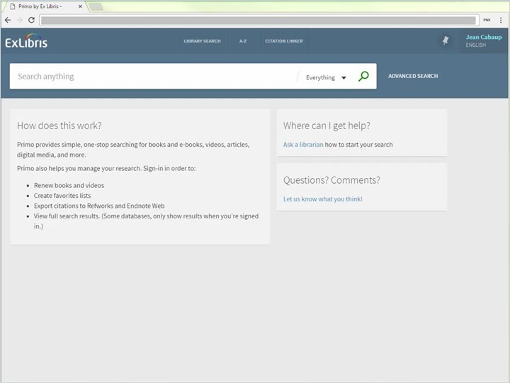
Notes:
For my last search, I want to pick up copies of Stephen Hawking's A Brief History of Time, and the newer version, A Briefer History of Time. Each of the words in these titles of these books are very general - brief, history, and time. I want to get the best possible results quickly, so I'm going to use the advanced search. I'm going to set the first field to title, and then type in the word Brief. Then I'm going to use the wild card which is an asterisk, so this will look for the word brief and any other word that starts with brief - briefer, briefly, and so on. I'll finish typing in the title History of Time, and then I’ll set my material type to books. Then I’ll click search. Here are both of the books! Notice that I have more than just these two results, but because of Primo’s relevancy ranking, these two books are at the top. Let's get those added to our favorites as well.

1.15 My Favorites
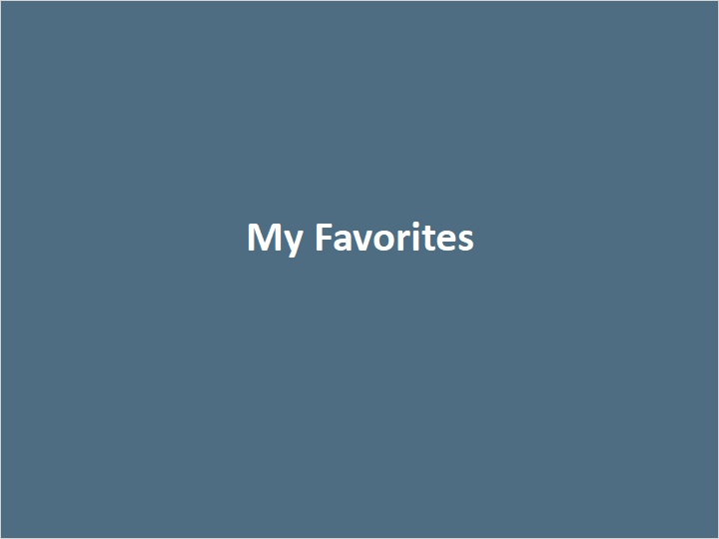
Notes:

1.16 My Favorites
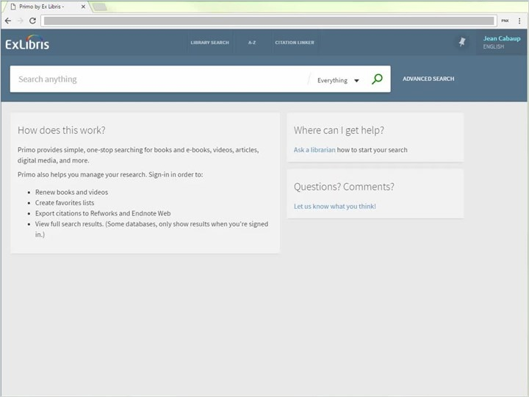
Notes:
Until now we've just been searching for materials in Primo we haven’t yet gone to the shelf to get any of the books we found, and we've only taken a cursory look at some of the articles that we're going to be accessing online.

To see everything in my favorites I would click on the pin at the top of the screen. Because I'm signed in, my favorites would be retained even if I logged off and walked away from the computer. And right now I can see I have a number of items in my list. Remember I was researching several different topics so the labels function allow me to organize my favorites. I'm going to go ahead and select the first two records. I'm going to add a label to both of these records - let's label them astronomy. Okay I would click enter and now I can see each label at the bottom of the brief records. Now for our music therapy articles. As I look at the titles I realize there’s one that I want to remove from my favorites - and I can do that by unpinning the item here. I’ll also make sure that only the records that I want to add labels to are selected. Then I’ll click add labels at the top, and add music therapy. Ok. I'm going to leave the landscape resources unlabeled but I'll make a final label for my ecotourism resources. There. Now I can see three different labels over here on the right and if I click on one of these labels, I can filter my favorites to show just those materials.

By having a list of all of the resources I am using on each research assignment, I can quickly generate bibliographies based on the citation information provided in each of these records.

I can do this by selecting all of the records and then selecting ‘push to actions’ I can export the citations to RIS, RefWorks, Endnote or EasyBib, and I can print or email them.

From the saved searches screen I can see the queries that I've saved, I can set them up as alerts and I can disable or delete them.

1.17 My Account
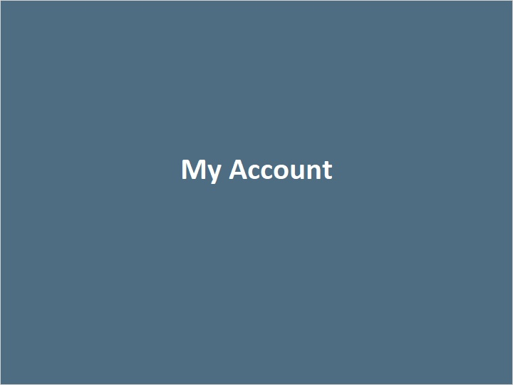
Notes:

1.18 My Library Card
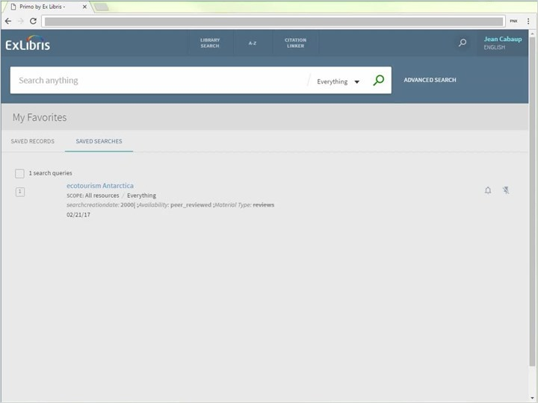
Notes:
If I want to see my library account information, I can hover over my name and then select my library card. From this screen I can see an overview of the books I have on loan, my fines and fees, my requests, and any blocks or messages pertaining to my account.

If I wanted more information on books that I have on loan, I can either click on the item itself or I could go to the loans area. From here I can see more information about the loan.

In the requests any items that I've placed on hold will appear here. It looks like I'm still waiting on the book Wild Ice Antarctic Journeys, but I can see I’m next in line to receive the book. I could also cancel my request from here.

In the fines and fees I can see that I have a $5 charge for photocopies. In the blocks and messages I can see any Messages or blocks of associated with my account.

Under personal details, I see and edit my account information, including my email, and I can change which language Primo will default to when I login.

And I can always return to the Primo home page by clicking on Library Search at the top of the screen.

1.19 Additional Resources
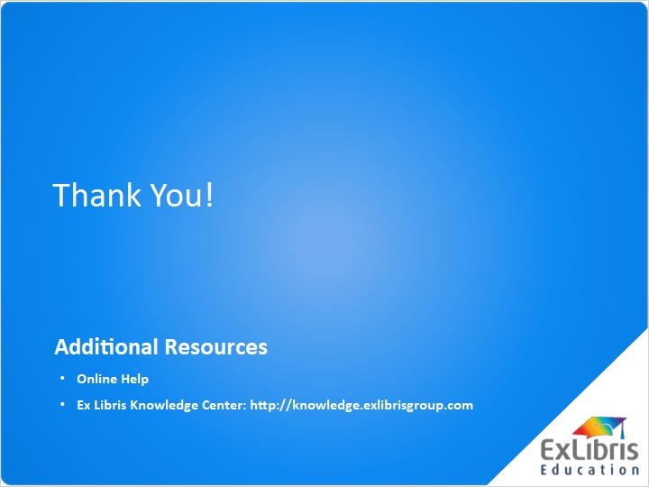
Notes:
Thank you for watching this tutorial Using Primo. Please consider watching the ‘How Primo Works’ tutorial next.

1.20 About this Training
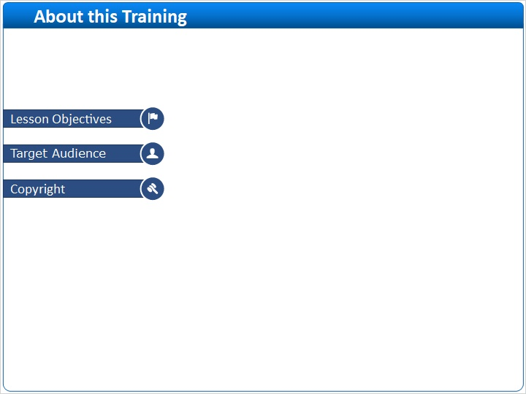
Notes:

2 (Slide Layer)
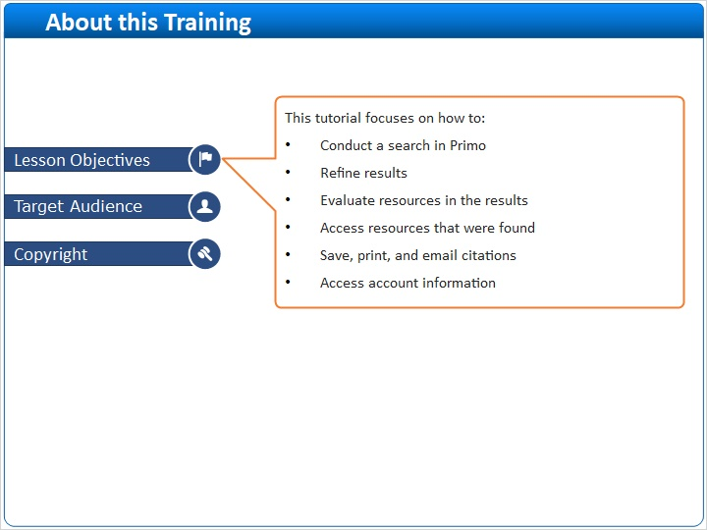

3 (Slide Layer)
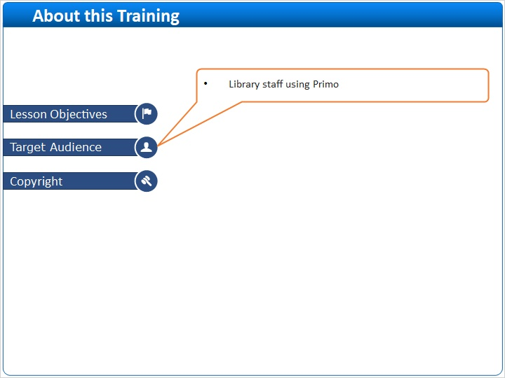

4 (Slide Layer)


