Summon Over Alma: Configuring the Alma Services Page

1. Configuring the Alma Services Page

1.1 Configuring the Alma Services Page
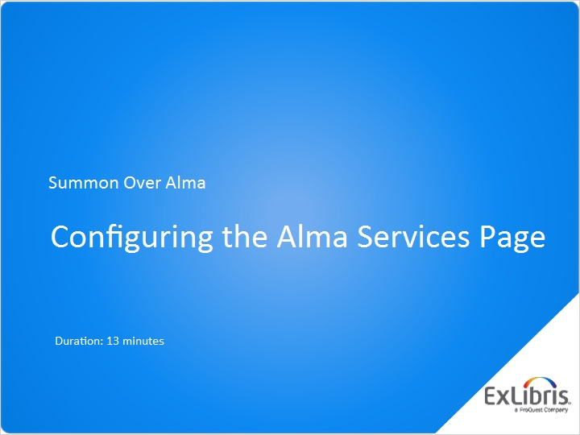
Notes:
Hello, and welcome to this Summon Over Alma session, Configuring the Alma Services Page.

1.2 Introduction
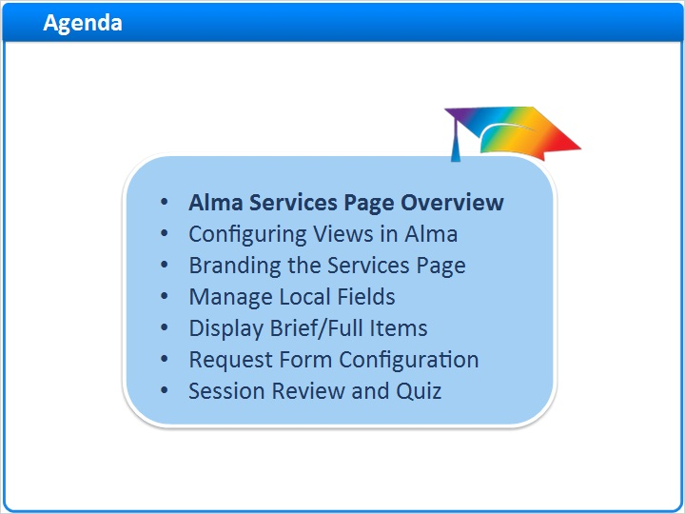
Notes:
In this session, we’ll start by covering Display configuration for the Alma Services page, beginning with how to configure views, including the General configuration, Brief Record Display, and Full Record Services display.
- We’ll then show you how to use the Customization Package to manage the branding of your Alma Services page.
- And discuss how to display Brief Item and Full Item Display on the Alma Services page.
- We’ll also talk about how you can map local MARC fields for searching or display.
Finally we’ll walk through the basics of configuring request forms for Digitization, Hold and Booking, Purchase, and Resource Sharing Requests.
After a brief session review, there will be a short quiz to test your knowledge.

1.3 Summon and the Services Page Overview
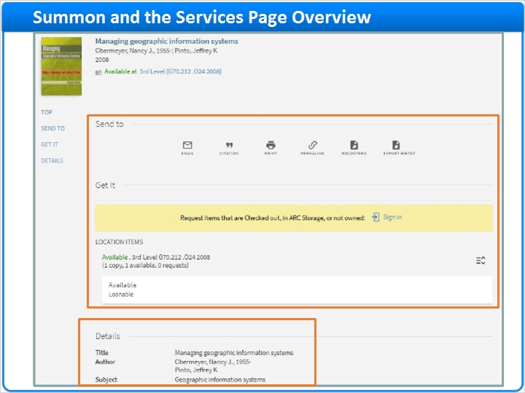
Notes:
Clicking on the title in the Brief Result brings us to the full record display on the Alma Services page, where we can see more information about the item in the Details section.

If it’s an electronic resource, you see additional information about the record in the Links section. We can also see Send to and Get It information as well.

While there may be more sections in this full display, in this session we’ll be focusing on those that are customized in Alma’s Views Configuration.

1.4 Configuring Views in Alma
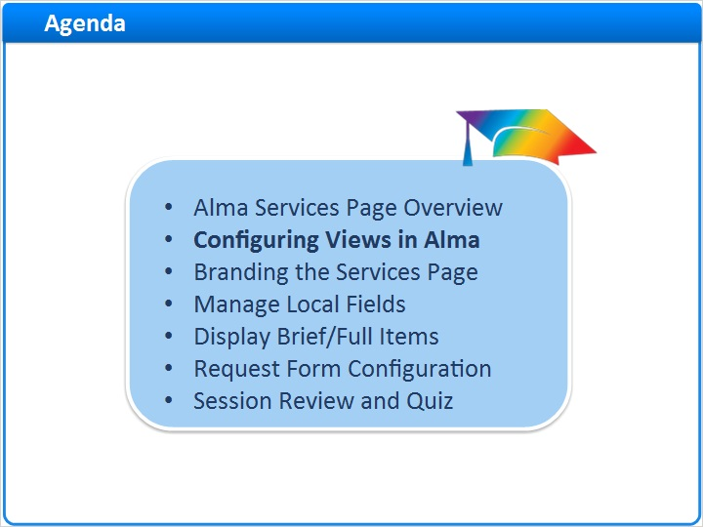
Notes:
Let’s begin the session by learning how to configure Views in Alma.

1.5 Configuring Views in Alma
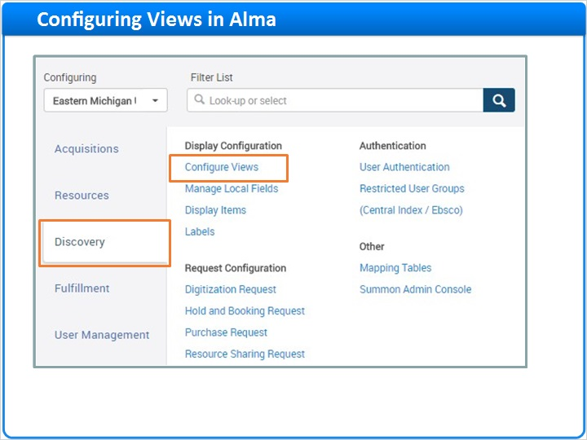
Notes:
To configure views, navigate to the Discovery Configuration menu, and under Display Configuration click Configure Views.
Clicking on Configure Views brings us to the Views List. In this case, there are few Views already defined. During implementation, your Ex Libris project team will have already configured your default view.

From here you can see the View Code for each view, along with the name and description of the view. You can indicate which view is the default view for the institution here.

Clicking on the Row Actions menu reveals several actions available for each view that enable you to edit the existing view, duplicate it, or delete it. The Override option allows you to replace the view with a different view, acting as a redirect to the new view.

To add a new view, click the Add View link at the top of the table.

Views List (Slide Layer)
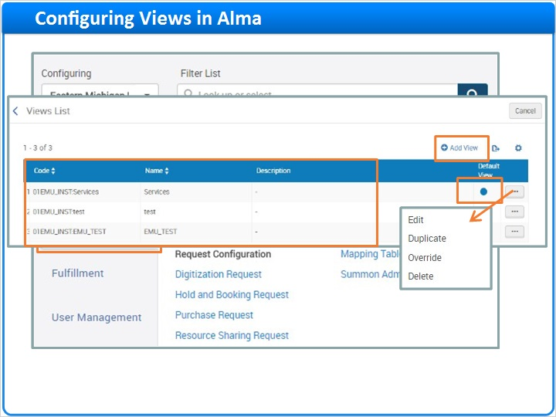

1.6 Adding a New View
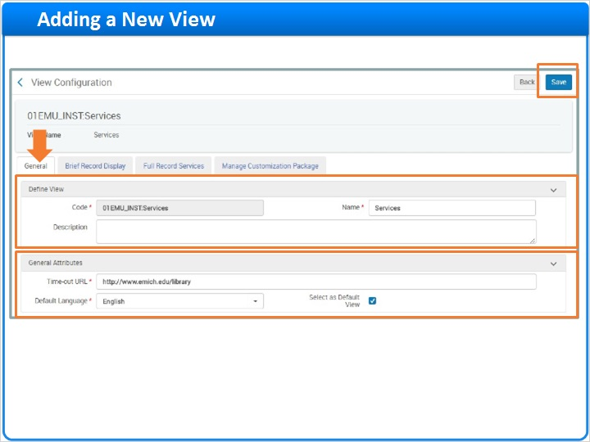
Notes:
The View Configuration’s initial page appears under the General Tab. Here you can define the view by entering in a code, a name, and a description.

Remember that the View Code is used to form the base URL of the View. After saving the view, the system will automatically prefix the code with the institution code.

- Next, you’ll determine the general attributes of the view. The default language for this view will be English.
The Time-out URL determines where the user goes after they log out of their session, or where they go when they let their session idle long enough to time-out. Typically institutions use their library URL for this field.
You can set this view as the default view if you want to as well.
Click the blue Save button to save the view.

1.7 Brief Record Display
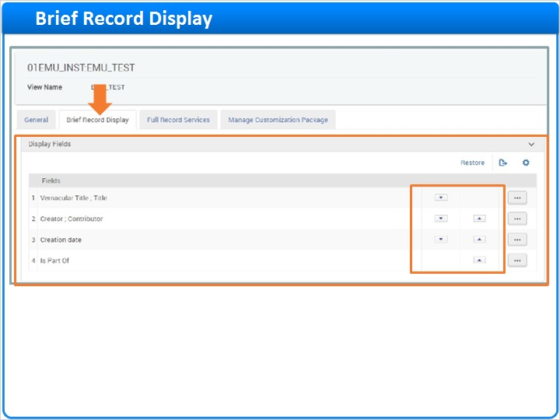
Notes:
The Brief Record Display, Display Fields section controls the top of the services page (up to 4 rows), including the Title, Creator/Contributor, Creation Date and Is Part Of. You can define which fields are shown and the order in which they are displayed by using the up/down arrows.
Here is where the Brief Record Display is shown on the Alma Services page.
Lower on the page is the Record Actions section, which controls the actions the user can take in the Send to section of the Services page. You can see the Export BibTex / RIS/Zotero / Permalink / Print / Citation / Email codes have been enabled.
And here you can see they are visible on the Services page.

Brief Record Display Services Page (Slide Layer)
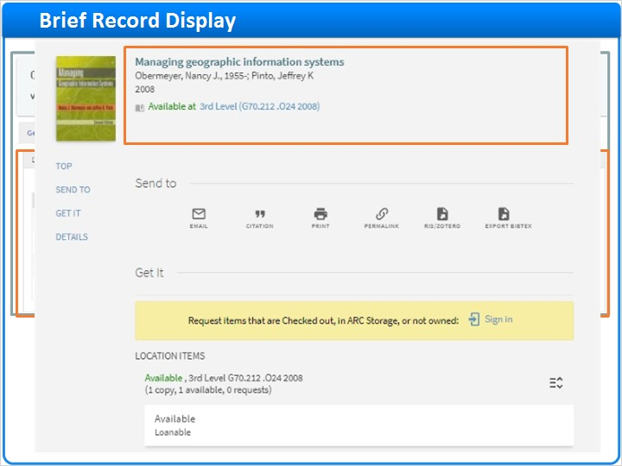

Record Actions Section (Slide Layer)
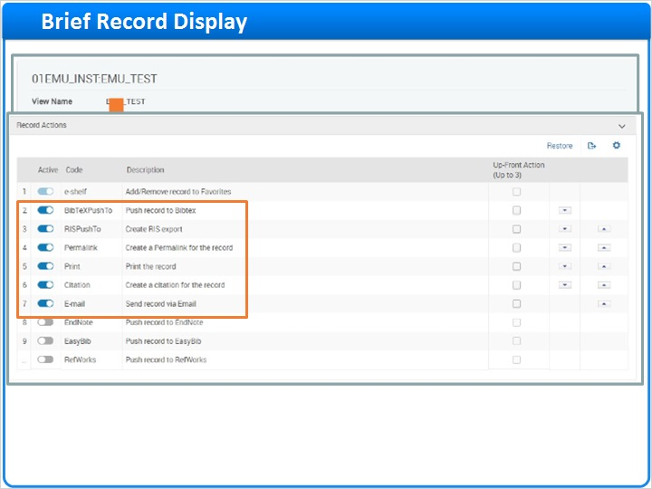

Send to on Services Page (Slide Layer)
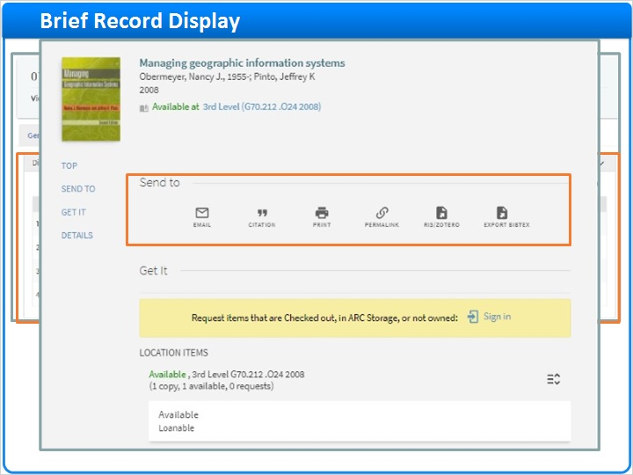

1.8 Full Record Services
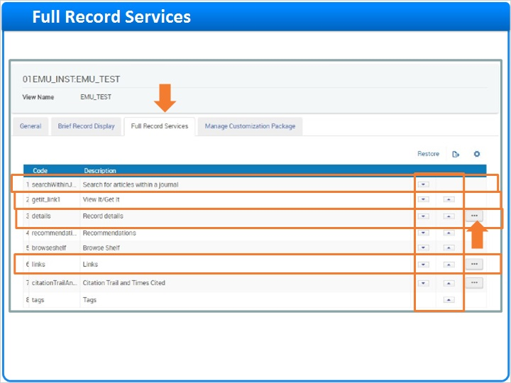
Notes:
The Full Record Services tab allows you to configure the various service sections that appear on the Alma Services page. Use the Row Actions menu to customize the codes and use the up/down arrows to change the placement of the code.

The following services are supported in the Alma-Summon environment:

getit_link1 - This code enables the View It, Get It, and How to Get It sections on the Services page. These sections allow users to view online materials, request physical items in the library or partner libraries, or get materials from other sources. The How to Get It section displays only general electronic services that are delivery-related (such as an ILL service), and appears when the record has no holdings.
links - This code enables the Links section on the Services page. The Links section displays all general electronic services that are not delivery-related.
searchWithinJournal - This code enables the Search for articles within a journal section. This section displays in the Journal Search and on the Alma Services page when the record has an ISSN, and it lets users search the Community Zone for that specific journal by adding the ISSN to the query.
details - This code enables the Details section only for records in your local catalog. It allows you to display the same fields that you can include in the brief records display, but it is meant to include additional information, which can be displayed on more than three rows.
Here you can see some of these views for How to get it, Details and Links sections on the Services page.

Full Record Services Page (Slide Layer)
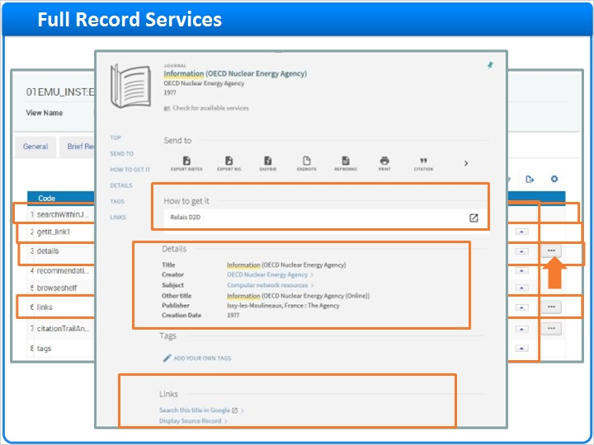

1.9 Branding the Services Page
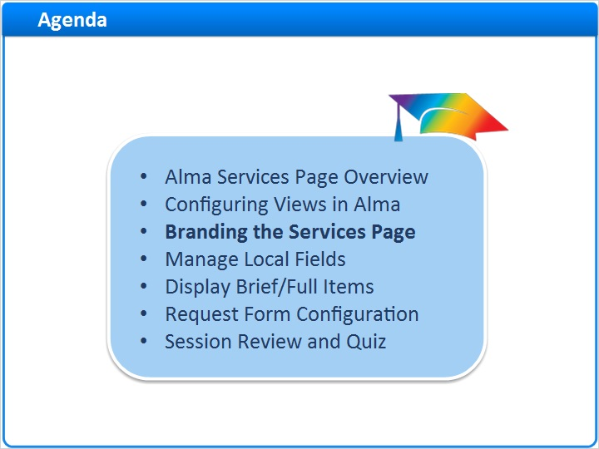
Notes:
It’s possible to brand the Alma Services page using a customization package. Let’s take a quick look at that now.

1.10 Managing Customization Package
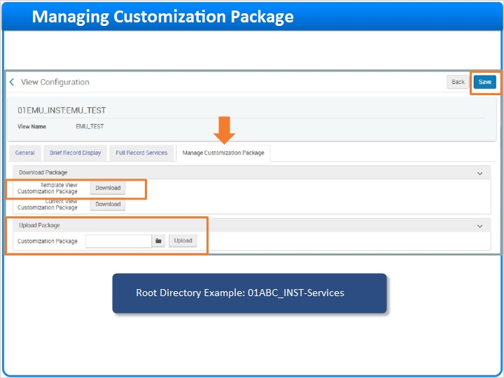
Notes:
The last tab in the View Configuration is Manage Customization Package. This allows you to brand the Alma Services page, changing the look and feel of the view to reflect your library or institution’s brand. If you don’t already have a customization package uploaded you’ll see a short note.

The Customization Package allows you to modify the CSS files, javascript, HTML and related images.

If this is your first time branding the services page, Click the Download button next to the Template View Customization Package. A template file will be downloaded.
Unzip the package and edit the CSS and javascript files as needed.
Make sure that the root directory for the package uses the <institution ID>-Services format-for example, 01ABC_INST-Services.
Zip the package and specify the name.
Click Upload to upload the package to the new view.
And be sure to click the blue Save button at the top of the page to save any configurations you make and to install the new branding customization on your Alma Services page.

1.11 Managing Local Fields
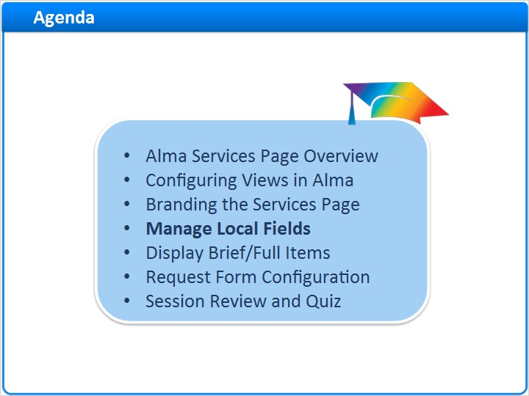
Notes:
Alma allows you to make special MARC fields available for viewing on the Alma Services page.

1.12 Manage Local Fields
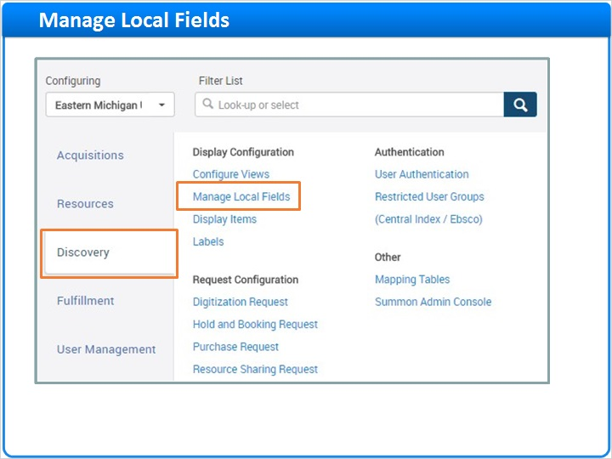
Notes:
The use of local fields allows you map information (such as resource, donor, curator or special notes) from specific MARC fields in the source records.

These fields can then be used to extend search queries and to display additional information in the record's brief and full displays.

From the Discovery Configuration menu, under Display Configuration, click the Manage Local Fields link.

1.13 Manage Local Fields
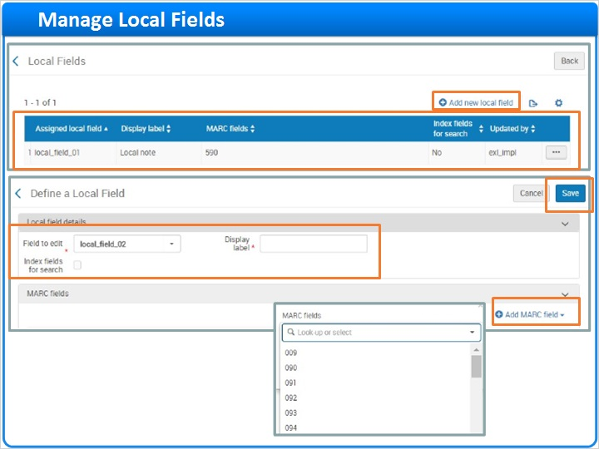
Notes:
The Local Fields page appears and allows you to view any local fields already configured or add a new one. The Assigned local field, Display label, and MARC Fields are all visible. The Index fields for search enables the local field to be searchable by users, is also shown.

Use the Row Actions menu at the end of the row to edit or delete the local field.

To add a new local field, click Add new local field at the top of the table. Add the appropriate information to the following fields:

- Field to edit - Select the local field that you want to use.
Display label - Specify a display label for the information that you are mapping from the source records.
- Index fields for search - Select this field if you want the information in this local field to be searchable by users.
Add the MARC Field - choose the field from the drop-down menu and Add MARC field.
Click the Save button to create the local field.

1.14 Display Brief/Full Items
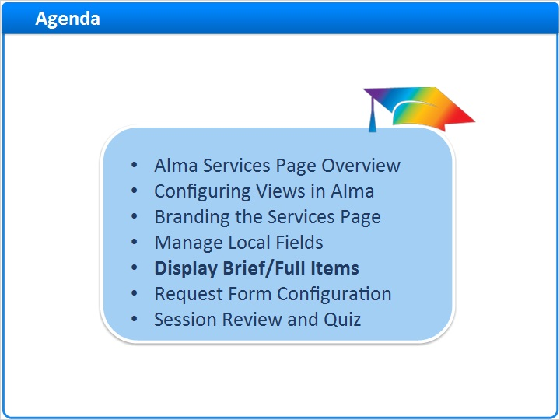
Notes:
The Display Items configuration allows you to configure the Brief Item and Full Item Display in the Get It section of the Alma Services page.

1.15 Display Items
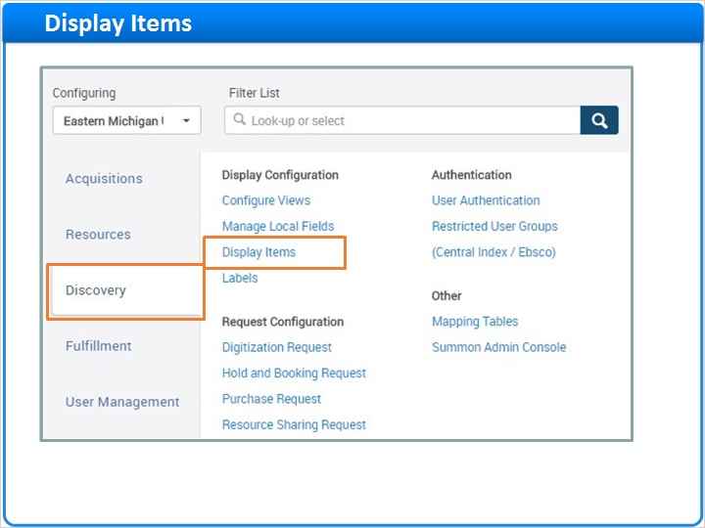
Notes:
From the Discovery Configuration menu, click on Display Items under the Display Configuration section.

1.16 Configuring Display Items
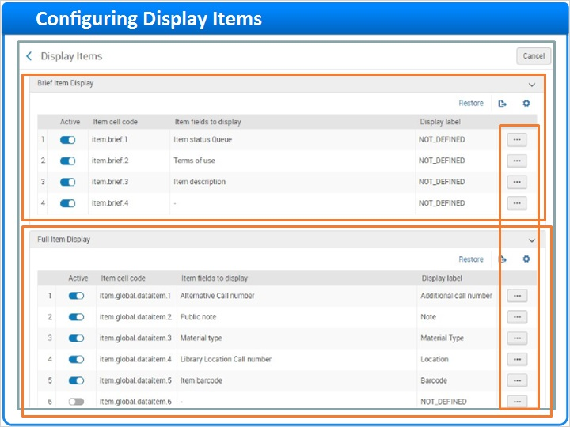
Notes:
The Brief item display opens and can contain up to four display lines. By default, the Alma Services page displays the item's status, terms of use, and the item's description on separate display lines if available for the item.

The Full Item Display displays the additional call number, public notes, material type, location (which includes the library, location, and call number fields), and the barcode on separate display lines if available for the item. You can configure up to 12 display lines and each line can contain up to three fields.

Use the Row Actions menu to edit the fields for each Item Display.

The Alma Services page shows the location of the Item Display configuration. Note that when patrons click on the arrow to expand the availability field, the additional Full Item information is revealed.

Get it - Services Page (Slide Layer)
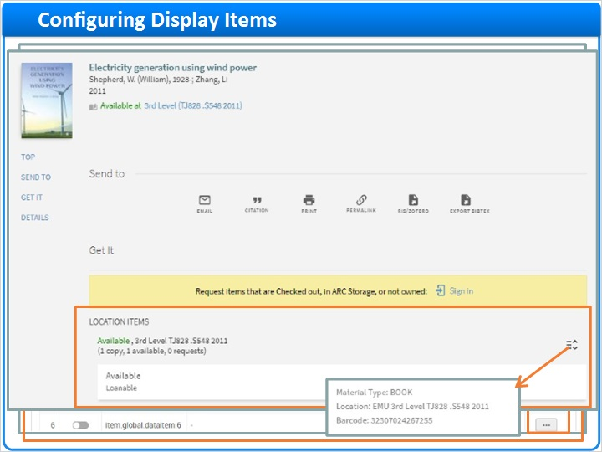

1.17 Request Form Configuration
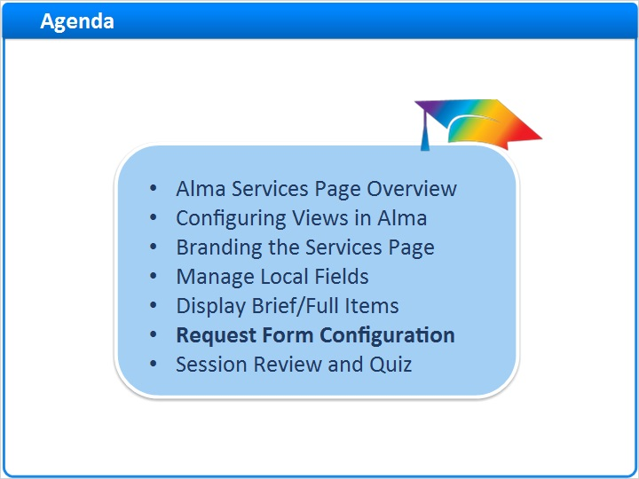
Notes:
The last part of the session will describe how to configure 4 different Request Forms in Alma.

1.18 Request Configuration Menu
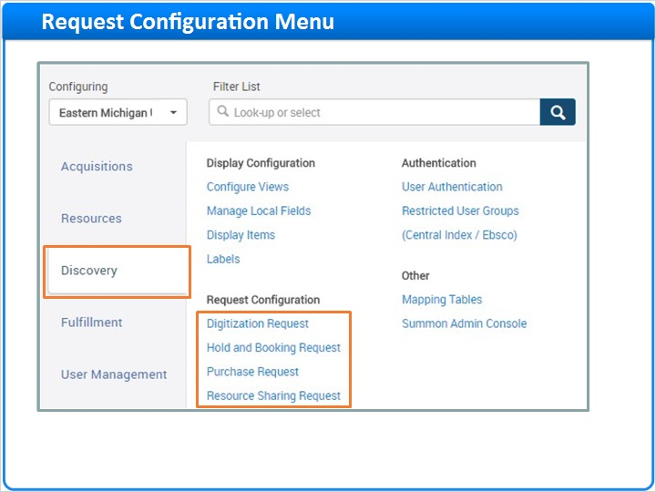
Notes:
Alma allows authenticated users to fill out various request forms so that they can provide additional information when requesting an item from the Services page. The ability for users to submit these requests is based on the Terms of Use and Fulfillment rules your library has defined in Alma.
The workflows for configuring the mapping tables for Digitization, Hold and Booking and Purchase Requests Forms are very similar and allow you to define the optional fields that appear in each of those request forms on the Services page.

From the Discovery Configuration menu, click on the appropriate Request.

1.19 Hold and Booking Request Parameters
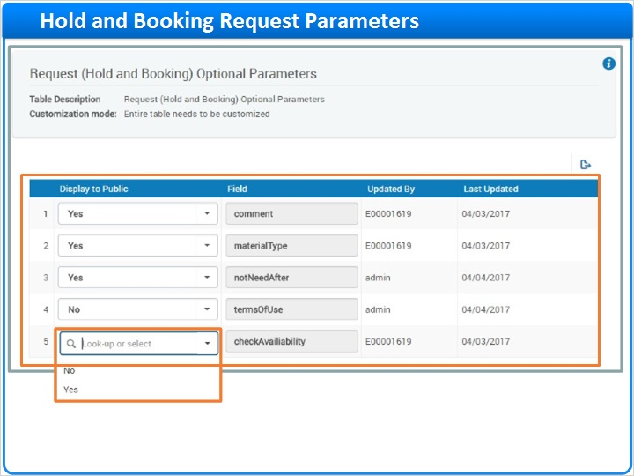
Notes:
For example, after clicking on the Hold and Booking Request link, you’re taken to the Request Optional Parameters page where you can view the optional fields that appear in the Hold and Booking Request form.

You’ll see a nearly identical table for Digitization and Purchase Request parameters as well.

To configure which fields to display, simply use the Display to Public Yes/No drop-down menu.

1.20 Resource Sharing Request Parameters
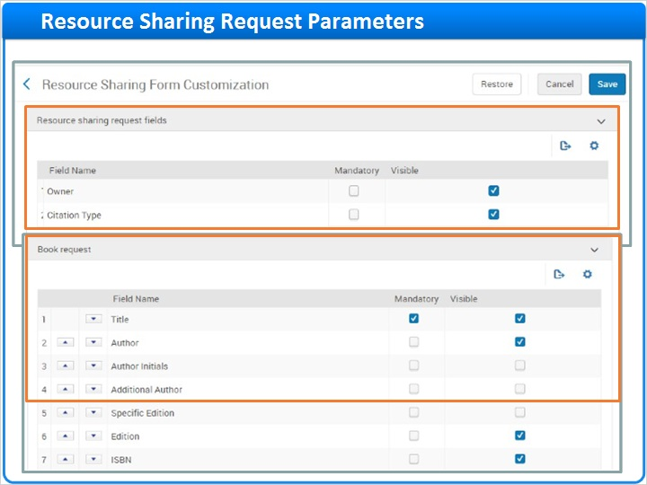
Notes:
The Resource Sharing Request Customization page is more lengthy with 4 sections that allow you to configure various aspects of the Resource Sharing Request Form.

- The Resource sharing request fields configure the general fields, which apply to book and article requests. This section allows you to specify the order of fields, to show/hide fields, and indicate which fields users must populate by selecting the Mandatory checkbox.
The Book Request section configures the fields associated with book requests and allows you to specify the order of fields, show/hide fields, and indicate which fields users must populate.
The Article request section configures the 20-plus optional fields associated with article requests. Like the other 2 sections, it allows you to specify the order of fields, show/hide fields, and indicate which fields users must populate.
The Delivery fields configures the fields associated with the delivery of the book or article. This section also allows you to specify the order of fields, show/hide fields, and indicate Mandatory fields that must be populated by the patron. In addition, some of the fields allow you to specify a default, which may be useful when hiding a field.

Article Request and Delivery Fields (Slide Layer)
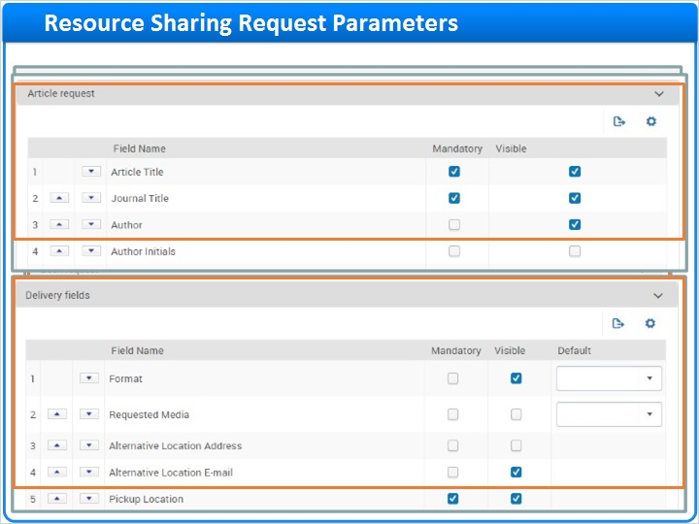

1.21 Session Review and Quiz
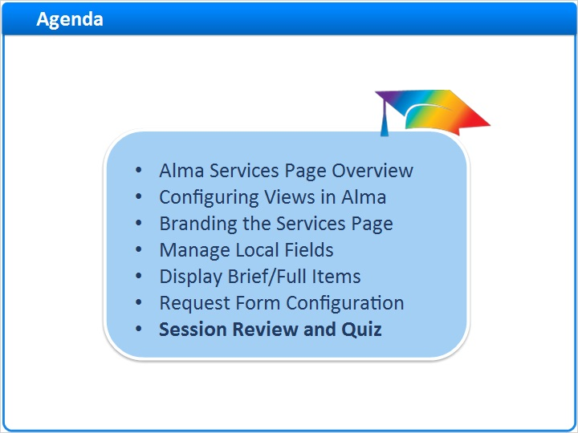
Notes:
That concludes the main portion of this training session. Let’s briefly review what was covered and then proceed to a short quiz.

1.22 Session Review
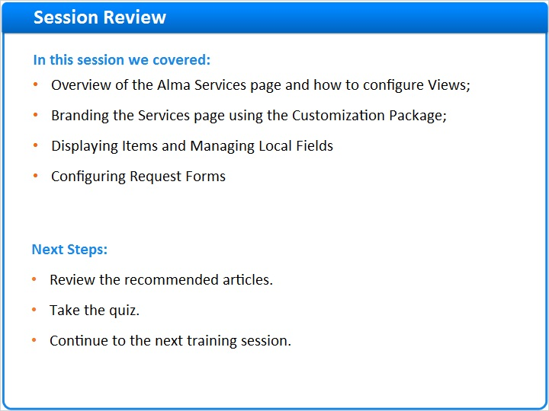
Notes:
In this session we:
- We began with a short overview of the Alma Services page and how to configure views, including the General configuration, Brief Record Display, and Full Record Services;
- We then showed you how to use the Customization Package to manage the branding of your Alma Services page;
- We also discussed how to display Brief Item and Full Item Display on the Services page, as well as how to add local MARC fields for searching or display.
And finally we walked through the basics of configuring request forms for Digitization, Hold and Booking, Purchase and Resource Sharing Requests as well.
Please refer to the Recommended Articles section where you launched this training session for additional information.
After the short quiz that begins on the next page, you can continue on to the next training session in this series.

1.23 Quiz: Request Forms Configuration
(Multiple Choice, 10 points, 1 attempt permitted)
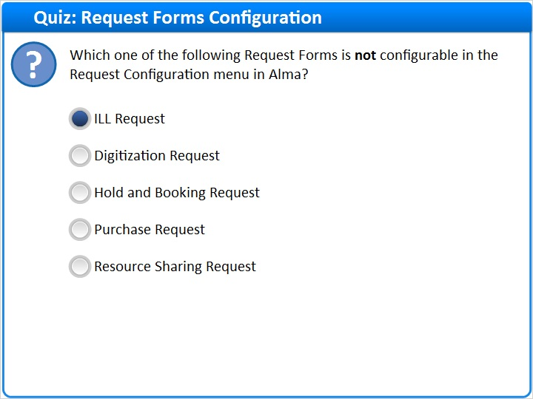
Correct | Choice
X | ILL Request
 | Digitization Request
 | Hold and Booking Request
 | Purchase Request
 | Resource Sharing Request
Feedback when correct:
Right! ILL Request is not configurable in the Request Configuration menu in Alma.
Feedback when incorrect:
Digitization, Hold and Booking, Purchase, and Resource Sharing are configurable in the Request Configuration menu in Alma.

Notes:

Correct (Slide Layer)
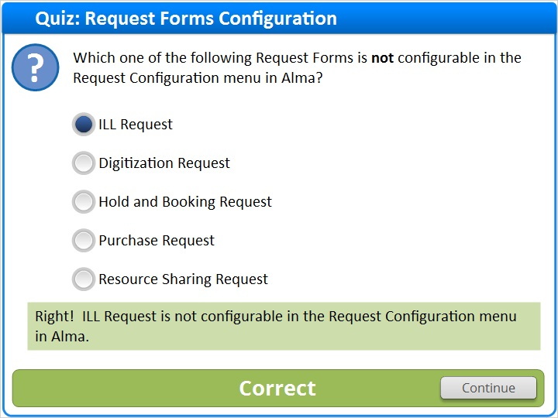

Incorrect (Slide Layer)
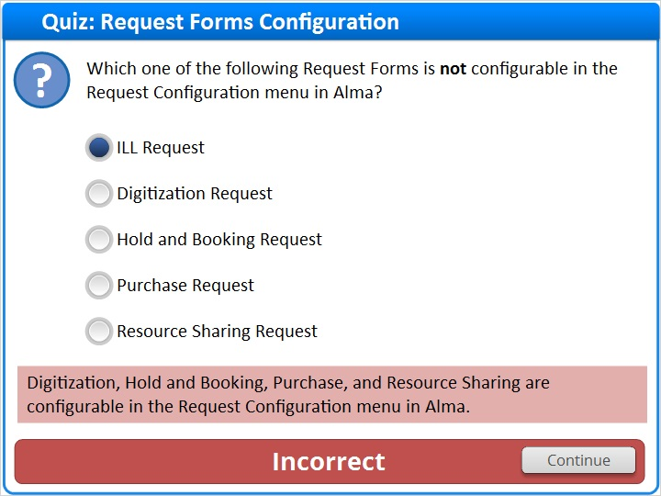

1.24 Quiz: Brief Record Display
(Multiple Choice, 10 points, 1 attempt permitted)
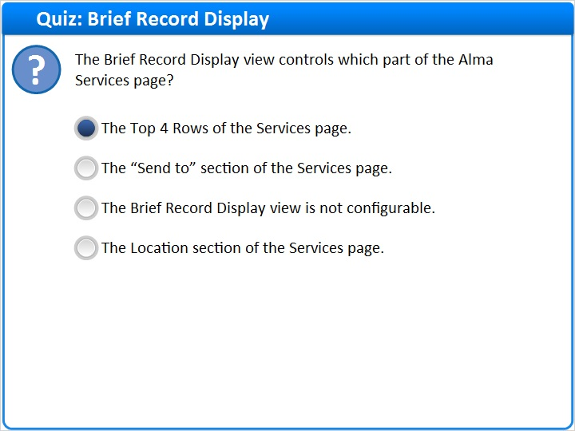
Correct | Choice
X | The Top 4 Rows of the Services page.
 | The “Send to” section of the Services page.
 | The Brief Record Display view is not configurable.
 | The Location section of the Services page.

Feedback when correct:
Right! The Brief Record Display view controls what can be seen in the first top 4 rows of the Services page.
Feedback when incorrect:
Actually, the Brief Record Display view controls what can be seen in the first top 4 rows of the Services page.

Notes:

Correct (Slide Layer)
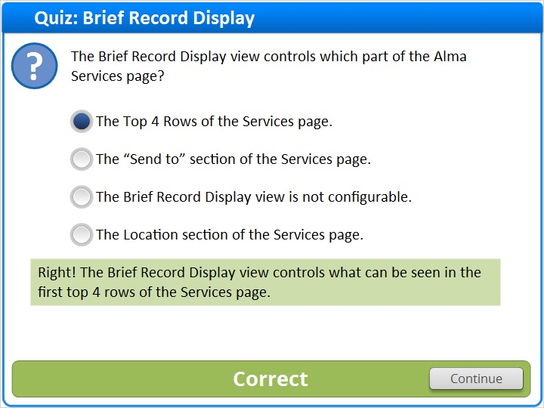

Incorrect (Slide Layer)
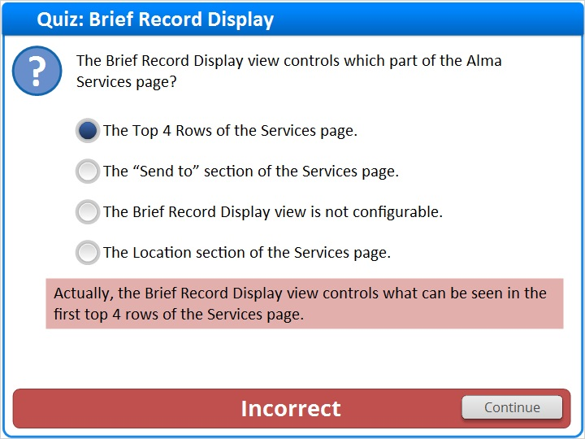

1.25 Quiz: Branding the Sevices Page
(True/False, 10 points, 1 attempt permitted)
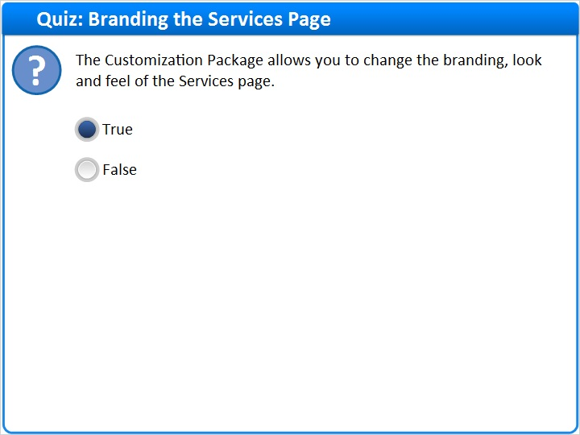
Correct | Choice
X | True
 | False

Feedback when correct:
It allows you to modify CSS, javascript, HTML and image files to brand your Services page as you wish.
Feedback when incorrect:
It actually does let you to modify CSS, javascript, HTML and image files to brand your Services page as you wish.

Notes:

Correct (Slide Layer)
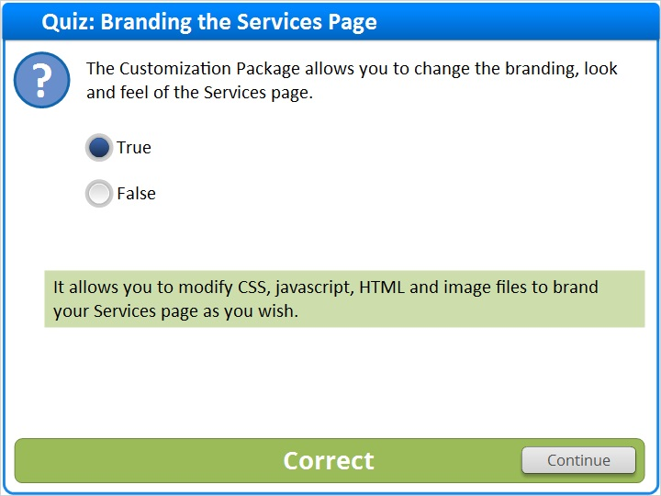

Incorrect (Slide Layer)
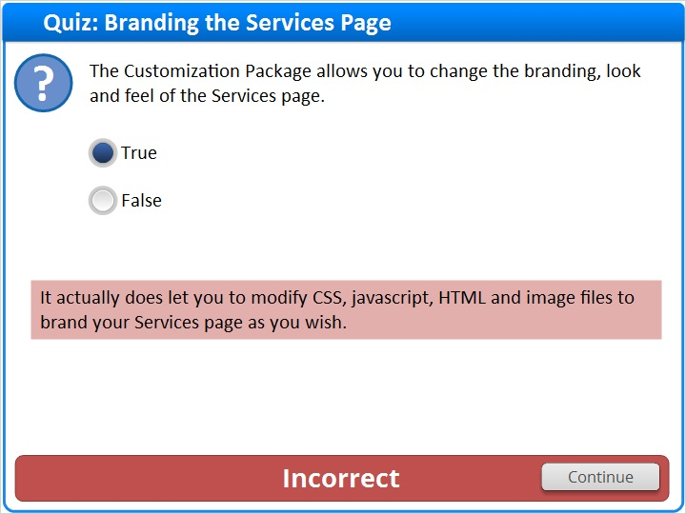

1.26 Thank You!

Notes:
Thank you for joining this session. Please visit the Ex Libris Knowledge Center for additional documentation and resources.

1.27 About this Training

Notes:

1 (Slide Layer)
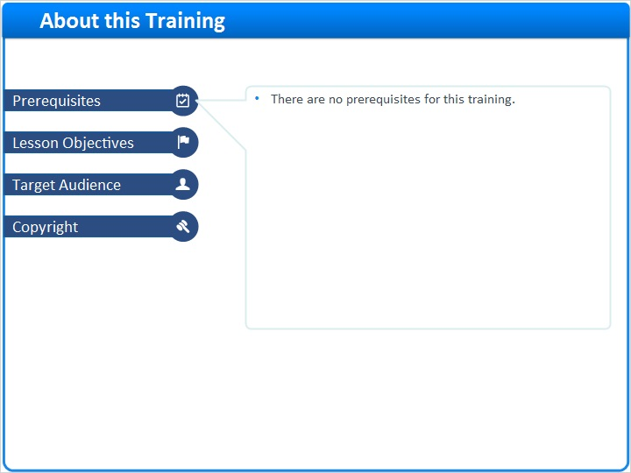

2 (Slide Layer)
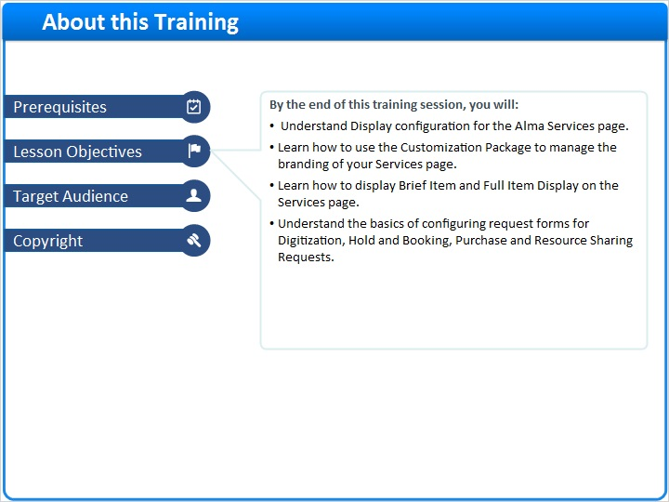

3 (Slide Layer)
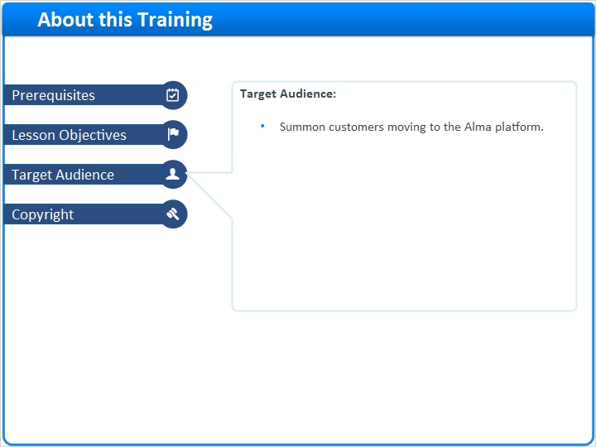

4 (Slide Layer)


