Add Citations via Leganto Search

1. Working with Courses and Reading Lists in Leganto

1.1 Add Citations via Leganto Search

Notes:
There are several ways to add a citation to a reading list in Leganto. Let's see how to add a citation by searching in Leganto.

1.2 Search and Add from Library Resources
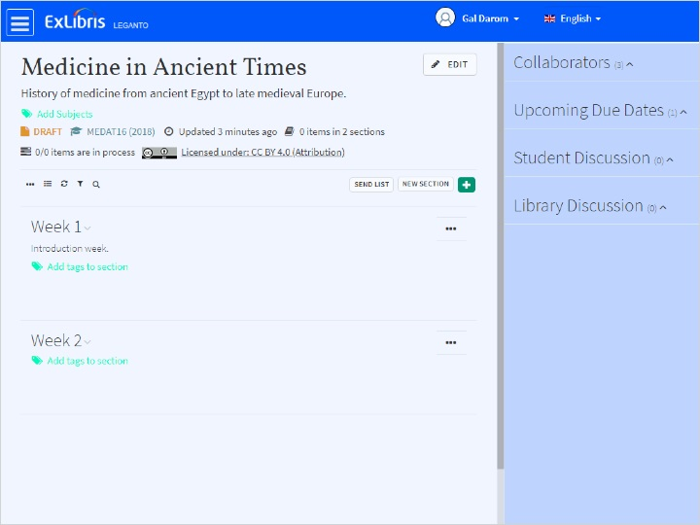
Notes:
To add a citation by search, click on the ‘+’ icon.
Here you can search your library’s inventory using ‘Simple Search’ or ‘Advanced Search’.
Depending on how your Library staff configured Leganto, a drop-down list of search scopes may appear, like this one.
Let’s choose the search scope ‘Alma’, and enter a search term to find items in our library.
Here are the results, you can scroll down to see more.
Note that each citation has an availability status stating whether the citation is available in physical format or an electronic format.
Let’s add some of these items. We can do this via drag-and-drop. Our Citation has now been added to the desired section.
Another way to add, is by selecting an item, which shows us additional item options, selecting a List section, and clicking Add to List.
The citation is now added to the desired section.

1.3 Search and add from Other Repositories
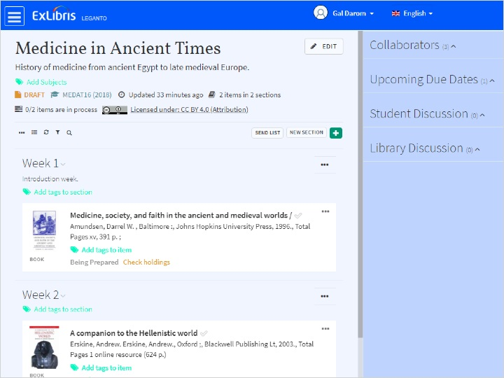
Notes:
Let’s Search for another item, this time from a different scope. Let’s choose ‘Primo Local Repository’ and search for ‘Medicine in ancient Greece’.
If an item has multiple editions or exists in several publications or sources, an ‘Additional versions available’ link will appear on the item.
This let’s you see the additional versions of the item and choose the exact one you want.
Let’s add our item.

1.4 Remove an Item from List
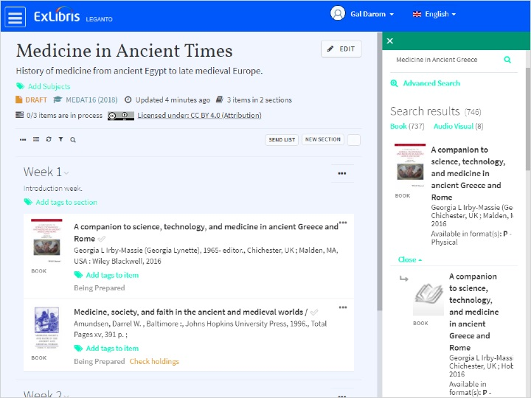
Notes:
And now if we want to remove the item, we go to options > Delete item, and confirm.

1.5 Quiz: Add Citations via Leganto Search
(True/False, 10 points, 1 attempt permitted)
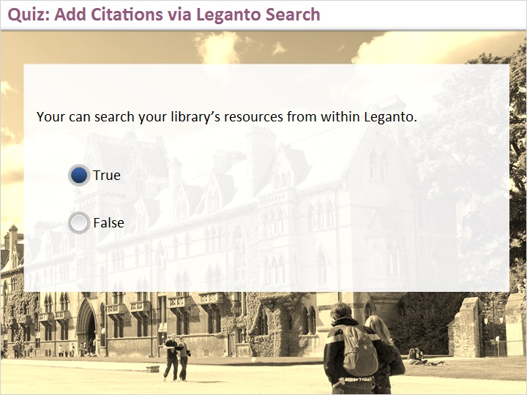
Correct | Choice
X | True
 | False
Feedback when correct:
That's right! You can create search both your library’s resources and other repositories, if configured by your library.
Feedback when incorrect:
No sorry, that’s not right. You can create search both your library’s resources and other repositories, if configured by your library.

Notes:

Correct (Slide Layer)
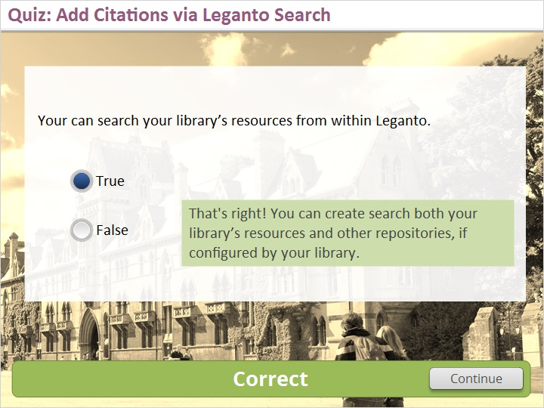

Incorrect (Slide Layer)
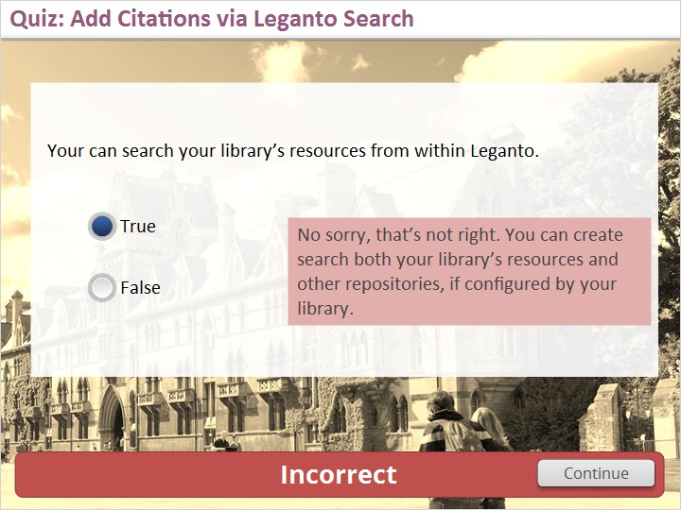

1.6 Thank You

Notes:
Thanks for joining this session!

2. Empty Shell

2.1 About this Training
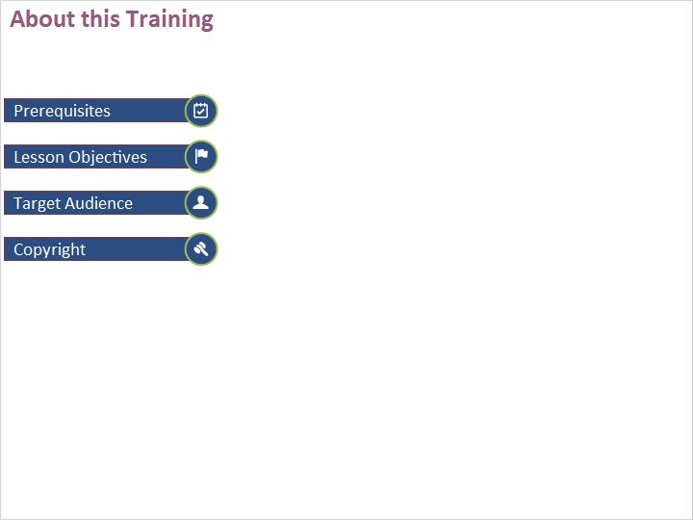
Notes:

1 (Slide Layer)
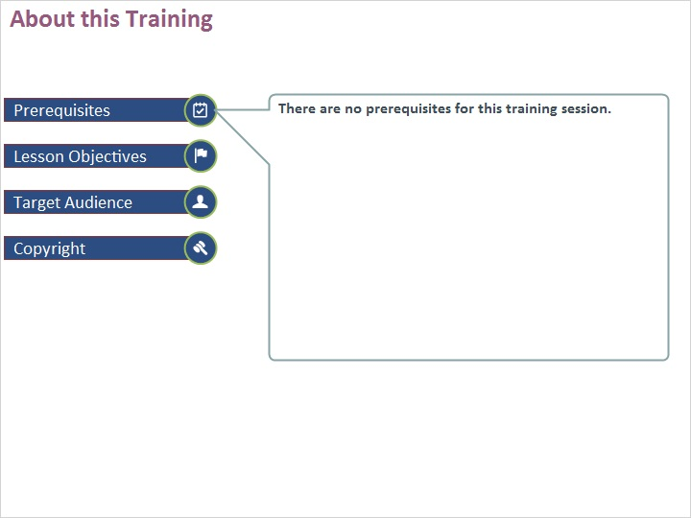

2 (Slide Layer)
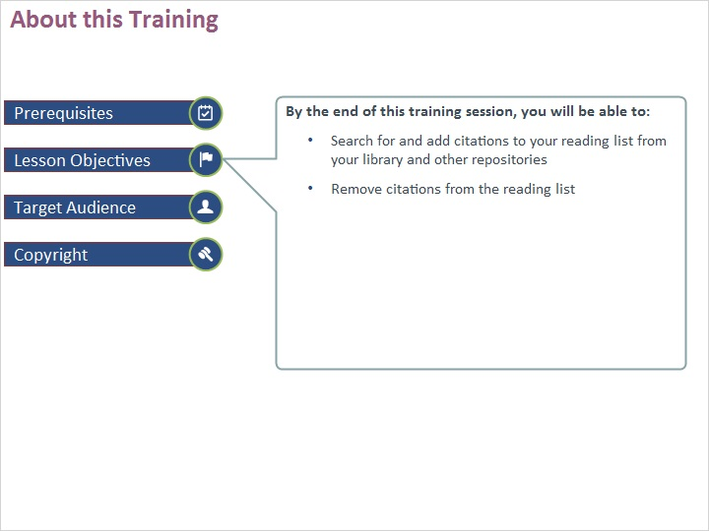

3 (Slide Layer)
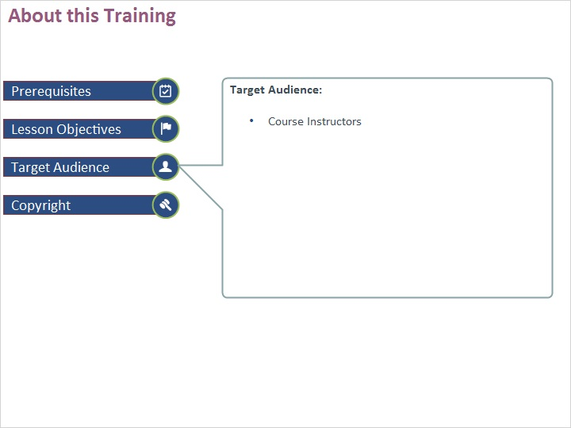

4 (Slide Layer)


