Add Citations from Web via Cite It! Widget

1. Working with Courses and Reading Lists in Leganto

1.1 Add Citations via Upload

Notes:
There are several ways to add a citation to a reading list in Leganto:
One cool way to add items, from anywhere online, is with the ‘Cite It!’ toolbar widget.
This widget enables you to cite a web page or an item on a web page.

1.2 Install the Cite It! Widget
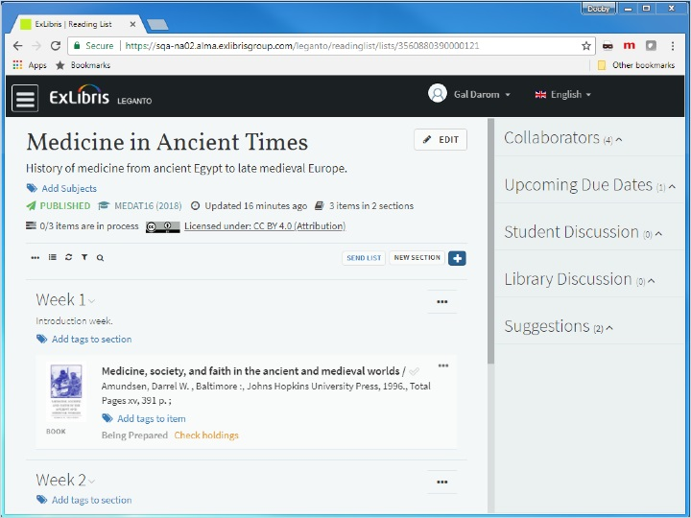
Notes:
To install Cite It on your browser, click your user-name and select ‘Leganto Cite It!’
Here you can see the list of all the sites supported by the widget. This list gets updated on a regular basis.
Now to install, simply, drag and drop the ‘CITE IT!’ link to your browser’s toolbar. That’s it. You are ready to start adding web citations.

1.3 Cite from a Web Page
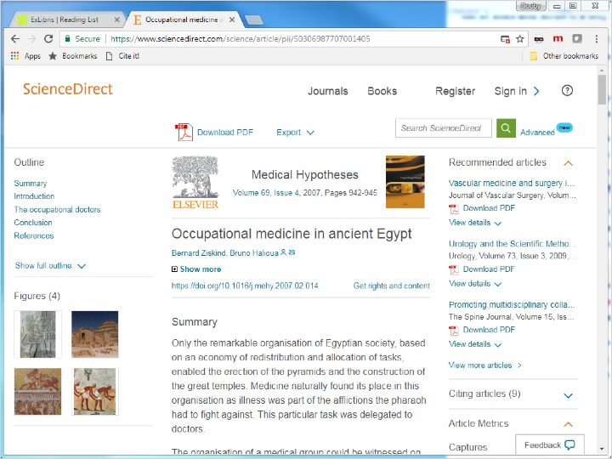
Notes:
We are now looking at a webpage with a wanted item.
In our example it’s an article from ScienceDirect, but it can also be from Amazon, or a YouTube video, or an item from any of the supported web-pages.
To add this item to our reading list, click ‘Cite It!’ and a pop-up appears with the item’s details.
If the item already has coverage by the library, Leganto recognizes this and displays the “covered by your library” indication. This applies to both books and articles!
You can add the citation either to your collection in Leganto, making it available to add to your lists later; or directly to your reading list by clicking ‘List’ and selecting the list, and then section within the list.
Now if we want to add this item to several lists we click Add, and then repeat with another list; otherwise simply click Add and Close.

1.4 Item has been Added
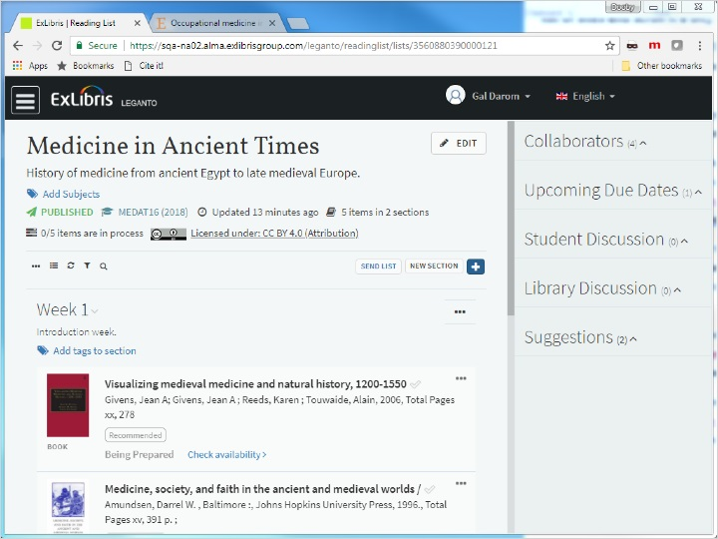
Notes:
Back at the list, we can see the article has been added, and we can view it via Check availability > and in the citation page click on the desired link.

1.5 Quiz: Add Citations from Web via Cite It! Widget
(True/False, 10 points, 1 attempt permitted)
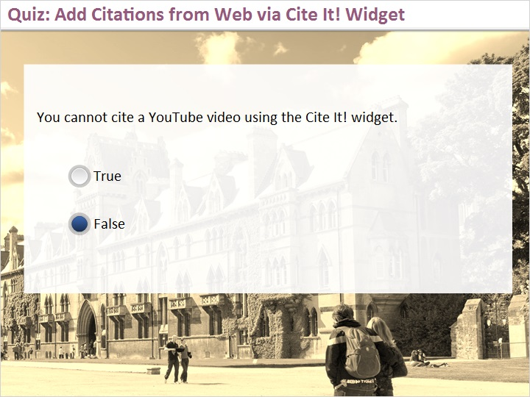
Correct | Choice
 | True
X | False
Feedback when correct:
That's right! Youtube is one of the many websites supported by the Cite It! widget. You can find the full list of supported sites in Leganto, under User Menu > Cite It!
Feedback when incorrect:
No sorry, that’s not right. Youtube is one of the many websites supported by the Cite It! widget. You can find the full list of supported sites in Leganto, under User Menu > Cite It!

Notes:

Correct (Slide Layer)
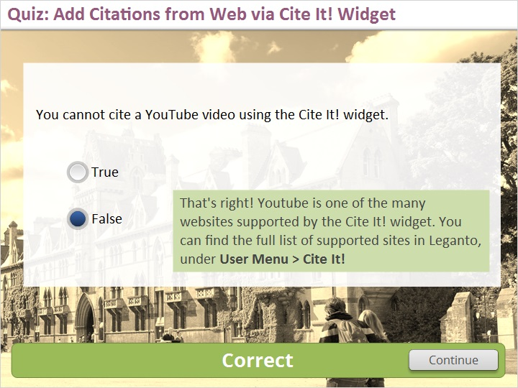

Incorrect (Slide Layer)
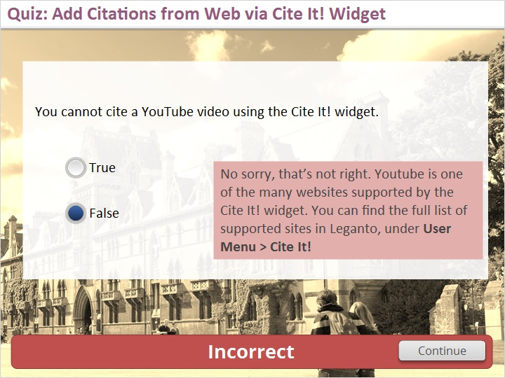

1.6 Thank You

Notes:
Thanks for joining this session!

2. Empty Shell

2.1 About this Training
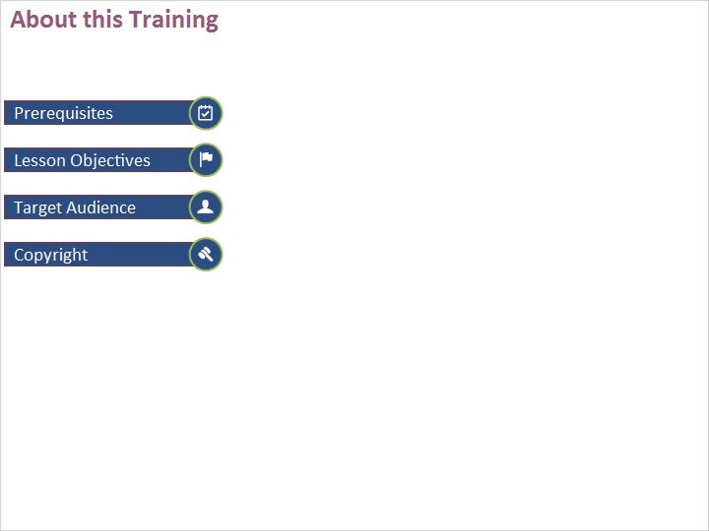
Notes:

1 (Slide Layer)
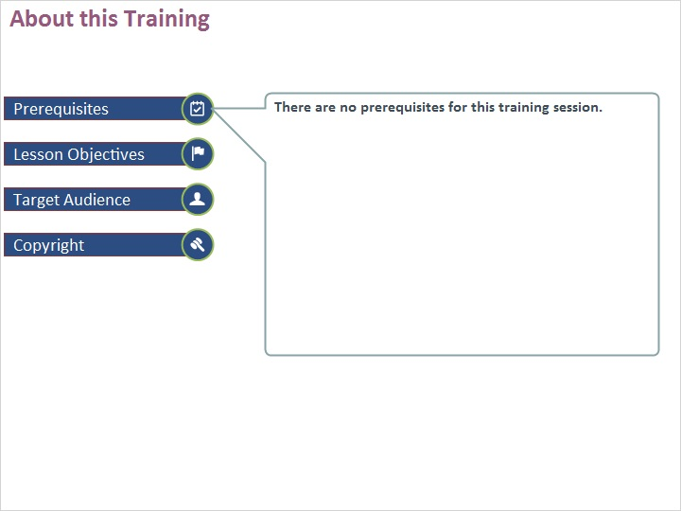

2 (Slide Layer)
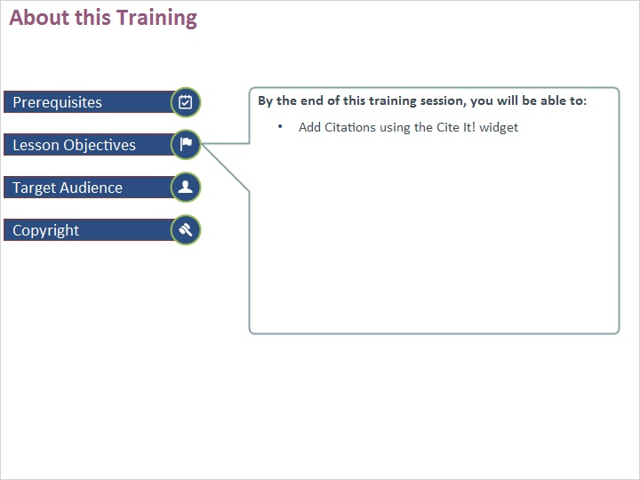

3 (Slide Layer)
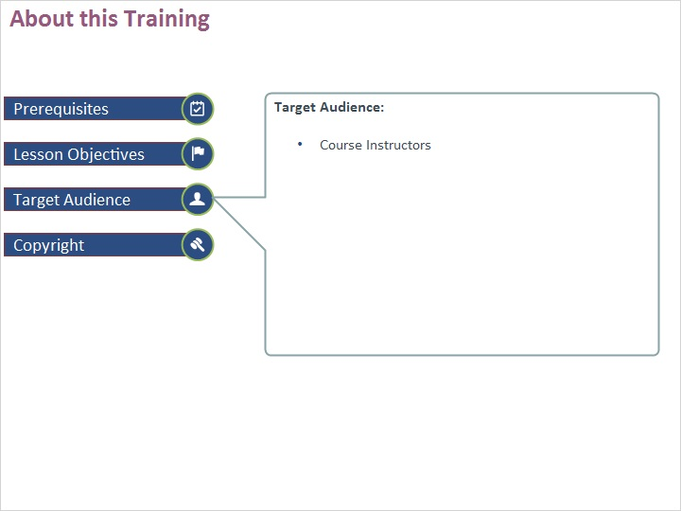

4 (Slide Layer)


