Sending Reading Lists to the Library

1. Sending Reading Lists to the Library

1.1 Sending Reading Lists to the Library

Notes:
Now it’s time to see how to send reading lists and citations to the Library so Librarians can fulfill the citations for your students.

1.2 Reading List Status
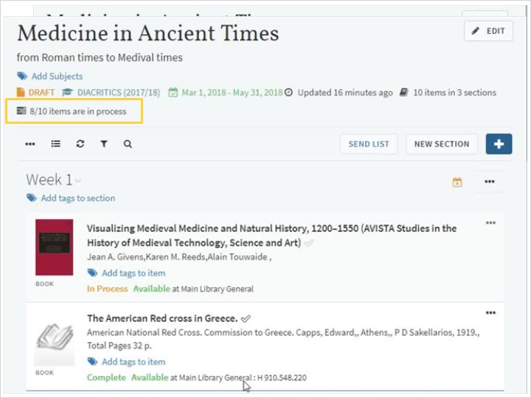
Notes:
When you’ve finished compiling the list, the next step is to send it to the library so that the library staff can prepare the items for the students.
You might have noticed that each citation in the list already has a status associated with it: ‘Being prepared’.
This status means that the citation is still being prepared and is not yet ready for the library to start processing.
You can send the entire list to the library for processing from the send list link - the tool-tip shows us the last-sent-date of the list. As a side-note, it’s also possible to send only an individual item or a section, but best practice is to send the whole list. So now let’s send the entire reading list to the library for processing by clicking on the Send List link.
All citations with the status ‘BEING PREPARED’ have their status changed to ‘Sent’.
When library staff starts processing a citation they can change its status to ‘In Process’ to let us know that the citation is currently being worked on.
Once finished, they set it to ‘COMPLETE’, indicating that the citation is ready for the students.
By hovering over ‘items in process’ you can a see short summary of how many citations in are in each status.
Even when all of the items in a reading list are set to ‘COMPLETE’, the students cannot view the list until you publish it. To learn how to publish a list please view the next session on ‘Publishing a list’.

1.3 Quiz: Sending Citations to the Library
(True/False, 10 points, 1 attempt permitted)
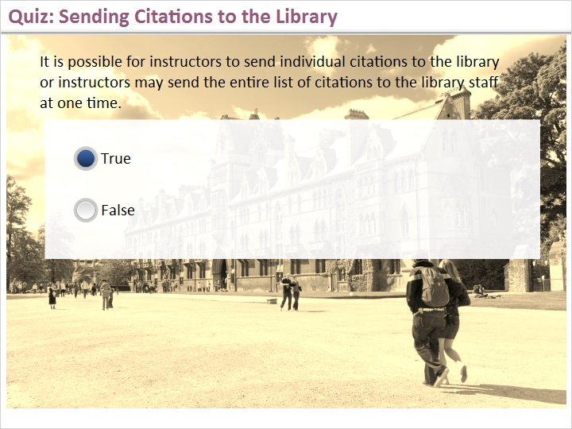
Correct | Choice
X | True
 | False
Feedback when correct:
That’s correct. We just saw that instructors can use the “send list” button to send all citations to the library staff for processing. From the options list, we also saw that it is possible to send an individual citation to the library for fulfillment.
Feedback when incorrect:
Sorry, that’s not correct. We just saw that instructors can use the “send list” button to send all citations to the library staff for processing. From the options list, we also saw that it is possible to send an individual citation to the library for fulfillment.

Notes:

Correct (Slide Layer)
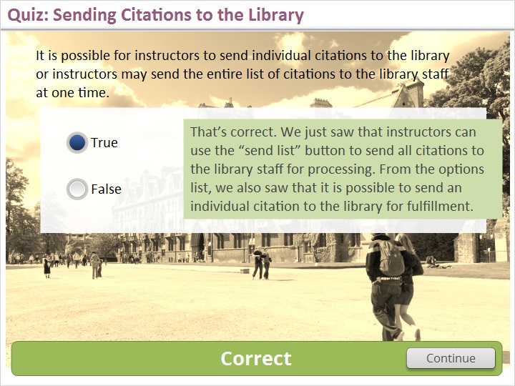

Incorrect (Slide Layer)
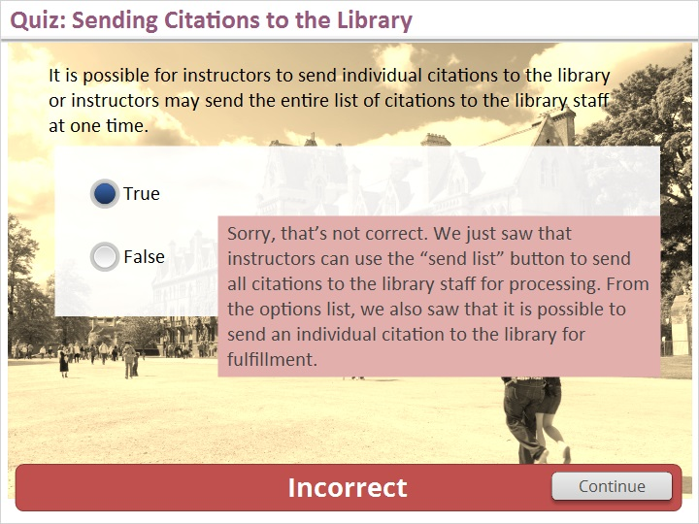

1.4 Quiz: Citations set to Complete
(True/False, 10 points, 1 attempt permitted)
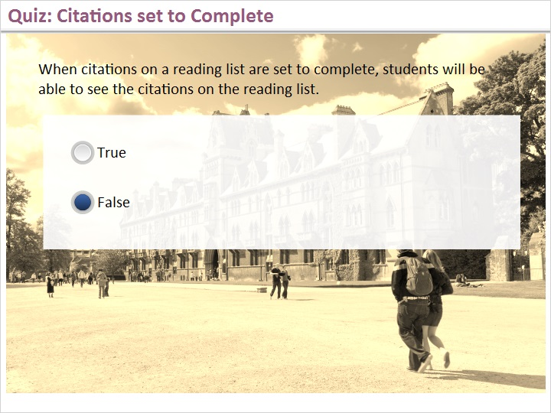
Correct | Choice
 | True
X | False

Feedback when correct:
That's right! Even if all citations on the reading list are set to complete by the library staff, the citations will not be visible to students until the list is published.
Feedback when incorrect:
Sorry, that’s not right. Even if all citations on the reading list are set to complete by the library staff, the citations will not be visible to students until the list is published.

Notes:

Correct (Slide Layer)
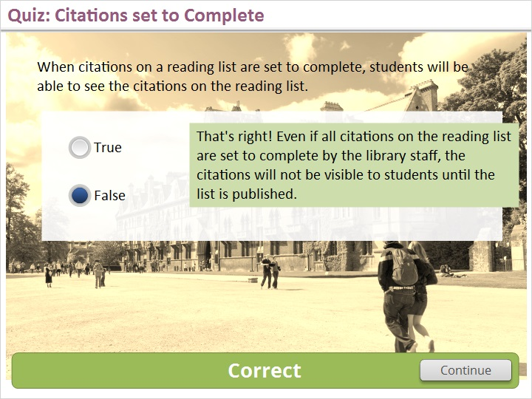

Incorrect (Slide Layer)
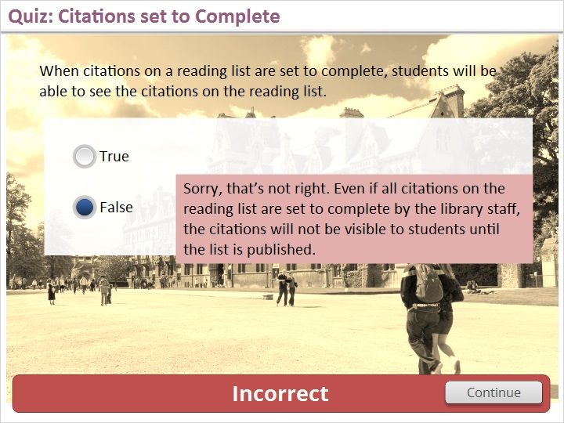

1.5 Thank You

Notes:
Thanks for joining this session! Visit the Ex Libris Knowledge Center to learn even more!!

2. About this Training

2.1 About this Training
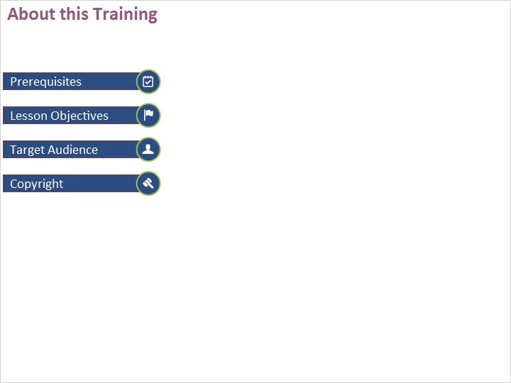
Notes:

Prerequisites (Slide Layer)
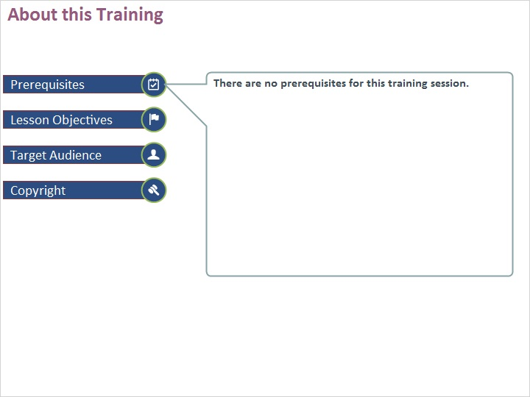

Learning Objectives (Slide Layer)
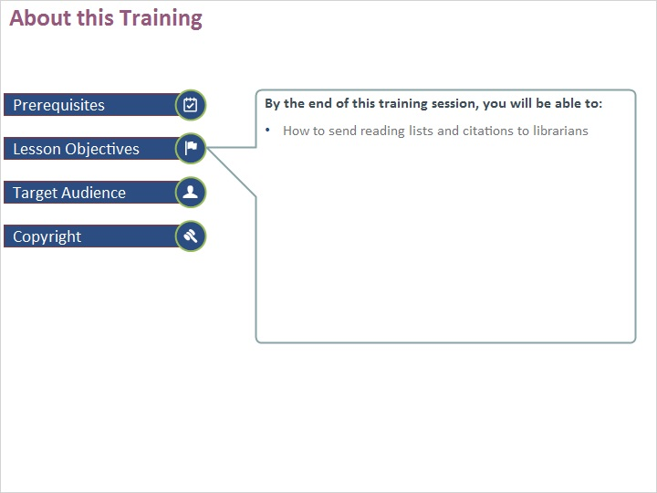

Target Audience (Slide Layer)
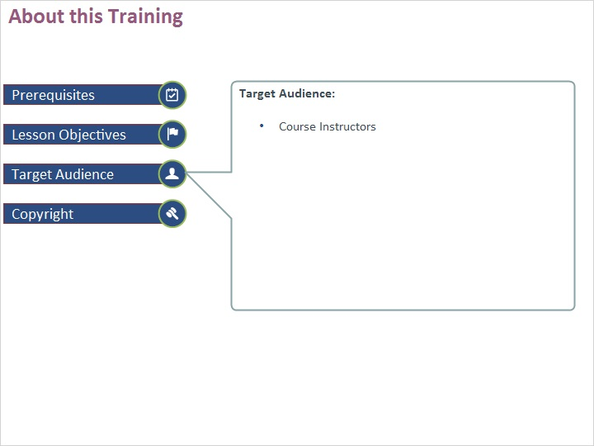

Copyright (Slide Layer)


