Student Interaction with Reading Lists

1. Student Interaction with a Reading List

1.1 Student Interaction with Reading Lists
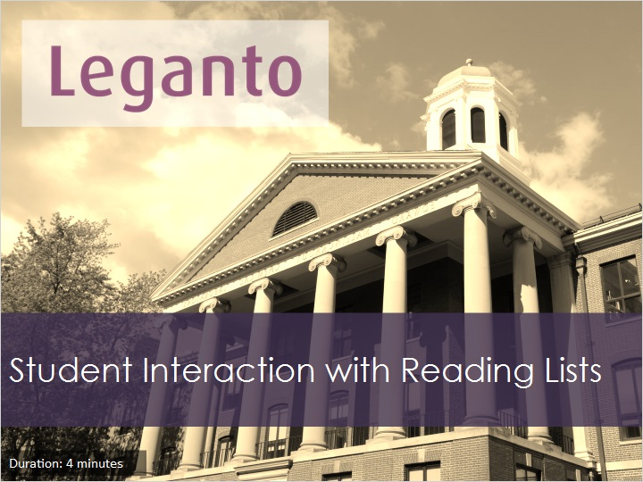
Notes:
In this session, you’ll see how to interact with course participants through the Student Discussion, citations comments and student suggestions for the reading list.

1.2 Student Discussion
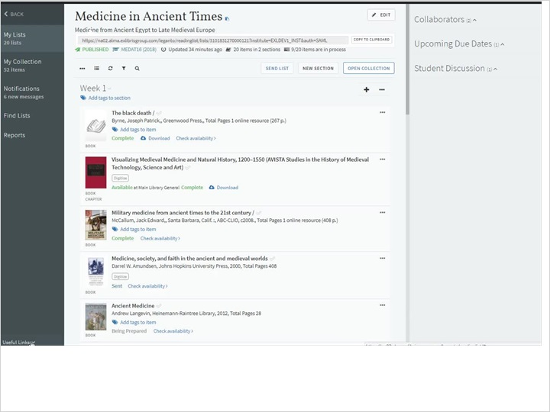
Notes:
When viewing a list or citation, you may see a Student Discussion area in the right pane of the reading list view. Students can add comments and questions here.
As an administrator of the reading list, you can delete comments from the discussion list.
From the Reading list options menu you can disable all discussions about citations on a reading list by clicking on the Reading List Options Menu , then selecting Configure List Discussion and then the ‘Hide student discussion thread’. The Student Discussion link will be hidden.
To re-enable the discussion thread, select ‘Show student discussion thread’ under the Configure List Discussions link.
If configured by your institution, you can add or edit a text header to be displayed on top of the discussion thread by selecting ‘Edit Discussion Header’ from the Reading List Options menu, Configure List Discussions link.
You can see the new header for the discussion thread displays here.

Working with Unassigned Reading Lists (Slide Layer)
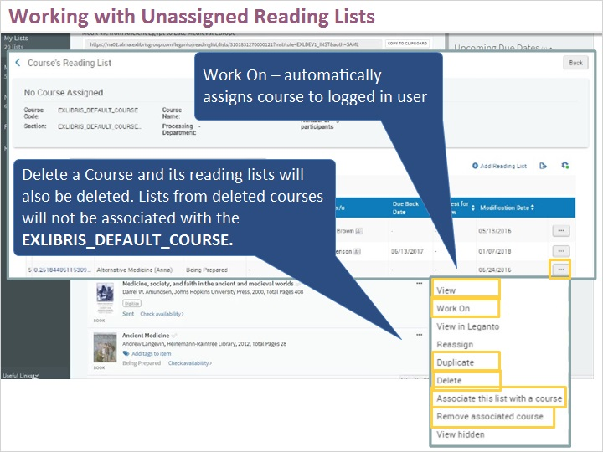

1.3 Likes, Views and Comments
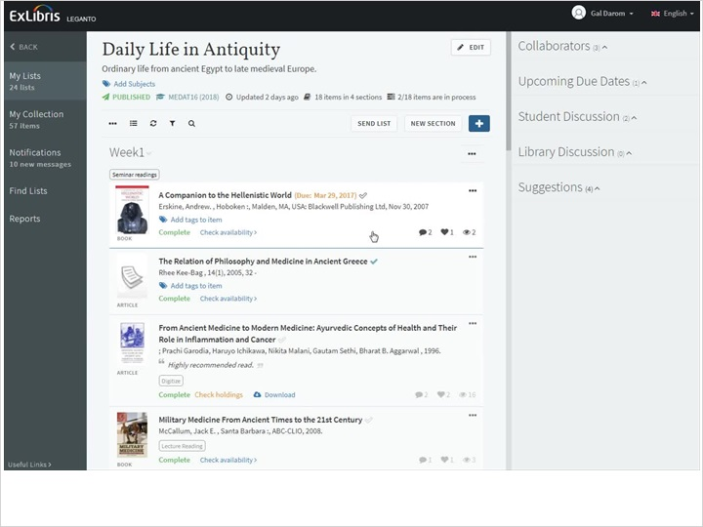
Notes:
Looking at the citations from our list, you can see the number of likes, comments and views for the item. You can like an item from the citation page by clicking on the citation title and clicking the Like button at the top right of the page.
Students can mark a citation as read by clicking on the checkmark icon next to the citation title. The citations is marked as read only for the user who marked it. You can also change the status to ‘Mark as unread’ by clicking the checkmark again.

Working with Unassigned Reading Lists (Slide Layer)
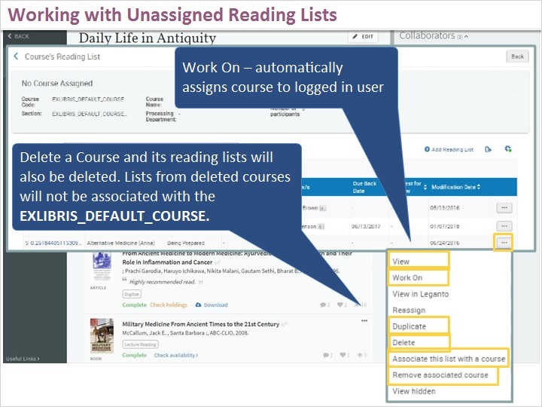

1.4 Student Suggestions
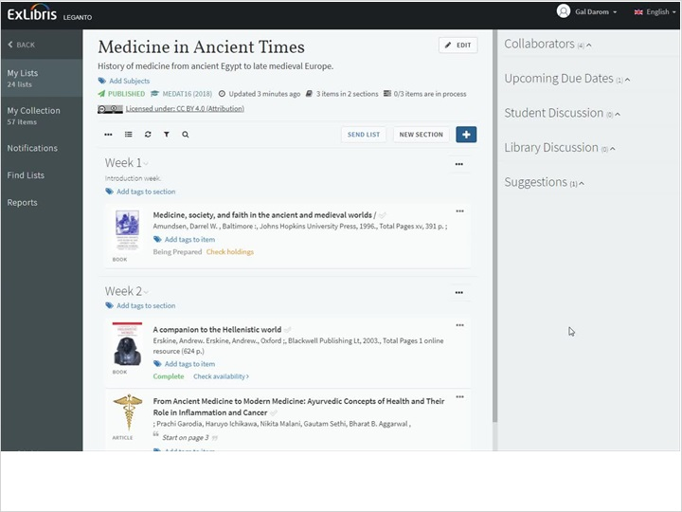
Notes:
Also in the pane to the right of the reading list is a Suggestions area where students can add suggested citations for the reading list. To add a suggestion the student would go to their My Collection Page, find an item, and under the ellipsis, choose suggest this item, select the appropriate reading list, and click Add Suggestion.

Working with Unassigned Reading Lists (Slide Layer)
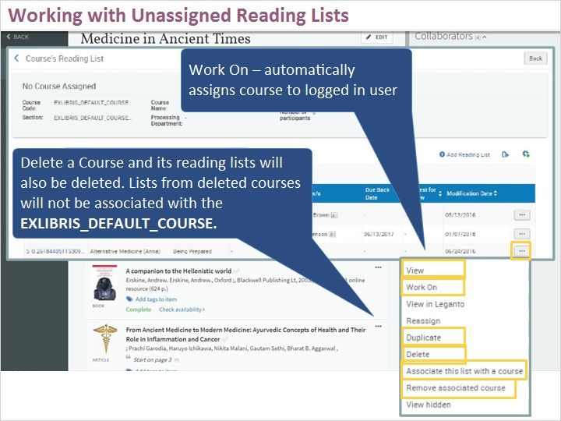

1.5 Add Suggestion to Reading List
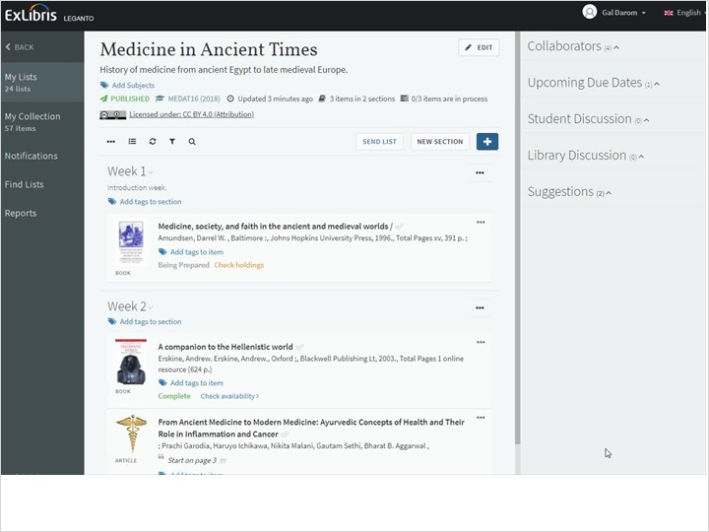
Notes:
Back at the list, we can see the item has been added to the Suggestion panel. From here an instructor can add it to the list by selecting the item and dragging it to the reading list.

Working with Unassigned Reading Lists (Slide Layer)
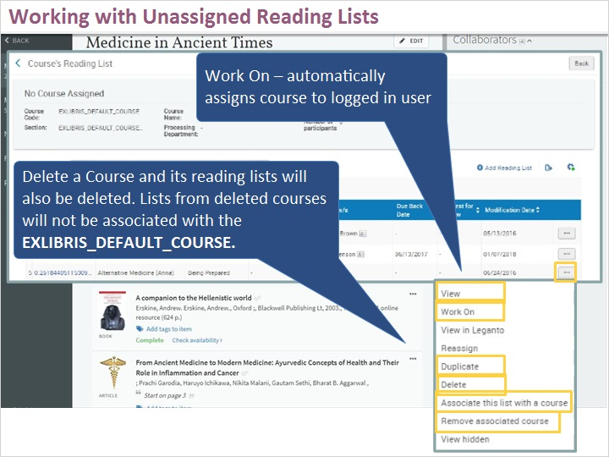

1.6 Export and Accessibility
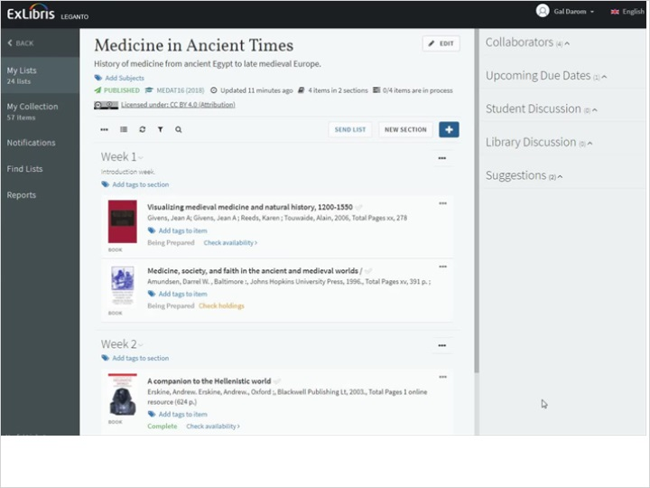
Notes:
Students or instructors, can export a list or a section to a variety of formats from the Reading list options menu. In addition to the export options, the list can also be printed.
To accommodate users who are visually impaired, it’s possible to enhance the accessibility of the list by clicking on the ‘Accessibility Menu’ at the top right of the Leganto screen. Users may change the font size or choose one of the site contrast options to make the screen, text and images more readable.
Note that Leganto is screen-reader friendly as well.

Working with Unassigned Reading Lists (Slide Layer)
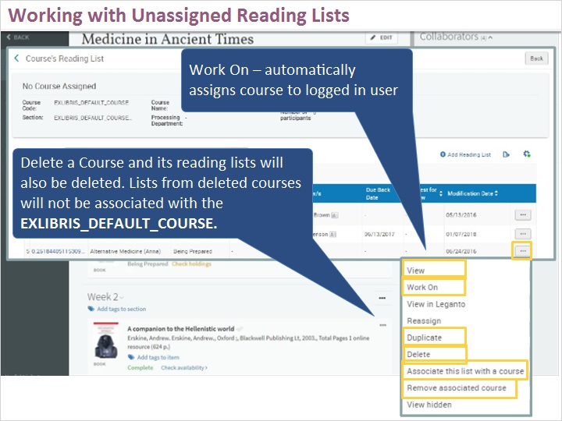

1.7 Quiz: Student List Discussion
(True/False, 10 points, 1 attempt permitted)
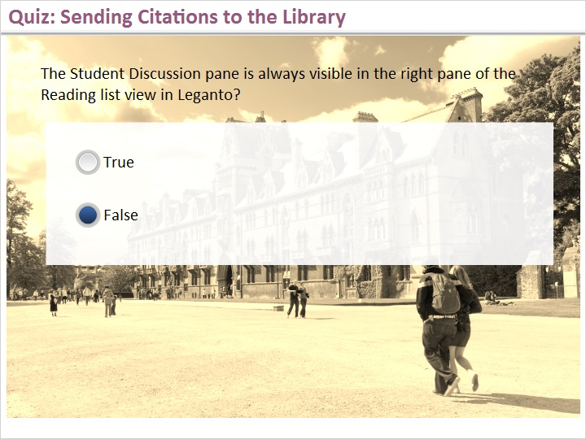
Correct | Choice
 | True
X | False
Feedback when correct:
That’s right. The Student discussion area is configurable. An instructor can choose to hide or show the student discussion from the Reading List Options menu> Configure List Discussion options
Feedback when incorrect:
Sorry, that’s not right. The Student discussion area is configurable. An instructor can choose to hide or show the student discussion from the Reading List Options menu> Configure List Discussion options menu > Show/Hide Student Discussion thread.

Notes:

Correct (Slide Layer)
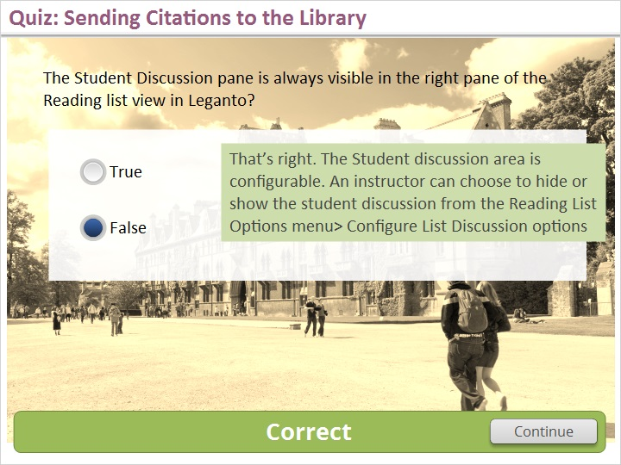

Incorrect (Slide Layer)
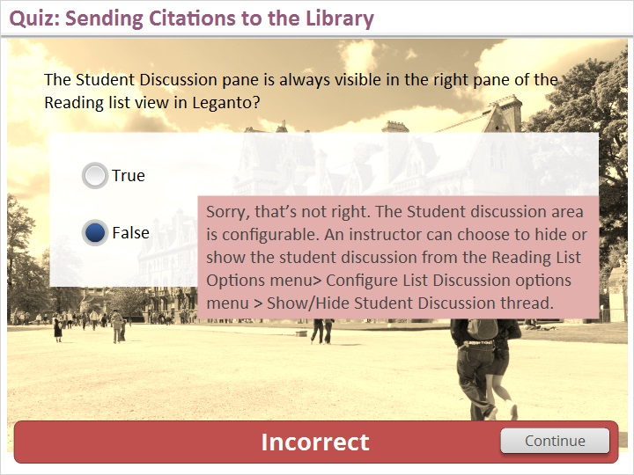

1.8 Thank You

Notes:
Thanks for joining this session! Visit the Ex Libris Knowledge Center to learn even more!!

2. About this Training

2.1 About this Training
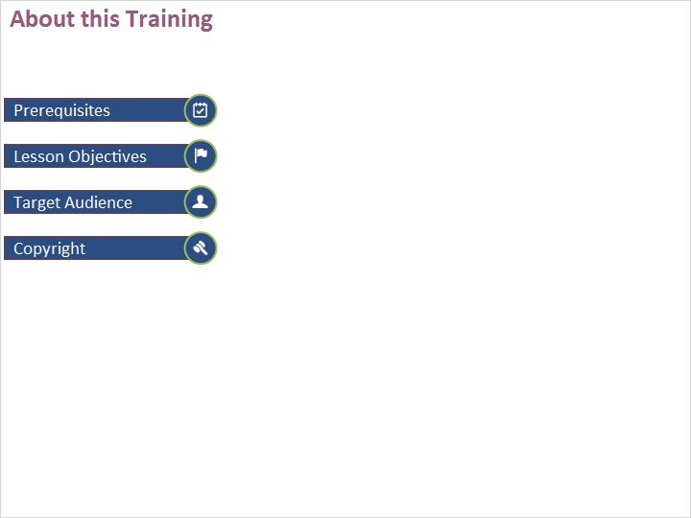
Notes:

Prerequisites (Slide Layer)
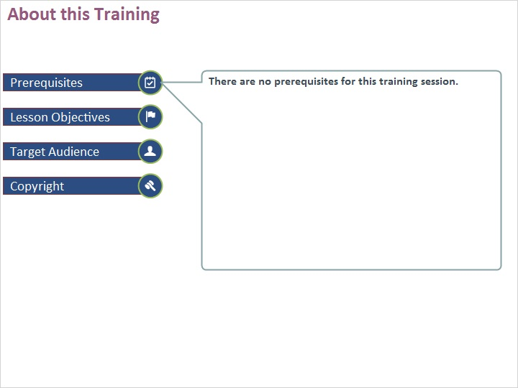

Learning Objectives (Slide Layer)
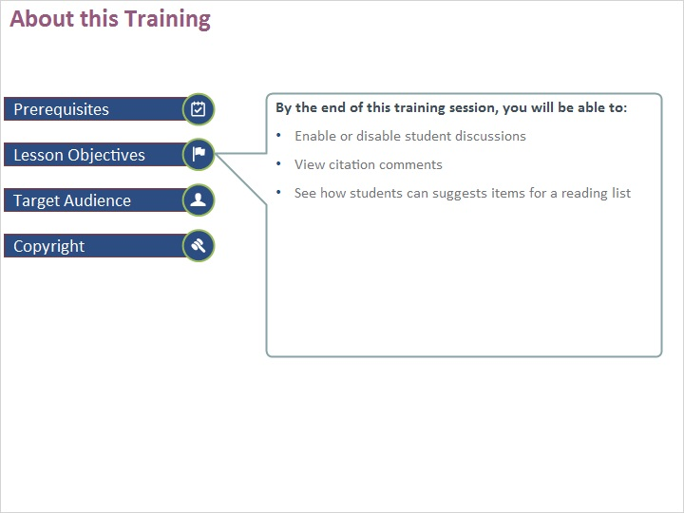

Target Audience (Slide Layer)
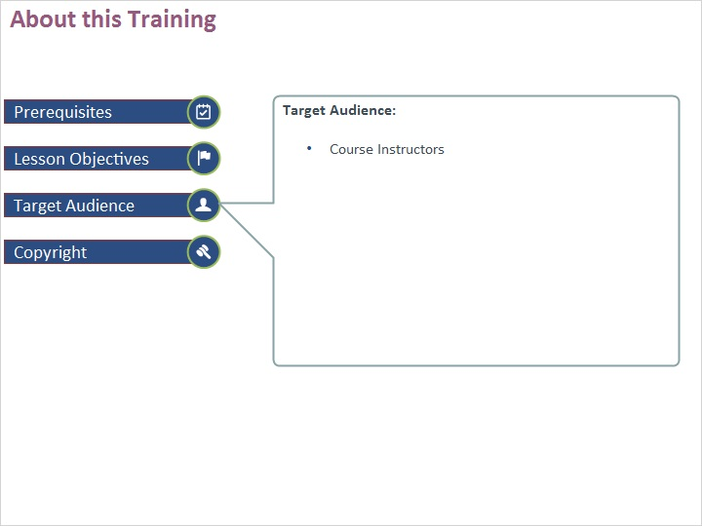

Copyright (Slide Layer)


